Lab 7
Afra Ali Fetais Al-Marri
201903378

B.1 Identify classes and typed attributes - 25 minutes
Use the APS case from Lab 3 and Lab 6, Figure 2 and the Register client example. Keep PoB financial accounts and login outside APS. Identify classes needed by the case and specifications. Record typed attributes and a brief justification in the table; state assumptions. Add rows as needed.
Class Name | Typed attributes | Evidence and justification
Client |  | Needed to store client registrations with name, address, and unique ID.
IndividualClient | (Inherits from Client)
CorprateClient | (Inherits from Client)
Item | -itemId: String  -make: String  -model: String  -saleType: SaleType  -startingPrice: BigDecimal  -reservePrice: BigDecimal  -fixedPrice: BigDecimal  -auctionEndTime: DateTime  -status: ItemStatus | Needed to store the physical telephone product specifications
ItemStatus | AVAILABLE, SOLD
Bid | -amount: Decimal  -timestamp: DateTime | Needed to record bid details against an auction item transaction.
Invoice | -invoiceID: String  -totalAmount: BigDecimal  -status: InvoiceStatus | Needed to record generated bills and payment statues.
InvoiceStatus | PAID, UNPAID
CatalogEntry | -entryId: String  -dateListed: DateTime | Needed to keep a registry record of an item listed within the shops active sale catalog.

B.2 Develop the APS class diagram - 35 minutes
Develop the diagram in Visual Paradigm using B.1. Show typed attributes and visibility, associations with multiplicity at both ends, and justified generalization and whole-part relationships. Briefly explain your main relationship choices below the diagram.

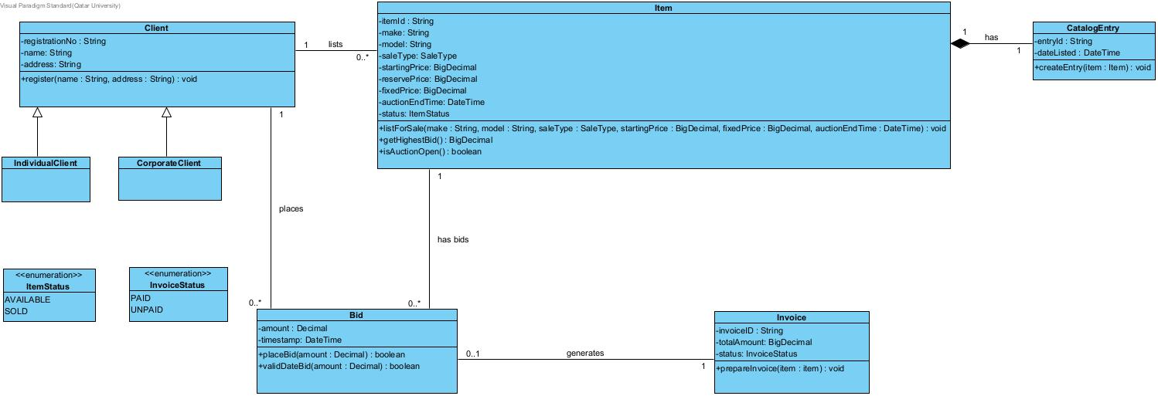

B.3 Assign operations from the use case specifications - 30 minutes
Derive operations from UC001 Register client, UC003 List item for sale and UC006 Place bid. For each, record its responsible class, typed parameters, return type and source use case step. Add the operations to your diagram.

Class | Operation with parameter and return types | Use case step and placement reason
Client | Register( name: String, address: String) : void | Register Client: APS records the clients registratuin details. Exact step requires the Register Client specification.
Item | listForSale( saleType: SaleType, auctionEndTime: DateTime) : void | UC002 Step 2: Aps assigns an ID to the item and attaches its details to the clients registration.
CatalogEntry | createEntry(item: Item) : void | UC002 Steps 3-5: APS creates the catalog entry and displays th approved itm.
Bid | Placebid(amount : Decimal) : boolean | UC003 Step 2: APS checks the bid and records it against the clients registration.
Item | markSold(): void | UC003 Step 4: APS marks the item as sold and removes it from the catalog.
Invoice | prepareInvoice(item:Item) : void | UC003 Steps 5-7: APS prepares the invoice and attaches it to the winning clients registration as unpaid.

