B.1: Identify classes and typed attributes - 25 minutes
Class Name | Typed attributes | Evidence and justification
Client | -registrationNo: String  -name: String  -address: String | Needed to store client registration with name, address, and unique id.
IndividualClient | (Inherits from Client)
CorprateClient | (Inherits from Client)
Item | -itemId: String  -make: String  -model: String  -saleType: SaleType  -startingPrice: BigDecimal  -reservePrice: BigDecimal  -fixedPrice: BigDecimal  -auctionEndTime: DateTime  -status: ItemStatus | Needed to store the physical telephone product specifications.
ItemStatus | AVAILABLE, SOLD
Bid | -amount: Decimal  -timeStamp: DateTime | Needed to record bid details against auction item statuses.
Invoice | -invoiceID: String  -totalAmount: BigDecimal  -status: InvoiceStatus | Needed to record generated bills and payment statuses.
InvoiceStatus | PAID, UNPAID
CatalogEntry | -entryId: String  -dateListed: DateTime | Needed to keep a registry record of an item listed within the shop’s active sales catalog.
B.2:
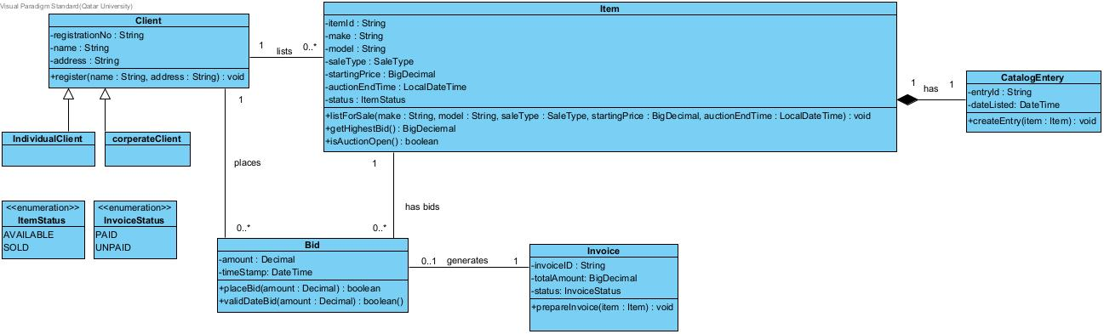
B.3:
Class | Operation with parameter and return | Use case
Client | +register(name : String, address : String) : void | UC001: records the clients registration details.
Item | +listForSale(make : String, model : String, saleType : SaleType, startingPrice : BigDecimal, auctionEndTime : LocalDateTime) : void | UC003: records the item and its proposed sale details
catalogEntery | +createEntry(item: Item): void | UC003: creates catalog entry and displays the approved item
Bid | +placeBid(amount : Decimal) : boolean | UC006: record the client’s bid against the auction item
Invoice | +prepareInvoice(item : Item) : void | UC003: APS prepares the invoice and attaches it to the winning client’s registration

