Affidavit in Support of Motion for Custody Modification.
IN THE CIRCUIT COURT FOR THE 14th JUDICIAL CIRCUIT FAMILY DIVISION.
MUSKEGON COUNTY, MICHIGAN.
Case No. 2024-001507-DC.
Honorable Judge Jenny McNeill.
Andrew J. Pigors, Plaintiff,
v.
Emily A. Watson, Defendant.

Affidavit of Andrew J. Pigors.
I, Andrew J. Pigors, being of sound mind and legal age, swear and affirm that the following statements are true to the best of my knowledge, information, and belief:
1. I am the father of Lincoln David Watson (LDW), born November 9, 2022. I have been an active and dedicated father since his birth, providing daily care, love, and support.
2. I am filing this affidavit in support of my Motion for Custody Modification. The current custody arrangement is not in LDW’s best interest due to changes in circumstances and the environment provided by the Defendant, Emily A. Watson, and her family.
3. Since the current custody order was put in place, I have made every effort to maintain a meaningful relationship with LDW, but the Defendant has consistently limited my parenting time and communication, and has diminished my relationship with my son, and my reputation, through manipulation, lies, and accusations. I will attach (Exh. XX) this is a detailed list of every lie, assertion, presumption, and manipulation of the court, carried out by Emily Ann Watson.

Cody Watson’s Dangerous Behavior.
4. The Defendant’s brother, Cody Watson, resides in the same household as LDW and exhibits highly erratic, dangerous behavior. Cody regularly uses drugs, including marijuana, MDMA/Molly, Alcohol, in the presence of the children. His history of drug use also includes inhaling nitrous oxide ('whip-its'), which caused him to crash his vehicle, on camera, in front of Sam’s Drink All on Getty St, in 2023.
5. Cody has also threatened me personally on several occasions. During a roofing job with the Defendant’s father, Albert Watson, Cody threatened to kick me off a ladder. I possess video and audio recordings documenting this threat, as well as threatening text messages from Cody.(ALBCO1-2-3)
6. In addition to the threats, Cody is known to keep firearms in the house, which further endangers LDW and the other children living there. His temper and frequent outbursts of anger make this a highly volatile situation. (ALBCO1-2-3)
7. I have personally witnessed Cody Watson spank his daughter, on multiple occasions, for very minor reasons including being rowdy, or disobedient. I sincerely expressed this concern to Emily, about Cody’s spanking of Lincoln. My concerns were dismissed and ignored.
8. Lincoln displays symptoms of physical discipline, which are developing and can lead to the following;
- Spanking can lead to anxiety, depression, and other mental health problems.
- Spanking can lead to antisocial behavior.
- Spanking can lead to increased aggression.
- Cognitive difficulties: Spanking can lead to cognitive difficulties.
- Spanking can lead to impaired academic achievement.
- Spanking can lead to lower self-esteem.
- Children who are spanked may be more likely to be victims of physical abuse.

Emily Watson’s Role in Creating an Unstable Environment.
8. Emily Watson has allowed Cody to remain in the household despite his dangerous behavior. She has not taken any meaningful steps to remove him or limit his influence on LDW. In fact, she has facilitated Cody’s continued presence, despite knowing the risk he poses to the children.
9. Emily has also allowed Cody to bring strangers into the house, even on first dates, while LDW is present. This reckless behavior creates an unstable and potentially harmful environment for LDW. Emily herself has engaged in this type of lifestyle as well, only 3 months after my exit Emily had already begun bringing another man around the children. That makes 2 new men, a bedroom change, additional children, animals, and now several “overnight guests”. I’m sure, knowing her past behavior and the types of women she surrounds herself with, that there has been more than just a couple “overnight guests” that have frequented 2160 Garland Dr. (Exhibit KCSH)
10. Emily receives rental payments from Cody Watson, not reported in child support calculations.
11. Emily receives child support from Austin Muratori
11. Emily administered Ozempic (semaglutide) Injection, her mother Lori Watson’s prescription, without consulting a physician. Ozempic (semaglutide) Injection is administered sub-dermally with a syringe/needle. It’s half life, when being tested for in a Hair Follicle, is up to 365 days, a hair follicle or blood test would reveal its presence, still.
12. Lori Watson gave Emily Watson the unused prescription, because she has Lupus, and it is not advised for people with Lupus to take Ozempic.

My Fitness as a Custodial Parent
11. Excellent Mental and Physical Health, Absence of Substance Abuse, and No History of Violence
I am in excellent mental and physical health, which directly contributes to my ability to provide a stable and nurturing environment for Lincoln David Watson (LDW). I have no history of drug use, substance abuse, or any form of violence, either towards my child or others. This is an essential factor in ensuring that I am fully capable of caring for LDW in a safe, loving, and supportive manner.
Furthermore, I have made every effort to maintain my emotional well-being, including healthy stress management practices and positive lifestyle choices. My commitment to physical fitness and mental clarity allows me to be fully present and engaged in LDW’s life, providing the consistent, loving, and attentive parenting he needs at this crucial stage in his development. In contrast to concerns raised about the respondent’s health and possible use of unprescribed medication, I prioritize maintaining a clean, drug-free lifestyle that fosters a healthy home environment for Lincoln.
12. Financial Stability, Gainful Employment, and a Safe Home Environment
I am gainfully employed at Shape Corp. as a material handler, where I earn a stable income of $19.86 per hour. My position includes full benefits, such as health, dental, vision, life, and disability insurance for both myself and LDW. My consistent employment and financial stability enable me to provide for all of LDW’s needs, ensuring that he has access to proper healthcare, nutritious meals, clothing, and educational opportunities. I have taken proactive steps to ensure that LDW is well cared for, including attending his medical appointments and actively participating in decisions regarding his well-being.
Additionally, I maintain a safe, structured, and nurturing home environment for LDW at 1977 Whitehall Rd, Muskegon, MI, where he has his own dedicated space and all necessary amenities. This includes a consistent routine, which is critical for LDW’s sense of security and development. The home is childproofed, clean, and well-maintained, offering a safe environment that promotes his physical and emotional well-being. I have invested significant time and resources into ensuring that LDW’s living space is conducive to his growth, including providing books, educational materials, and toys that support his developmental milestones. I have purchased him a drumset, piano, a TV for his room. 3 bins full of toys and blocks and everything a young boy could want. We spend most of our time outdoors, in his power wheels, at the parks, Mullaly and North Muskegon park near Bear Lake Tavern are his favorites. He loves to help me with “yard work”, we have a fire in the fireplace, watch movies and snuggle together. Up until Emily separated LDW and myself, we had NOT spent a single night away from eachother for the first year of his life.
Commitment to Emotional, Physical, and Developmental Needs
Since birth, I have been deeply committed to meeting LDW’s emotional, physical, and developmental needs. I have fostered a strong emotional bond with my son by being present, attentive, and responsive to his needs. This bond is crucial to his emotional security, and I have consistently demonstrated my ability to provide comfort, love, and guidance in a manner that supports his emotional growth.
In terms of LDW’s physical needs, I have ensured that he receives proper medical care, nutritious meals, and a balanced diet. I actively engage in outdoor activities, reading, and educational play to support his physical and intellectual development. Moreover, I emphasize the importance of routine, discipline, and structure, all of which contribute to LDW’s overall well-being. By providing stability and consistency in his daily life, I am fostering a healthy environment for his continued growth and success.
Conclusion: Fitness as a Custodial Parent
Given my excellent health, financial stability, safe home environment, and unwavering commitment to LDW’s development, I am fully capable of serving as a custodial parent. I have consistently demonstrated my ability to meet all of LDW’s needs and maintain a stable, loving, and supportive environment where he can thrive. My fitness as a custodial parent is evident in my daily actions, my strong bond with LDW, and my dedication to his future well-being. I have been very patient, paying child support to someone who makes 20,000$ more a year than I do, despite that, I still manage to pay my rent, bills, and provide everything that I and LDW need.

Conclusion.
13. For the reasons stated above, I respectfully request For the reasons outlined in this affidavit, it is clear that the current custody arrangement is not in the best interest of Lincoln David Watson. The Defendant has consistently created a volatile and unstable environment that endangers the well-being of our son. In contrast, I provide a safe, loving, and stable home, where LDW can thrive emotionally, physically, and developmentally. My request for joint physical and legal custody with equal parenting time, and make up parenting time, to make up for the days my son was withheld from me, by the hand of the court and Emily, is made in good faith, as I it has been proven, and is the actual GOAL of the Muskegon County Family Court system, so that a 50/50 custody situation is achieved, and will best serve our son's long-term health and happiness, and development into the man that I can only teach, and wish to be.
14.Additionally, I respectfully request the termination of the existing PPO, which has obstructed effective co-parenting communication and further strained my relationship with LDW, and has been used as a metaphorical shield by Emily, to prevent her from sustaining any accountability. It is essential that the Court act in Lincoln’s best interest by ensuring both parents have the opportunity to contribute meaningfully to his upbringing.
15I have invested blood, sweat, tears, hundreds of sleepless nights, countless days at the library researching law and learning by trial and error, the Judicial System, and invested every financial resource I have, in providing the best possible environment for LDW. The best comfort giving items, and belongings. ( piano, drums, new bed, TV, new clothes-bottles-trucks and toys) All of which I purchased while living with Emily, and had to purchase again, for my new home. The renovations, with a median estimated cost, of 24,000$, was completed by me, and only me, for LDW, between the months of Feb 2024-Sept 2024. Simultaneously trying to litigate these cases, while also being a father week on week off (daycare, routines, teaching, play) while also working full time jobs, whether it was Indigrow, Shape Corp, or running my own small business { Pig’s Projects}. Pig’s Project’s generated over 2,000$ its first month running, yet the court deemed it “not gainable” income. And yet, the average income in Muskegon County is $32,219 (Source United States Census Bureau).
With a conservative estimated growth rate of 40%, my business, Pig’s Projects over the course of 12 months, predictably, could have potentially generated;
Formula-Monthly Growth Rate=(1+Annual Growth Rate)1/12−1 Substituting 40% (0.40):
Monthly Growth Rate=(1+0.40)1/12−1=1.401/12−1≈0.02844\text{Monthly Growth Rate} = (1 + 0.40)^{1/12} - 1 = 1.40^{1/12} - 1 \approx 0.02844
Monthly Growth Rate=(1+0.40)1/12−1=1.401/12−1≈0.02844
The monthly growth rate is approximately 2.844%.•
40% annual growth: $35,233.80 • 50% annual growth: $36,257.57
• 60% annual growth: $37,254.36 • 70% annual growth: $38,226.65
30 year Business Projection 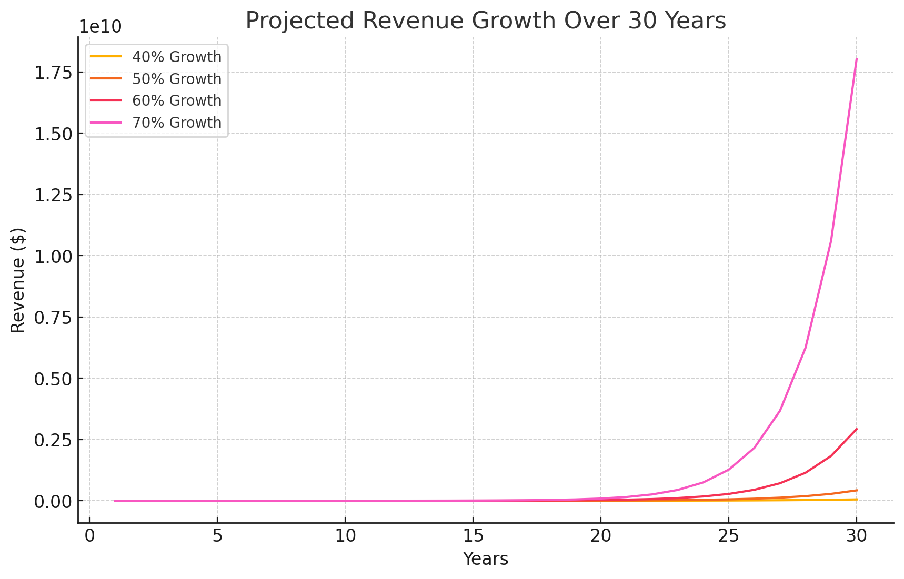
After 30 years, estimated worth based on different growth rates would be:
- At a 40% annual growth rate: $53,243,151.18
- At a 50% annual growth rate: $421,852,330.31
- At a 60% annual growth rate: $2,924,301,590.73
- At a 70% annual growth rate: $18,025,624,596.79
- The courts did not deem that Pig’s Projects, gainable income.
I hereby swear and affirm that the statements made in this affidavit are true to the best of my knowledge and belief.
Respectfully submitted,
Andrew J. Pigors
Date:
that the Court modify the existing custody order to grant joint physical and legal custody of LDW, with a 50/50 parenting time schedule.
I also request the Court terminate the current PPO that has hindered necessary co-parenting communication.

I swear and affirm that the above statements are true to the best of my knowledge.
Andrew J. Pigors.
Sworn and subscribed before me this _____ day of _______________, 2024.
_____________________________
Notary Public, State of Michigan
My Commission Expires: ____________.

