Affidavit in Support of Motion for Custody Modification.
IN THE CIRCUIT COURT FOR THE 14th JUDICIAL CIRCUIT FAMILY DIVISION.
MUSKEGON COUNTY, MICHIGAN.
Case No. 2024-001507-DC.
Honorable Judge Jenny McNeill.
Andrew J. Pigors, Plaintiff,
v.
Emily A. Watson, Defendant.

Affidavit of Andrew J. Pigors.
I, Andrew J. Pigors, being of sound mind and legal age, swear and affirm that the following statements are true to the best of my knowledge, information, and belief:
1. I am the father of Lincoln David Watson (LDW), born November 9, 2022. I have been an active and dedicated father since his birth, providing daily care, love, and support.
2. I am filing this affidavit in support of my Motion for Custody Modification. The current custody arrangement is not in LDW’s best interest due to changes in circumstances and the environment provided by the Defendant, Emily A. Watson, and her family.
3. Since the current custody order was put in place, I have made every effort to maintain a meaningful relationship with LDW, but the Defendant has consistently limited my parenting time and communication, and has diminished my relationship with my son, and my reputation, through manipulation, lies, and accusations. I will attach (Exh. XX) this is a detailed list of every lie, assertion, presumption, and manipulation of the court, carried out by Emily Ann Watson.

Cody Watson’s Dangerous Behavior.
4. The Defendant’s brother, Cody Watson, resides in the same household as LDW and exhibits highly erratic, dangerous behavior. Cody regularly uses drugs, including marijuana, MDMA/Molly, Alcohol, in the presence of the children. His history of drug use also includes inhaling nitrous oxide ('whip-its'), which caused him to crash his vehicle, on camera, in front of Sam’s Drink All on Getty St, in 2023.
5. Cody has also threatened me personally on several occasions. During a roofing job with the Defendant’s father, Albert Watson, Cody threatened to kick me off a ladder. I possess video and audio recordings documenting this threat, as well as threatening text messages from Cody.(ALBCO1-2-3)
6. In addition to the threats, Cody is known to keep firearms in the house, which further endangers LDW and the other children living there. His temper and frequent outbursts of anger make this a highly volatile situation. (ALBCO1-2-3)
7. I have personally witness Cody Watson spank his daughter, on multiple occasions, for very minor reasons including being rowdy, or disobedient. I sincerely expressed this concern to Emily, about Cody’s spanking of Lincoln.
8. Lincoln displays symptoms of physical discipline, which are developing and can lead to the following;
- Mental health problems: Spanking can lead to anxiety, depression, and other mental health problems.
- Antisocial behavior: Spanking can lead to antisocial behavior. (Exh RPS1)
- Aggression: Spanking can lead to increased aggression. (Exh LDWP1)
- Cognitive difficulties: Spanking can lead to cognitive difficulties.
- Impaired academic achievement: Spanking can lead to impaired academic achievement. (Exh. APPC00)
- Lower self-esteem: Spanking can lead to lower self-esteem.
- Increased risk of physical abuse: Children who are spanked may be more likely to be victims of physical abuse.

Emily Watson’s Role in Creating an Unstable Environment.
8. Emily Watson has allowed Cody to remain in the household despite his dangerous behavior. She has not taken any meaningful steps to remove him or limit his influence on LDW. In fact, she has facilitated Cody’s continued presence, despite knowing the risk he poses to the children.
9. Emily has also allowed Cody to bring strangers into the house, even on first dates, while LDW is present. This reckless behavior creates an unstable and potentially harmful environment for LDW.
10. Emily receives rental payments from Cody Watson, not reported in child support calculations.
11. Emily administered Ozempic (semaglutide) Injection, her mother Lori Watson’s prescription, without consulting a physician. Ozempic (semaglutide) Injection is administered sub-dermally with a syringe/needle. It’s half life, when being tested for in a Hair Follicle, is up to 365 days.
12. Lori Watson gave Emily Watson the unused prescription, because she has Lupus, and it is not advised for people with Lupus to take Ozempic

My Fitness as a Custodial Parent.
11. I am in excellent mental and physical health and have no history of drug use or violence. I have consistently provided for LDW’s emotional, physical, and developmental needs.
12. I am gainfully employed, financially stable, and maintain a safe, structured, and nurturing home environment for LDW.

Conclusion.
13. For the reasons stated above, I respectfully request For the reasons outlined in this affidavit, it is clear that the current custody arrangement is not in the best interest of Lincoln David Watson. The Defendant has consistently created a volatile and unstable environment that endangers the well-being of our son. In contrast, I provide a safe, loving, and stable home, where LDW can thrive emotionally, physically, and developmentally. My request for joint physical and legal custody with equal parenting time, and make up parenting time, to make up for the days my son was withheld from me, by the hand of the court and Emily, is made in good faith, as I it has been proven, and is the actual GOAL of the Muskegon County Family Court system, so that a 50/50 custody situation is acheived, and will best serve our son's long-term health and happiness, and development into the man that I can only teach, and wish to be.
14.Additionally, I respectfully request the termination of the existing PPO, which has obstructed effective co-parenting communication and further strained my relationship with LDW, and has been used as a metaphorical shield by Emily, to prevent her from sustaining any accountability. It is essential that the Court act in Lincoln’s best interest by ensuring both parents have the opportunity to contribute meaningfully to his upbringing.
15I have invested blood, sweat, tears, hundreds of sleepless nights, countless days at the library researching law and learning by trial and error, the Judicial System, and invested every financial resource I have, in providing the best possible environment for LDW. The best comfort giving items, and belongings. ( piano, drums, new bed, TV, new clothes-bottles-trucks and toys) All of which I purchased while living with Emily, and had to purchase again, for my new home. The renovations, with a median estimated cost, of 24,000$, was completed by me, and only me, for LDW, between the months of Feb 2024-Sept 2024. Simultaneously trying to litigate these cases, while also being a father week on week off (daycare, routines, teaching, play) while also working full time jobs, whether it was Indigrow, Shape Corp, or running my own small business { Pig’s Projects}. Pig’s Project’s generated over 2,000$ its first month running, yet the court deemed it “not gainable” income. And yet, the average income in Muskegon County is $32,219 (Source United States Census Bureau). (EXH__________________________________________________)

With a conservative estimated growth rate of 40%, my business, Pig’s Projects over the course of 12 months, predictably, could have potentially generated;
Formula-Monthly Growth Rate=(1+Annual Growth Rate)1/12−1 Substituting 40% (0.40):
Monthly Growth Rate=(1+0.40)1/12−1=1.401/12−1≈0.02844\text{Monthly Growth Rate} = (1 + 0.40)^{1/12} - 1 = 1.40^{1/12} - 1 \approx 0.02844
Monthly Growth Rate=(1+0.40)1/12−1=1.401/12−1≈0.02844
The monthly growth rate is approximately 2.844%.•
40% annual growth: $35,233.80 • 50% annual growth: $36,257.57
• 60% annual growth: $37,254.36 • 70% annual growth: $38,226.65
30 year Business Projection 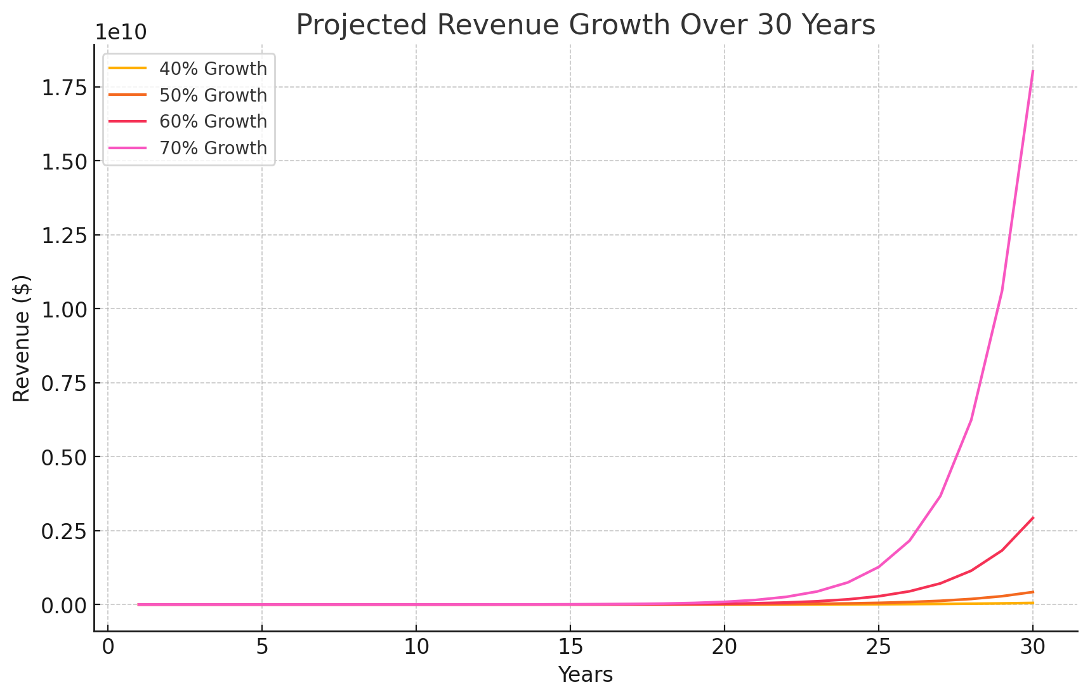
After 30 years, estimated worth based on different growth rates would be:
- At a 40% annual growth rate: $53,243,151.18
- At a 50% annual growth rate: $421,852,330.31
- At a 60% annual growth rate: $2,924,301,590.73
- At a 70% annual growth rate: $18,025,624,596.79
- The courts did not deem that Pig’s Projects, gainable income.

I hereby swear and affirm that the statements made in this affidavit are true to the best of my knowledge and belief.
Respectfully submitted,
Andrew J. Pigors
Date: [Insert Date
that the Court modify the existing custody order to grant joint physical and legal custody of LDW, with a 50/50 parenting time schedule.
I also request the Court terminate the current PPO that has hindered necessary co-parenting communication.

I swear and affirm that the above statements are true to the best of my knowledge.
_____________________________
Andrew J. Pigors.
Sworn and subscribed before me this _____ day of _______________, 2024.
_____________________________
Notary Public, State of Michigan
My Commission Expires: ____________.

