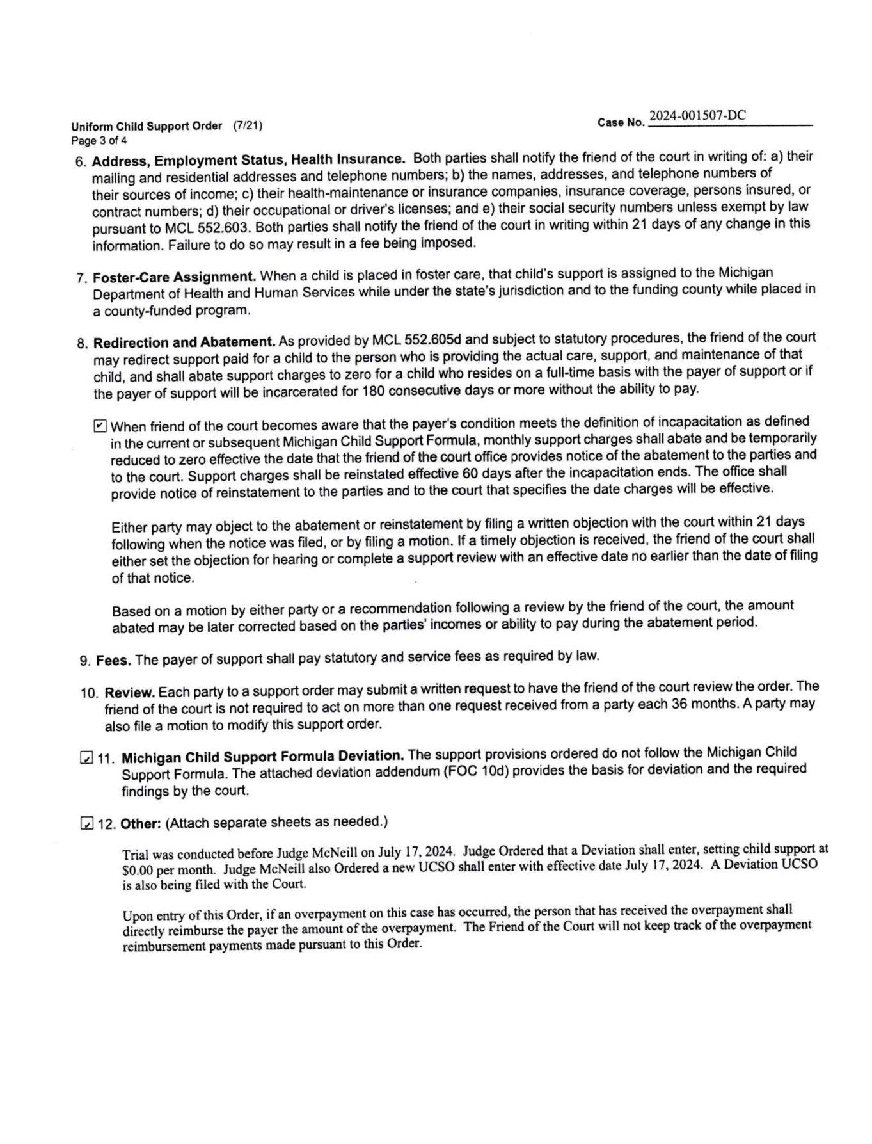
Uniform Child Support Order (7/21) Page 3 of 4
Case No..
2024-001507-DC
6. Address, Employment Status, Health Insurance. Both parties shall notify the friend of the court in writing of: a) their mailing and residential addresses and telephone numbers; b) the names, addresses, and telephone numbers of their sources of income; c) their health-maintenance or insurance companies, insurance coverage, persons insured, or contract numbers; d) their occupational or driver's licenses; and e) their social security numbers unless exempt by law pursuant to MCL 552.603. Both parties shall notify the friend of the court in writing within 21 days of any change in this information. Failure to do so may result in a fee being imposed.
7. Foster-Care Assignment. When a child is placed in foster care, that child's support is assigned to the Michigan Department of Health and Human Services while under the state's jurisdiction and to the funding county while placed in a county-funded program.
8. Redirection and Abatement. As provided by MCL 552.605d and subject to statutory procedures, the friend of the court may redirect support paid for a child to the person who is providing the actual care, support, and maintenance of that child, and shall abate support charges to zero for a child who resides on a full-time basis with the payer of support or if the payer of support will be incarcerated for 180 consecutive days or more without the ability to pay.
When friend of the court becomes aware that the payer's condition meets the definition of incapacitation as defined in the current or subsequent Michigan Child Support Formula, monthly support charges shall abate and be temporarily reduced to zero effective the date that the friend of the court office provides notice of the abatement to the parties and to the court. Support charges shall be reinstated effective 60 days after the incapacitation ends. The office shall provide notice of reinstatement to the parties and to the court that specifies the date charges will be effective.
Either party may object to the abatement or reinstatement by filing a written objection with the court within 21 days following when the notice was filed, or by filing a motion. If a timely objection is received, the friend of the court shall either set the objection for hearing or complete a support review with an effective date no earlier than the date of filing of that notice.
Based on a motion by either party or a recommendation following a review by the friend of the court, the amount abated may be later corrected based on the parties' incomes or ability to pay during the abatement period.
9. Fees. The payer of support shall pay statutory and service fees as required by law.
10. Review. Each party to a support order may submit a written request to have the friend of the court review the order. The friend of the court is not required to act on more than one request received from a party each 36 months. A party may also file a motion to modify this support order.
11. Michigan Child Support Formula Deviation. The support provisions ordered do not follow the Michigan Child Support Formula. The attached deviation addendum (FOC 10d) provides the basis for deviation and the required findings by the court.
12. Other: (Attach separate sheets as needed.)
Trial was conducted before Judge McNeill on July 17, 2024. Judge Ordered that a Deviation shall enter, setting child support at $0.00 per month. Judge McNeill also Ordered a new UCSO shall enter with effective date July 17, 2024. A Deviation UCSO is also being filed with the Court.
Upon entry of this Order, if an overpayment on this case has occurred, the person that has received the overpayment shall directly reimburse the payer the amount of the overpayment. The Friend of the Court will not keep track of the overpayment reimbursement payments made pursuant to this Order.

