Comparing metrics of species distribution change across spatial scales with spatiotemporal models

Lewis A.K. Barnett^{1*}, Eric J. Ward², Sean C. Anderson³

¹ Resource Assessment and Conservation Engineering Division, Alaska Fisheries Science Center, National Marine Fisheries Service, NOAA, 7600 Sand Point Way N.E, Seattle, WA 98115, USA

² Conservation Biology Division, Northwest Fisheries Science Center, National Marine Fisheries Service, NOAA, 2725 Montlake Boulevard East, Seattle, WA 98112, USA
³ Pacific Biological Station, Fisheries and Oceans Canada, 3190 Hammond Bay Rd, Nanaimo, BC, V6T 6N7, Canada

* Corresponding author: lewis.barnett@noaa.gov
Abstract
Species distribution models and environmental niche models to understand how species change over space and time have evolved rapidly over the last decade, and these approaches have seen wide use in applications to plants, terrestrial species, and marine fishes. In addition to the advances in modeling approaches, a number of summary statistics have been developed to quantify and communicate spatial change over the entire range of a species, including the center of gravity, area occupied, and extremes of the range where the species occurs. A limitation in all of these metrics is that change may not be heterogeneous. In this paper, we develop a new modeling approach to explicitly estimate a spatial trend, alongside spatial (temporally constant) and spatiotemporal (time varying, random) components. To demonstrate the utility of this new approach, we focus on the application of this model to a community of well studied marine fish species on the west coast of the USA (19 species, representing a wide range of presence-absence and densities). Conventional model selection techniques suggests that the use of the model explicitly accounting for a spatial trend is justified in 17 of 19 cases. In addition to making better predictions, we illustrate how estimated spatial fields (trend, intercept) from the spatial trend model can be used to classify regions within the species range where change is relatively homogenous. Using cluster analysis to identify regions, most species in our analysis support 2 or 3 regions. Conventional summary statistics, such as center of gravity, can then be calculated on each region, illustrating that change is more nuanced than what is expressed via global metrics. Using arrowtooth flounder (latin name) as an example, southward movement in the global center of gravity is driven by an increasing trend in the central region and decrease in density in the northern region.

Keywords: spatiotemporal modeling, species distribution modeling, spatial management, monitoring
Introduction
In the fields of natural resource conservation, management and global change biology, demand for—and implementation of—tools for assessing species distribution shifts has grown dramatically in recent decades (Elith and Leathwick 2009). These approaches are widely applicable, from studies of plants (Lenoir et al. 2008), terrestrial vertebrates (Hitch and Leberg 2007), and marine fishes (Pinsky et al. 2013). However, the way distribution shifts are quantified has changed relatively little (Elith et al. 2010). At the simplest level, researchers often use existing tools to estimate occurrence probability, present maps of how the extent and distribution of suitable habitat is expected to change, and sometimes present descriptive statistics on the mean change throughout a region (Yackulic et al. 2013). However, when reliable population density data are available, distribution shifts are better quantified by spatial predictions of population size. Shifting distributions of abundance or population density may be qualitatively conveyed through maps but also through quantitative spatial indicators, such as the mean location weighted by population density (also termed the center of gravity, COG).
Spatial distributions of population density are often complex and heterogeneous (Sagarin et al. 2006), particularly in typical marine ecosystems where complex coastline and bathymetric topography and geology interact with physical oceanographic drivers (Levin et al. 2010). Heterogeneity may be present in the distribution of a species throughout its range, but the change in a species’ population density over time may also have a spatially varying component. Consequently, attempting to describe a uniform shift in distribution across a broad geographic range can be misleading, particularly when different regions exhibit contrasting trends. For example, if densities increase at opposing range boundaries at an equivalent rate, there may be no trend in the range-wide COG, masking finer-scale shifts. Thus, when using spatial indicators to describe species distribution shifts, the spatial scale of aggregation can affect inference, as in the classic problem of pattern and scale in ecology (Levin 1992). Therefore, there is a general need to develop objective methods for defining appropriate scales to evaluate changes in species distributions. Such tools are widely applicable for solving specific problems in fish and wildlife conservation and management by defining spatial domains with distinct population dynamics.
One of the most rapidly evolving applications of models to predict species’ range shifts has been in the field of commercial fisheries management. In addition to having ecological implications, changes in the spatial distribution of marine fishes has implications for national food security (Rice and Garcia 2011). The most reliable estimates of marine fish densities are generally derived from fishery-independent survey data. In addition to providing population size data used for managing individual fish populations, fishery-independent survey data may be used to derive indicators for ecosystem assessments (Nicholson and Jennings 2004, Harvey et al. 2018), to help understand the impacts of fishing on non-target species (Stock et al. 2019), or to inform reference points in applications of ecosystem-based fisheries management (Link et al. 2002).
Techniques for estimating how fish populations vary over space and time have evolved rapidly over the last 5 years. The largest methodological changes have been advances in spatiotemporal modeling that have modeled space continuously and explicitly accounted for spatial autocorrelation between spatially-referenced observations that are proximate in both space and time (Shelton et al. 2014, Thorson et al. 2015). These newer analytical approaches having many places replaced conventional design- or strata-based estimators, which assumed that density is homogenous within sampling strata (Chen et al. 2004). These newer modeling tools have become accessible in open source software, such as INLA (Rue et al. 2009) or VAST (Thorson 2019b) and as a result these approaches have been applied to fish populations in diverse ecosystems around the world. In addition to being used for estimating population density or spatial distributions, output from these modeling approaches have been used to generate model-based summaries to track change in species distributions, including the COG or area occupied, with more robust estimation than those provided by design-based estimates (Thorson et al. 2016).
There are a number of advantages of estimating a species’ density in a framework that accounts for spatial or spatiotemporal variation. First, explicitly accounting for spatial variation in density has been shown to increase precision of estimated temporal trends (Thorson et al. 2015). Second, the framework used in the majority of approaches for modeling spatial or spatiotemporal variation in fish density is extremely flexible and extendable. Approaches include using mixed-effect models where the spatial or spatiotemporal components are typically estimated as random effects (Latimer et al. 2009, Shelton et al. 2014) and annual effects are included as factors to allow for unbiased estimates of trends. Additional extensions include the incorporation of covariates such as depth (Johnson et al. 2019), or modeling extremes in spatial processes (Anderson and Ward 2019).
Similar to the non-spatial case, recently developed spatiotemporal modeling approaches have generally treated time as a discrete factor, and allowed the spatial distribution of density to be constant (modeled as a single spatial field, ignoring time) or time-varying (with variability modeled either as independent over time, or as an autoregressive process). The objective of this manuscript is to introduce a new modeling approach, explicitly accounting for spatial variability in how species population densities change through time. While widely applicable to a wide range of biological data (or even non-biological data), we focus on an application to changes in the distribution of commercially fished species. These represent 19 species from a 15-year publically available trawl survey dataset. We illustrate how our new approach may be used to infer changes over time, and also how output from this modeling approach may be useful in identifying spatial regions where change is greater than or less than average. We demonstrate how model-based COG estimates for these regions may be more useful than global COG trends calculated over an entire survey domain.

Methods
Spatial GLMM Overview
The majority of recent applications of SDMs to marine fish survey data have been implemented in a GLMM (generalized linear mixed‐effects model) framework, where random effects are used to describe spatial or spatiotemporal components. Spatial components are differentiated from spatiotemporal components in that the former are constant, whereas the latter vary through time. Examples include applications to Gaussian predictive process models (Shelton et al. 2014, Thorson et al. 2015, Anderson and Ward 2019), and predictive modeling using integrated nested Laplace approximations (INLA; Rue et al. 2009, Ruiz-Cárdenas et al. 2012). The latter approach has been particularly useful for large datasets, where substantial gains in computational efficiency are accomplished by taking advantage of sparse matrix approximations to the variance-covariance matrix (Thorson and Barnett 2017). Regardless of the estimation approach used, the general formulation of these models uses a link function $g(∙)$ to relate the observed response to covariates and a latent spatial process. For example,

$g\left(u_{s,t}\right)=X_{s,t}b+{ω_{s}+γ}_{s,t}$,

where $u_{s,t}$ is the expectation at location s and time t, $X_{s,t}$ are covariates, $b$ represents a vector of estimated coefficients, $ω_{s}$ is the mean spatial component at location s (constant through time), and $γ_{s,t}$ is the spatiotemporal process at location s and time t. The spatiotemporal process describing $γ$ is flexible in that it can be removed from the model (leaving a model with a spatial but no spatiotemporal component), may be independent for each time slice, or modeled with an autoregressive process (allowing hotspots to persist through time; Thorson et al. 2015, Ward et al. 2015, Anderson and Ward 2019). Previous applications to marine fishes have either used a delta-GLMM framework to model presence-absence and positive catch rates separately (e.g., Thorson et al. 2015) or a Tweedie distribution to model total variation in density (Anderson et al. In press, Shono 2008).
Within this GLMM framework, non-stationary changes in the spatial predictions through time can only be modeled with inclusion of covariates, or by modeling spatiotemporal variability as an autoregressive spatial process through time. Estimates of spatial trends may be derived from spatial and spatiotemporal fields post-hoc, but doing so results in biases (Fig. S1). To explicitly account for non-stationary trends in densities, we extend the above framework to include a trend parameter as an additional spatial field. Extending the model above, this becomes

$g\left(u_{s,t}\right)=X_{s,t}b+{ω_{s}+γ}_{s,t}+{t∙z}_{s}$,

where $z_{s}$ represents the spatially varying temporal trend. This trend field can be thought of as the spatial variability in how a species’ density changes through time (Figure 1).

Testing the ability to recover spatial trends
We conducted a simulation analysis to evaluate our ability to recover an added spatial field representing the trend. Given results from previous work with state space models (Auger-Méthé et al. 2016), we focused our simulations on understanding how the magnitude of spatiotemporal variation or observation error variation affect our ability to recover the spatial trend (details in Table S1). The simulations were conducted as follows: for each value of spatiotemporal variation and observation error, we simulated a random spatial field. We then simulated a latent spatiotemporal process over 10 time steps, using spatial and spatiotemporal components (modeled as independently from year to year) along with a spatial field representing the temporal trend. To include measurement or observation error, we simulated normally distributed observations from this spatiotemporal process. We then fit a spatial GLMM to the simulated data and assumed the model structure to be known. We then compared estimated values of the spatial trend at the locations of the data with known values to generate statistical summaries (bias, variance, correlations between predicted and observed values). For each combination of parameter values, we simulated 100 random datasets. Code to replicate this analysis is included in the repository for this project (https://github.com/fate-spatialindicators/spatial-trend).

West coast groundfish application
As an example, we fit the spatial-trend model to groundfish data collected from a fishery-independent survey along the US West Coast: the NOAA Fisheries, Northwest Fisheries Science Center, US West Coast Groundfish Bottom Trawl Survey (Keller et al. 2017) from 2003 to 2018. This survey represents an ideal case study because it has been used extensively in testing new index standardization methods for stock assessments (Thorson et al. 2015), is publicly available (https://www.nwfsc.noaa.gov/data/map), and has been used to develop coastwide indicators including shifts in center of gravity (Thorson et al. 2016). We selected 19 groundfish species to model in this analysis based on a combination of high commercial landings, market value, conservation concern, and prevalence in the survey data (Table S2).
We fit spatial GLMMs with and without a spatial trend to each species to evaluate whether the spatial trend may be appropriate for modeling how these 19 species change over time. We allowed both models to include spatial and spatiotemporal components (independent by year), depth modeled as a quadratic effect (Thorson et al. 2015), and year as a factor. We modeled spatial components as random fields, using a triangulated mesh with vertices at 350 knots to approximate a continuous spatial field (Rue et al. 2009, Lindgren et al. 2011). The inclusion of year as a factor centered each of the estimated spatiotemporal fields to have mean zero. Because of the positive continuous nature of the recorded fish densities combined with some zeros, we modeled the response with a Tweedie distribution and a log link (Anderson et al. In press, Tweedie 1984, Dunn and Smyth 2005). All estimation was done in R version # (R Core Team 2018) in a maximum likelihood framework, using the package sdmTMB (Anderson et al. In press, Anderson 2019) which interfaces automatic differentiation in Template Model Builder (Kristensen et al. 2016) with INLA (Rue et al. 2009). Because we were interested in comparing models with different random effect structures (with and without the spatial-trend field), we used restricted maximum likelihood (REML, Zuur et al. 2009) to generate Akaike’s Information Criterion values for each model (AIC, Akaike 1973). Using AIC as a model screening tool, we found broad support for the inclusion of the spatial trend for these 19 species, with the trend model generating lower AIC values in 17 of the 19 cases, and AIC scores differing by less than two in the remaining two cases (Table S3).
Given the evidence supporting the spatial-trend model as the most parsimonious model, we used this model structure to evaluate changes in species density distributions over time. To obtain a smooth surface of predicted density across the footprint of the survey area (Fig. 2), we predicted density using a depth layer defined by NOAA bathymetry data (https://www.ngdc.noaa.gov/mgg/coastal/crm.html), averaged over space to match the resolution of the survey sampling grid (~2.8 x 3.7 km), which is the spatial resolution we used for all analyses. A number of diagnostics could be implemented on these predictions or raw model fits to further analyze whether a spatial trend may be appropriate; examples include examining spatial patterns in residuals or the estimated spatiotemporal component.

Using spatial trends as indicators of change
We compared inferences of changes in species density distributions obtained from metrics calculated on a spectrum of spatial resolution to demonstrate the utility of understanding fine-scale temporal trends. Quantifying change at multiple spatial scales has implications for the management of marine fishes, and has utility as a spatial indicator within the California Current ecosystem. Specifically, we compared the fine-scale interpretation of the spatial trend and mean predicted density over all years to coarse-scale interpretations of: 1) the spatial trend, 2) regional COGs and 3) coastwide COG calculated from predicted densities. Furthermore, we evaluated whether spatial-trend estimates from our model can be used to identify discrete areas of change that may reflect stock structure. One approach for doing this is to apply post-hoc cluster analyses to model outputs or covariates; for our groundfish application, we used the partitioning around medoids (PAM) algorithm with estimation of the number of clusters (implemented with R packages “fpc” and “cluster”, Hennig 2019, Maechler et al. 2019). PAM is a robust clustering algorithm that minimizes the sum of Euclidean dissimilarities (root of sum-of-squares of differences) between observations and cluster values (Reynolds et al. 2006, Kaufman and Rousseeuw 2009). We used latitude and the predicted spatial trends as clustering variables given that the majority of the contrast in dynamics along the US West Coast is in the latitudinal direction. Other metrics could also be included in clustering including longitude, habitat features, environmental covariates, or human impacts such as fisheries removals. We chose the number of clusters (constrained between 2 and 10) that maximized the average silhouette width across all predictions for a given species (Kaufman and Rousseeuw 2009).

Results
Simulation testing
Results from our simulation indicated that, as expected, both observation error variation and spatiotemporal variation degraded our ability to estimate the true spatial trend (Fig. 3). When both variance parameters are small, estimates are precisely estimated and unbiased; however, large values of either can limit the ability to recover the trend (Fig. 3). The performance of these models is also conditional on additional parameters and structure not included in our sensitivity analysis (e.g., spatial decay and spatial variation parameters); however, these results indicate that spatiotemporal variation and observation error have similar effects on our ability to recover trends (comparison of rows in Fig. 3).

West Coast groundfish application
Predictions of the spatially explicit trend from the spatial-trend model revealed intricate fine-scale spatial structure and rates of change of species in the West Coast groundfish community. Our cluster analysis of the estimated spatial trend and latitude helped to delineate areas with the greatest relative rate of change in density over time. Among all 19 species, typically at least one of the breaks between clusters occurred at a latitude corresponding to a recognized biogeographic break (Fig. 4). These locations of similarity between the boundaries of the spatial-trend clusters occurred most often near Point Conception in southern California and Cape Mendocino in northern California. Approximately 14-15 species had cluster boundaries near Cape Mendocino, with roughly 6-7 near Point Conception. Nearly all major cluster breaks occurred within latitudes between Cape Mendocino and Point Conception. However, there was some variability among species in the precise location of the boundary of the spatial-trend cluster. Similar results were obtained when clustering was performed on the spatial trend alone, without inclusion of latitude as an additional variable, yet cluster assignment was somewhat less cohesive. Given the general proximity between trend cluster breaks and the established biogeographic boundaries, we chose to evaluate the latitudinal center of gravity (COG) within each biogeographic region to compare with the coastwide COG.
We highlight results for six groundfish species with unique distributional responses (Fig. 5; see Fig. S2 for results from additional species and Fig. S3 for predicted density distributions for all 19 species). Within each of the six species, there was support for 2-3 trends (Fig. 5; second column). Comparison of the spatial-trend predictions and clusters (Fig. 5; first two columns) and the mean density from the full model (Fig. 5; third column) revealed how several unique patterns of regional relationships can contribute to nuanced and difficult to detect broad-scale distributional changes including northward, southward, and bi-directional (convergent or divergent) density shifts, in addition to localized offshore shifts. Furthermore, the interpretation of the distributional change often varied between spatial scales of metrics. Typically, inference differed the most between the fine-scale map-based interpretation of the spatial trend and the coastwide COG. The map of estimated mean density allows one to visually weight the spatial-trend map to better understand where absolute changes in density are greatest.
Examining the predictions of the spatial trend and density indicated that arrowtooth flounder (Atheresthes stomas) had a southward density shift and shortspine thornyhead (Sebastolobus alascanus) had a northward shift, yet the COG inferences differed to some degree between species. The predicted density indicated that the majority of arrowtooth flounder (Fig. 5, first row) was in the northern region, yet the spatial-trend pattern indicates that their density is increasing at the highest rate in the central region. Combined, these regional results suggest a southward shift driven by increases at the southern range edge, similar to the traveling wave pattern demonstrated by many species invasions. The time series of the coastwide COG (black line in last column of Fig. 5) is in agreement of a southward shift, yet the interpretation is not as clear because the coastwide pattern is heavily weighted by the high densities in the far northern portion of the study area. When the COG from each biogeographic region is calculated (colored lines in last column of Fig. 5), we can see that coastwide COG has been driven further south in the latter half of the time series by decreases in the COG in the central region while the northern COG had almost no trend, providing additional support for the possibility that the change is due to increased density or southward shifts in the central region.
For other species in our analysis, even the region-specific COG does not accurately capture the nuanced spatial changes described by the spatial-trend field. For example, shortspine thornyhead is distributed coastwide, yet their density is increasing fastest in the north-central area and decreasing in the south and within some isolated patches in the far northern end of the region (Fig. 5, last row, left column). In this case, the coastwide COG indicates a northward distribution shift, yet the region-specific COG indicates converging trends: slightly southward shifting of the northern region and slight northward shift in the central region. Thus, the interpretation from the COGs at both scales are relatively consistent with the fine-scale interpretation of the spatial trend, yet these coarse-scale metrics still mask underlying patterns, in this case the decreased density in the southern region.
Other species demonstrated additional patterns of changes in spatial distribution of density and contrasting inference among metrics, including bocaccio rockfish (Sebastes paucispinis), English sole (Parophrys vetulus), petrale sole (Eopsetta jordani), and sablefish (Anoplopoma fimbria). Bocaccio were typically more abundant in the southern and central areas yet were experiencing the fastest increases in density in the north, indicating a northward density shift. These observations contrast with those from the COG, where the coastwide COG for bocaccio was highly variable with either no trend or a very slight southward trend, and the COG of the northern region indicates a southward shift in some years. Divergent density shifts were observed for English sole and, to some extent, petrale sole. English sole were typically present in relatively similar densities coastwide, yet the spatial trend indicated that densities were increasing fastest at the northern and southern ends of the region. However, the coastwide COG reveals only a slight southward shift, while the region-specific COGs show only a slight northward shift in the northern region. Petrale sole had a complex spatial-trend field, increasing fastest in the north with the exception of isolated declining patches on the inshore side. These changes are somewhat consistent with the coastwide COG indicating a slight northward trend amidst moderate interannual variability. However, COGs of the northern and central regions--where petrale are typically most prevalent--indicated a divergent pattern, in which densities were shifting northward in the northern region and slightly southward in the central region. Finally, no obvious directional shift in density was apparent in the spatial trend for sablefish, yet the coastwide COG timeseries indicated that a northward shift had occurred in the most recent 5-6 years. The region-specific COG indicates that this was driven by density changes in the northern and to some extent central regions. Thus, depending on the evidence used, one could either conclude that there was a recent northward density shift, or simply an increase in productivity or aggregation near the core of the range within the north-central area.

Discussion
The complex spatial distribution of biotic and abiotic drivers of population productivity and habitat suitability in ecosystems suggests that fine-scale descriptors may provide a more accurate representation of changes in species distributions than global indicators calculated across an entire region. Here, we introduced a new approach to modeling and summarizing spatially referenced time series data on species population densities to calculate area-specific trends in population size. Our approach was able to recover spatial trends in simulated data and reveal nuanced spatial trends in the dynamics of 19 marine fishes off the west coast of the USA that often differed from conventional descriptors of larger scale distribution shifts (Woillez et al. 2009, Pinsky et al. 2013, Thorson et al. 2016). Furthermore, the ability of our models to detect geographic boundaries between regions with different trends was affirmed as these boundaries were largely congruent with known biogeographic breaks (yet we acknowledge that this may be influenced by assumptions affecting the optimization of the number of clusters).
Our simulations and application of the spatial-trend model indicate that our proposed approach can improve estimation and communication of spatially-varying temporal trends in population density. In particular, our application to marine fish survey data indicated that models including a spatial-trend field were more parsimonious than those without a spatial trend. This result is consistent with a recent study incorporating a spatially varying influence of an oceanographic index on groundfish distributions in the eastern Bering Sea (Thorson 2019a). Furthermore, according to our simulations the estimated spatial trends were less biased than those estimated post-hoc from predictions of a model without the spatial-trend field. However, the spatial-trend model is somewhat sensitive to observation error and spatiotemporal variation. Such sources of variation can obscure the spatial trend, yet this is to be expected in the same way that any trend is less detectable given noisier data (Weatherhead et al. 1998). Therefore, our method is likely most skillful at detecting spatial structure in population or community dynamics from observations with precise measurement within systems with low temporal variation in spatial structure (e.g., those consisting of species with slower life histories and lower variation in dispersal paths). Further ways to constrain the variance parameters, such as developing informative Bayesian priors from similar surveys might extend the detectability of spatial trend structure over the models used here.
We show how the inference about shifts in species’ population density depend on the spatial scale at which they are summarized. When we applied the spatial-trend model to marine fishes, the resulting maps of the spatially explicit trend and density from the model revealed nuanced patterns of heterogeneity and directional change in groundfish density (COG; this study, Thorson et al. 2016). Taking the predicted density to represent the underlying spatial heterogeneity, the spatial-trend random field conveyed fine-scale information about potential range dynamics that were masked when evaluating coastwide COG time series. The disparity of inference was greatest in cases where density was increasing fastest at opposing ends of a range, density was spatially diverging, or where density among patches were converging toward the center of the distribution. Furthermore, when examining only the coastwide COG, one is unable to differentiate between shifts due to an increase in density in one area or a decrease in density in another area.
For complex ecosystems such as the US West Coast, and other coastal upwelling systems where physical variables like temperature do not follow a simple monotonic gradient over broad geographic scales, it may be too simplistic to expect clear coastwide trends in COG across multiple species as a result of climate change. These coastwide patterns are observed in systems with broader continental shelves such as the northeast US (Pinsky et al. 2013, Kleisner et al. 2016). However, along coastlines with narrower continental margins, such as the US West Coast, fish may be able to find equivalent temperatures by moving much shorter distances perpendicular to the shelf break (Li et al. 2019). Furthermore, population and community biomass are inherently patchy, meaning that detecting a redistribution over time may require careful examination of the microstructure of biomass distribution rather than a region-wide shift in mean biomass distribution. We encourage future research on species distribution shifts that begins with more specific and nuanced hypotheses regarding the expected response. For example, if climate change causes a global intensification of upwelling as some researchers predict (Bakun et al. 2010), one could hypothesize that biomass distributions will become patchier over time in response to increasing contrast in local physical conditions, or that distributions will shift deeper as larvae are transported further offshore before settling.
The future of environmental conservation and natural resource management relies on greater incorporation of spatial information into models and decision-making processes (Berger et al. 2017, Lowerre-Barbieri et al. 2019). By defining the geography of population trends and the breaks between clusters of locations with similar trends, our modeling framework provides a data-driven method to objectively define the spatial scale and boundaries for summarizing monitoring data and structuring these inputs to resource management models. This is an important advancement over non-spatial resource assessments or the reliance on the use of jurisdictional boundaries to structure assessments. Our vision is that these and subsequent methods for boundary detection will aid the development of spatial resource assessment models and stimulate further applications of such approaches to more disparate management solutions such as invasive species management.

Acknowledgements
We thank the NOAA NWFSC FRAM Fisheries Research Survey Team (Keith Bosley, John Buchanan, Mark Bradburn, Doug Draper, Melissa Head, John Harms, Aimee Keller, Dan Kamikawa and Victor Simon) and commercial captains and crew on the US West Coast Groundfish Bottom Trawl Survey; Chris Harvey for guidance on management needs and valued research directions, and for funding the spatial indicators working group that helped refine the analysis; Stanislaw Kotwicki for providing resources supporting analysis and writing; Ole Shelton and Jameal Samhouri for helpful discussions; Blake Feist for assistance with bathymetry data; and James Thorson and Cecilia O’Leary for manuscript comments. LAKB was supported by funding from the NOAA Fisheries and the Environment (FATE) program, and the Joint Institute for the Study of the Atmosphere and Ocean (JISAO) under NOAA Cooperative Agreement No. NA15OAR 4320063.
Figure 1. Visualization of the spatiotemporal component of a GLMM with (top row) and without (bottom row) a spatial trend. The panels show spatiotemporal fields representing variation in population density over five years. When a spatial trend is present, some regions develop systematically higher (red) or lower (blue) density over time. When a spatial trend is absent, spatial deviations from year to year are independent. For this example, we have omitted all other sources of variability and error for simplicity.

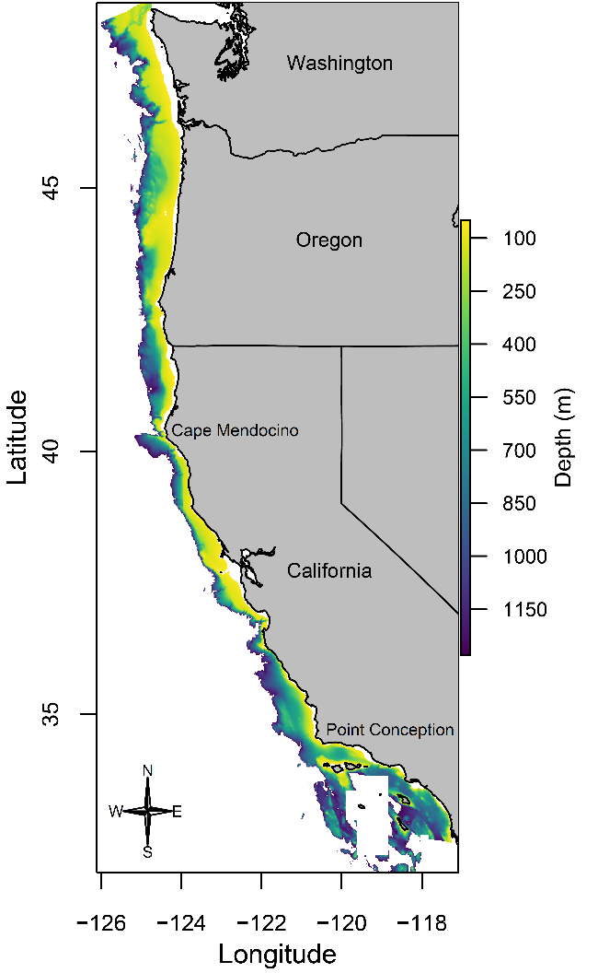
Figure 2. Map of the bathymetry within the US west coast groundfish bottom trawl survey area. Cape Mendocino and Point Conception are labeled to represent the latitudinal boundaries between known biogeographic regions.

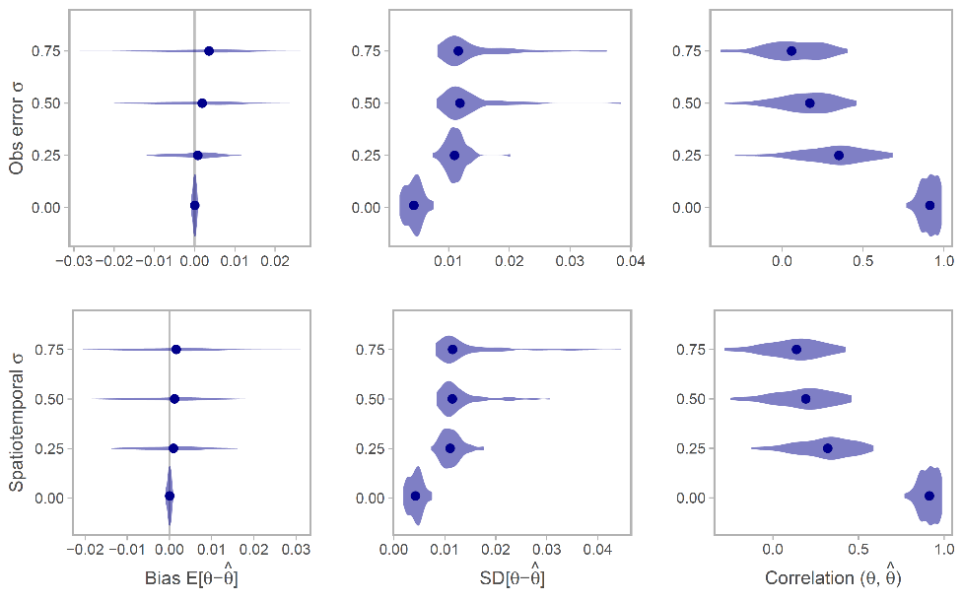
Figure 3. Simulation testing the effects of observation error and spatiotemporal variation on the ability to recover the spatial trend. Each violin represents 100 simulations and the dots represent the median value. In all cases, the standard deviation of the non-varying parameter is held at 0.01. The symbols $θ$ and $\hat{θ}$ refer to the spatial-trend random effect values $z_{s}$ and their estimate, respectively.
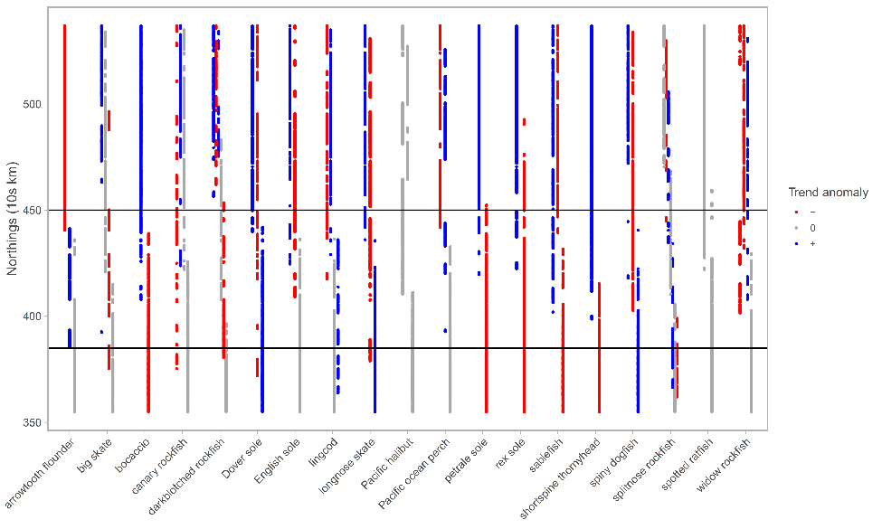
Figure 4. Strip plot showing each unique cluster of latitude and spatial trend (slope over time) by species. Each set of points associated with a given cluster are represented by a different column and colored by their deviation from the mean coastwide trend for a given species. Grey points represent clusters from which the trend was within 0.01 of the mean coastwide trend. Horizontal lines represent approximate positions of known biogeographic breaks: Cape Mendocino, California in the north; Point Conception, California in the south.

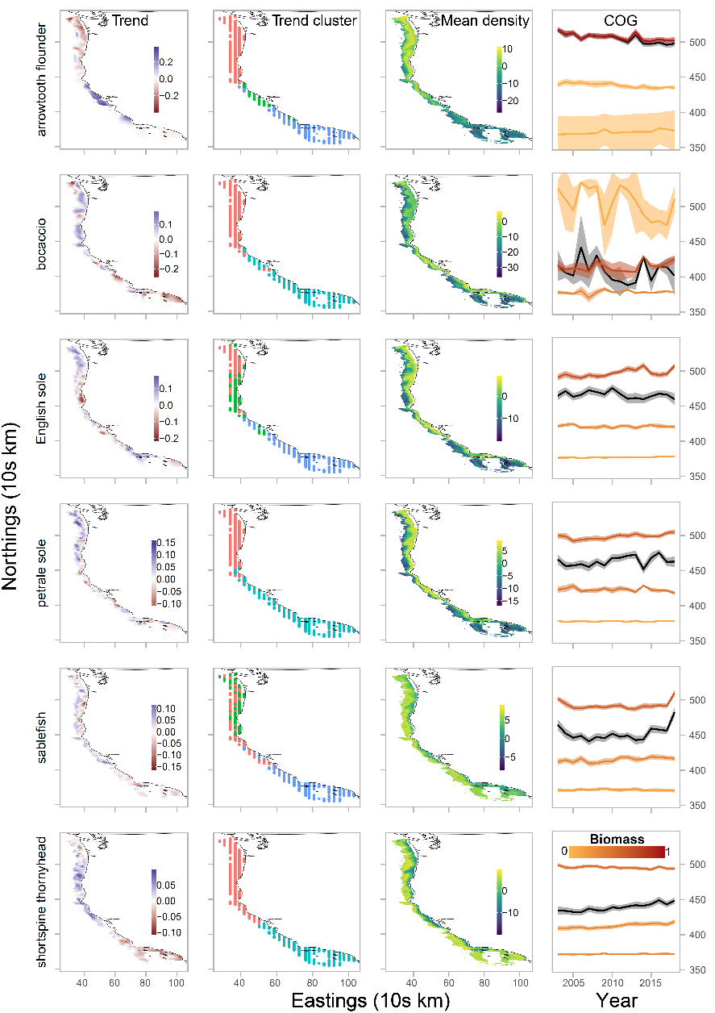
Figure 5. Spatial and temporal patterns of predicted density for selected species. The first column shows maps of the predicted spatial trend (slope of log density across years). The second shows how each spatial location groups with a unique cluster of latitude and spatial trend. The third column represents the mean density over all years (in units of kg km⁻² on a log scale). The fourth column shows the time series of the center of gravity (COG), or latitude weighted by density, with 95% confidence intervals. The black line with grey interval represents the COG calculated from predicted densities coastwide, whereas the colored lines represent the COGs for each unique biogeographic region (separated by Cape Mendocino, California in the north; Point Conception, California in the south). Line color represents the proportion of a species’ relative biomass in a given region.
REFERENCES
Akaike, H. 1973. Information theory and an extension of the maximum likelihood principle. Page 2nd International Symposium on Information Theory. Budapest: Akadémiai, Tsahkadsor, Armenia, USSR.
Anderson, S. C. 2019. sdmTMB: An R package for spatial and spatiotemporal GLMMs with TMB.
Anderson, S. C., E. A. Keppel, and Edwards, A.M. In press. A reproducible data synopsis for over 100 species of British Columbia groundfish.
Anderson, S. C., and E. J. Ward. 2019. Black swans in space: modeling spatiotemporal processes with extremes. Ecology 100:e02403.
Auger-Méthé, M., C. Field, C. M. Albertsen, A. E. Derocher, M. A. Lewis, I. D. Jonsen, and J. Mills Flemming. 2016. State-space models’ dirty little secrets: even simple linear Gaussian models can have estimation problems. Scientific Reports 6:26677.
Bakun, A., D. B. Field, A. Redondo-Rodriguez, and S. J. Weeks. 2010. Greenhouse gas, upwelling-favorable winds, and the future of coastal ocean upwelling ecosystems. Global Change Biology 16:1213–1228.
Berger, A. M., D. R. Goethel, P. D. Lynch, T. Quinn, S. Mormede, J. McKenzie, and A. Dunn. 2017. Space oddity: The mission for spatial integration. Canadian Journal of Fisheries and Aquatic Sciences 74:1698–1716.
Chen, J., M. E. Thompson, and C. Wu. 2004. Estimation of Fish Abundance Indices Based on Scientific Research Trawl Surveys. Biometrics 60:116–123.
Dunn, P. K., and G. K. Smyth. 2005. Series evaluation of Tweedie exponential dispersion model densities. Statistics and Computing 15:267–280.
Elith, J., M. Kearney, and S. Phillips. 2010. The art of modelling range-shifting species. Methods in Ecology and Evolution 1:330–342.
Elith, J., and J. R. Leathwick. 2009. Species Distribution Models: Ecological Explanation and Prediction Across Space and Time. Annual Review of Ecology, Evolution, and Systematics 40:677–697.
Harvey, C., N. Garfield, G. Williams, N. Tolimieri, I. Schroeder, E. Hazen, K. Andrews, K. Barnas, S. Bograd, R. Brodeur, B. Burke, J. Cope, L. deWitt, J. Field, J. Fisher, T. Good, C. Greene, D. Holland, M. Hunsicker, M. Jacob, S. Kasperski, S. Kim, A. Leising, S. Melin, C. Morgan, B. Muhling, S. Munsch, K. Norman, W. Peterson, M. Poe, J. Samhouri, W. Sydeman, J. Thayer, A. Thompson, D. Tommasi, A. Varney, B. Wells, T. Williams, J. Zamon, D. Lawson, S. Anderson, J. Gao, M. Litzow, S. McClatchie, E. Ward, and S. Zador. 2018. Ecosystem Status Report of the California Current for 2018: A Summary of Ecosystem Indicators Compiled by the California Current Integrated Ecosystem Assessment Team CCIEA. U.S. DEPARTMENT OF COMMERCE National Oceanic and Atmospheric Administration National Marine Fisheries Service Northwest Fisheries Science Center.
Hennig, C. 2019. fpc: Flexible Procedures for Clustering.
Hitch, A. T., and P. L. Leberg. 2007. Breeding Distributions of North American Bird Species Moving North as a Result of Climate Change. Conservation Biology 21:534–539.
Johnson, K. F., J. T. Thorson, and A. E. Punt. 2019. Investigating the value of including depth during spatiotemporal index standardization. Fisheries Research 216:126–137.
Kaufman, L., and P. J. Rousseeuw. 2009. Finding groups in data: an introduction to cluster analysis. John Wiley & Sons.
Keller, A. A., J. R. Wallace, and R. D. Methot. 2017. The Northwest Fisheries Science Center’s West Coast Groundfish Bottom Trawl Survey: History, Design, and Description. NOAA Technical Memorandum, Northwest Fisheries Science Center, Seattle, WA.
Kleisner, K. M., M. J. Fogarty, S. McGee, A. Barnett, P. Fratantoni, J. Greene, J. A. Hare, S. M. Lucey, C. McGuire, J. Odell, V. S. Saba, L. Smith, K. J. Weaver, and M. L. Pinsky. 2016. The Effects of Sub-Regional Climate Velocity on the Distribution and Spatial Extent of Marine Species Assemblages. PLOS ONE 11:e0149220.
Kristensen, K., A. Nielsen, C. W. Berg, H. Skaug, and B. M. Bell. 2016. TMB: Automatic Differentiation and Laplace Approximation. Journal of Statistical Software 70:1–21.
Latimer, A. M., S. Banerjee, H. S. Jr, E. S. Mosher, and J. A. S. Jr. 2009. Hierarchical models facilitate spatial analysis of large data sets: a case study on invasive plant species in the northeastern United States. Ecology Letters 12:144–154.
Lenoir, J., J. C. Gégout, P. A. Marquet, P. de Ruffray, and H. Brisse. 2008. A Significant Upward Shift in Plant Species Optimum Elevation During the 20th Century. Science 320:1768.
Levin, L. A., M. Sibuet, A. J. Gooday, C. R. Smith, and A. Vanreusel. 2010. The roles of habitat heterogeneity in generating and maintaining biodiversity on continental margins: an introduction. Marine Ecology 31:1–5.
Levin, S. A. 1992. The problem of pattern and scale in ecology: the Robert H. MacArthur award lecture. Ecology 73:1943–1967.
Li, L., A. B. Hollowed, E. D. Cokelet, S. J. Barbeaux, N. A. Bond, A. A. Keller, J. R. King, M. M. McClure, W. A. Palsson, P. J. Stabeno, and Q. Yang. 2019. Subregional differences in groundfish distributional responses to anomalous ocean bottom temperatures in the northeast Pacific. Global Change Biology 25:2560–2575.
Lindgren, F., H. Rue, and J. Lindström. 2011. An explicit link between Gaussian fields and Gaussian Markov random fields: the stochastic partial differential equation approach. Journal of the Royal Statistical Society: Series B (Statistical Methodology) 73:423–498.
Link, J. S., J. K. T. Brodziak, S. F. Edwards, W. J. Overholtz, D. Mountain, J. W. Jossi, T. D. Smith, and M. J. Fogarty. 2002. Marine ecosystem assessment in a fisheries management context. Canadian Journal of Fisheries and Aquatic Sciences 59:1429–1440.
Lowerre-Barbieri, S. K., I. A. Catalán, A. Frugård Opdal, and C. Jørgensen. 2019. Preparing for the future: integrating spatial ecology into ecosystem-based management. ICES Journal of Marine Science 76:467–476.
Maechler, M., P. Rousseeuw, A. Struyf, M. Hubert, and K. Hornik. 2019. cluster: Cluster Analysis Basics and Extensions.
Nicholson, M. D., and S. Jennings. 2004. Testing candidate indicators to support ecosystem-based management: the power of monitoring surveys to detect temporal trends in fish community metrics. ICES Journal of Marine Science 61:35–42.
Pinsky, M. L., B. Worm, M. J. Fogarty, J. L. Sarmiento, and S. A. Levin. 2013. Marine taxa track local climate velocities. Science 341:1239–1242.
R Core Team. 2018. R: A language and environment for statistical computing. Vienna, Austria.
Reynolds, A. P., G. Richards, B. de la Iglesia, and V. J. Rayward-Smith. 2006. Clustering Rules: A Comparison of Partitioning and Hierarchical Clustering Algorithms. Journal of Mathematical Modelling and Algorithms 5:475–504.
Rice, J. C., and S. M. Garcia. 2011. Fisheries, food security, climate change, and biodiversity: characteristics of the sector and perspectives on emerging issues. ICES Journal of Marine Science 68:1343–1353.
Rue, H., S. Martino, and N. Chopin. 2009. Approximate Bayesian inference for latent Gaussian models by using integrated nested Laplace approximations. Journal of the Royal Statistical Society: Series B (Statistical Methodology) 71:319–392.
Ruiz-Cárdenas, R., E. T. Krainski, and H. Rue. 2012. Direct fitting of dynamic models using integrated nested Laplace approximations — INLA. Computational Statistics & Data Analysis 56:1808–1828.
Sagarin, R. D., S. D. Gaines, and B. Gaylord. 2006. Moving beyond assumptions to understand abundance distributions across the ranges of species. Trends in Ecology & Evolution 21:524–530.
Shelton, A. O., J. T. Thorson, E. J. Ward, and B. E. Feist. 2014. Spatial semiparametric models improve estimates of species abundance and distribution. Canadian Journal of Fisheries and Aquatic Sciences 71:1655–1666.
Shono, H. 2008. Application of the Tweedie distribution to zero-catch data in CPUE analysis. Fisheries Research 93:154–162.
Stock, B. C., E. J. Ward, T. Eguchi, J. E. Jannot, J. T. Thorson, B. E. Feist, and B. X. Semmens. 2019. Comparing predictions of fisheries bycatch using multiple spatiotemporal species distribution model frameworks. Canadian Journal of Fisheries and Aquatic Sciences.
Thorson, J. T. 2019a. Measuring the impact of oceanographic indices on species distribution shifts: The spatially varying effect of cold-pool extent in the eastern Bering Sea. Limnology and Oceanography 64:2632–2645.
Thorson, J. T. 2019b. Guidance for decisions using the Vector Autoregressive Spatio-Temporal (VAST) package in stock, ecosystem, habitat and climate assessments. Fisheries Research 210:143–161.
Thorson, J. T., and L. A. K. Barnett. 2017. Comparing estimates of abundance trends and distribution shifts using single- and multispecies models of fishes and biogenic habitat. ICES Journal of Marine Science 74:1311–1321.
Thorson, J. T., M. L. Pinsky, and E. J. Ward. 2016. Model-based inference for estimating shifts in species distribution, area occupied and centre of gravity. Methods in Ecology and Evolution 7:990–1002.
Thorson, J. T., A. O. Shelton, E. J. Ward, and H. J. Skaug. 2015. Geostatistical delta-generalized linear mixed models improve precision for estimated abundance indices for West Coast groundfishes. ICES Journal of Marine Science 72:1297–1310.
Tweedie, M. C. 1984. An index which distinguishes between some important exponential families. Pages 579–604 Statistics: Applications and New Directions. Proceedings of the Indian Statistical Institute Golden Jubilee International Conference (Eds. J. K. Ghosh and J. Roy). Calcutta: Indian Statistical Institute.
Ward, E. J., J. E. Jannot, Y.-W. Lee, K. Ono, A. O. Shelton, and J. T. Thorson. 2015. Using spatiotemporal species distribution models to identify temporally evolving hotspots of species co-occurrence. Ecological Applications 25:2198–2209.
Weatherhead, E. C., G. C. Reinsel, G. C. Tiao, X.-L. Meng, D. Choi, W.-K. Cheang, T. Keller, J. DeLuisi, D. J. Wuebbles, J. B. Kerr, A. J. Miller, S. J. Oltmans, and J. E. Frederick. 1998. Factors affecting the detection of trends: Statistical considerations and applications to environmental data. Journal of Geophysical Research: Atmospheres 103:17149–17161.
Woillez, M., J. Rivoirard, and P. Petitgas. 2009. Notes on survey-based spatial indicators for monitoring fish populations. Aquatic Living Resources 22:155–164.
Yackulic, C. B., R. Chandler, E. F. Zipkin, J. A. Royle, J. D. Nichols, E. H. Campbell Grant, and S. Veran. 2013. Presence-only modelling using MAXENT: when can we trust the inferences? 4:236–243.
Zuur, A. F., E. N. Ieno, N. Walker, A. A. Saveliev, and G. M. Smith. 2009. Mixed Effects Models and Extensions in Ecology with R, 1st edition. Springer, New York.

APPENDIX TABLES
Table S1. Simulation parameters to evaluate sensitivity to spatiotemporal variation and observation error.
Parameter | Interpretation | Value
T | Time steps | 10
$$κ$$ | Decay of spatial correlation | 1
$$σ_{O}$$ | Standard deviation of spatial process | 0.01
$$σ_{E}$$ | Standard deviation of spatiotemporal process | 0.01, 0.25, 0.5, 0.75, 1
$$ϕ$$ | Observation error scale | 0.01, 0.25, 0.5, 0.75, 1
$$κ_{trend}$$ | Decay of spatial correlation (trend field) | 0.1
$$σ_{O,trend}$$ | Standard deviation of spatial process (trend field) | 0.01

Table S2. Empirical occurrence and mean catch rates for positive tows (CPUE in kg/km²) for the 19 West Coast groundfish species included in our analysis.
Species common name | Species | Occurrence | Mean CPUE
arrowtooth flounder | Atheresthes stomias | 0.36 | 1535.47
big skate | Raja binoculata | 0.15 | 826.21
bocaccio | Sebastes paucispinis | 0.07 | 1116.80
canary rockfish | Sebastes pinniger | 0.08 | 3217.57
darkblotched rockfish | Sebastes crameri | 0.18 | 960.41
Dover sole | Microstomus pacificus | 0.84 | 2968.49
English sole | Parophrys vetulus | 0.41 | 695.70
lingcod | Ophiodon elongatus | 0.33 | 873.42
longnose skate | Raja rhina | 0.60 | 985.95
Pacific halibut | Hippoglossus stenolepis | 0.08 | 1031.22
Pacific ocean perch | Sebastes alutus | 0.07 | 2191.36
petrale sole | Eopsetta jordani | 0.43 | 909.81
rex sole | Glyptocephalus zachirus | 0.62 | 1011.33
sablefish | Anoplopoma fimbria | 0.65 | 1191.93
shortspine thornyhead | Sebastolobus alascanus | 0.51 | 690.99
North Pacific spiny dogfish | Squalus suckleyi | 0.28 | 2819.21
splitnose rockfish | Sebastes diploproa | 0.21 | 2619.62
spotted ratfish | Hydrolagus colliei | 0.50 | 617.10
widow rockfish | Sebastes entomelas | 0.04 | 1846.20

Table S3. Delta-AIC values comparing spatial GLMMs with and without an estimated spatial-trend field. Delta-AIC values are interpreted relative to the best model for each species (0 = most parsimonious model).
Species common name | No spatial trend | Spatial trend
arrowtooth flounder | 87.10 | 0.00
big skate | 0.00 | 0.81
bocaccio | 6.25 | 0.00
canary rockfish | 4.55 | 0.00
darkblotched rockfish | 6.30 | 0.00
Dover sole | 88.24 | 0.00
English sole | 45.79 | 0.00
lingcod | 3.43 | 0.00
longnose skate | 28.43 | 0.00
Pacific halibut | 0.00 | 1.90
Pacific ocean perch | 0.67 | 0.00
petrale sole | 25.87 | 0.00
rex sole | 88.61 | 0.00
sablefish | 20.23 | 0.00
shortspine thornyhead | 35.38 | 0.00
North Pacific spiny dogfish | 38.58 | 0.00
splitnose rockfish | 1.28 | 0.00
spotted ratfish | 15.83 | 0.00
widow rockfish | 5.60 | 0.00

APPENDIX FIGURES
Fig. S1. Estimates of linear trend in a generalized linear mixed model. Plots are based on 1000 simulated data sets, 15 time steps each, with multiple observations (n=2) every other time step. The underlying model included both a linear trend and varying degrees of inter-annual variability (variance of the temporal random effects). Two estimation models were fit to each of the 1000 datasets: (1) a GLMM that included random effects, but not an explicit trend ('Trend estimated post-hoc') and (2) a GLMM that included both random effects and linear trend. For the post-hoc model, a trend estimate was generated by regressing time against the estimated temporal random effects. For both models, we calculated the bias of the trend estimated versus the known value.

Fig S2. Spatial and temporal patterns of predicted density for additional species not shown in Figure 5 of the main text. The first column shows maps of the predicted spatial trend (slope of log density across years). The second shows how each spatial location groups with a unique cluster of latitude and spatial trend. The third column represents the mean density over all years (in units of kg/km² on a log scale). The fourth column shows the time series of the center of gravity (COG), or latitude weighted by density, with 95% confidence intervals. The black line with grey interval represents the COG calculated from predicted densities coastwide, whereas the colored lines represent the COGs for each unique biogeographic region (separated by Cape Mendocino, California in the north; Point Conception, California in the south). Line color represents the proportion of a species’ relative biomass in a given region. Note that for Pacific Ocean Perch, the coastwide COG time series is completely overlapped by the northern regional COG.
[Figure attached as PDF]

Fig S3. Predicted density maps for the full study region by year for all species (in units of kg/km² on a log scale). Note that coordinates are scaled to 10s of km.
[Figure attached as PDF]

