June 30, 2020

Dear Dr. Araujo,

Attached please find a revision of manuscript ECOG-05176 for consideration for inclusion as an original research paper in *Ecography*. The revised manuscript is entitled “*Estimating local population trends improves interpretation of species distribution change*.” We have responded to all reviewer comments with improvements to the manuscript. Particularly substantial changes include two sets of additional simulations demonstrating that the model is robust to variation in all parameters and that the correct model (the one most consistent with the data-generating process) can be recovered by standard model selection approaches. We added additional methods details to the main text and appendix to improve repeatability and the ability of the reader to assess the validity of our approach. Furthermore, we greatly revised the introduction to make it more accessible to a general audience and improved the interpretability of the figures.

This work represents fresh and distinctive research, and has not been submitted for publication in any other form or place. Thank you for considering this manuscript for publication.

Sincerely,

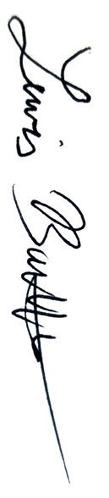

Lewis Barnett, PhD

NOAA Fisheries, Alaska Fisheries Science Center

7600 Sand Point Way NE, Bldg 4

Seattle, Washington 98115

Office phone: (206) 526-4111

Email: [lewis.barnett@noaa.gov](mailto:lewis.barnett@noaa.gov)