APPENDIX 1: SUPPLEMENTARY METHODS, TABLES AND FIGURES

APPENDIX 1 SUPPLEMENTARY METHODS: SIMULATION OVERVIEW

For each combination of parameters (Table S1), we generated 100 simulated datasets. First, we simulated random coordinates representing the locations of observed data (40 points, uniform on a grid from 0-10 in the x- and y-axes). Using these knot locations we simulated data from a spatial Matérn process using the RandomFields::RFsimulate() function. We chose to simulate observations over a period of 10 years, and did not model any components of the model as being autoregressive. We simulated observations with a Gaussian error distribution, and assumed observation error to be constant over space and time. This simulated dataset includes a spatial component (constant over time) and a spatiotemporal component (time varying, but independent from year to year). To include a spatially explicit temporal trend (or local trend), we used the same process as above, but for 1 time step (omitting the spatiotemporal component) and fixing parameter values ( shared with the spatial process of the observations – Table S1, = 0.1). We then projected the effect of the local trend on the observations with a linear model (e.g., , but in 2-dimensions). All code to replicate these analyses are available on GitHub: <https://github.com/fate-spatialindicators/spatial-trend>.

APPENDIX 1: TABLES

Table S1. Simulation parameters to evaluate sensitivity to spatiotemporal variation and observation error.

|  |  |  |
| --- | --- | --- |
| *Parameter* | *Interpretation* | *Value* |
| T | Time steps | 10 |
|  | Decay of spatial correlation | 1 |
|  | Standard deviation of spatial process | 0.01, 0.25, 0.5 |
|  | Standard deviation of spatiotemporal process | 0.01, 0.25, 0.5, 0.75, 1 |
|  | Observation error scale | 0.01, 0.25, 0.5, 0.75, 1 |
|  | Decay of spatial correlation (local trend field) | 0.1 |
|  | Standard deviation of the spatial process (local trend field) | 0.01, 0.25, 0.5 |

Table S2. Empirical occurrence and mean catch rates for positive tows (CPUE in kg/km2) for the 19 West Coast groundfish species included in our analysis.

|  |  |  |  |
| --- | --- | --- | --- |
| *Species common name* | *Species* | *Occurrence* | *Mean CPUE* |
| arrowtooth flounder | *Atheresthes stomias* | 0.36 | 1535.47 |
| big skate | *Raja binoculata* | 0.15 | 826.21 |
| bocaccio | *Sebastes paucispinis* | 0.07 | 1116.80 |
| canary rockfish | *Sebastes pinniger* | 0.08 | 3217.57 |
| darkblotched rockfish | *Sebastes crameri* | 0.18 | 960.41 |
| Dover sole | *Microstomus pacificus* | 0.84 | 2968.49 |
| English sole | *Parophrys vetulus* | 0.41 | 695.70 |
| lingcod | *Ophiodon elongatus* | 0.33 | 873.42 |
| longnose skate | *Raja rhina* | 0.60 | 985.95 |
| Pacific halibut | *Hippoglossus stenolepis* | 0.08 | 1031.22 |
| Pacific ocean perch | *Sebastes alutus* | 0.07 | 2191.36 |
| petrale sole | *Eopsetta jordani* | 0.43 | 909.81 |
| rex sole | *Glyptocephalus zachirus* | 0.62 | 1011.33 |
| sablefish | *Anoplopoma fimbria* | 0.65 | 1191.93 |
| shortspine thornyhead | *Sebastolobus alascanus* | 0.51 | 690.99 |
| North Pacific spiny dogfish | *Squalus suckleyi* | 0.28 | 2819.21 |
| splitnose rockfish | *Sebastes diploproa* | 0.21 | 2619.62 |
| spotted ratfish | *Hydrolagus colliei* | 0.50 | 617.10 |
| widow rockfish | *Sebastes entomelas* | 0.04 | 1846.20 |

Table S3. Delta-AIC values comparing spatial GLMMs with and without an estimated spatial-trend field. Delta-AIC values are interpreted relative to the best model for each species (0 = most parsimonious model).

|  |  |  |
| --- | --- | --- |
| *Species common name* | *No local trend* | *Local trend* |
| arrowtooth flounder | 87.10 | **0.00** |
| big skate | **0.00** | 0.81 |
| bocaccio | 6.25 | **0.00** |
| canary rockfish | 4.55 | **0.00** |
| darkblotched rockfish | 6.30 | **0.00** |
| Dover sole | 88.24 | **0.00** |
| English sole | 45.79 | **0.00** |
| lingcod | 3.43 | **0.00** |
| longnose skate | 28.43 | **0.00** |
| Pacific halibut | **0.00** | 1.90 |
| Pacific ocean perch | 0.67 | **0.00** |
| petrale sole | 25.87 | **0.00** |
| rex sole | 88.61 | **0.00** |
| sablefish | 20.23 | **0.00** |
| shortspine thornyhead | 35.38 | **0.00** |
| North Pacific spiny dogfish | 38.58 | **0.00** |
| splitnose rockfish | 1.28 | **0.00** |
| spotted ratfish | 15.83 | **0.00** |
| widow rockfish | 5.60 | **0.00** |

APPENDIX 1: FIGURES



Fig. S1. Estimates of linear trend in a generalized linear mixed model. Plots are based on 1000 simulated data sets, 15 time steps each, with multiple observations (n=2) every other time step. The underlying model included both a linear trend (with magnitude B[1]) and varying degrees of inter-annual variability (with magnitude determined by the random effect σ, the standard deviation of the temporal random effects). Two estimation models were fit to each of the 1000 datasets: (1) a GLMM that included random effects, but not an explicit trend ('Trend estimated post-hoc') and (2) a GLMM that included both random effects and linear trend. For the post-hoc model, a trend estimate was generated by regressing time against the estimated temporal random effects. For both models, we calculated the bias of the trend estimated versus the known value.

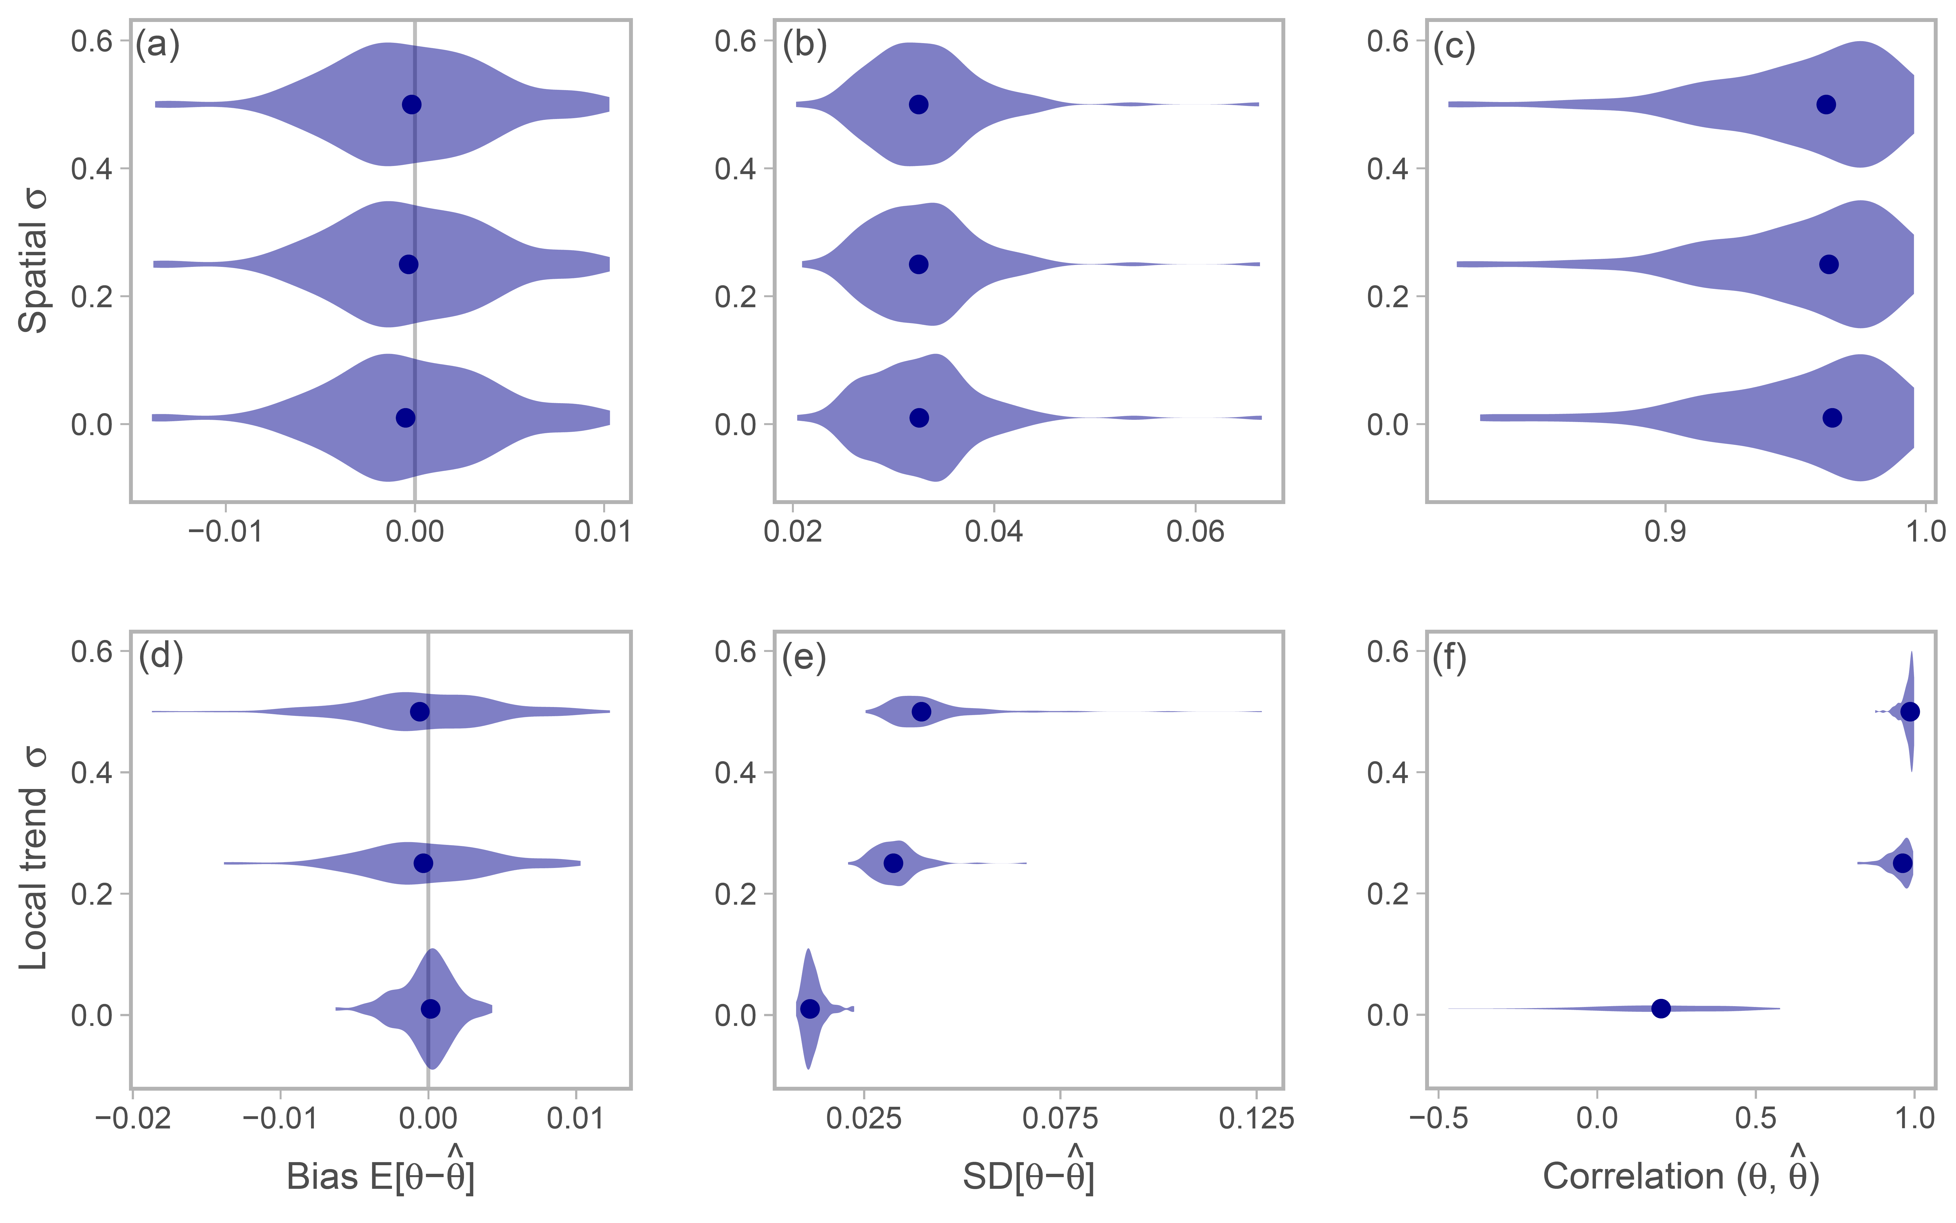

Fig. S2. Simulation testing the effects of spatial variation and local trend variation on the ability to recover the local trend. The symbols and refer to the local trend random effect values at each location and their estimate, respectively. Each violin represents the distribution of location by location comparisons from 100 simulations and the dots represent the median value. In all cases, the standard deviation of the non-varying parameter is held at 0.01, while varies along .

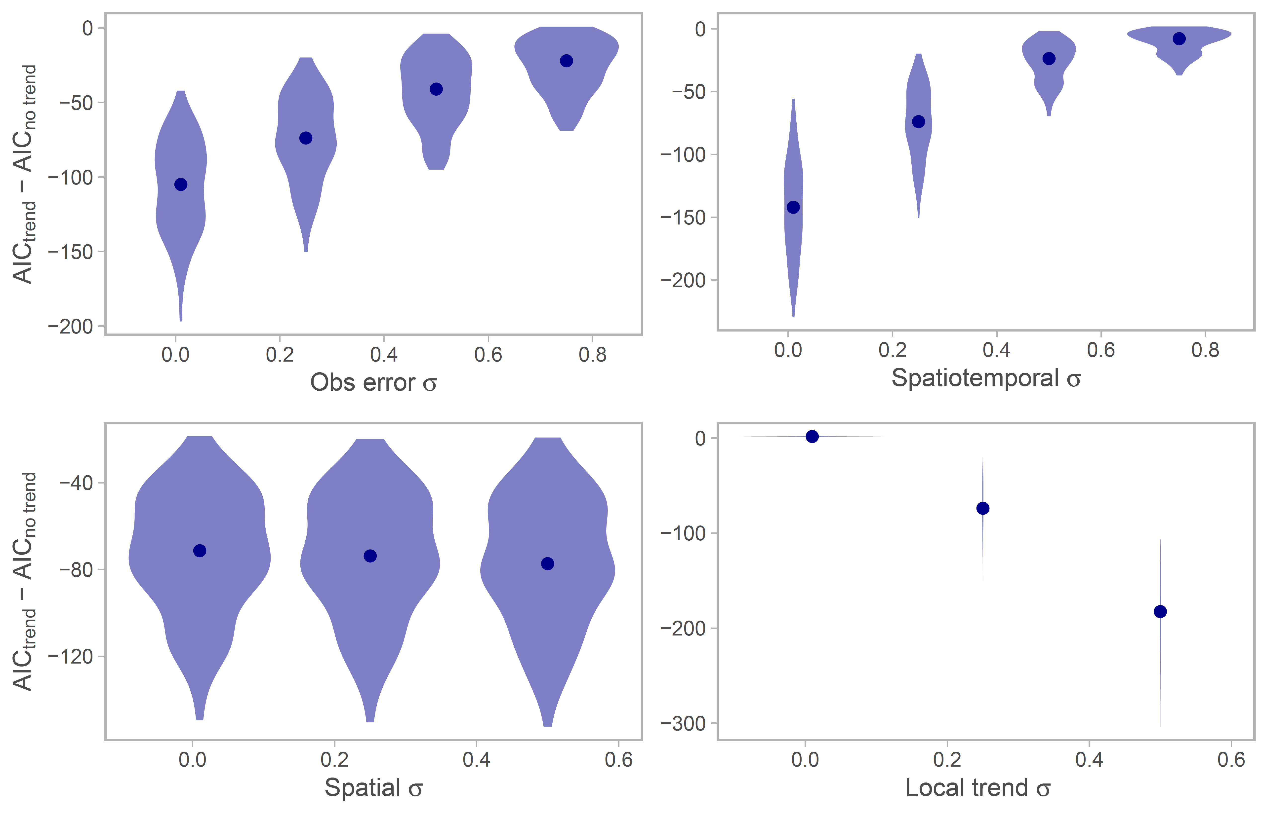

Fig. S3. Simulation testing the effects of variation in observation error and the spatial, spatiotemporal and local trend fields on the ability to identify the correct model structure using information criterion. Each violin represents the distribution of the difference in AIC between a GLMMs with and without the local trend from 100 simulations, and the dots represent the median value. In all cases, the standard deviation of the non-varying parameter is held at 0.01, while varies along in addition to for the observation error and spatiotemporal .

Fig. S4. Spatial and temporal patterns of predicted density for additional species not shown in Figure 5 of the main text. The first column shows maps of the predicted local trend (slope of log density across years). The second shows how each spatial location groups with a unique cluster of latitude and local trend. The third column represents the mean density over all years (in units of kg/km2 on a log scale). The fourth column shows the time series of the center of gravity (COG), or latitude weighted by density, with 95% confidence intervals. The black line with grey interval represents the COG calculated from predicted densities coastwide, whereas the colored lines represent the COGs for each unique biogeographic region (separated by Cape Mendocino, California, in the north; Point Conception, California, in the south). Line color represents the proportion of a species’ relative biomass in a given region. Note that for Pacific Ocean perch, the coastwide COG time series is completely overlapped by the northern regional COG.

[Figure attached as PDF]

Fig. S5. Predicted density maps for the full study region by year for all species (in units of kg/km2 on a log scale). Note that coordinates are scaled to 10s of km.

[Figure attached as PDF]