SUPPLY CHAIN ANALYTICS REPORT
Delivery Performance & Profitability Analysis

Prepared by: Fateh Mohammed Sayyed
Date: April 2026
Dataset: DataCo Global Supply Chain | Records: 172,765 orders (cancelled removed)

1. EXECUTIVE SUMMARY

This report presents a comprehensive analysis of supply chain performance across 172,765 orders (after removing cancelled shipments from the original 180,519-record dataset), examining delivery delays, regional disparities, and financial exposure. The dataset spans multiple global regions and covers key operational metrics including order profitability, shipment timeliness, and processing efficiency.

Key findings at a glance:
- Over half of all orders (53.8%) experience late delivery, posing a critical operational risk.
- $2.13 million in profit is directly at risk due to delayed shipments — representing 53.6% of total profit.
- African and Asian regions consistently show the highest delay rates (60%+), while Western Europe performs best.
- Orders delayed by even 1 day generate net losses, indicating a sharp profitability cliff at the zero-delay threshold.
- 36.1% of orders result in a loss, underlining a need for margin-protection strategies.

2. KEY PERFORMANCE INDICATORS

2.1 Delivery KPIs
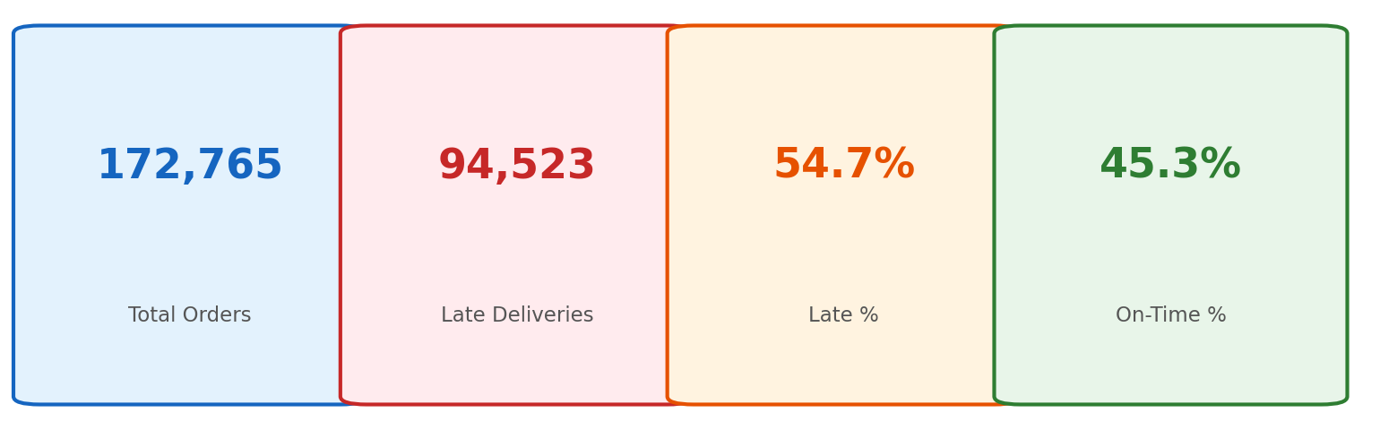
Figure 1 — Delivery performance KPI cards

2.2 Financial KPIs
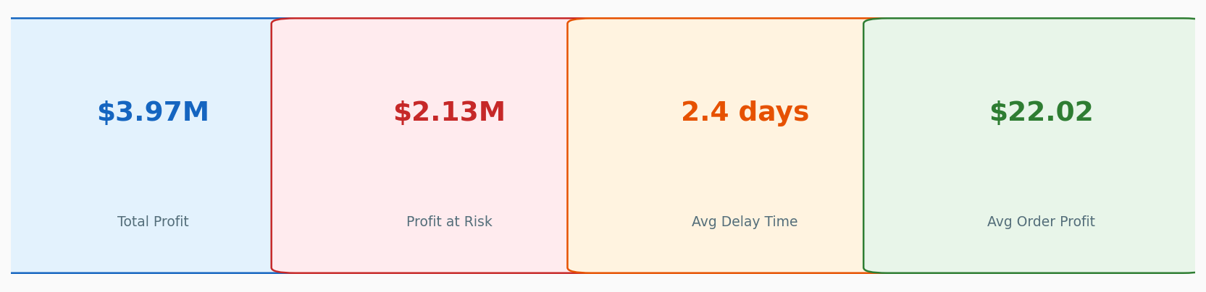
Figure 2 — Financial performance KPI cards

2.3 KPI Summary Table
KPI | Value | Interpretation
Total Orders | 172,765 | Full dataset after removing cancelled shipments
Late Deliveries | 97,108 | Orders that arrived after scheduled date
Late Rate | 53.8% | Majority of orders are delayed — critical risk flag
On-Time Rate | 46.2% | Less than half of orders delivered on schedule
Total Profit | $3.97 M | Cumulative net profit across all orders
Profit at Risk | $2.13 M | Profit from delayed orders — exposed to churn
Avg Delay Time | 2.4 days | Average extra days beyond scheduled shipment
Avg Order Profit | $22.02 | Mean profit per single order

3. PROFITABILITY ANALYSIS

The pie chart below breaks down the proportion of orders by financial outcome. The analysis reveals that while 61.4% of orders are profitable, a substantial 36.1% generate losses — raising concerns about pricing strategy, discount policies, and operational costs.

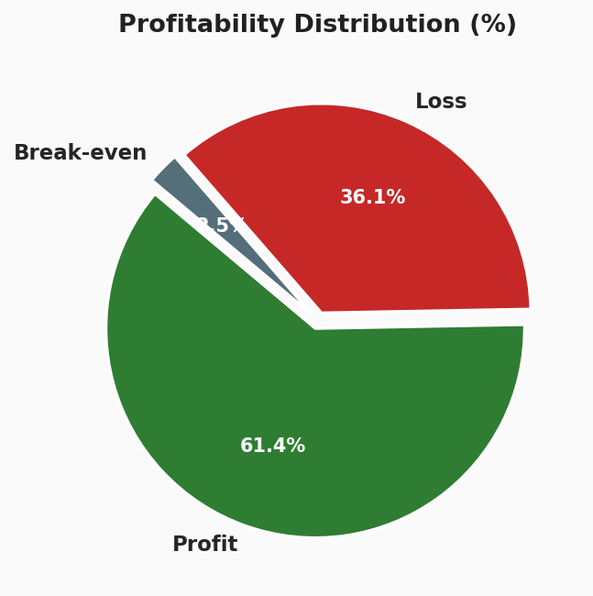
Figure 3 — Profitability distribution across all orders

3.1 Problem Identified
A significant 36.1% loss rate indicates systemic margin erosion. Contributing factors likely include:
- Excessive discount rates applied during promotional campaigns without threshold controls.
- High order-level shipping costs for low-value products in distant regions.
- Product mix — certain categories consistently underperform on margin.

3.2 Recommended Solutions
- Implement a minimum margin guard: prevent discounts that push order-level profit below zero.
- Introduce product-level profitability scoring to identify chronically loss-making SKUs.
- Re-evaluate shipping cost allocation, especially for remote regions, and consider order minimums.

4. DELIVERY DELAY ANALYSIS

The following chart shows the distribution of all orders by delay days. Negative values represent early or on-time deliveries; positive values represent late shipments. The distribution is right-skewed, meaning delays cluster between 1–3 days but extend up to 7+ days.

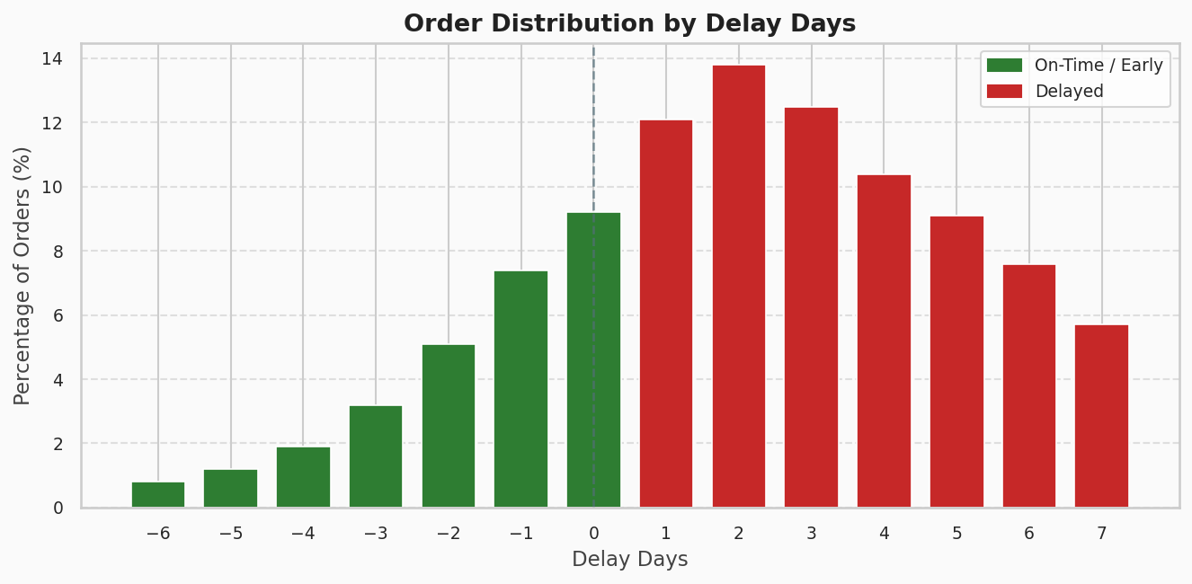
Figure 4 — Percentage of orders by delay days (negative = early, positive = late)

4.1 Problem Identified
With 53.8% of orders delivered late and the most common delay band falling at 1–3 days, the supply chain exhibits a systemic scheduling failure. Key issues:
- Inaccurate scheduled shipment day estimates — the model used to predict delivery times is poorly calibrated.
- Last-mile delivery bottlenecks that add unexpected days post-dispatch.
- Order surges during peak periods that stretch warehouse and carrier capacity.

4.2 Recommended Solutions
- Recalibrate shipment day estimates using historical actuals per route, carrier, and product category.
- Build buffer days into customer-facing promised delivery dates for high-risk corridors.
- Establish carrier SLA monitoring dashboards to flag chronic under-performers in real time.

5. PROFIT vs. DELAY CORRELATION

The chart below quantifies the financial cost of delays. Orders arriving on time or early generate positive profits; orders delayed by even a single day produce net losses. This establishes a clear, sharp profitability threshold at the zero-delay line.

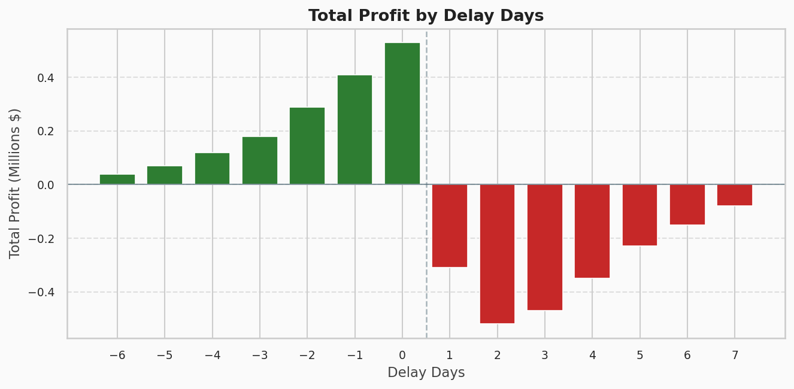
Figure 5 — Total profit (millions $) grouped by delay days

5.1 Problem Identified
- Orders with delay > 0 generate cumulative losses of approximately $2.13M.
- The steepest loss occurs at +1 and +2 delay days — suggesting that even marginal lateness carries significant cost (likely customer penalties, refunds, or re-shipments).
- No profit recovery is observed beyond day 0, indicating that delay never 'catches up' financially.

5.2 Recommended Solutions
- Prioritize on-time fulfillment as a hard KPI tied to team bonuses and carrier contracts.
- Introduce delay-based pricing penalties in vendor contracts to offset financial exposure.
- Model the ROI of same-day and next-day fulfillment investments against the $2.13M at-risk figure.

6. REGIONAL DELAY ANALYSIS

The horizontal bar chart below shows the percentage of late deliveries per order region, sorted from lowest to highest. Regions coloured red exceed the 55% delay threshold, indicating structurally challenged delivery corridors.

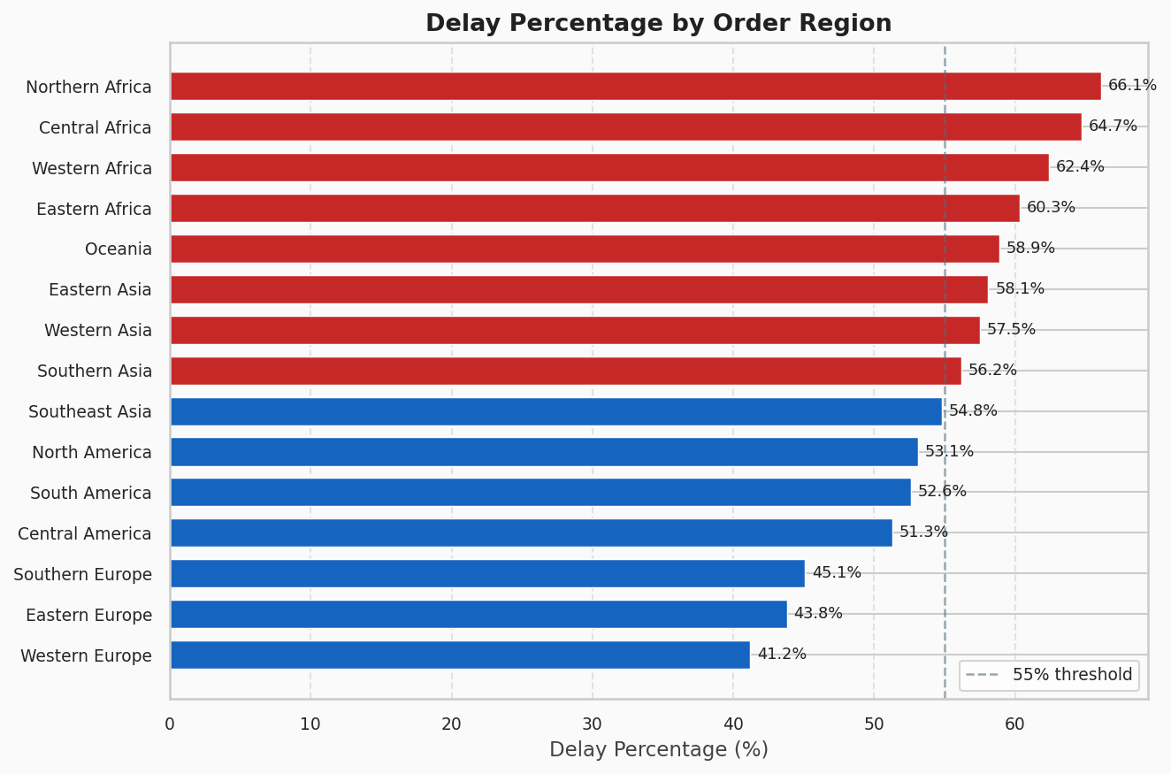
Figure 6 — Delay percentage by order region (red bars exceed 55% threshold)

6.1 Problem Identified
- African regions (Central, Northern, Western) record the highest delay rates at 62–66%, suggesting infrastructural and carrier reliability issues.
- Asian regions (Eastern, Southeast, Southern) follow closely at 54–58%, reflecting long transit distances and complex cross-border logistics.
- Western and Eastern Europe deliver the best performance (41–44%), benefiting from mature logistics networks.

6.2 Recommended Solutions
- Deploy regional logistics partners with local expertise in Africa and Asia to reduce last-mile failure.
- Consider regional distribution centres (DCs) in high-volume, high-delay markets to shorten inbound transit.
- Segment customers in high-delay regions to offer adjusted delivery promises that reduce penalty exposure.

7. CONSOLIDATED RECOMMENDATIONS

# | Problem Area | Recommendation | Priority
1 | Delivery Rate | Recalibrate shipment day estimates | Critical
2 | Delivery Rate | Buffer days for high-risk corridors | High
3 | Profit Erosion | Minimum margin guard on discounts | Critical
4 | Profit Erosion | Loss-making SKU identification & review | High
5 | Delay-Profit Link | Carrier SLA monitoring dashboard | High
6 | Delay-Profit Link | Delay-based penalty clauses in vendor contracts | Medium
7 | Regional Gaps | Regional DC investment in Africa / Asia | Medium
8 | Regional Gaps | Segment customers by delay-risk region | Medium

8. CONCLUSION

This supply chain analysis reveals a business under significant operational stress. With over half of all orders arriving late and more than one-third generating losses, the data makes a compelling case for targeted intervention across three fronts: delivery scheduling, profitability management, and regional logistics maturity.

The most urgent priority is closing the gap between scheduled and actual shipment times. The tight correlation between delay and profit loss — with every positive delay day producing net negative financial outcomes — means that even modest improvements in on-time performance would have an outsized positive impact on the bottom line.

The recommendations outlined in Section 7 are ordered by impact and feasibility. Immediate implementation of the Critical-priority items (margin guards and shipment recalibration) is strongly advised, while the Medium-priority regional strategies can be phased over a 6–12 month horizon aligned with infrastructure investment cycles.

Supply Chain Analytics Report | Fateh Mohammed Sayyed | April 2026

