

**Personal Budgeting**

**Course name :** Introduction to Software Engineering .

**Course code :** CS251.

**Level :** second level **.**

**DR:** Mohamed Elramly‏**.**

**Students preparation:**

* Ahmed Hussein Ahmed ( 20230015)
* Mawad Emad Abdo (20230527)
* Menna AbdElGawad (20230423)
* Fatema Elzhraa Ahmed Elfiky (20230280)
* Malak Mohamed Refaat Mohamed (20240831)

Contents

**1.Insights** 3

**Global Practices** 3

**1. USA: You Need A Budget (YNAB):** 3

**2. Singapore: MoeySense (Government initiative):** 4

**3. UK: MyMoneySense by NatWest :** 5

**Local Practices** 6

**Some Example:** 6

**Comparative Analysis:** 6

**2. SWOT and GAP Analysis:** 7

**2.1 SWOT Analysis** 7

**Strengths** 7

**Weaknesses:** 8

**Opportunities:** 8

**Threats:** 9

**2.2 GAP Analysis:** 10

**Gaps in Egypt:** 10

**Global Solutions:** 11

**3.Target Customer(Segmentation):** 11

1) Customer Segments 11

**2)** Demographics: 12

**4.Solution Details** 12

**1)Proposition:** 12

2) Benefits 13

3) Challenges 13

4) SRS …………………………………….

**1.Insights**

Many countries and people have faced the same challenge, and using a personal budget was the smart and simple way to improve their financial life.

With the rise in prices and the growing daily needs, understanding and managing a personal budget is no longer a choice it’s a must. A personal budget helps people control their spending, save for the future, and stay ready for any financial challenge. Learning how to track income and expenses is the first step to achieving dreams, avoiding debt, and living with financial peace of mind.

**Global Practices**

**1. USA: You Need A Budget (YNAB):**

first started in 2004 as a free Excel tool. By 2015, it evolved into a global budgeting application, now used by more than **4 million users** worldwide.

**Why it's popular?**  
YNAB is a simple and user-friendly app that helps people track their budget and save money. Its success is due to:

* Ease of use.
* Support from financial education programs and institutions.
* Focus on user goals and clear financial planning.

The app starts with a few easy questions:

* Do you have debts?
* What is your dream?
* How old are you?

These questions help build a personal budget plan and motivate users to control their expenses.

Link: <https://app.ynab.com>

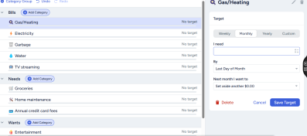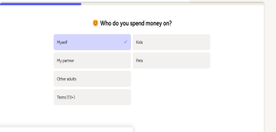 Questions To Make Page For users: control their expenses:

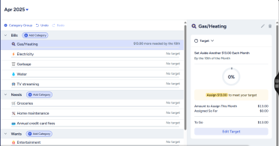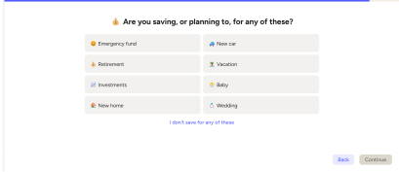

**2. Singapore: MoeySense (Government initiative):**

MoneySense is a national program launched by the Singapore government in 2003 to help people manage their money better. The goal is to make financial knowledge simple and available for everyone.

**Why it’s special?**

* It offers free tools, guides, and tips on saving, budgeting, and investing.
* It helps users plan for daily expenses, future goals, and even retirement.
* The program also runs workshops and online courses for all age groups.

MoneySense has made financial education a part of daily life in Singapore. Thanks to this program, more people have learned how to make smarter money choices and avoid debt

Link: <https://www.moneysense.gov.sg>

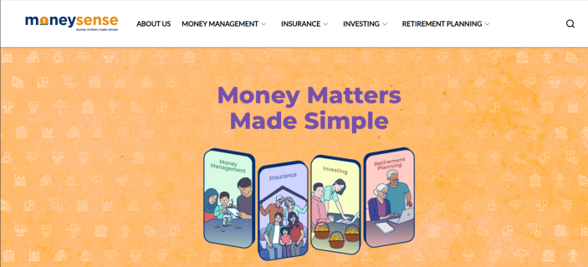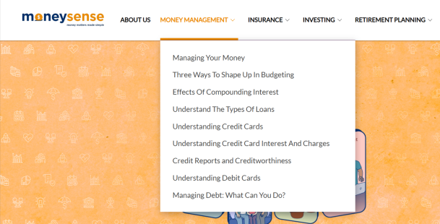The main page: Simple navigation bar and a lot of choices:

Explanations: Simple explanations:

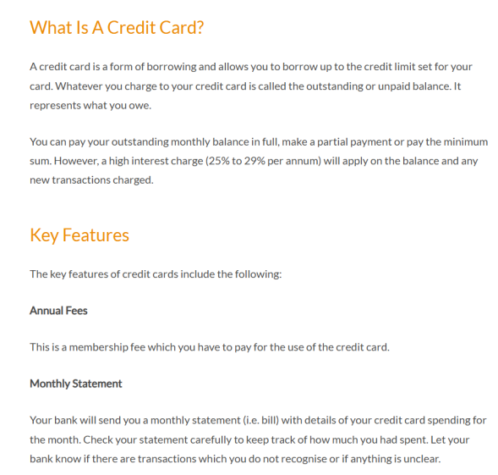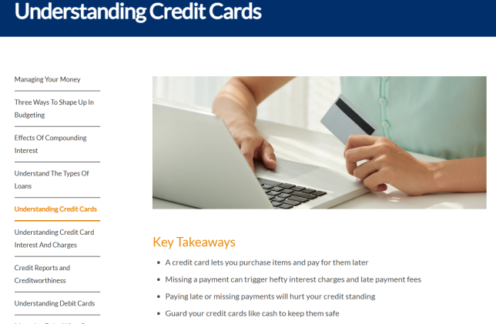

**3. UK: MyMoneySense by NatWest :**

MyMoneySense is an easy-to-use website, known for its **simplicity and attractive design**.  
This bank-led initiative offers **interactive tools, helpful articles, and fun learning modules** created especially for both individuals and schools.

The platform focuses on:

* Teaching basic money management skills.
* Helping users create and follow a personal budget.
* Making financial education simple and fun through games and real-life scenarios.

This approach encourages young people and adults to build strong financial habits early and apply them confidently in their daily lives

**Links:** [**https://natwest.mymoneysense.com**](https://natwest.mymoneysense.com)

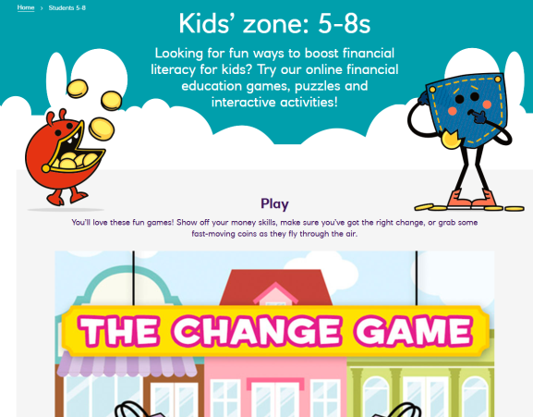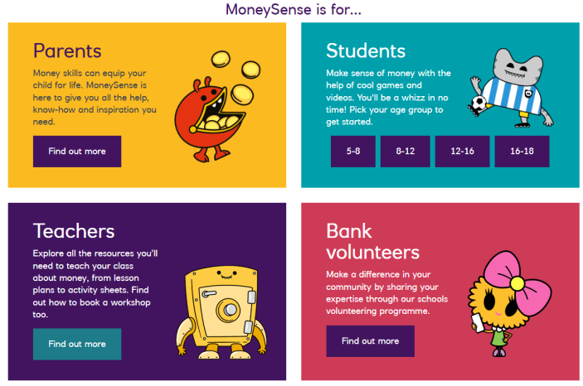**Attractive and easy design**: Games For children :

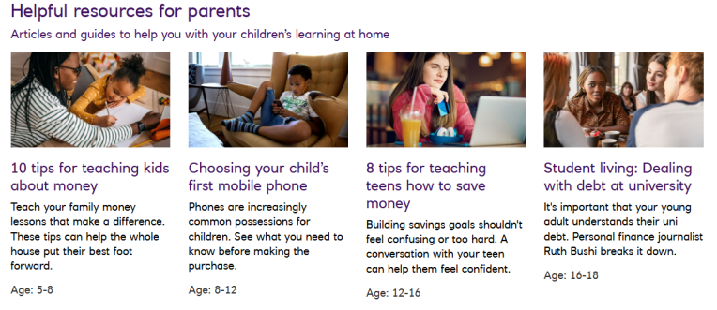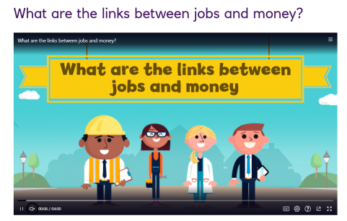Articles for parents: Educational videos for children:

**Local Practices**

In Egypt, the culture of personal budgeting is still not very strong or widespread. Some apps and programs offer simple tools for managing money)like telda ,masary) ,but they are not as advanced or popular as the global solutions like YNAB or MoneySense.

Most people depend on traditional ways like personal notes or mental tracking to manage their spending, and there is still a big need for more awareness and easy-to-use digital tools to help individuals plan their budget and save for the future.

**Some Example:**

**1.Masary**  
Masary is a digital wallet and payment platform that helps users manage their daily transactions, pay bills, and control spending — but it focuses more on payments rather than full personal budgeting.

2.**Fawry**  
Fawry is one of Egypt’s biggest electronic payment platforms. It allows users to pay bills, recharge mobile balance, and track transactions, but it does not offer advanced budget planning tools.

3.**Telda**  
Telda is a fintech app that allows users to send, receive, and spend money with more control. It gives a simple overview of spending habits, helping users become more aware of their financial behavior.

**Comparative Analysis:**

When we compare personal budgeting in Egypt to other countries around the world, we find that Egypt still lacks awareness and access to modern personal budgeting tools and technologies. Most people in Egypt prefer to use traditional ways like **pen and paper** or just **mental calculations**, which are old methods and not effective at all.

On the other hand, many other countries have created strong programs to support personal budgeting. For example, in the **UK**, there is a website designed for children to teach them how to manage their personal budget in a simple and fun way using games and easy videos. Parents also receive guidance on how to teach their children about saving, spending, and financial planning. The strong point here is that the government supports this learning and schools help students understand the importance of personal budgeting, which makes them more aware from a young age.

In another example, countries like **Singapore** created government websites that guide people and teach them important financial skills, including personal budgeting. These websites also offer free documents, tools, and useful resources to help users improve their financial life.

Some countries also provide **mobile apps** that help people manage their personal budget, reduce debt, save money, and plan for future goals. These apps offer easy tools and useful features to make budgeting simple and effective.

In Egypt, there is a strong need to raise financial awareness and change people's mindset about money. Personal budgeting can help people reach their goals, avoid debt, and build a better financial future.

**2. SWOT and GAP Analysis:**

**2.1 SWOT Analysis**

**Strengths**

**1. Visibility and Tracking:**  
Personal budgeting gives you clear control and understanding of your money. Unlike random spending, budgeting helps you track where your money goes. This makes it easier to make smart spending decisions and avoid surprises. It builds a more organized and responsible financial life.

**2. Goal Achievement:**  
Budgeting helps people reach their financial goals. Without a plan, money often disappears without any real progress. A clear budget helps you save for both short-term and long-term goals like buying a car, traveling, or starting a business. It gives your money a clear direction.

**3. Customizability:**  
Budgeting is flexible. It can fit your income, lifestyle, and future plans. Whether you are a student, a young worker, or a family person you can build a budget that matches your needs. And you can always adjust it when your situation changes.

**4. Financial Discipline:**  
A budget teaches you self-control and smart decision-making. Over time, it helps you avoid random or emotional spending and encourages you to use your money wisely. This habit makes your financial future stronger and more stable.

**5. Emergency Preparedness:**  
A good budget helps you save for emergencies. When unexpected things happen like car repairs, medical bills, or job loss you will be ready. This makes financial problems easier to handle and gives you peace of mind.

**Weaknesses:**

**1. Lack of Financial Awareness:**  
Many people don’t fully understand the value of personal budgeting. They might think budgeting is difficult or unnecessary, which causes them to waste money or live paycheck to paycheck.

**2. Limited Use of Technology:**  
In Egypt, personal budgeting apps or digital tools are not widely used. Most people still depend on pen and paper or mental notes, which makes it hard to track and manage money effectively.

**3. Cultural Habits:**  
Some people are not used to planning their expenses or setting financial goals. This habit leads to random and emotional spending without thinking about the future.

**4. Income Instability:**  
For people with unstable or low income, making a budget can be difficult, as their money often goes to cover basic needs, leaving little room for savings or planning.

**Opportunities:**

1. **Financial Education:**  
Budgeting gives a great chance to improve financial knowledge. It teaches people how to manage their money better, which helps with smarter financial decisions in the long run.

2. **Technology Integration:**  
With the growth of fintech, budgeting tools can become much easier and more efficient. Features like automation and AI can make budgeting faster and more accurate, which fits well with Egypt’s digital transformation plans.

3. **Life Planning:**  
Budgeting can go beyond money management. It helps link spending to life goals and personal values, leading to better decision-making and more purposeful living.

4. **Partnership with Banks:**  
Apps can work together with banks to offer special services — like automatic saving plans, financial advice, or discounts for users.

5. **Growing Digital Payment Systems:**  
As more people use digital wallets and online banking, personal budgeting apps can connect with these systems to give users a full view of their spending.

6. **Government Support:**  
If governments support financial education, they might recommend personal budgeting apps to schools and families, which will increase users.

**Threats:**

**1. External Economic Factors:**  
Personal budgets are vulnerable to broader economic conditions like inflation, economic downturns, and market volatility. These factors can disrupt well-designed budgets and require flexibility and contingency planning to remain effective during economic uncertainties.

2. **Income Instability:**  
Modern work patterns, including gig economy jobs and commission-based pay, create income volatility. This unpredictability can make it harder to apply traditional budgeting methods, which assume a stable, monthly income.

3. **Lifestyle Inflation:**  
As income increases, so do social and cultural pressures to increase consumption. This phenomenon, known as lifestyle inflation, can undermine budgeting success. Even with higher earnings, failing to maintain disciplined spending habits can hinder financial growth.

4. **Technological Vulnerabilities:**  
While digital budgeting tools offer convenience, they also introduce cybersecurity and data privacy risks. Financial data stored in apps can attract hackers, and concerns about how providers handle user data may reduce trust in these tools.

5. **Family Dynamics:**  
Budgeting within households can face challenges due to differing financial priorities and attitudes. Disagreements about spending, saving, and financial goals among family members can create tension, complicating the budgeting process and hindering its success

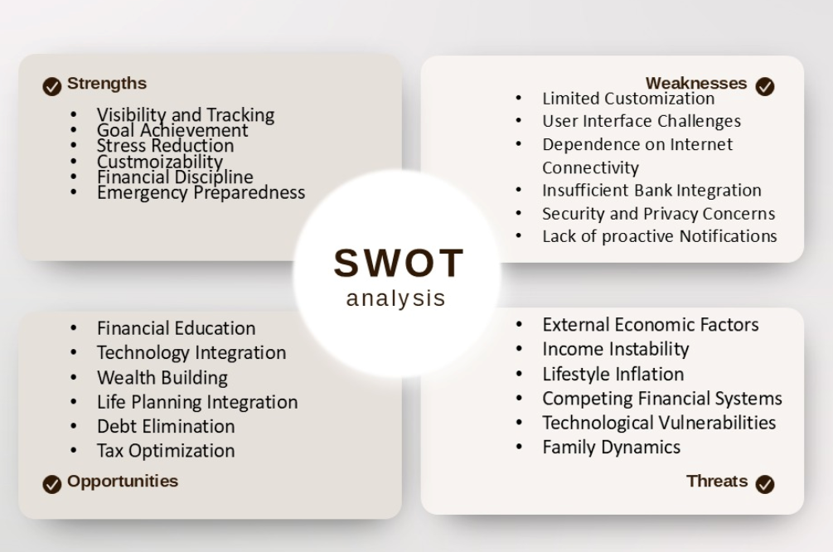

We can summarize all this point in this:

**2.2 GAP Analysis:**

There is a clear gap in the market in the lack of awareness of personal budgeting software among users, especially in Egypt and Arab countries, compared to foreign countries. Although financial planning has become a necessity with the rising cost of living, many individuals do not realize the importance of these tools or how to benefit from them.

**Gaps in Egypt:**

|  |  |  |
| --- | --- | --- |
| **Major Problem** | **Gap** | **Opportunity for Innovation** |
| Lack of Financial Awareness and Literacy. | In Egypt, awareness programs about personal budgeting are limited and not accessible to all social classes. | Develop financial education programs for schools, universities, and online platforms to embed financial skills early in life. |
| Lack of Financial Data Integration. | Most apps in Egypt lack integration with local banks, forcing users to manually input data, risking errors. | Create applications integrated with Egyptian banks and e-wallets for real-time data updates and enhanced user convenience. |
| Lack of Intelligent Spending Analysis. | Existing tools only record expenses without offering insights or recommendations for improving financial health. | Incorporate AI-driven analysis and reporting that provides users with actionable financial advice and goal tracking. |
| Lack of Awareness About Saving and Investing. | Users tend to focus on daily expense management rather than long-term wealth building through savings and investments. | Develop apps or platforms that guide users in saving and investing smartly, introducing them to stocks, funds, and local opportunities. |

**Global Solutions:**

|  |  |
| --- | --- |
| **Gap in Global Solutions** | **Opportunity for Innovation** |
| Foreign apps do not support Egyptian wallets or local banks, and often use a language that is difficult for many Egyptians. | Create a user-friendly, fully localized Egyptian budgeting app that supports Egyptian banks and e-wallets, and offers clear Arabic language. |
| Complex technology and too many unnecessary features that overwhelm average users. | Develop a simple, intuitive Egyptian budgeting app with only essential features, designed for everyday use by all income groups. |

**3.Target Customer(Segmentation):**

## ****1) Customer Segments****

**1. Unbanked Young Adults**  
Young adults (aged 18-30) who do not have formal banking relationships and rely mainly on cash for transactions.  
This segment represents a strong opportunity for financial inclusion, as they seek simple and affordable solutions to manage daily expenses and save for short-term goals.

**2. Financially Stretched Middle Class**  
Middle-class individuals and families who struggle to balance their income with increasing living expenses.  
This segment needs easy-to-use tools for tracking expenses, identifying saving opportunities, reducing debt, and building emergency funds.

**3. Micro and Small Entrepreneurs**  
Small business owners who often mix personal and business finances, which affects the growth and sustainability of their ventures.  
They require solutions to monitor revenues, expenses, and make more informed financial decisions for their businesses.

**4. Digital-First Gen Z**  
Young people raised in the digital era who expect financial services to match their fast-paced, connected lifestyle.  
They prefer instant, engaging, user-friendly applications, ideally with social features, gamification, and competitive elements.

**5. Financial Dependents in Transition**  
Students and recent graduates who are shifting from financial dependence on family to self-management.  
They seek tools to build basic financial habits, avoid common financial pitfalls, and start establishing a healthy credit history.

**2)** Demographics:

|  |  |
| --- | --- |
| Attribute | Details |
| Age Range | 18 – 40 |
| Income | 300-1000EGP/monthly |
| Education | moderate to high educational levels |
| Location | Egypt |
| Occupation |  |
| Technology | Smartphone and financial app users, but not deep financial software  experience. |

**4.Solution Details**

**1)Proposition:**

**A. Purpose and Goals**

**1. Start Budgeting**

• The essential purpose of a budget is to ensure you live within your means while setting aside money for future expenses.

• Budgeting doesn’t require strict spreadsheets, start by subtracting average expenses from income. For stricter control, allocate fixed amounts to categories (e.g., groceries, rent).

• Example: The average family of four spends **$7,095/month** on essentials (housing, food, bills). Track your own spending for **3 months** to build a realistic budget.

**2. Build Your Savings**

• Savings prepare you for emergencies (medical bills, car repairs) and future goals (home, vacation).  
• **Short-term goals** (e.g., vacation): Save monthly for **6–12 months**.  
• **Long-term goals** (e.g., home down payment): Use high-yield accounts or investments.  
• **You can** Automate transfers to a separate savings account to stay disciplined.

**3. Improve Your Credit**

• A strong credit score unlocks better loan rates and approval chances.  
• **How to build credit:**

* Pay bills **on time**
* Pay off debts.
* Keep credit card balances **low**.
* Avoid opening too many lines of credit
* Check your reports regularly

**4. Save for Retirement**

• Start early to benefit from **compound growth**.  
• **Options:**

* **Employer 401(k)**: Contribute enough to get full **employer matching** (free money).
* **IRAs/Roth IRAs**: Tax-advantaged personal retirement accounts.
* **Investments**: Stocks/real estate for long-term growth.

**B. Key Features and Functionality**

**1. Income & Expense Tracking**

• Log transactions manually or **sync bank accounts** for automatic tracking.  
• **AI categorization**: Labels spending ("Food," "Utilities" ,..etc).

**2. Budget Creation**

• Set **monthly limits** per category (e.g., $500 for groceries).  
• **Alerts** when nearing budget caps.

**3. Goal Setting**

• Create goals.  
• **Progress bars** visualize savings growth.

**4. Reports & Insights**

* **Spending trends**: Charts and graphs show where money goes ("You spend 40% on rent").
* Provide **insights** into spending patterns
* **Give suggestions**: "You should reduce dining out to once a week."

**5. Bank Integrations**

• Secure APIs (**Plaid/Yodlee**) sync banks, e-wallets (e.g., **Vodafone Cash**), and credit cards.

**6. User-Friendly Design**

• **Mobile app (Flutter) + web (React.js)** for easy access.  
• **Simple UI**: Color-coded budgets, one-click reports.

**7. Question and answer section**:

* That feature would be able to let the Egyptians to ask about any question related to the finance and there will be a chatbot answer to their questions.

**8. Tutorial section:**

* You will be able to learn more about finance. It will be supported by the CBE to increase the awareness of finance in Egypt.
* There will be also interactive and motivating activities and questions to be done and answered to encourage the finance awareness.

**9. AI Automated plans:**

* It will suggest for you a plan to follow to manage your personal budget according to your answers of the questions that will be asked iteratively about your financial circumstances and your priorities.

**C. Target Users**

**1. Individuals**

• Manage daily spending and debt repayment.

**2. Youth (18–30)**

• Save for travel, education, or starting a business.

**3. Students**

• Track expenses (books, rent) and avoid overspending.

**4. Freelancers & Entrepreneurs**

• Handle **irregular income** and separate business/personal finances.

**D. Technologies**

**1. Frontend**

• **Web**: React.js/Angular for responsive dashboards.  
• **Mobile**: Flutter (ios/Android).

**2. Backend**

• **Framework**: Node.js/Express.js or Django.  
• **Database**: PostgreSQL (secure transaction storage).

**3. APIs**

• **Banking**: Plaid/Yodlee.  
• **Payments**: PayPal/InstaPay (Egypt).

**4. Hosting**

• **Cloud**: AWS/Google Cloud for scalability.

**5. Security**

• **Auth**: OAuth 2.0 + biometric login.  
• **Encryption**: AES-256 for sensitive data.

**6. AI :**

**Chat bot** and **Automated AI**

## 2) Benefits

**1. Financial Inclusion**  
The app empowers underserved populations, including youth and low-income segments, to actively manage their finances, thereby increasing their engagement with the formal financial system.

**2. Encourages Saving and Responsible Spending**  
Through goal tracking and budgeting features, users are encouraged to adopt better financial habits, reduce unnecessary spending, and improve their long-term financial resilience.

**3. Increased Financial Literacy**  
The app integrates educational content and visual analytics, helping users better understand essential financial concepts such as interest, debt management, and long-term planning.

**4. Cost Reduction for Financial Institutions**  
By encouraging self-service and reducing financial mismanagement, the app can help lower loan defaults and facilitate more accurate customer risk assessments for financial institutions.

**5. Improves Accessibility to Financial Planning Tools**  
With its mobile-first design, the app ensures that users from various geographic and economic backgrounds can access advanced budgeting features at little to no cost.

**6. Supports National Digital Transformation Goals**  
The solution aligns with Egypt’s financial inclusion strategy and Vision 2030 goals, aiming to expand digital services to underserved communities.

## 3) Challenges

**1. User Adoption and Digital Literacy Gaps**  
A significant portion of the target market may lack the necessary digital skills or financial confidence to use budgeting tools effectively, requiring dedicated user education campaigns.

**2. Regulatory and Compliance Barriers**  
Integration with financial institutions and handling personal financial data must comply with local regulations, including data protection laws and Central Bank requirements, to avoid legal and operational challenges.

**3. Cybersecurity and Privacy Risks**  
Storing and processing sensitive user data presents risks of breaches or misuse. Ensuring strong encryption and transparent data handling policies will be essential for protecting users' privacy.

**4. Trust and Cultural Barriers**  
Some users may be hesitant to trust digital apps with their financial information, particularly in societies where cash transactions dominate, requiring trust-building efforts and cultural awareness.

**5. Integration with Financial Institutions**  
Achieving seamless integration with various banks and mobile wallets requires standardized APIs and cooperation from financial service providers, which may be challenging in a market with diverse technical infrastructures.

**6. Sustainability and Monetization**  
Without careful planning, the business model may become too dependent on freemium features or ads, which could compromise the user experience or app quality over time. A balanced approach between providing value to users and generating revenue will be critical for long-term success.

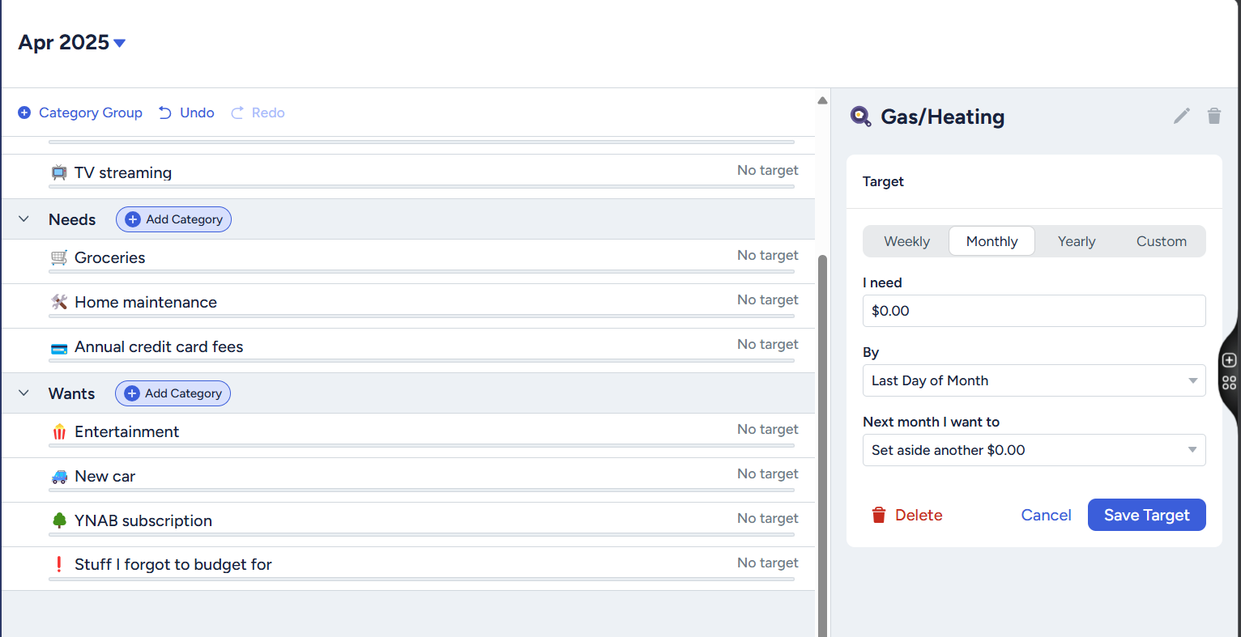

**4) SRS :**

# Document Purpose and Audience

Purpose

In this document, we focus and practice on the methods of specifying software requirements, how we collect the requirements, what the criteria for collecting the requirements are, and what the purpose of all of this is. This document will give us a lot of knowledge about the process of collecting the requirements, and we will apply this process to our project (Personal Budgeting). We will use the IEEE SRS document to do this.

Audience

* Stakeholders
* Software developers
* Software designers
* Anyone who wants to learn about the process of collecting requirements
* Professional users who are knowledgeable about the field

**Introduction**

**Software Purpose**

Our purpose is to spread the culture of personal budgeting as a software application in the Arab world, particularly in Egypt. In Egypt and the Arab world, most people don’t know about personal budgeting software and resort to old methods for calculating their personal budget, such as using pen and paper. These methods are outdated and inefficient.

Our goal is to improve this by providing software that helps track personal budgeting, making it easier to save money, set goals, and create a roadmap to achieve them.

## Software Scope

Personal Budgeting is developed to help people who have no knowledge of personal budgeting, have basic computer skills, and want to manage their personal budget.

This software primarily targets Egypt and the Arab world. We aim to provide easy to use software with a friendly user interface. Additionally, we will integrate all Arabic digital wallets, including Egyptian wallets such as (Vodafone Cash and Orange Cash).

We will create a personalized plan for you based on your goals and struggle to provide an effective budgeting strategy. You will also be able to track your budget, view your expenses and income, and follow steps to achieve your financial goals (e.g., performing Umrah, buying a home).

Furthermore, we will include Arabic language support for users who find English difficult.

## Definitions, acronyms, and abbreviations

|  |  |
| --- | --- |
| **Phrase** | **Definition** |
| **Budget** | A financial plan with the expected income and expenses over a specified period. |
| **Income** | Money received from various sources (salary, side businesses, etc.). |
| **Expense Tracking** | Recording and categorizing expenses to monitor financial habits. |
| **Financial Goals** | Specific savings or targets, such as buying a new house. |
| **Analytics** | Visualizations of financial data to help users make decisions. |
| **Bank Integration** | A feature that links user accounts with financial institutions to automatically track transactions (Vodafone Cash, Etisalat Cash, Fawry, etc.). |
| **Reminders** | : Notifications about due payments, progress toward goals, and alerts about overspending. |
| **Security** | Protecting users' data and taking actions to prevent unauthorized access. |
| **Savings** | Money set aside for future use, emergencies, or planned expenses. |

|  |  |
| --- | --- |
| **Debt Management** | Strategies for handling borrowed money and repaying loans efficiently. |
| **Expense Categories** | Classification of expenses (e.g., rent, groceries, entertainment) to better manage finances. |
| **Automatic Payments** | Automatic periodic payments for subscriptions, bills, or loans. |
| **Budget Change** | Modifying financial plans based on changes in income or expenses. |
| **Spending Limit** | A predefined maximum amount set for a specific category to control expenses. |
| **FR (Functional Requirement)** | A specific function or feature that the software must provide to meet user needs. |
| **RE (Requirements)** | The process of defining, documenting, and maintaining software requirements. |

# Requirements

## Functional Requirements

|  |  |  |
| --- | --- | --- |
| **ID** | **Requirement** | **Description** |
| **FR-01** | **User login** | •The user can **log in** to their account using a valid **email** or **username** and **password**. If the user enters **incorrect** credentials **three times**, the account will be **temporarily locked for 1 minute**.     * **Or sign up with valid credentials , if it is not valid he will receive a warning message.** * The user can **recover** his account by **receiving a** **verification code** **via email.** |
| **FR-02** | **User Opens App** | * The user can set up **facial recognition, fingerprint authentication, or a password** to unlock the application and keep their information secure. * **If the user exits the application without closing it, it will remain open for up to** 15 minutes**. After this period, they must** authenticate using their fingerprint **to regain access.** |
| **FR-03** | **Set Income** | * The user can add their income sources, specifying the amount and the date of receiving the money. * The user can add new income, edit existing income, and delete an income source. * The user can also mark an income as non recurring if it is a one time payment. |
| **FR-04** | **Expense tracking** | • The user can **add** items or budgets for which they spend money, such as **household supplies**, **transportation**, **gasoline** **expenses**, **food**, **school** **expenses**, **vacation** **expenses**, and **trips**. |

|  |  |  |
| --- | --- | --- |
|  |  | * The user can **mark** certain expenses as **recurring**, so they are **automatically** **deducted** from the **budget** when income is **received**.      * The user can also **manually** add other expenses, **edit** existing ones, and **manage** expense records. |

|  |  |  |
| --- | --- | --- |
| **FR-05** | **Budget creation** | * The user can set a budget limit, such as "I want to spend at most 10K this month."      * The user can edit the budget and choose to make it fixed for a specific period.      * The system will provide recommendations, including suggested actions, flowcharts, and diagrams for managing expenses during the current and previous periods. The user can select a specific period to review.      * If the user exceeds the budget, they will receive a warning notification along with budget management recommendations, such as reducing vacation expenses to balance their spending.      * The user can set budget limits for different categories, such as food, transportation, and entertainment, to better control spending.      * The app can send notifications to inform the user when they have spent a certain percentage of their budget, like "You have spent 70% of your budget for this month."      * The system can suggest saving plans based on the user's spending habits, such as "You spent too much on entertainment this month. Try reducing this category to save more."      * The user can compare their current budget with previous months to track progress and improve financial management. |

|  |  |  |
| --- | --- | --- |
| **FR-06** | **User goal** | * The user can set a goal, such as going to Umrah, visiting a new country, buying a new car, or purchasing a new home.        * The user can choose how much to save each month for their goal, and the system will calculate how long it will take to achieve it.      * Alternatively, the user can set a target date for their goal, and the system will create a saving plan showing how much to save each month and how much they can spend.      * The user can add money to their goal or take out money if needed for urgent expenses, and the system will automatically update the plan and timeline.      * The user can reallocate money from other budget categories (e.g., reducing transportation expenses to save more for their goal). |
| **FR-07** | **Put Credit or wallet** | * The user can **add their credit card or digital wallet** to the app to track their **budget, available money, and expenses**. * **The app will display** the current balance **and** transactions **from the connected credit card or wallet.** |
| **FR-08** | **Financial reports** | * **The system provides detailed analytics and reports on income, expense, and saving.**      * **Users can view summaries, charts, and trends to better understand their financial habits.**      * **The system can generate reports for specific time periods (daily, weekly, monthly, or year).** |
| **FR-09** | **Q&A and Tutorial** | * **The system provides chatbot as you can ask for a question related to the finance.** * **There will be a tutorial part that will include also articles about finance that will be provided by the CBE.** * **There will be some motivating and interactive activities and questions.** |

## Non Functional Requirements

|  |  |
| --- | --- |
| **Measure** | **Details** |
| **Performance** | * The **sign-in** and **app opening** process should take no more than **5 seconds**.      * Every page in the system should load within **10 seconds**.      * Checking the available balance in the **eWallet** should take no more than **15 seconds**, as it requires fetching data from an external service.      * Generating and loading **financial reports or diagrams** should take no more than **10 seconds**.      * Updates in income, expenses, and budgeting should be **reflected in real-time** or within **3 seconds**.      * The system should respond to user interactions (clicking buttons, navigating pages) **within 1 second** for smooth usability. |
| **Scalability** | * The system should **support at least 1000 concurrent users** without **a drop in performance**.      * It should be designed to **handle future growth** by allowing easy upgrades to support more users if needed. |
| **Usability** | * The system should have a friendly and easy-to-use interface to ensure a smooth user experience. * The design should be simple, easy to understand, and accessible for users with basic technical skills.      * Icons, buttons, and navigation should be clear and well organized to help users complete tasks efficiently. |
| **Security** | * The system should use strong encryption to protect user data and bank or wallet details.      * User passwords and sensitive information should be securely stored and not accessible to unauthorized users.      * The app should support two factor authentication for additional security. |

# System Models

## Use Case Model

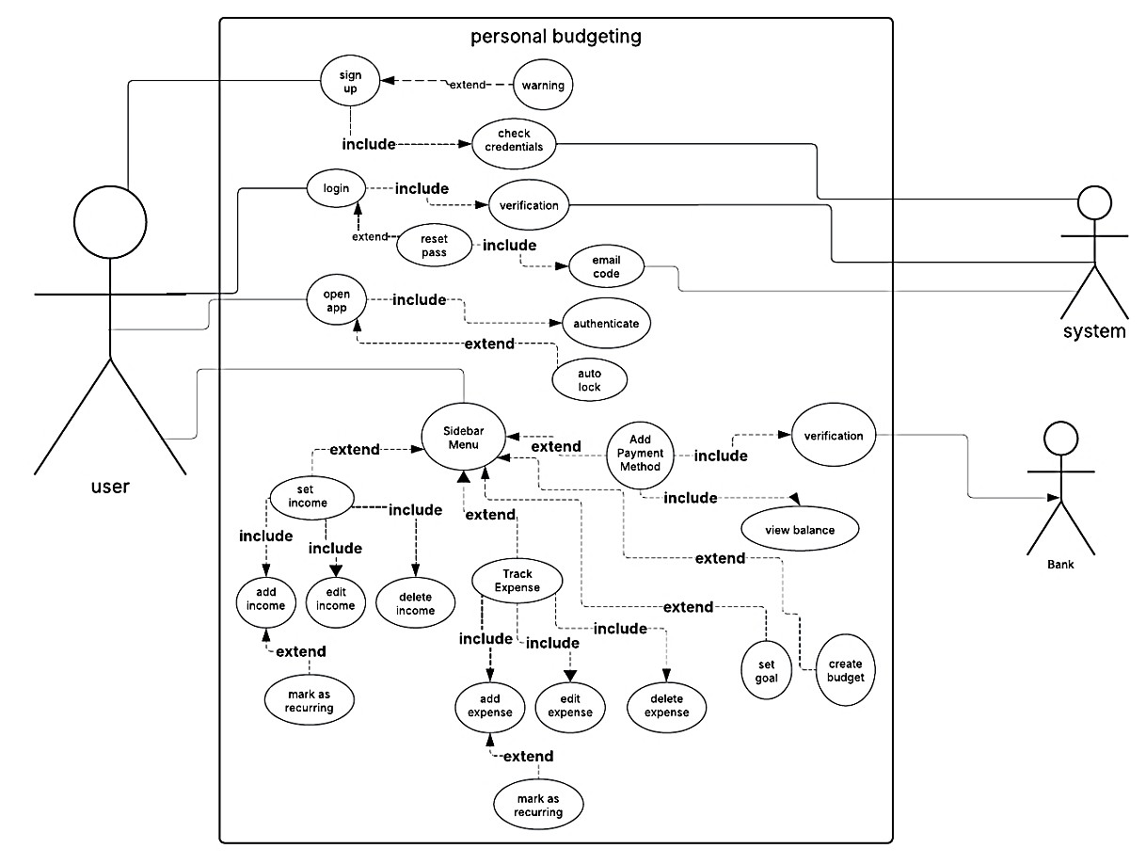

**System:**

•The system is the main manager of the application.

•It verifies operations (such as payment verification, sending notifications, and providing financial recommendations).

**User:**

•The user is the person who uses the app to manage their budget and finances.

•They can add income sources, set a budget, track expenses, and receive financial alerts.

**Bank:**

•The bank is the financial institution responsible for processing transactions related to credit cards and digital wallets.

•It allows users to link their bank accounts to the app to monitor their balance and spending.

## Enriched User Stories

### • User Story #1

|  |  |
| --- | --- |
| **User Story ID** | US #1 |
| **User Story Name** | Sign Up |
| **Actors** | New User |
| **Description** | **As** a new user  **I like** to be able to create an account using my email and password  **So** that I can securely access my budgeting information |
| **Per condition** | * The user is on the sign-up page. * The user does not already have an account. |
| **Post condition** | * The user account is successfully created. * The user is logged in and redirected to their dashboard. |
| **Acceptance Criteria** | **Given** I’m a new user and I’m on the Sign-Up page,  **When** I fill in the “Email”, “Username”, and “Password” fields with valid information and click the Sign-Up button,  **Then** the system creates my account, logs me in, and redirects me to my dashboard. |
|  |  |

### • Scenarios

#### Normal Scenario

|  |  |  |
| --- | --- | --- |
| **Actor Action** | **System Response** | |
| 1. User Enter email, username, and password 2. User clicks Sign-Up |  | |
|  | | | 1. System validates the email, username, password, and phone number. 2. System sends an OTP to the provided phone | |

|  |  |
| --- | --- |
|  | number. |
| 5- User enters the OTP received via SMS. | 1. System verifies the OTP and creates a new user account. 2. System logs the user in automatically. 8- System redirects the user to their dashboard. |

#### Exceptional Scenario

|  |  |
| --- | --- |
| **Actor Action** | **System Response** |
| 1. User Enters an invalid email 2. User clicks Sign-Up |  |
|  | 6- System verifies the user information 7-  System finds input information invalid  8- System displays “Please enter valid information.” message |

### • Screen Design

**Figure 1 – Sign-Up page**

• **Data Dictionary:**

|  |  |  |
| --- | --- | --- |
| **Element Label** | **Type/Length** | **Data Validation / Business Rule** |
| User Name | String(3-50 characters) | * Must be between 3 and 50 characters. - Can contain letters, numbers, and   special characters (e.g., underscores _ or hyphens -).   * Must be unique (no two users can have the same username). - Cannot contain spaces. * Must be validated against a list of reserved or inappropriate usernames. |
| Email | String(valid email format) | * Must be a valid email address (e.g., contains “@” and a domain). * Must be unique (no two users can have the same email). * Must be verified via a confirmation email. |
| Phone Number | String(16) | * Must 16 digits. * Must follow a valid phone number format (e.g., +20 for Egypt, +1 for the US). * Must be unique (no two users can have the same phone number). * Must be verified via an OTP (One-Time Password) sent via SMS. * Can include optional formatting (e.g., spaces, hyphens, or parentheses). |
| Password | String(8-16 characters) | - Must be between 8 and 16 characters. - Must contain at least one uppercase letter, one lowercase letter, one number, and one special character. - Must be hashed and securely stored in the database. |
| Confirm Password | String(8-16 characters) | * Must match the “Password” field exactly. * Used to ensure the user did not make a typo when entering their password. |

**___________________________________________________________________________________**

### • User Story #2

|  |  |
| --- | --- |
| **User Story ID** | US #2 |
| **User Story Name** | Login |
| **Actors** | User |
| **Description** | **As** a user  **I like** to be able to log in using my credentials  **So** that I can access my personalized dashboard |
| **Per condition** | -The user has already registered and created an account. -The user is on the login page. |
| **Post condition** | * The user is successfully logged in. * The user is redirected to their personalized dashboard. |
| **Acceptance Criteria** | **Given** I’m a logged-out system user and I’m on the Sign-In page  **When** I fill in the “Username” and “Password” fields with my authentication credentials and I click the Sign-In button  **Then** the system signs me in and redirects me to my personalized dashboard. |
|  |  |

#### • Scenarios Normal Scenario

|  |  |  |  |
| --- | --- | --- | --- |
| **Actor Action** | | | **System Response** |
| 1- User Email and Password. | | |  |
| 2- Click | |  | | --- | | **Submit** | |  |
|  | | | 1. System Verify user data 2. System displays list of Mobile companies |

**Exceptional Scenario**

|  |  |  |  |
| --- | --- | --- | --- |
| **Actor Action** | | | **System Response** |
| 1- User Enter Card and Password. | | |  |
| 2- Click | |  | | --- | | **Submit** | |  |
|  | | | 1. System detects that the card is invalid (e.g., expired or incorrect details). 2. System rejects the card and displays an |

error message: “Invalid card

. Please check

your card details and try again.”

#### • Screen Design

**Figure 2 – Login Page**

* **Data Dictionary:**

|  |  |  |
| --- | --- | --- |
|  |  |  |
| **Element Label** | **Type/Length** | **Data Validation / Business Rule** |
| Email | String(valid email formate) | * Must be a valid email address (e.g., contains “@” and a domain). * Must be unique (no two users can have |

|  |  |  |  |  |  |
| --- | --- | --- | --- | --- | --- |
|  | |  | |  | |
| **Element Label** | | **Type/Length** | | **Data Validation / Business Rule** | |
|  | |  | | the same email).  - Must be verified via a confirmation email. | |
| Password | | String(8-16 characters) | | - Must be between 8 and 16 characters. - Must contain at least one uppercase letter, one lowercase letter, one number, and one special character. - Must match the user’s stored password in the system. | |

* **User Story #3**

|  |  |
| --- | --- |
| **User Story ID** | **US #3** |
| **User Story Name** | Tracking Income |
| **Actors** | User |
| **Description** | **As a** user  **I like to be able** to track my income sources and amounts  **So that** I can monitor my earnings and plan my budget accordingly |
| **Per condition** | * The user is logged in. * The user is on the “Income Tracking” page. |
| **Post condition** | - The income data is saved and displayed in the user’s dashboard**.** |
| **Acceptance Criteria** | **Given** I’m a logged-in user and I’m on the Income Tracking page, **When** I enter my income source (e.g., salary, freelance) and amount, and click Save,  **Then** the system saves the income data and displays it in my dashboard. |
|  |  |

* **Scenarios**

**Normal Scenario**

|  |  |
| --- | --- |
| **Actor Action** | **System Response** |
| 1. User enters income source (e.g., salary) and amount. 2. User clicks Save. |  |
|  | 3- System validates the income data. 4- System saves the income data. |

5

-

System displays the income data in the

user’s dashboard.

**Exceptional Scenario**

No exceptional scenario for this user story.

* **Screen Design**

**Figure 3 – Tracking Income Page**

* **Data Dictionary:**

|  |  |  |  |  |  |
| --- | --- | --- | --- | --- | --- |
|  | |  | |  | |
| **Element Label** | | **Type/Length** | | **Data Validation / Business Rule** | |
| Income Source | | String(3-50 characters) | | * Must be between 3 and 50 characters. * Can contain letters, numbers, and spaces. * Must be a valid income source (e.g., salary, freelance, bonus). | |
| Income Amount | | Decimal | | - Must be a positive number. | |

|  |  |  |
| --- | --- | --- |
|  |  |  |
| **Element Label** | **Type/Length** | **Data Validation / Business Rule** |
|  |  | - Must be in a valid currency format (e.g., 1000.00). |
| Income Date | Date(YY-MM-DD) | * Must be a valid date. * Cannot be a future date. |

**_____________________________________________________________________________________**

#### • User Story #4

|  |  |
| --- | --- |
| **User Story ID** | **US #4** |
| **User Story Name** | Budgeting & Analysis |
| **Actors** | User |
| **Description** | **As a** user  **I like to be able** to create a budget and analyze my spending  **So that** I can manage my finances effectively |
| **Per condition** | * The user is logged in. * The user has added income and expense data. |
| **Post condition** | - The budget is created and displayed in the user’s dashboard. - Spending analysis is generated. |
| **Acceptance Criteria** | **Given** I’m a logged-in user and I’m on the Budgeting page,  **When** I set a budget for a category (e.g., groceries) and click Save, **Then** the system saves the budget and displays it in my dashboard. |

* **Scenarios**

**Normal Scenario**

|  |  |
| --- | --- |
| **Actor Action** | **System Response** |
| 1. User sets a budget for a category (e.g., groceries). 2. User clicks Save. |  |
|  | 1. System validates the budget data. 2. System saves the budget. 3. System displays the budget in the user’s |

|  |  |
| --- | --- |
|  | dashboard. |

**Exceptional Scenario**

No exceptional scenario for this user story.

* **Screen Design**

**Figure 4 – Budgeting Page**

* **Data Dictionary:**

|  |  |  |
| --- | --- | --- |
|  |  |  |
| **Element Label** | **Type/Length** | **Data Validation / Business Rule** |
| Budget Category | String(3-50 characters) | * Must be between 3 and 50 characters. * Can contain letters, numbers, and spaces. * Must be a valid category (e.g., groceries, rent, entertainment). |
| Budget Amount | Decimal | - Must be a positive number. - Must be in a valid currency format (e.g., 500.00). |
| Spending Analysis | String (Variable length) | - Must display a summary of |

|  |  |  |
| --- | --- | --- |
|  |  |  |
| **Element Label** | **Type/Length** | **Data Validation / Business Rule** |
|  |  | spending by category (e.g., “You have spent $200 on groceries this month.”). |

**_____________________________________________________________________________________**

#### • User Story #5

|  |  |
| --- | --- |
| **User Story ID** | **US #5** |
| **User Story Name** | Reminders |
| **Actors** | User |
| **Description** | **As a** user  **I like to be able** to set reminders for bill payments and financial tasks,  **So that** I don’t miss important deadlines. |
| **Per condition** | * The user is logged in. * The user is on the “Reminders” page. |
| **Post condition** | - The reminder is saved and the user receives a notification at the specified time. |
| **Acceptance Criteria** | **Given** I’m a logged-in user and I’m on the Reminders page,  **When** I set a reminder for a bill payment (e.g., electricity bill) with a date and time, and click Save,  **Then** the system saves the reminder and sends me a notification at the specified time. |
|  |  |

* **Scenarios**

**Normal Scenario**

|  |  |
| --- | --- |
| **Actor Action** | **System Response** |
| 1. User sets a reminder for a bill payment (e.g., electricity bill). 2. User clicks Save. |  |
|  | 3- System validates the reminder data. 4- System saves the reminder data. 5- System sends a notification at the specified time. |

**Exceptional Scenario**

No exceptional scenario for this user story.

* **Screen Design**

**Figure 2 – Reminders Page**

* **Data Dictionary:**

|  |  |  |
| --- | --- | --- |
| **Element Label** | **Type/Length** | **Data Validation / Business Rule** |
| Reminder Title | String(3-50 characters) | * Must be between 3 and 50 characters. * Can contain letters, numbers, and spaces. |
| Reminder Date | Date(YYYY-MM-DD) | - Must be a valid future date. |
| Reminder Time | Time (HH:MM) | - Must be a valid time. |

**_______________________________________________________________________________** **User Story #6**

|  |  |
| --- | --- |
| **User Story ID** | **US #6** |
| **User Story Name** | Savings & Goals |
| **Actors** | User |
| **Description** | **As a** user  **I like to be able** to set savings goals and track my progress, |
|  |  |

|  |  |
| --- | --- |
|  | **So that** I can achieve my financial targets. |
| **Per condition** | * The user is logged in. * The user is on the “Savings & Goals” page. |
| **Post condition** | - The savings goal is saved and progress is displayed in the user’s dashboard. |
| **Acceptance Criteria** | **Given** ’m a logged-in user and I’m on the Savings & Goals page,  **When** I set a savings goal (e.g., save $1000 for a vacation) and click Save,  **Then** the system saves the goal and displays my progress in the dashboard. |
|  |  |

* **Scenarios**

**Normal Scenario**

|  |  |
| --- | --- |
| **Actor Action** | **System Response** |
| 1. User sets a savings goal (e.g., save $1000 for a vacation). 2. User clicks Save. |  |
|  | 1. System validates the savings goal. 2. System saves the savings goal. 5- System displays the progress in the user’s dashboard. |

**Exceptional Scenario**

No exceptional scenario for this user story.

* **Screen Design**

**Figure 6 – Saving & Goals Page**

* **Data Dictionary:**

|  |  |  |
| --- | --- | --- |
|  |  |  |
| **Element Label** | **Type/Length** | **Data Validation / Business Rule** |
| Goal Name | String(3-50 characters) | * Must be between 3 and 50 characters. * Can contain letters, numbers, and spaces. |
| Target Amount | Decimal | - Must be a positive number. - Must be in a valid currency format (e.g., 1000.00). |
| Current Savings | Decimal | - Must be a positive number. - Must be in a valid currency format (e.g., 500.00). |

* **User Story #7**

|  |  |
| --- | --- |
| **User Story ID** | **US #7** |
| **User Story Name** | Expense Tracking |
| **Actors** | User |
| **Description** | **As a** user  **I would like to be able** to track my expenses  **So that** I don’t overspend my income and see where my money is going. |
| **Pre-conditions** | * The user is logged in. * The user is on the “Track Expenses” page. |
| **Post-conditions** | - The expenses are recorded and stored in the system. **-**the user can view the updated expenses in their transaction history. |
| **Acceptance Criteria** | **Given** I’m a logged-in user and I’m on the Expenses page, **When** I enter a valid expense amount with its category and date and click save,  **Then** the system saves the expense and update the budget and display a confirmation message. |

* **Scenarios**

##### Normal Scenario

|  |  |
| --- | --- |
| **Actor Action** | **System Response** |
| 1- User clicks on “Track Expenses” icon. |  |
| 3- add new expenses manually and its category | 2- display the expenses .      4-display confirmation message that a new expense has been added .    5- display the expenses with its category , payment method and date. |

**Exceptional Scenario**

No exceptional scenario for this user story

##### Screen Design

**Figure 7 – Expenses Page**

**____________________________________________________________________________________**• **User Story #8**

|  |  |
| --- | --- |
| **User Story ID** | **US #8** |
| **User Story Name** | Debt Repayment |
| **Actors** | User |
| **Description** | **As a** user  **I want a plan** to track my debts (e.g.,loans..) and create a repayment plan to be debt free. |
| **Pre-conditions** | * **The user is logged in.** * **The user must have** at least one active debt or allow the user to add new debts. |
| **Post-conditions** | **- The debt repayment plan** is recorded and stored in the system. **-the system updates the total user’s debt.** |
| **Acceptance Criteria** | **Given** I’m a logged-in user and I’m on the debt repayment page**,**  **When** I enter a valid debt info and click save**,**  **Then** the system saves the debt and display it on my debt tracker **.** |

• **scenarios**

##### Normal Scenario

|  |  |
| --- | --- |
| **Actor Action** | **System Response** |
| 1- User navigates to debt repayment section. 2- User adds debt and click Save. |  |
|  | 1. System saves the debt. 2. System displays the debt in the user’s dashboard. |

|  |  |
| --- | --- |
|  | 6-system track payments and adjust the remaining balance accordingly to free the user from their debt. |

##### Exceptional Scenario

|  |  |
| --- | --- |
| **Actor Action** | **System Response** |
| 1- User navigates to debt repayment section. 2- User enters debt value with a negative number or 0. |  |
|  | 3 – display a message to the user that “debt amount must be a non negative/zero number”. |

##### Screen Design

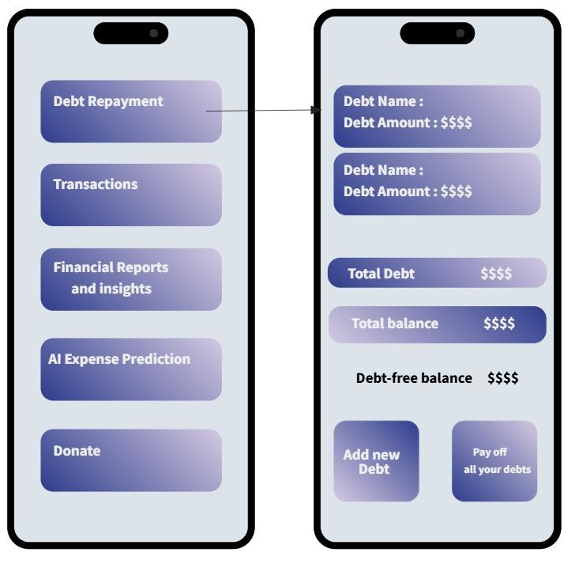

**Figure 8 – Debt Repayment Page**

• **Data Dictionary**

|  |  |  |
| --- | --- | --- |
|  |  |  |
| **Element Label** | **Type/Length** | **Data Validation / Business Rule** |
| Debt Name | String | - required.  -user defined name for the debt. |
| Total debt amount | Decimal | - Must be greater than zero. |
| Remaining balance | decimal | - Must be greater than zero. |

**_____________________________________________________________________________________**

#### • User Story #9

|  |  |
| --- | --- |
| **User Story ID** | **US #9** |
| **User Story Name** | Transactions |
| **Actors** | User |
| **Description** | **As a** user  **I want to** set up recurring income and expense transactions so that I don’t have to enter them manually |
| **Pre-conditions** | * **The user is logged in.** * **The user must have** at least one income or expense category already set up. |
| **Post-conditions** | **- The system successfully** schedules the recurring transaction. **-the Transaction is automatically** recorded on the due data **.** |

**Given** I’m a logged-in user and I’m on the debt repayment page**,**

**When** I set up a recurring transaction with valid details**,**

**Acceptance Criteria**

**Then** the system should schedule the transaction and execute it automatically on the specified dates **.**

• **scenarios**

##### Normal Scenario

|  |  |
| --- | --- |
| **Actor Action** | **System Response** |
| 1- User enters the “ Transactions” section. 2- User adds transaction details then confirms and saves. |  |
|  | 1. System saves the transaction. 2. System schedule the transaction and add it to the budget plan . 3. on the due date the system informs the user with a notification that the transaction has been recorded. |

##### Exceptional Scenario

|  |  |
| --- | --- |
| **Actor Action** | **System Response** |
| 1. User enters Transactions system . 2. user tries to cancel recurring transaction |  |
|  | 3 – system allows cancellation but asks for confirmation and entering the password. |

##### Screen Design

**Figure 9– Transactions Page**

• **Data Dictionary**

|  |  |  |
| --- | --- | --- |
|  |  |  |
| **Element Label** | **Type/Length** | **Data Validation / Business Rule** |
| Transaction ID | Integer | - unique identifier for each recurring transaction . |
| Category | String(3-50 characters) | - Must be predefined or user-created |

|  |  |  |
| --- | --- | --- |
|  |  |  |
| **Element Label** | **Type/Length** | **Data Validation / Business Rule** |
|  |  | category. |
| Date Range | Date | - Must be in YYYY/MM/DD format.  Cannot be in the future  -starts with todays date or any future date ( not necessarily to add end date). |
| Transaction Type | Enum | - Must be (income- Expense) |
| amount | Decimal | - Must be greater then zero. |

**_____________________________________________________________________________________**

#### • User Story #10

|  |  |
| --- | --- |
| **User Story ID** | **US #10** |
| **User Story Name** | Financial Reports and insights. |
| **Actors** | User |
| **Description** | **As a** user  **I want** generated reports and insights so I can understand better my financial situation. |
| **Pre-conditions** | * **The user is logged in.** * **The user must have** financial data (income- expense-debt savings). |
| **Post-conditions** | **- The system** generate the financial report showing categorized spending ,income sources and debt status.  **-the system** provides insights and recommendations. |
| **Acceptance Criteria** | **Given** I’m a logged-in user **,**  **When** I request a financial report**,**  **Then** the system should display the reports and the insights**.** |
|  |  |

• **scenarios**

##### Normal Scenario

|  |  |
| --- | --- |
| **Actor Action** | **System Response** |
| 1- User enters the “Financial Reports and Insights ” section.  2-user request for report and insights. |  |
| 4-user asks for financial recommendation | 3- System displays the reports and the insights .      5- the user gets AI recommendations. |

**Exceptional Scenario**

|  |  |
| --- | --- |
| **Actor Action** | **System Response** |
| 1- User asks for financial report with no recorded transactions |  |
|  | 2 – system informs the user that they must have recorded transactions. |

##### Screen Design

**Figure 10 – Financial Reports and Insights**

* **Data Dictionary**

|  |  |  |
| --- | --- | --- |
|  |  |  |
| **Element Label** | **Type/Length** | **Data Validation / Business Rule** |
| Total income | Decimal | - sum of income transactions |
| Total expense | Decimal | - sum of expense transactions |
| Spending categories |  | -Spending categories in percentage |

**_____________________________________________________________________________________** • **User Story #11**

|  |  |
| --- | --- |
| **User Story ID** | **US #11** |
| **User Story Name** | AI-Powered Expense Prediction |
| **Actors** | User |
| **Description** | **As a** user |
|  |  |

|  |  |
| --- | --- |
|  | **I want the system** to analyze my spending patterns and predict upcoming expenses. |
| **Pre-conditions** | * **The user is logged in.** * **The user recorded** at least 3 months of financial transactions.   **-AI Prediction**  is enabled for the user. |
| **Post-conditions** | **- The system successfully** schedules the recurring transaction. **-the Transaction is automatically** recorded on the due data **.** |
| **Acceptance Criteria** | **Given** the user ( I ) has previous recorded financial data**,**  **When** I request an expense prediction**,**  **Then** the system provides estimated expenses for the next month**.** |

* **scenarios**

###### Normal Scenario

|  |  |
| --- | --- |
| **Actor Action** | **System Response** |
| 1- User requests expense prediction |  |
|  | 2-system analyzes past spending trends .    3- The system displays estimated expenses per category.  4-system alerts the user if the expenses exceed the budget. |

**Exceptional Scenario**

|  |  |
| --- | --- |
| **Actor Action** | **System Response** |
| 1- User requests prediction with no previous data recorded. |  |

2

-

system n

otify the user that there has to

be at least 3 months of data recorded.

##### Screen Design

**Figure 11 – AI Expense Prediction page**

* **Data Dictionary**

|  |  |  |
| --- | --- | --- |
|  |  |  |
| **Element Label** | **Type/Length** | **Data Validation / Business Rule** |
| Prediction date | Date | - the generated prediction date |
| Predicted expenses |  | - store the predicted expenses in different categories |
| Confidence level | Decimal(0 ,1) | -percentage score for accuracy |

**____________________________________________________________________________________**• **User Story #12**

|  |  |
| --- | --- |
| **User Story ID** | **US #12** |
| **User Story Name** | Donate |
| **Actors** | User |
| **Description** | **As a** user  **I want to be able to donate to charities and get monthly reminders for it.** |
| **Pre-conditions** | * **The user is logged in.** * **The user has linked payment method** for donation tracking **.** |
| **Post-conditions** | **- The system successfully** logs all donation transactions. **- the user can view donation history.** |
| **Acceptance Criteria** | **Given** I want to donate**,**  **When** I enter donation transaction**,**  **Then** the system records it in the donation page**.** |
|  |  |

* **scenarios**

###### Normal Scenario

|  |  |
| --- | --- |
| **Actor Action** | **System Response** |
| 1- User clicks at donation section  2-users enters a new donation |  |
|  | 3- System records donation and update the balance |

**Exceptional Scenario**

|  |  |
| --- | --- |
| **Actor Action** | **System Response** |
| 1- User tries to donate an amount that exceeds their available budget |  |
|  | 2- system warn the user and suggest adjusting the donation number. |

##### Screen Design

**Figure 12 – Donation page**

• **Data Dictionary**

|  |  |  |
| --- | --- | --- |
|  |  |  |
| **Element Label** | **Type/Length** | **Data Validation / Business Rule** |
| System alert | boolean | - if the input number exceeds the budget return false |
| Recipient name | string | - required , the user must enter the organization they want to donate to. |
| Donation amount | Decimal | -greater than zero |
|  |  |  |

## 

**User Story #13**

|  |  |
| --- | --- |
| **User Story ID** | **US #13** |
| **User Story Name** | Q&A and tutorial |
| **Actors** | User |
| **Description** | **As a** user  **I like to be able** to ask question or , learn more about finance or do some educational activity. |
|  |  |

|  |  |
| --- | --- |
|  | **So that** I can achieve the financial education target. |
| **Per condition** | * The user is logged in. * The user is on the “Q&A and tutorial” page. |
| **Post condition** | - The educational goal is achieved and reached to the information that he needed. |
| **Acceptance Criteria** | **Given** I’m a logged-in user and I’m on the Q&A and tutorial page,  **When** I ask the question and click submit ,  **Then** the system should answer to my question.  **When** I search for certain article,  **Then** the system should opens for me the article that related to my purpose.  **When** I click to start certain educational activity to make it,  **Then** the system should opens for me the page that includes that activity. |
|  |  |

* **Scenarios**

**Normal Scenario**

|  |  |
| --- | --- |
| **Actor Action** | **System Response** |
| 1. User sets a savings goal (e.g., save $1000 for a vacation). 2. User clicks Save. |  |
|  | 1. System validates the savings goal. 2. System saves the savings goal. 5- System displays the progress in the user’s dashboard. |

**Exceptional Scenario**

No exceptional scenario for this user story.

* **Screen Design**

**Figure 6 – Saving & Goals Page**

* **Data Dictionary:**

|  |  |  |
| --- | --- | --- |
|  |  |  |
| **Element Label** | **Type/Length** | **Data Validation / Business Rule** |
| Goal Name | String(3-50 characters) | * Must be between 3 and 50 characters. * Can contain letters, numbers, and spaces. |
| Target Amount | Decimal | - Must be a positive number. - Must be in a valid currency format (e.g., 1000.00). |
| Current Savings | Decimal | - Must be a positive number. - Must be in a valid currency format (e.g., 500.00). |

## ____ System Navigation Map

You can zoom for more details:

<https://drive.google.com/file/d/1yZFcYush3yEnM4HeuVmWHrK6JD8x_XLn/view?usp=drive_link>