**Mohamed Essam Said | 20190462**

**Fatema Hesham | 20190373**

**PCA**

**Pair 1: (0, 1)**

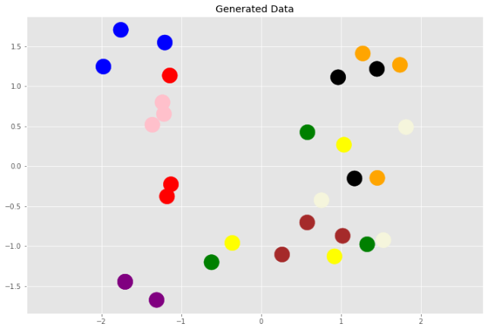

* **Variance:**

The best Variance (highest Eigen values), with very high variance

* **Overlapping:**

No overlapping

* **Clustering:**

This Pair of vectors can’t group each class to gather, but this pair is the best in clustering,

And this pair can group numbers (4) {Pink}, numbers (1) {Blue}

**Pair 2: (2, 3)**

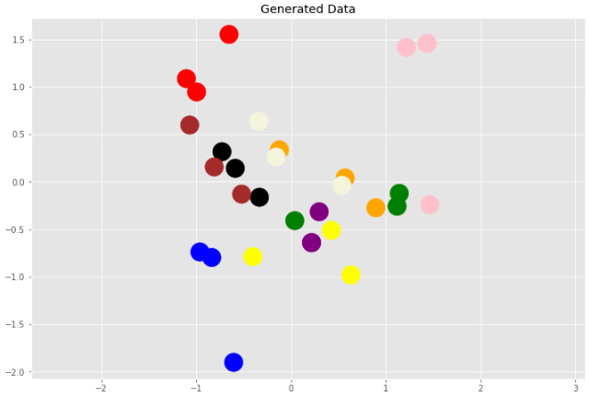

* **Variance:**

Rank 2 in Eigen vectors, but the variance between the points is small

* **Overlapping:**

No overlapping, but too close

* **Clustering:**

This Pair of vectors can’t group each class to gather, but this pair is good in clustering,

And this pair can group numbers (0) {Red}

**Pair 3: (4, 5)**

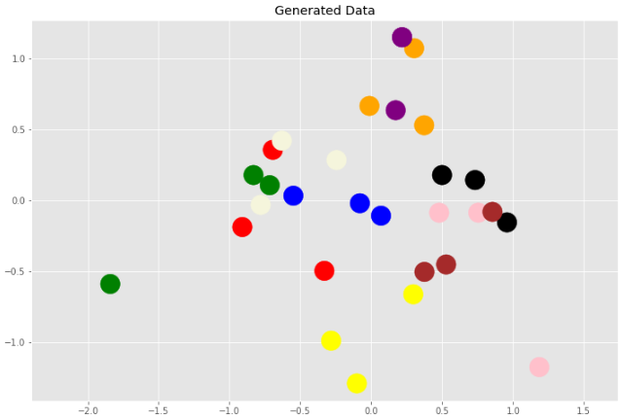

* **Variance:**

Rank 3 in Eigen vectors, with high variance

* **Overlapping:**

No overlapping, but some points are too close

* **Clustering:**

This Pair of vectors can’t group each class to gather, but this pair is good in clustering.

**Pair 4: (6, 7)**

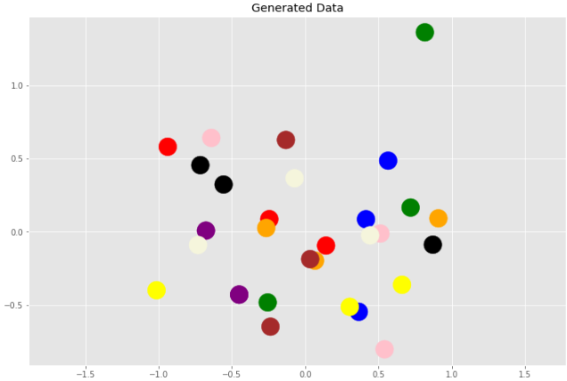

* **Variance:**

Rank 4 in Eigen vectors, with almost high variance

* **Overlapping:**

No overlapping, but many points are too close

* **Clustering:**

This Pair of vectors can’t group each class to gather

**Pair 5: (8, 9)**

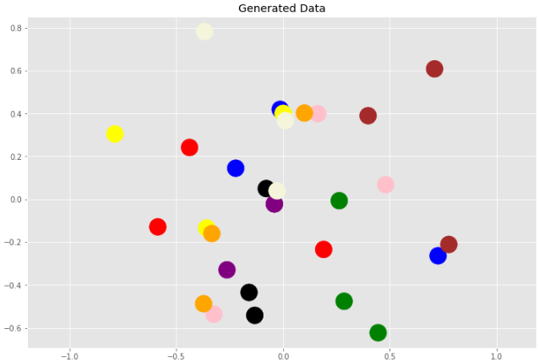

* **Variance:**

Rank 5 in Eigen vectors, with high variance

* **Overlapping:**

No overlapping, but some points are too close

* **Clustering:**

This Pair of vectors can’t group each class to gather

**Pair 6: (26, 27)**

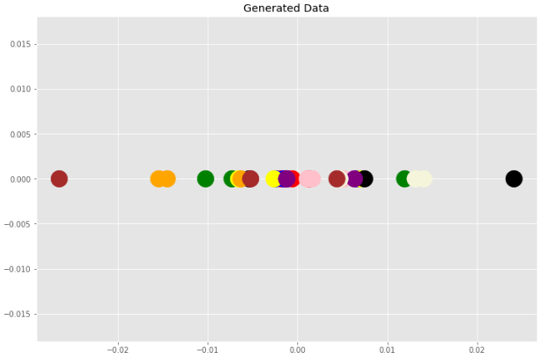

* **Variance:**

Last Rank in Eigen vectors, with very low variance

* **Overlapping:**

Overlapping is exist

* **Clustering:**

This Pair of vectors can’t group each class to gather

**Pair 7: (24, 25)**

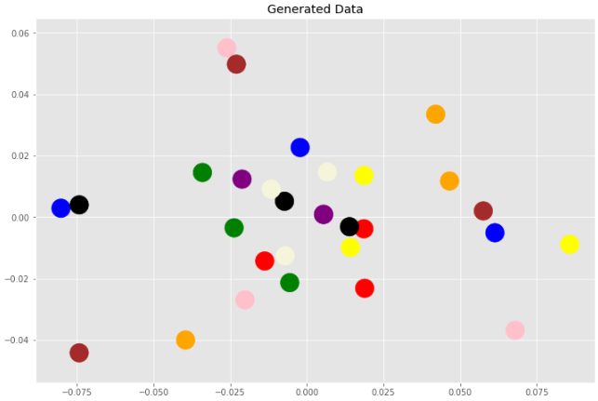

* **Variance:**

Rank 13 in Eigen vectors, but with high variance

* **Overlapping:**

No overlapping

* **Clustering:**

This Pair of vectors can’t group each class to gather

**Pair 8: (22, 23)**

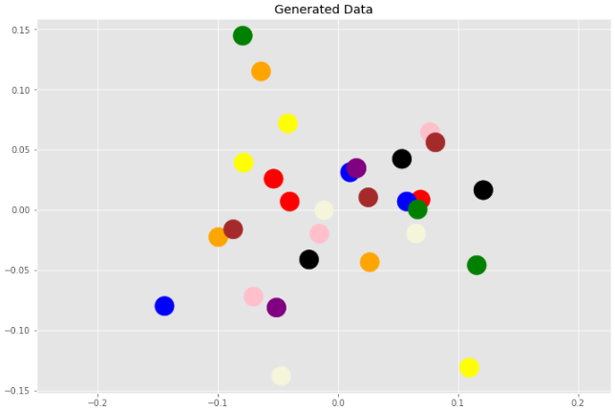

* **Variance:**

Rank 12 in Eigen vectors, with low variance

* **Overlapping:**

No overlapping, but many points are too close

* **Clustering:**

This Pair of vectors can’t group each class to gather

**Pair 9: (20, 21)**

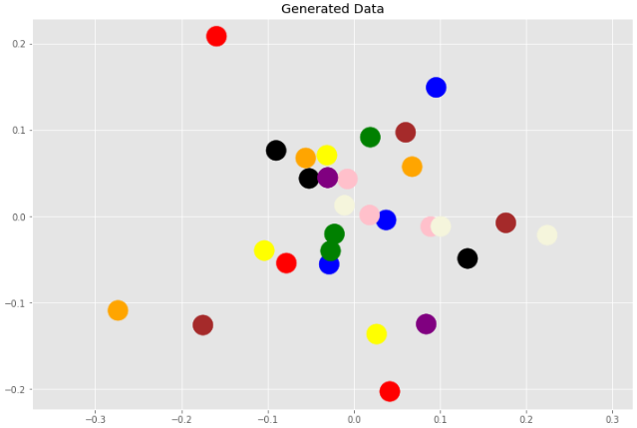

* **Variance:**

Rank 11 in Eigen vectors, with low variance

* **Overlapping:**

No overlapping, but many points are too close

* **Clustering:**

This Pair of vectors can’t group each class to gather

**Pair 10: (18, 19)**

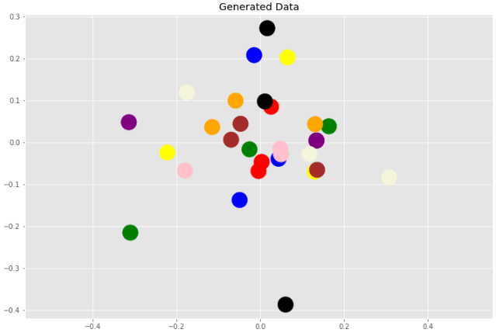

* **Variance:**

Rank 10 in Eigen vectors, with low variance

* **Overlapping:**

No overlapping, but some points are too close

* **Clustering:**

This Pair of vectors can’t group each class to gather