Student Performance Report (SGPA Analysis)
Generated: 16 Aug 2026, 00:11
Total students analyzed: 2 | Total papers detected: 6

Detected Columns
Paper / subject columns: BNGA-CC5, BNGA-CC6, BNGA-CC7, BNGA-SEC-A2, JORG-GE3, BNGA-SEC-A
SGPA column used: SGPA
Overall result column used: Remarks

Summary of Results
- Students with all papers cleared: 1 students (50.0%)
- Students with at least one fail: 1 students (50.0%)
- Students scoring SGPA < 5: 0 students (0.0%)
- Students scoring SGPA 5.1 to 7: 1 students (50.0%)
- Students scoring SGPA > 7.1: 0 students (0.0%)

Charts

Overall Performance Summary
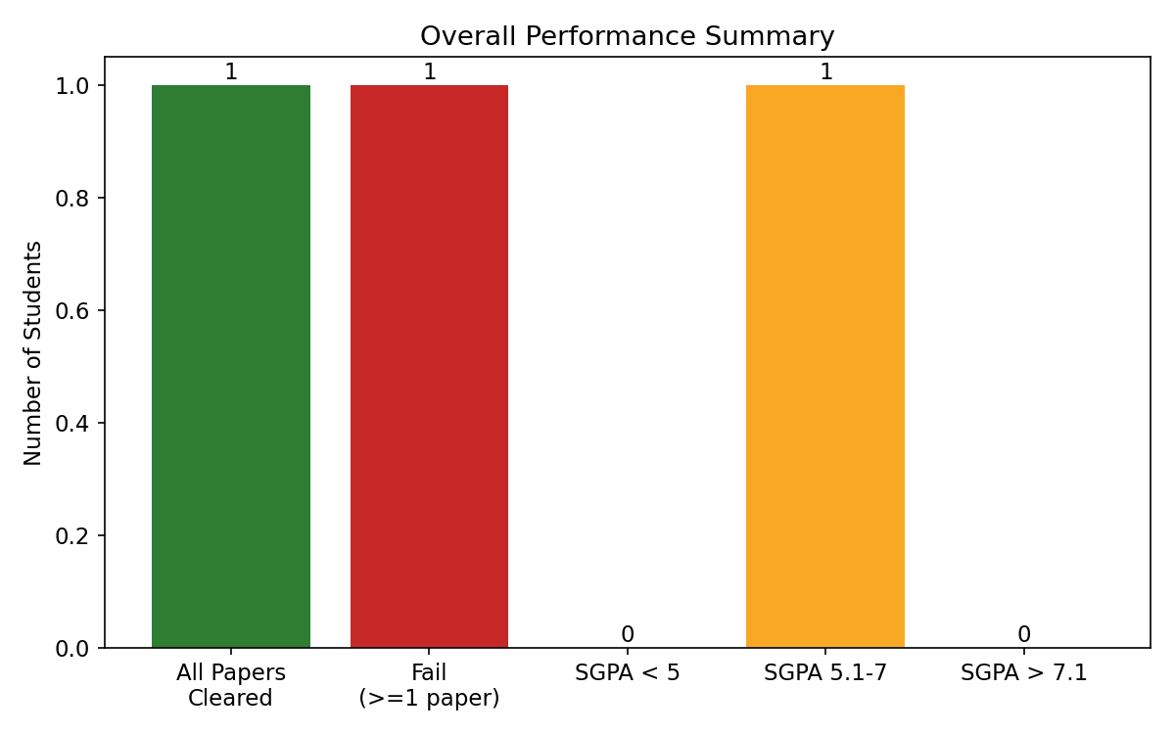
Overall Performance Summary

Pass vs Fail
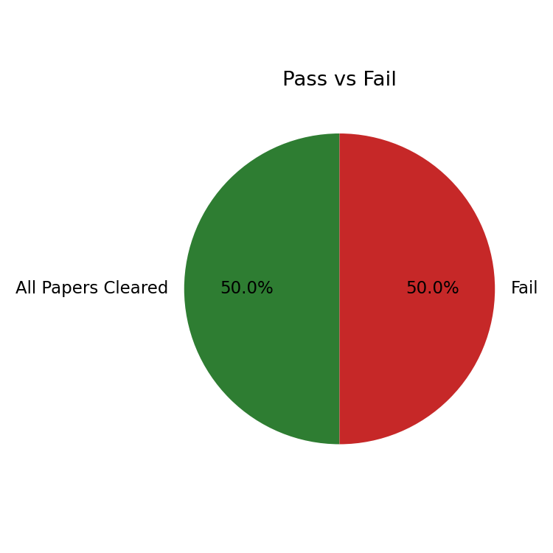
Pass vs Fail

SGPA Distribution
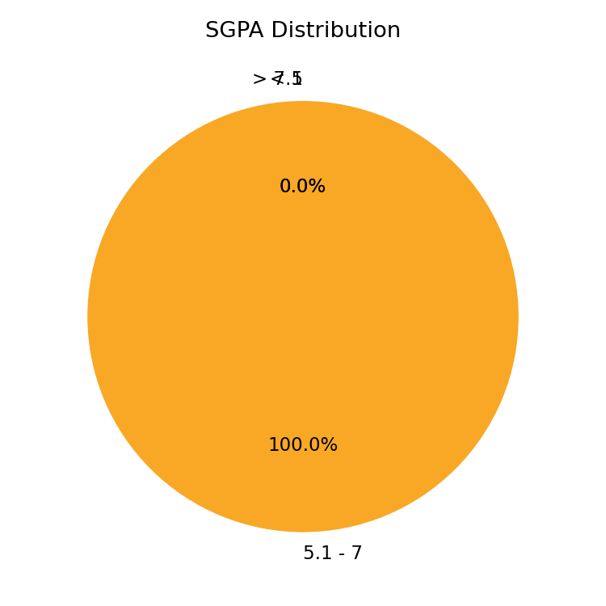
SGPA Distribution

