Department-wise Comparison Report — Sem VI
Generated: 01 Sep 2026, 14:20

Table 1: Aggregate and Subject-wise Result
Dept/Subject | Students Appeared | Cleared | Not Cleared | Cleared % | Not Cleared %
Philosophy | 77 | 12 | 65 | 15.58 | 84.42
Mzoo | 38 | 10 | 28 | 26.32 | 73.68
Mphc | 39 | 13 | 26 | 33.33 | 66.67
AGGREGATE | 154 | 35 | 119 | 22.73 | 77.27

Table 2: Subject-wise Students' Performance
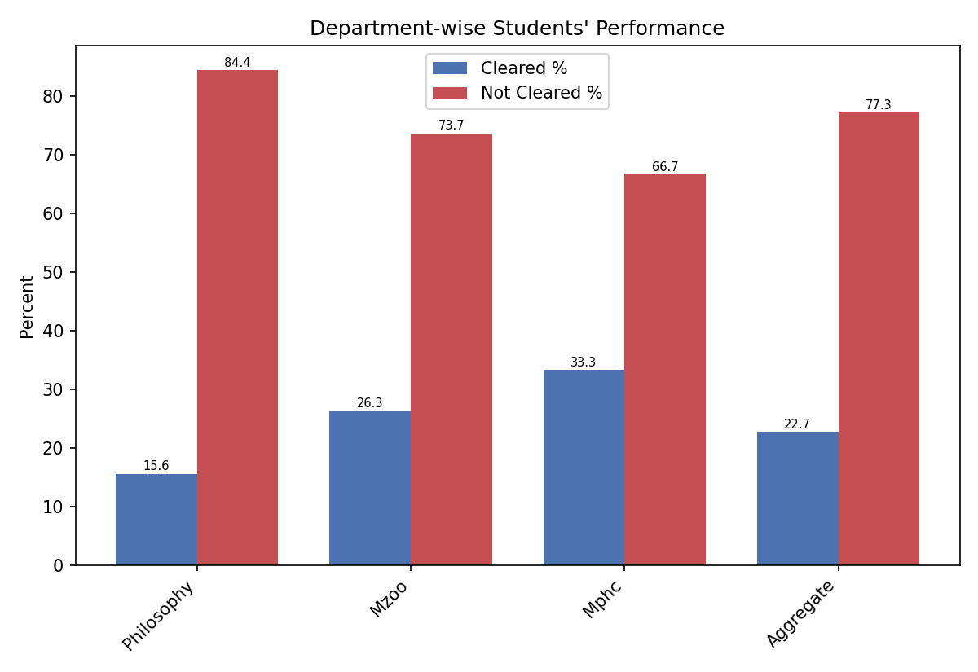

Top 3 Departments (by % cleared)
- Mphc — 13 out of 39 students @ 33.33%
- Mzoo — 10 out of 38 students @ 26.32%
- Philosophy — 12 out of 77 students @ 15.58%

Table 3: Students' Performance in terms of SGPA
Dept/Subject | Total Appeared | SGPA<5 No. | SGPA<5 % | SGPA 5-7.5 No. | SGPA 5-7.5 % | SGPA>7.5 No. | SGPA>7.5 %
Philosophy | 77 | 0 | 0.00 | 12 | 15.58 | 0 | 0.00
Mzoo | 38 | 2 | 5.26 | 12 | 31.58 | 0 | 0.00
Mphc | 39 | 1 | 2.56 | 12 | 30.77 | 0 | 0.00
AGGREGATE | 154 | 3 | 1.95 | 36 | 23.38 | 0 | 0.00

SGPA-wise Department Performance
