Project name: WaveShelf – Book Tracker
Schema:
- User
- Books (Title, Author, Genre, mood when starting it, start date, if possible cover image )
- If possible quotes ( quote , mood , feeling note , page num)
The project idea:
It's a book tracker website, that can see the book you currently reading, and everyone can see the book, I want the user to be able to add a book to the book reading list, the book contains details. It can be accessed by other users but only the owner can edit it and delete it.
Extra content:
- quotes can be added in the book page, the users can add a quote they liked in the book itself, you can write a quote even if you aren't the owner of the book.
- The progress update, the percentage or ( 200page of 500 pages) bar

ERD:
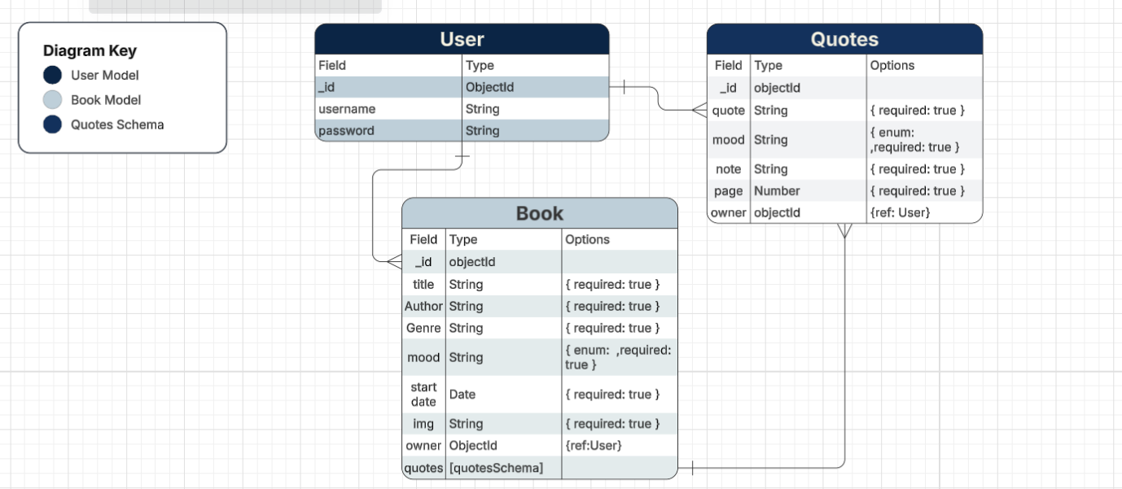

Mockup:
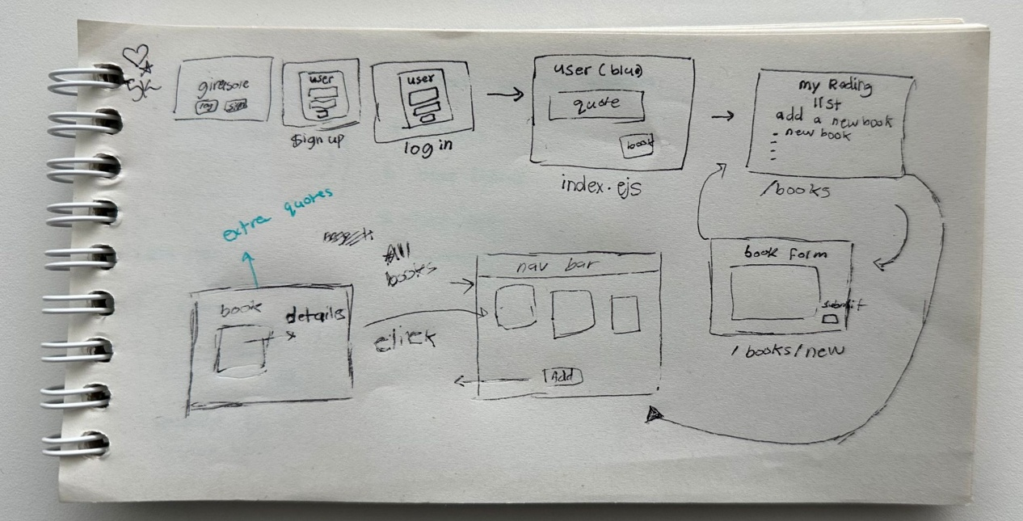

Color palette:
