Cell Mitosis Detection

Project Report

Fatema Quaid

Muzammil Abbasi

**Introduction:**

Mitosis detection is of immense importance in the field of pathology. It is an integrated part of the Bloom and Richardson system for grading of invasive breast cancer which is the second most frequent cancer. Pathologists routinely examine histology slides on standard light microscope which is a cumbersome process and opens scope for inter and intra-observer variability which is undesirable in serious medical cases such as that of breast cancer. Automated mitosis cell detection not only frees pathologists from this tedious task but also gives accurate results which is an important aspect of digital image processing. This project is based on the techniques of digital image processing and machine learning to classify an image and define its properties and also to refine its system by learning from its outcomes.

**Theory and Discussion:**

In this project we developed a program which automatically detects mitotic cells in a micrograph using image processing techniques. The details and procedure adopted for mitosis detection follow:

**Training Data:**

We started off with a set of images – the **training set for classifier** whichcontained pairs of images, each having an original cell image and the same image but with yellow marks displaying the mitotic regions in the image as shown below:

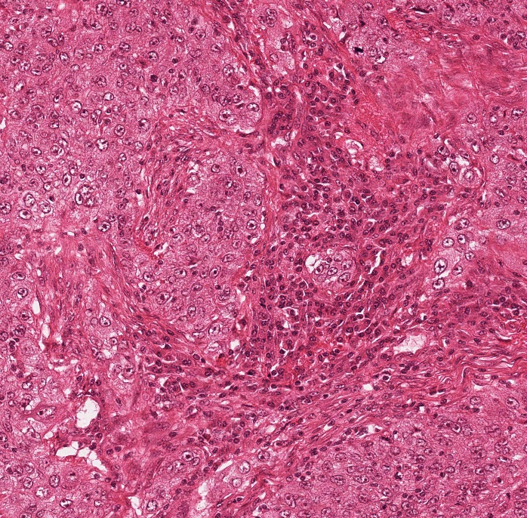 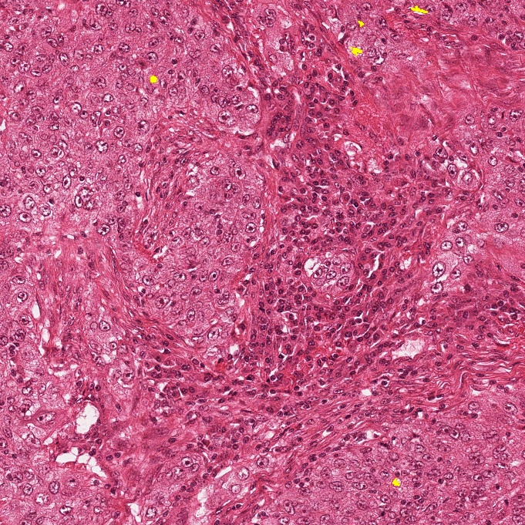

Original Image Image with yellow marks on mitotic regions

**Test/evaluation Data:**

The evaluation data also contains cell images with both mitotic and non-mitotic regions, similar to the one above. The task of the classifier after being trained is to classify and detect mitotic cells in these images.

The following steps were performed throughout the project:

1. **Region Extraction**:

Mitotic regions from the training data were first extracted from the entire image in order to limit execution time while extracting features. We used the image segmentation approach, namely Otsu thresholding to extract the mitotic(yellow) regions from the RGB image as shown:



Segmented mitotic cell

Each training image was then divided into 50x50 sub-images containing mitotic cells using the segmented binary image as mask.

It has been observed that mitosis occurred in the dark areas of image only hence in order to extract the non-mitotic cells, we were only required to extract the dark regions from the image in which mitosis was not taking place. The remaining areas were automatically filtered out. We obtained these dark regions by Otsu thresholding as well.

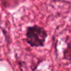

50x50 sub-image of extracted mitotic cell and its surrounding.

1. **Training:**

We used two types of filters as descriptors in this project namely, Harelick filter and Gabor filter.

Harelick filter is a set of 14 different textural features a few being variance, average, entropy etc.

Gabor filter, named after [Dennis Gabor](https://en.wikipedia.org/wiki/Dennis_Gabor), is a [linear filter](https://en.wikipedia.org/wiki/Linear_filter) used for [texture](https://en.wikipedia.org/wiki/Texture_mapping) analysis, which means that it basically analyses whether there are any specific frequency content in the image in specific directions in a localized region around the point or region of analysis.  In the spatial domain, a 2D Gabor filter is a [Gaussian](https://en.wikipedia.org/wiki/Gaussian) [kernel function](https://en.wikipedia.org/wiki/Kernel_function) modulated by a [sinusoidal](https://en.wikipedia.org/wiki/Sinusoidal) [plane wave](https://en.wikipedia.org/wiki/Plane_wave).

In this project we used matlab functions for Harelick and Gabor filters.

Prototype vectors consisting of Harelick and Gabor textural features were formed for every sub-image extracted out of the training set. These column vectors were concatenated to form a matrix for each of the two classes- mitotic and non-mitotic cells.

1. **Classification:**

Pattern vectors similar to the training set were formed for all the dark regions in the test images after thresholding and segmenting these regions. Only dark regions were used here because mitosis was observed to happen only in dark areas(cells) in the image.

We used minimum distance classifier for classification in which the pattern vector of each of the objects in the test image is subtracted from prototype vector of each class and its distance from each class is calculated using ‘abs’ function in Matlab, which is basically the vector norm.

In minimum distance classifier, we decide **x** to be from class wi if there is a prototype vector **m** assigned to class wi such that no other prototype vector is as near to **x** as **m**. For this project we created a vector say **z** which holds 1 if ||x-mi || is minimum for w1 - the mitotic cells class and vice versa. We then assigned x to w1 if sum(1) /sum(2) > 0.502 and to class w2- the non-mitotic cells class otherwise.

**Result and Analysis:**

We displayed the results of this classification using 3 colors:

* Blue for correct detection of mitotic cells
* white for incorrect detection of non-mitotic cells as mitotic.
* Red for cells which were not classified as mitotic but were mitotic.

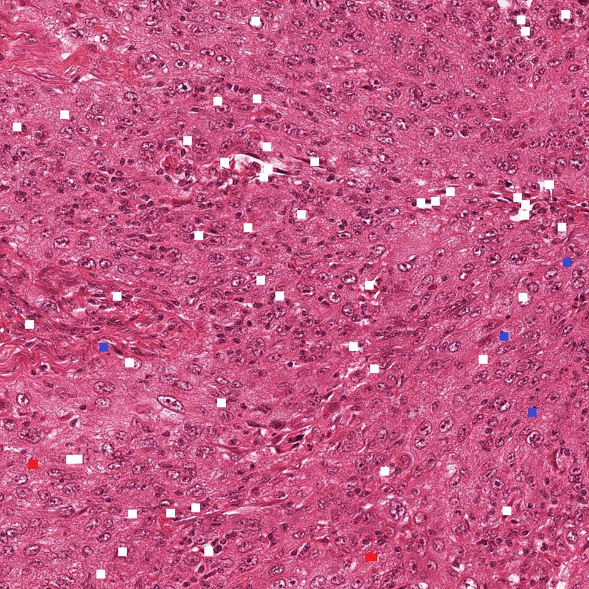

Final result of classification.

We observed that by altering the threshold from 0.502, the classification was greatly influenced. If we increase this threshold, we get more white regions that is more and more non-mitotic cells are misclassified but lesser red regions. Similarly, by decreasing the ratio, we get less white regions but more red ones.

As shown, the results of mitosis classification in this project are far from accurate. We can obtain much better results by:

* Including more feature vectors in the training hence more accuracy.
* Using a better and efficient classifier. Distance classifier did not turn out be a reasonable choice for this task.
* Instead of analyzing mitotic cell and its surrounding region together, we can separately deal with cell and the surrounding region and then combine the results.
* By adjusting the threshold such that the error is reduced significantly.

**References:**

1. M. Veta, P. J. van Diest, J. P. W. Pluim, "Detecting mitotic figures in breast cancer histopathology images", Proc. SPIE 8676, Medical Imaging 2013: Digital Pathology, 867607 (29 March 2013); doi: 10.1117/12.2006626; <http://dx.doi.org/10.1117/12.2006626>
2. <https://en.wikipedia.org/wiki/Gabor_filter>