Soundscape Reflection

This is soundscape project was my first ever experience with the recording and layering of sounds. This project has exposed me to the endless possibilities of creating and amending sounds.

In the beginning, I was a little confused as to what topic to choose. I was unsure what sounds I can possibly record in the amount of time given. It was a challenge for me to decide between the two ideas I had in mind one being a mid ocean scape and the other one being a haunted house scape. I selected the latter one because it gave me more freedom in terms of recording and manipulating sounds. The best part about this theme was that I could record all the sounds at home. Even if something goes wrong with my recorded sounds, I can go ahead and record it again!

I was having some difficulty making the assets list. I knew what sounds I wanted, but was having a hard time referencing those sounds. I mainly used fressounds.com to get sounds from the internet but a few sounds like the sound of starting a car or the car GPS voice were difficult to find on the internet. I either had to use the closest sound available online or record it myself.

The audacity software has been the biggest problem for me. Even though it offers great tools to alter and create sound effects, I had the worst of my nightmares when audacity crashed and I lost a valuable portion of my project. I was almost done and was about to save it but it suddenly crashed and its autosave feature did not work either. The only takeaway from this incident is to keep saving the project every time a new change has been made.

As far as the baseline criteria is concerned, I believe I have met all of them. In my project, not only have I recorded sounds my self but have used external sounds from the internet as well and have credited them appropriately. I have more than 3 layers of sound overlapping at different points in my soundscape as shown in the screenshot below:

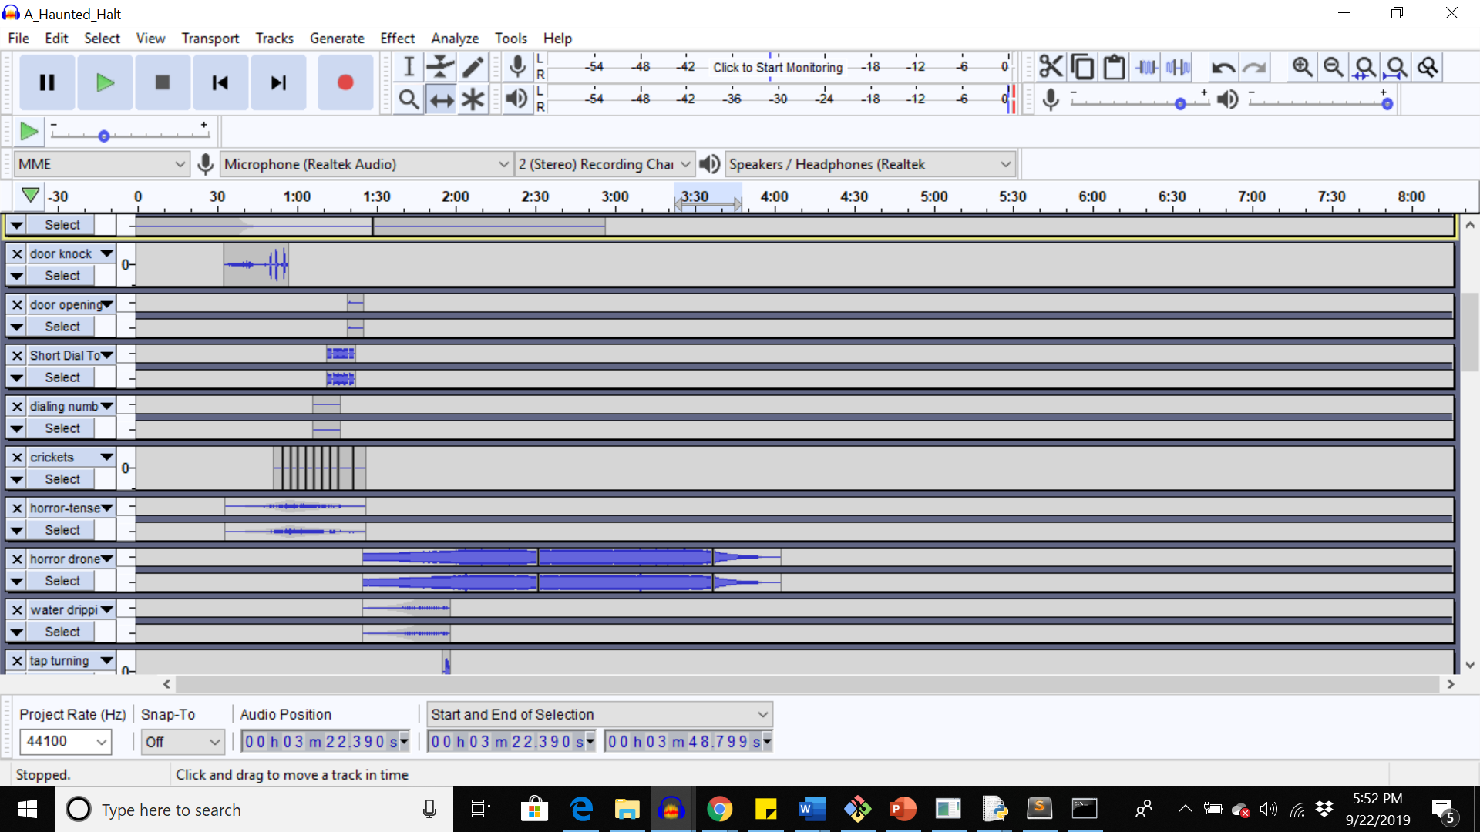

The total duration of my soundscape is around 4 minutes and something definitely changes from the beginning to the end of the soundscape.

As per the aspirational inspirations, I have included a .mp3 version of my project. I have also used special effects and tools in audacity which are new to me. When I started working on this project, I did not know much about these tools. I still need to understand and experience a lot of effects and tools but there are a couple I would like to mention here. Firstly, the envelope tool was a big help. I did not know how to use it so I looked up online and got to know that it is used to adjust the amplitude at different positions in the waveform. I used it quite for sounds in which I wanted the intensity to vary. For example, in the horror intense music as shown below:

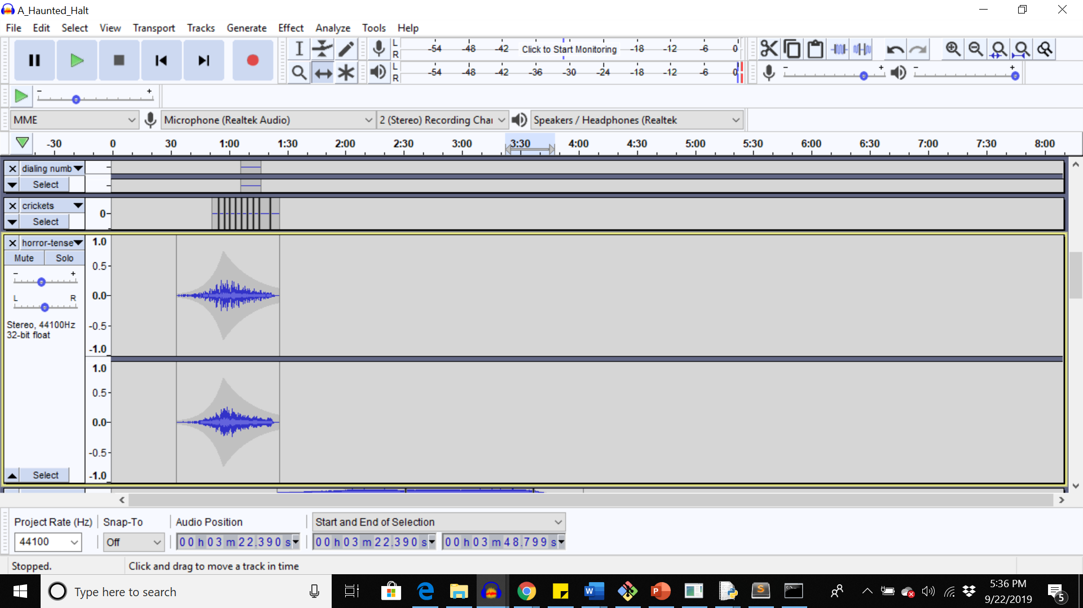

I used the envelope tool here to increase the amplitude hence its volume from very low to high in the middle and decreased it again at the end. This was a very helpful tool as at certain points I wanted the volume to be high and wanted it to change smoothly over time.

Working on a transcript was something new as well but the example shared by the instructor was quite helpful in understanding what to include in a transcript. I have included a transcript with my project. It can be found under ‘Transcript.txt’ in my repository. My story is based on a character and a plot where a girl faces an unexpected halt and ends up in a haunted house where she goes through a series of terrifying experiences. The background music, sudden sound effects, and the dialogue convey a change of emotion at various points in the plot. As can be noticed, the tone of the girl’s voice changes from calm to frustrated to terrified. The background music plays an important part in conveying the overall emotion of the soundscape.

As per the aspiration criteria, I have also included the mystery sound in my project and have pushed consequent versions of my project on GitHub. I had never forked a repository before on GitHub, so this is something I did in this project.

Corey mentioned in his feedback that at first it is hard to tell what is happening so he suggested me to add the sound of trying to start the car but failing.

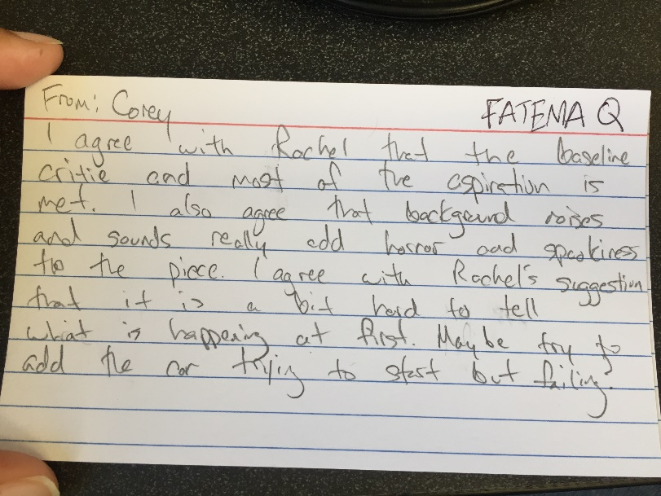

I had initially put the sound of car keys turning to give an impression of starting the car but I guess it did not work well:

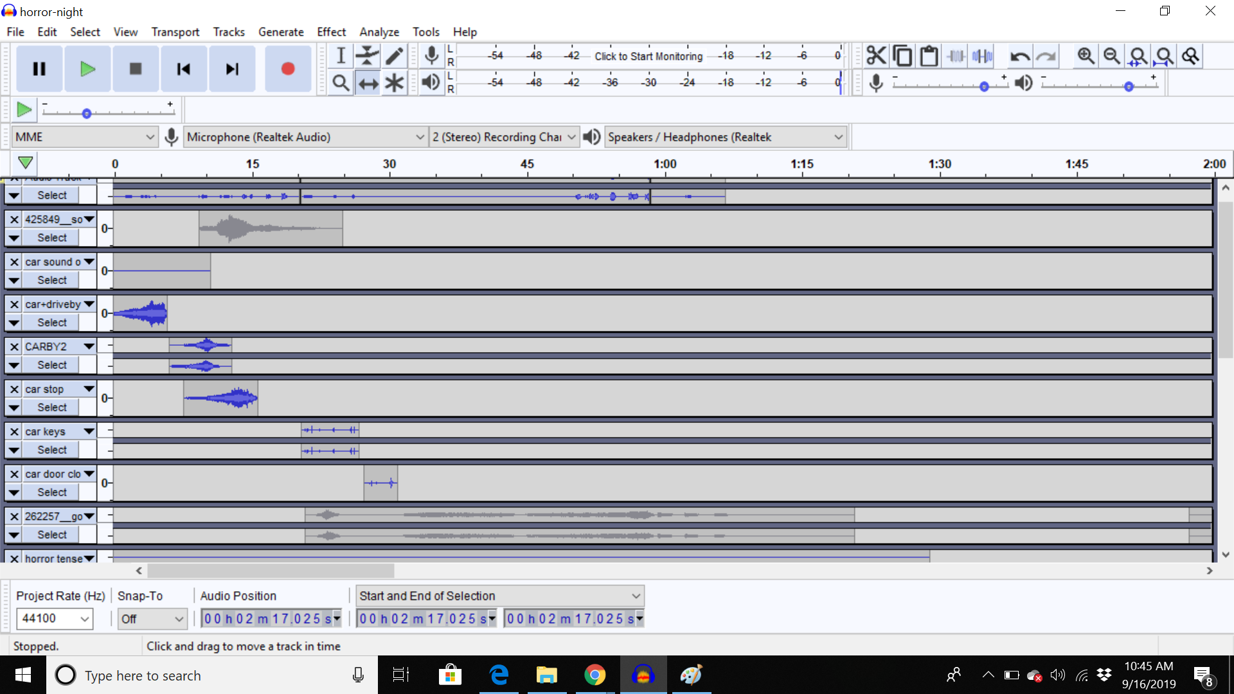

I replaced that with the sound of failed attempt at starting the car as shown in the image below:

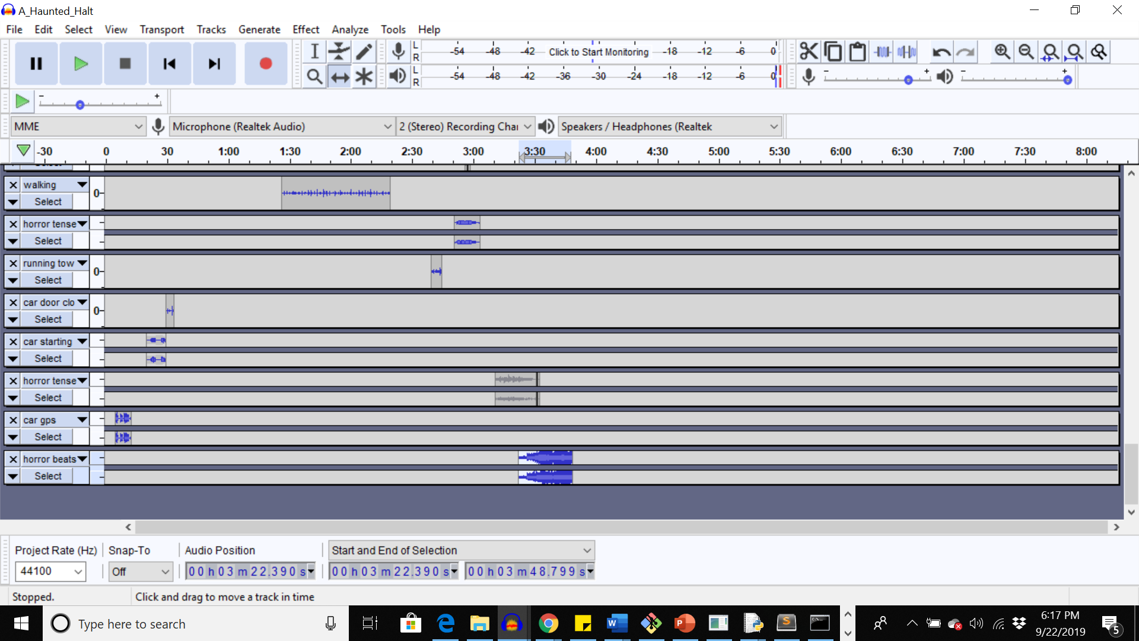

I don’t know how successful I am in giving that impression because as mentioned in the beginning, the sound I found online did not appeal me much.

Overall, I believe I have satisfied all the baseline criteria and most if not all of the aspirational aspirations and I am very happy with the work I have done.