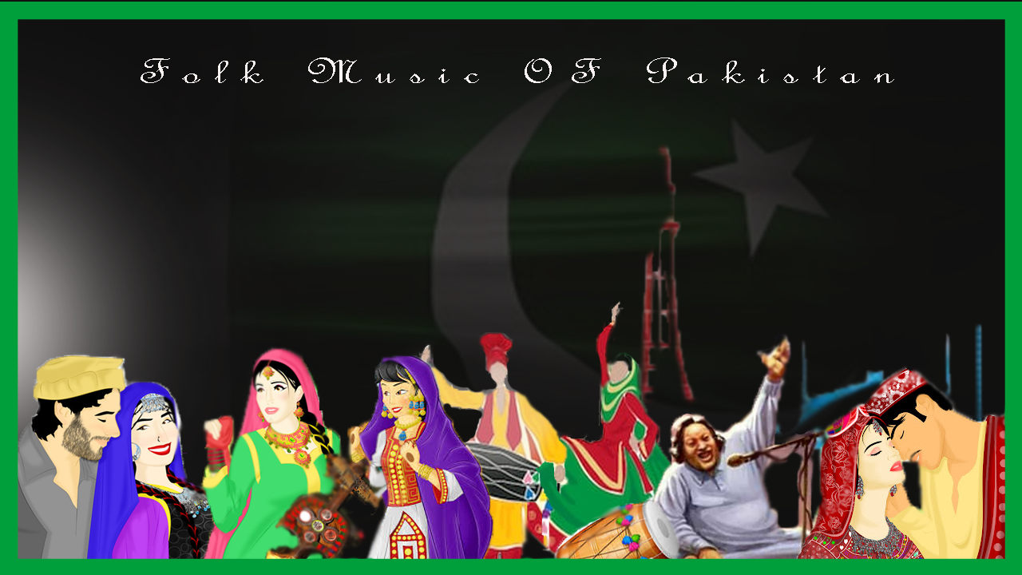

MIXTAPE PROJECT

By: Fatema Quaid

Liner Notes

Pakistan, a land which was once a part of the Indian subcontinent is where one of the world’s earliest civilizations rich in music and dance, ‘The Indus valley civilization’ flourished. Pakistani music dates back to 5000 years. It evolved throughout the history. Invaders from different parts of the world brought their own bits and pieces and amalgamated into the diverse Pakistani music we know today. The music of neighboring countries like India, Iran, Afghanistan has also shaped Pakistani music by and large.

The essence of Pakistani culture, lies in its diversity. Home to more than 70 languages, Pakistan is a hub of multilingual, multicultural and multiethnic groups. Each of the 4 provinces of Pakistan exhibits its own culture in the form of its language, traditional clothes, food and music. From the mountains of Balochistan to the hill-stations of Khyber Pakhtunkhwa – from the deep midlands of Sindh to the waters of Punjab – Pakistan’s cultural music is a blend of legendary singers and beautiful lyrics that has been cherished by the locals in the past to date.This mixtape highlights the different cultures constituting the country of Pakistan, their history, traditions, epics and styles by compiling some of the most famous, traditional folk songs sung and composed by iconic figures in the Pakistani history.

One of the most famous genres of Pakistani folk music is **Qawwali**. Linked closely to Sufiism in Islam, this style of music symbolizes the contact between the divine and human. In Sufi culture, Qawwali is considered to be a mode, a channel by which the devotee celebrates his love with the God (*Allah*). “Regular attendees of qawwali sessions often use the concept of travel when they speak of their experience during a qawwali. They feel as if they are travelling to another domain or plane, called hal literally ‘state of mind’, and is often used to denote musically induced ecstasy.” (Anuradha Bhattacharjee, 2012) Usually sung in chorus, in qawwali, a lead vocalist starts of a phrase and then is followed by the rest. The major instruments include Tabla, hand duff and clapping. It is sung in a strong gesture with very high intensity in order to portray the intensity of love towards the divine. However, the subject of qawwali is not limited to the Almighty. Many qawwalis address the Prophet Mohammed. This type of poetry subject is referred to as “naat”. The qawwali included in this mixtape is called “Tajdar-e-Haram”. Sung for the first time by the infamous ‘Sabri Brothers’, and written by Purnam Allahabadi­- a prolific Urdu poet, who moved to Pakistan from Allahabad, India after the 1947 partition.  This piece of qawwali is beautiful in every sense. Falling under the category of ‘naat’, this qawwali serves as a plea to Muhammad to bestow his mercy on the needy. While primarily in Urdu, this complex piece incorporates excerpts from other poetries written in different languages such as Arabic and Persian as well as Braj Bhasha (a Hindu dialect of Urdu). This signifies how Islamic culture itself is influenced by various languages and cultures from different parts of the world which travelled and settled in the land of Pakistan.

While Qawwali is used by and large to express one’s love for the Divine or its Prophet, there is another music genre in Pakistani folk, called **Ghazal**, used to express earthly love. Ghazal in Arabic means “talking to women”. This class of poetry involves love songs sung in Urdu and Persian. The subject of ghazal is ‘love’. Like Qawwali, ghazal can address the God as the lover (*Ishq-e-Haqiqi*) or a person *(Ishq-e-Mijazi*). This poetry is usually written in the form of couplets where the second line of every couplet rhymes with each other. The first couplet is called *Matla* and the last couplet in which the poet mentions his name is called *Maqta.* Unlike Qawwali,ghazal has a placid appeal to it. It is not loud or aggressive in expressing love but often expresses the feelings of loneliness, desire, sadness and ignorance (by the lover). Pakistani history has seen numerous poets who have written poetry in the form of ghazal often delivering ‘double meaning’ messages to people of the Indian subcontinent in order to invoke the spirit of independence from the British. The ghazal I have included in the mixtape has a double meaning context too. It is written by Faiz Ahmed (1911 - 1984) in Montgomery Jail on 29 Jan 1954. It is sung by Mehdi Hassan. This song expresses the poets desire to bring back glory in his country (Pakistan) which was under political turmoil at that time. This meaning is symbolic because literally, the poet is expressing his desire to meet his lover who has abandoned him for long, by recalling the physical beauty of the beloved and the glory it will bring if she comes back.

**Kafi** is an indigenous musical form of Sindh province of Pakistan. Kafi is an Arabic word which means “enough” or “final”. It is used in the context of “*Allah Kafi”* which means “God is enough or supreme”. It is a devotional form of music in close relation to qawwali. It is composed in a particular form derived from a mixture of classical, semi-classical, and light music forms. The *Sindhi kafi* is short, simple, and lucid in composition and tone. Shah Abdul Latif Bhitai, a renowned Sufi saint and mystic poet of Sindh (d. 1752), contributed considerably to the development of the*Sindhi kafi* (Travel andCulture Services) The kafi included in the mixtape is called “Main Naraye Mastana”, written by Wasif Ali Wasif and sung by the greatest female Kafi singer of Pakistan, Abida Parveen.

In addition to the above music forms, different regions of Pakistan have their own style of music mostly attributing to the folk tales and historical love epics of these regions.

These songs are predominantly strophic in pattern which is most suitable for simple lyrical pieces with a regular meter and uniform verses. The subject of love is very common in these folk musical cultures. Different regions of Pakistan have their own ways of celebrating love. One of such love songs is **Loba**, a popular and important form of Pushto folk music. Loba is usually sung by females. ***Loba*** means "a game." It’s a simple poetry with an enchanting composition. The poetry of the *loba*approachesfree verse. A complete *loba* ranges from three to six stanzas, eachconsisting of two verses or lines. Each stanza, and sometimes each line, has a different character and meter. The first two lines are called the *mukhra* or *soor*(face). These lay the foundation and are repeated as a refrain. It requires 2 or more persons who reply to each other in a poetic form. The two sides are usually the lover and the beloved (the man and woman). The pessimistic theme of the loba centers around the pangs of separation, the vicissitudes of traditional love, and the mishaps of human life. (Travel andCulture Services) The song included in the mixtape is called “Loba Me Da Khpal Zargi Na” and is sung by Gul Sanga. Another popular folk music, inculcating the spirit of love is **Mahiya**, a popular Punjabi Song. The content of the *mahiya* generally refers to the folk tale of Sohni and Mahiwal, two enormously celebrated lovers of Punjab. This song is also called *‘Latthe di chadar’* which means ‘a piece of woven cotton cloth’. It was sung by Surinder Kaur, a famous Punjabi singer who stayed in India after the 1947 partition. Although recorded in India after partition, this song depicts the Punjabi culture, which prevails throughout the Punjab regardless of the border separating the 2 states. Therefore, this song holds a great importance as it is a symbol of unity between the people of Punjab on either side. It is enjoyed equally on both the sides of the border as a token of celebration, love, peace and harmony.

**Tappa** is another very popular music in Khyber Pakhtunkhwa province of Pakistan. It is the oldest poetry genre in KPK which encapsulates the feelings and sentiments of people from different walks of life including peasants, laborers and women. This is the only song which is sung in the times of griefs as well as marriages. It is so common in the province of KPK that it is sung by the young and old, men and women alike. The structure of Tappa consists of a composition of two unequal meters where the first line is shorter than the succeeding one. Its music is played on Afghani instruments rubab and mangai. Sitar is also used when guests are invited for a feast in the Pashtun households. It has 16 different models of harmony and is sung with full orchestra. The Tappa included in the mixtape is sung by Gulzar Alam, a prominent Pushto singer. The track consists of the full orchestral instruments including rubab and mangai which can be heard. Drawing upon the love theme is a very popular Balochi song **Laila o Laila** which is also included in the mixtape. This song is sung by Naku Faiz Muhammed, a renown Balochi singer. The song has a music based on a fiddle like instrument and drums.

In addition to Laila o Laila, **Daanah pah Daanah** is also a very popular folk song from Balochistan. “It’s an anthem for some, a symbolic representation of culture for others and [an appealing melody](http://blogs.tribune.com.pk/story/6054/coke-studio-episode-1-less-hits-than-misses/) for many more.” (The Express Tribune). It is sung by “Akhtar chanal Zahri” in ‘Brahvi’ language, a language spoken by Brahvi people of Balochistan. “In “Daanah Pah Daanah” too, a shepherd introduces Balochistan to his sons and the sounds he makes while singing, are meant to create a visual of a flock of sheep that he is walking with” (The Express Tribune). This song is based on 6 beats which is different from many Punjabi and Balochi songs which are mostly based on 4 beats. This song released in 1990s talks about the province of Balochistan, it’s hills, rivers and mountains which existed in 17-1800s. This is a very celebrated song not only among Balochis but also among the people of Pakistan because as its writer says, “It is a message of peace and brotherhood” which is very important in todays world. As you may notice, the song has a constant tempo created by drums in the background.

# Songs List

1. [Qawwali- Tajdar-e-Haram](https://www.youtube.com/watch?v=eFMLmCs19Gk)
2. [Gazal- Gulon me rang bhare](https://www.youtube.com/watch?v=aKwCwDPlOy8)
3. [Kafi- Me naraye mastana](https://www.youtube.com/watch?v=hP52tw8OY-o)
4. [Loba- Loba Me Da Khpal Zargi Na](https://www.youtube.com/watch?v=k7xx6D6Hr5I)
5. [Tappa](https://www.youtube.com/watch?v=vblqPM1YhHk)
6. [Mahiya- Lathey di Chadar](https://www.youtube.com/watch?v=hvcGuIgiZfY)
7. [Laila o Laila](https://www.youtube.com/watch?time_continue=18&v=NK0HjeHUV9w)
8. [Daanah pah daana](1.%09https:/soundcloud.com/beard_boy/dane-pe-dana-original-by-akhtar%20chanal)h

Works cited

Bhattacharjee Anuradha, Shadab Alam. “The Origin And Journey Of Qawwali.” *Journal Of*

*Creative Communications*, vol. 7, no. 3, SAGE Publications, 2012, pp. 209-225, doi:10.1177/0973258613512439. Accessed 7 Mar. 2019.

Rafay Mahmood. "A Trip Through ‘Daanah Pah Daanah’.” *The Express Tribune*, 16 June 2011,

<https://tribune.com.pk/story/190149/a-trip-through-daanah-pah-daanah/>. Accessed 7 Mar. 2019.

"Music Of Pakistan - History Style And Future". *Travel And Culture Services*,

<https://www.travel-culture.com/pakistan/music/>. Accessed 7 Mar. 2019.

Shad, Hamza. “Lyrics, Translation, And Explanation Of “Tajdar-E-Haram”.” *Hamza Shad*, 23 Dec.

2015, <https://www.hamzashad.com/tajdar-e-haram/>. Accessed 7 Mar, 2019.

“Pashto Music.” *Wikipedia*, <https://en.wikipedia.org/wiki/Pashto_music>. Accessed 6 Apr. 2019.