|  |
| --- |
| Spectrum Engineering Consortium (Pvt.) Ltd |
| Inventory Management System |
| Created by Fatema Tuz Zohora for Job application |

|  |
| --- |
| Fatema Tuz Zohora  4-19-2024 |

**Fatema Tuz Zohora**

Enterprise Systems Analysis & Design-JEE Trainee IsDB-BISEW IT Scholarship Programme, Dhaka, Bangladesh.

Github: fatemazohor

Email: fatematuzzohora289@gmail.com

# Inventory Management System

## GitLink: https://github.com/fatemazohor/inventory-systme

## Dashboard

### Login Page

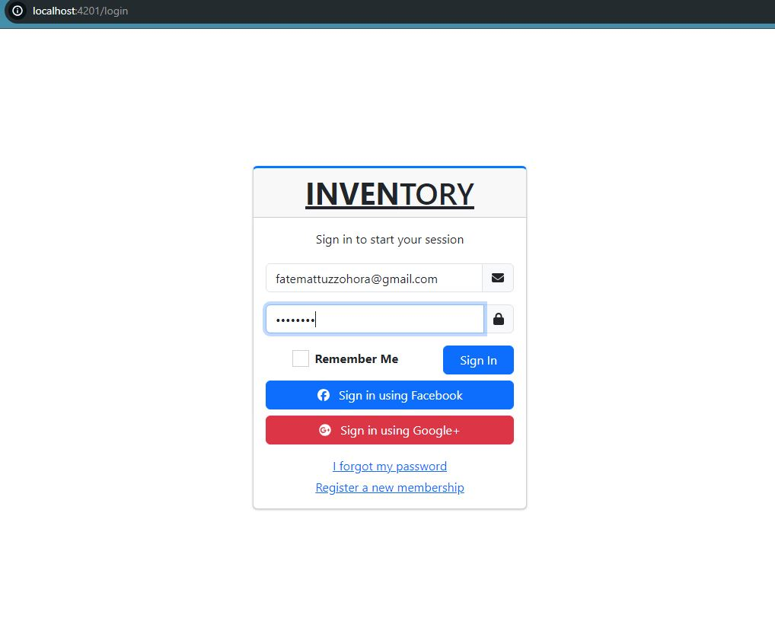

### Main Dashboard

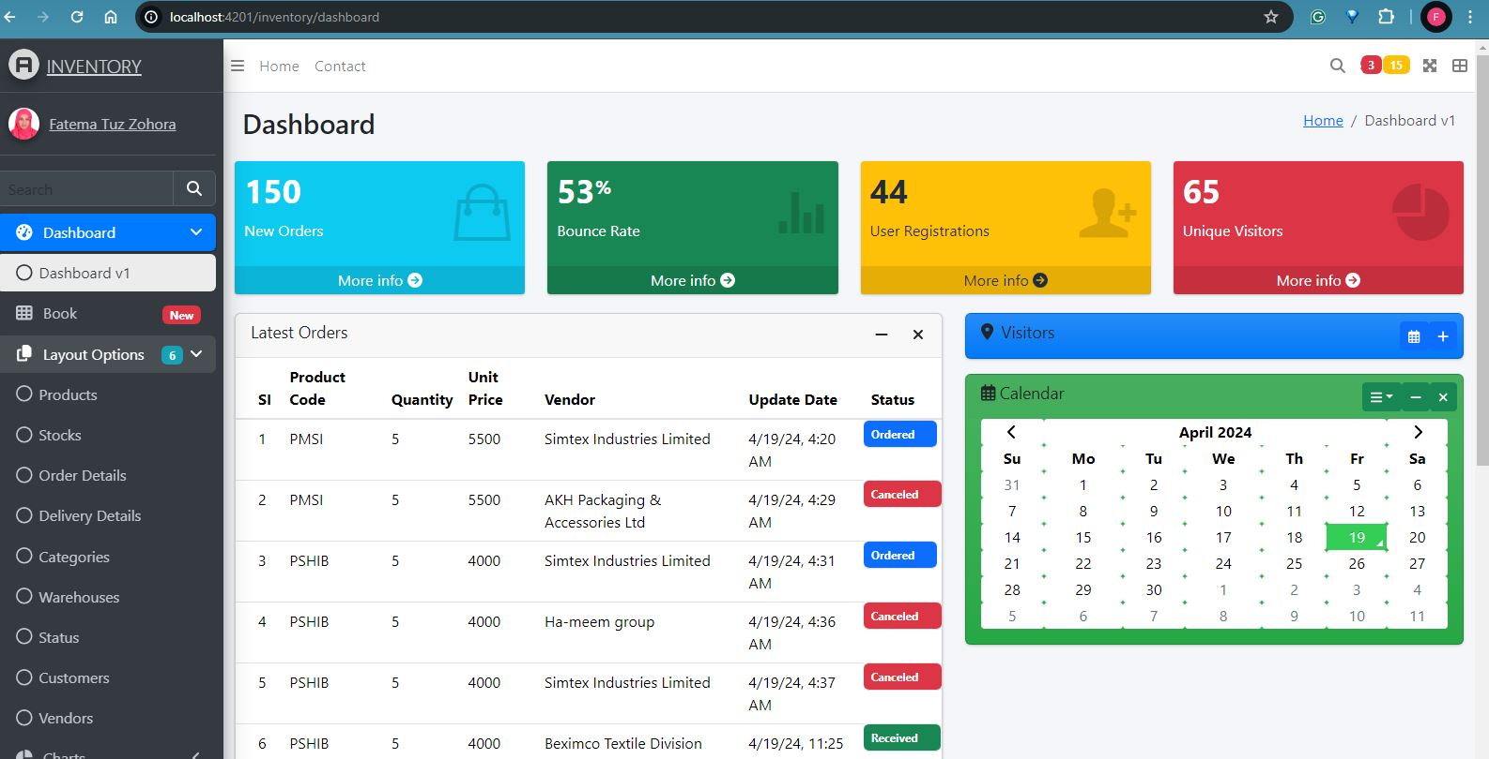

## Product Table

### Product Table View

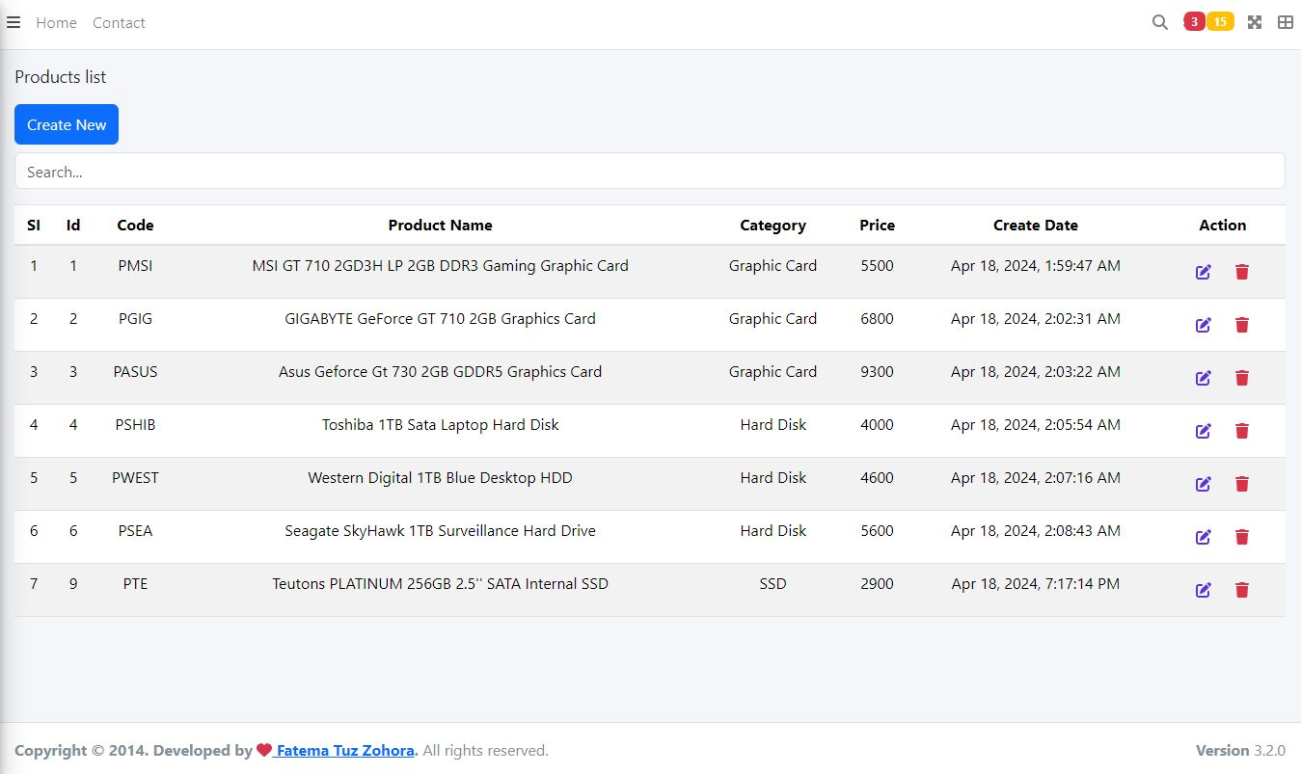

### Create new Product

#### Data Entry Form View

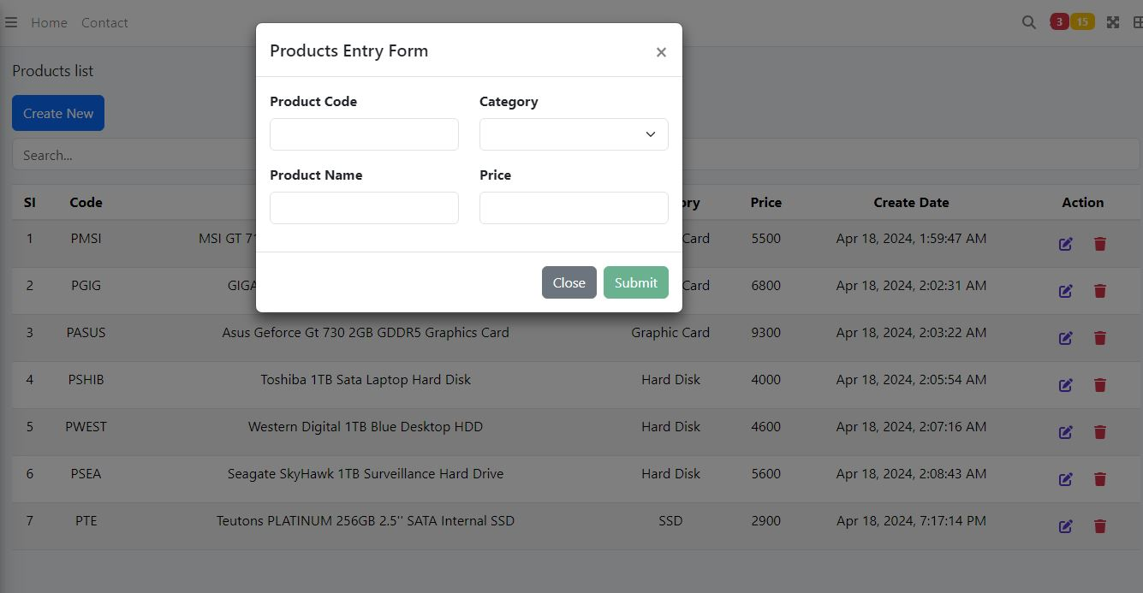

#### Data Entry

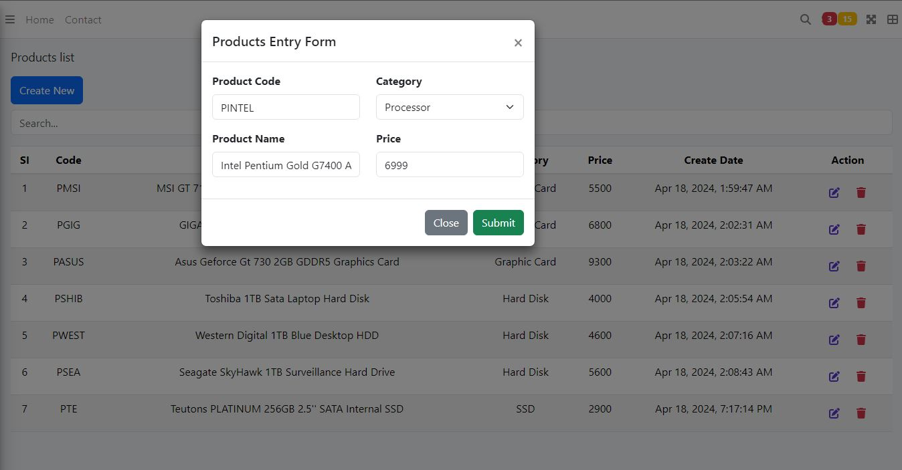

#### Confirmation Message

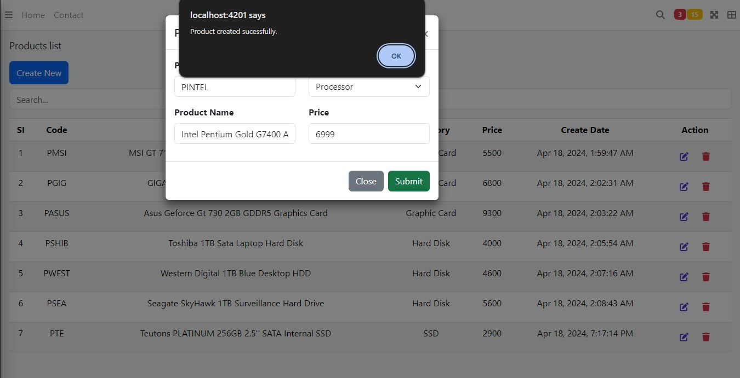

#### New Product Entry Complete

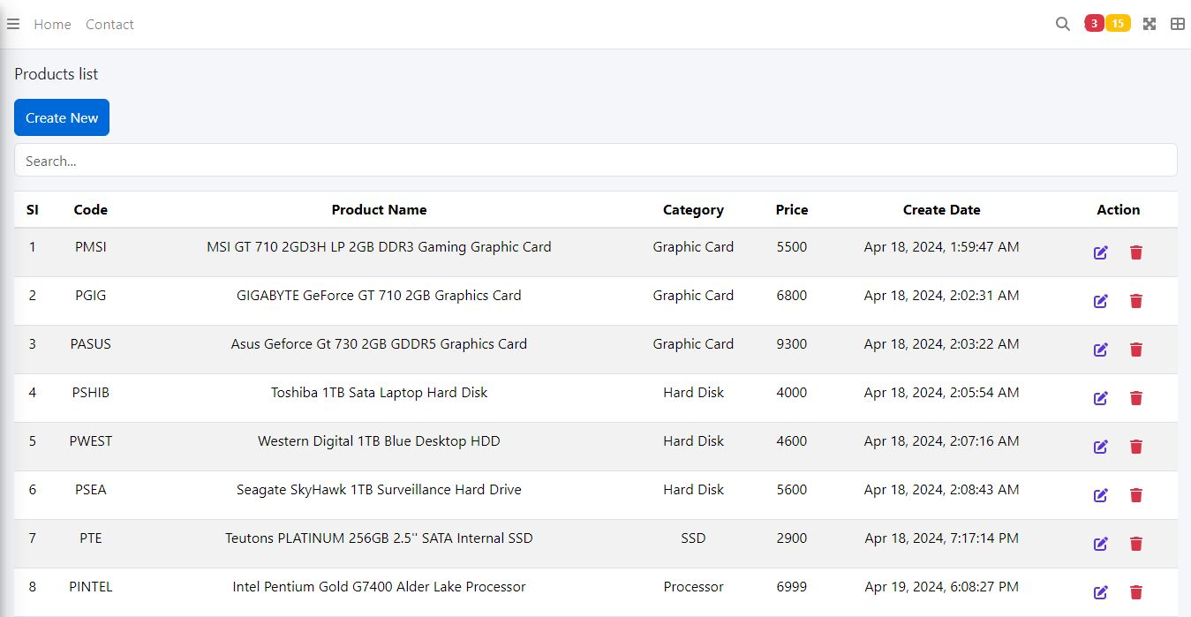

### Update Existing Product

#### Entry a new Product for demo Update

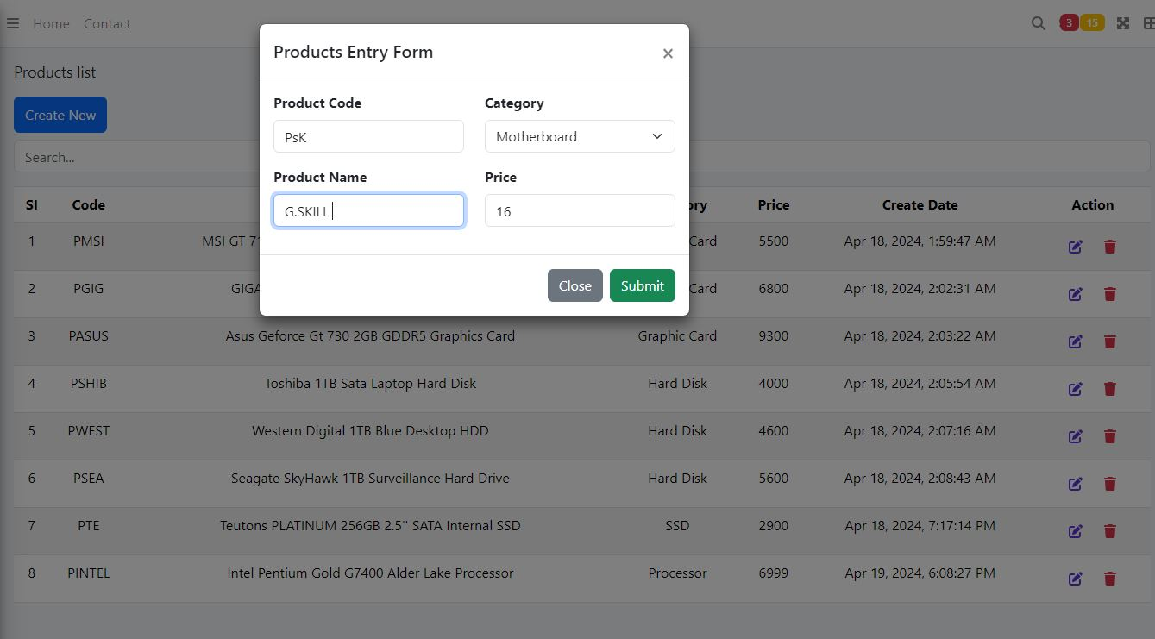

#### Target Product for Update

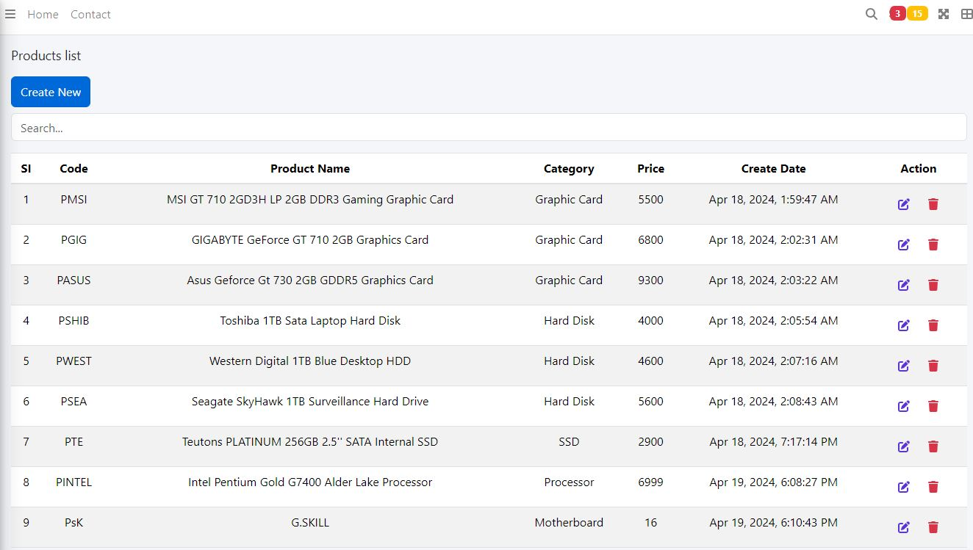

#### Select Target Product

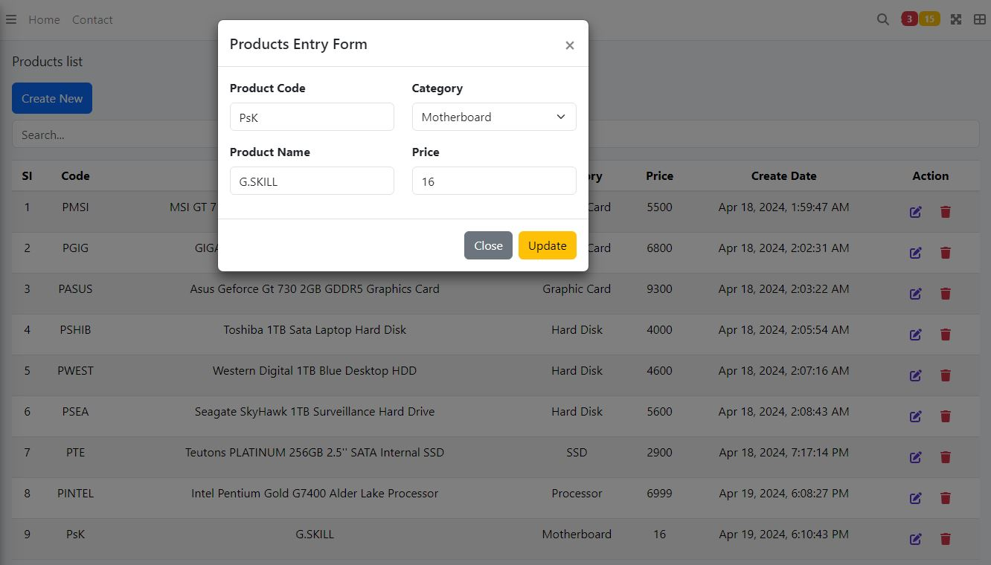

#### Change Data for Update

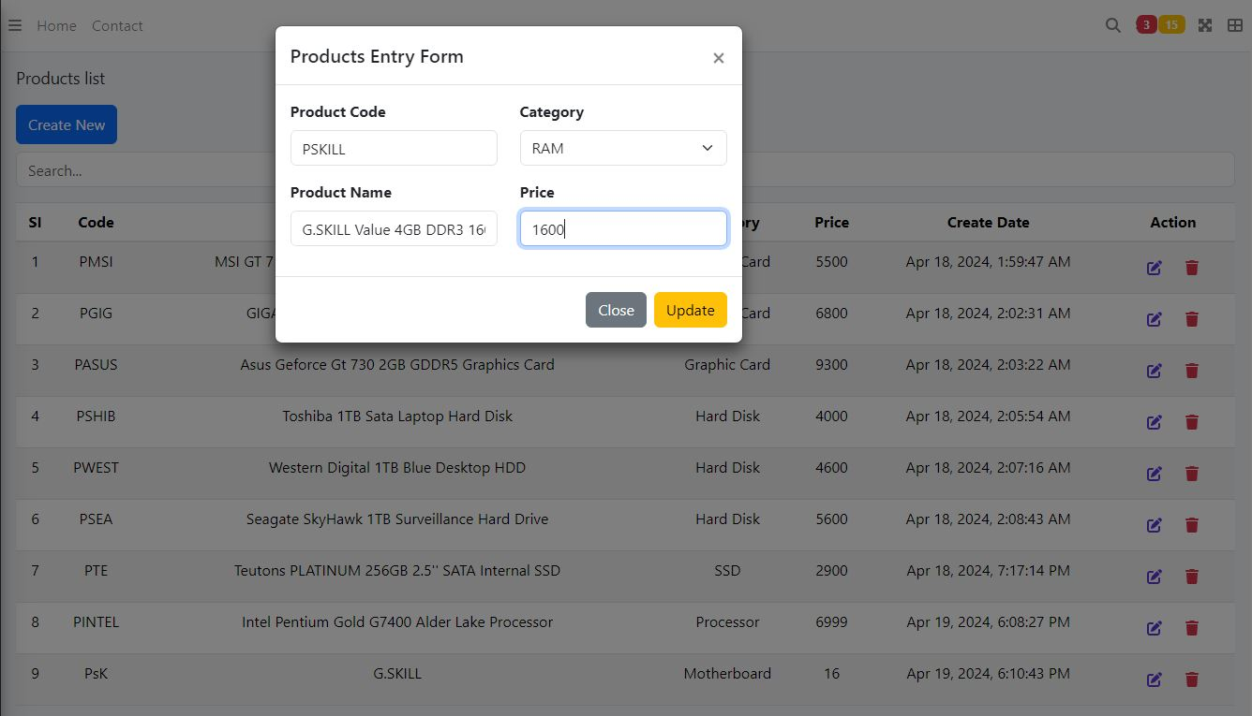

#### Confirmation Message

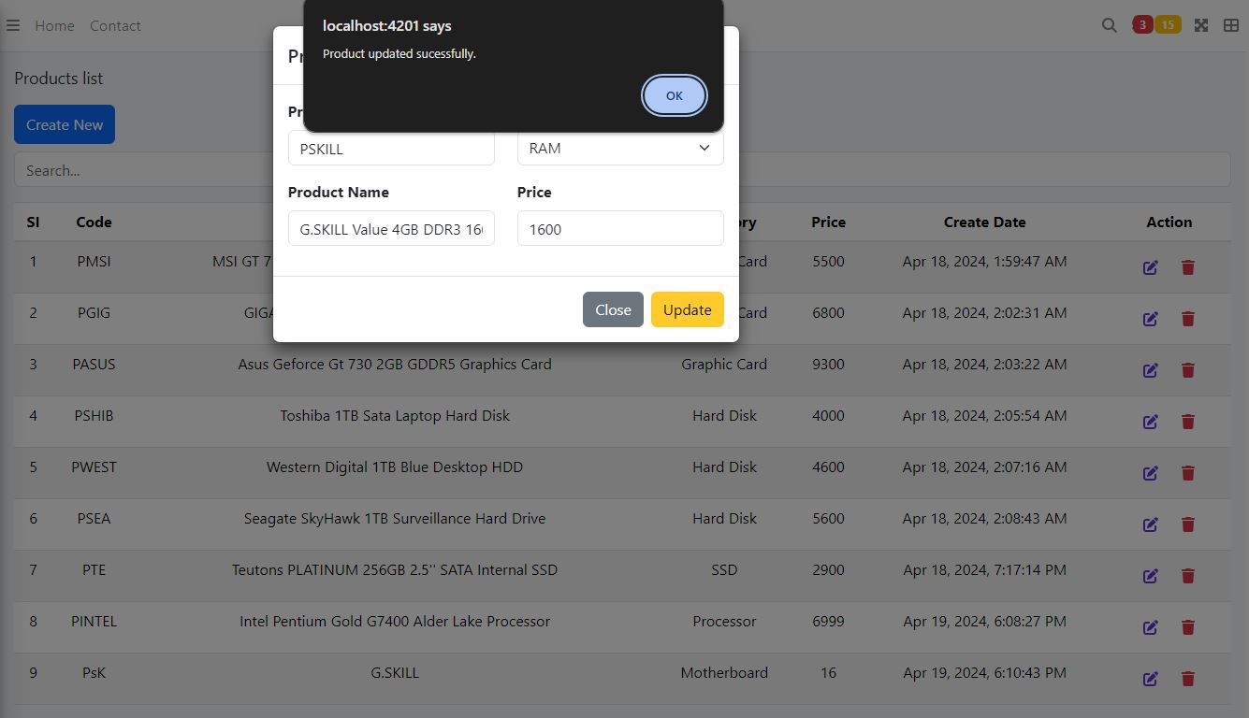

#### Product view after Update

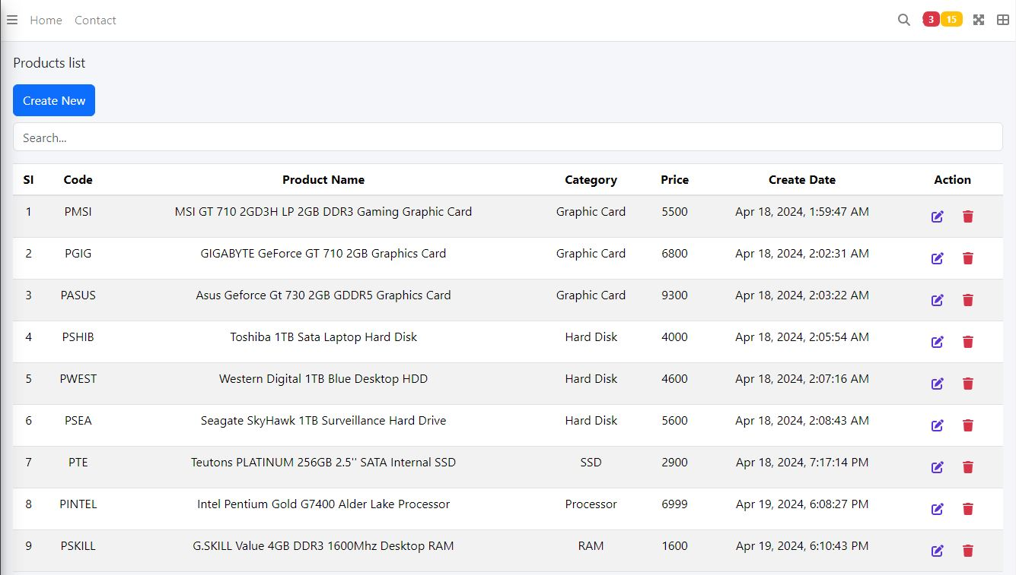

#### Compare Data change

##### Before



##### After



### Product Delete Operation

#### Entry a new Product for Delete Operation

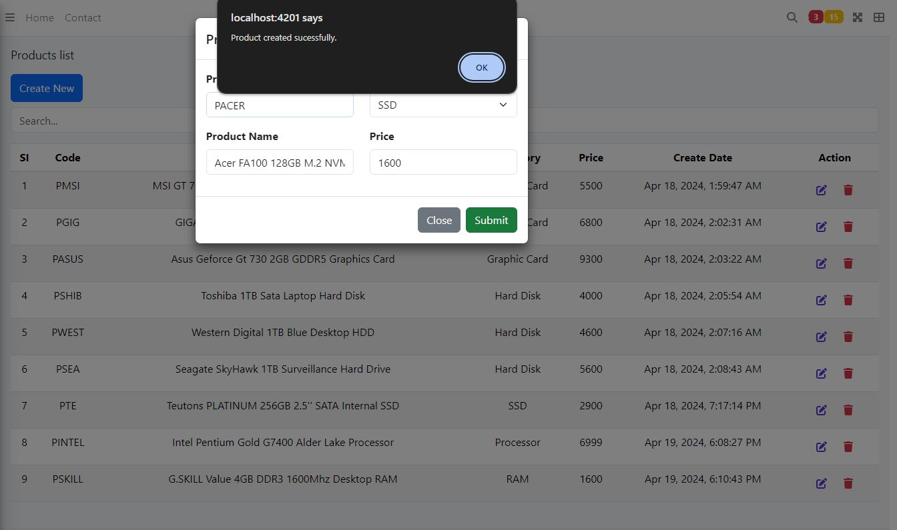

#### Target Product for Delete Operation

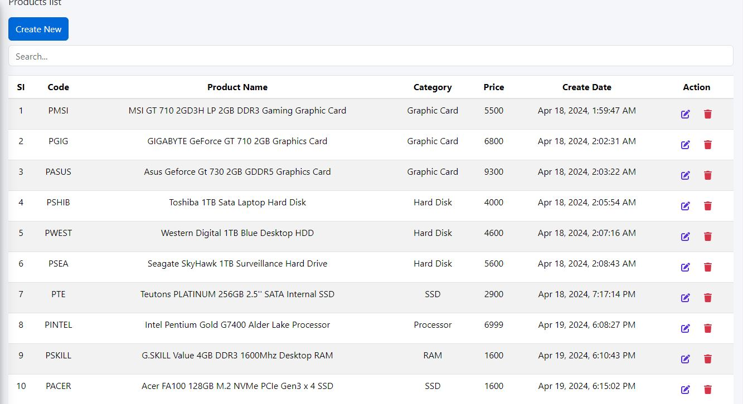

#### Delete Target Product

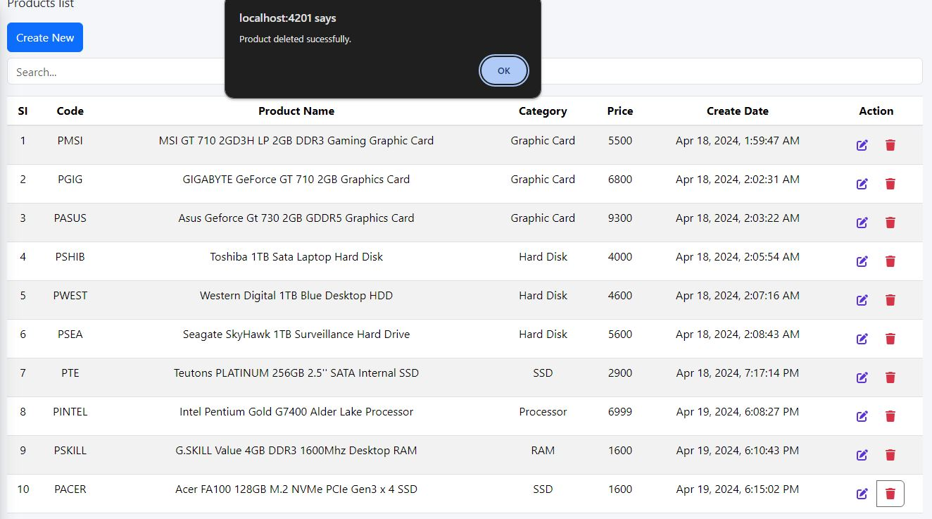

#### Product View after Delete Operation

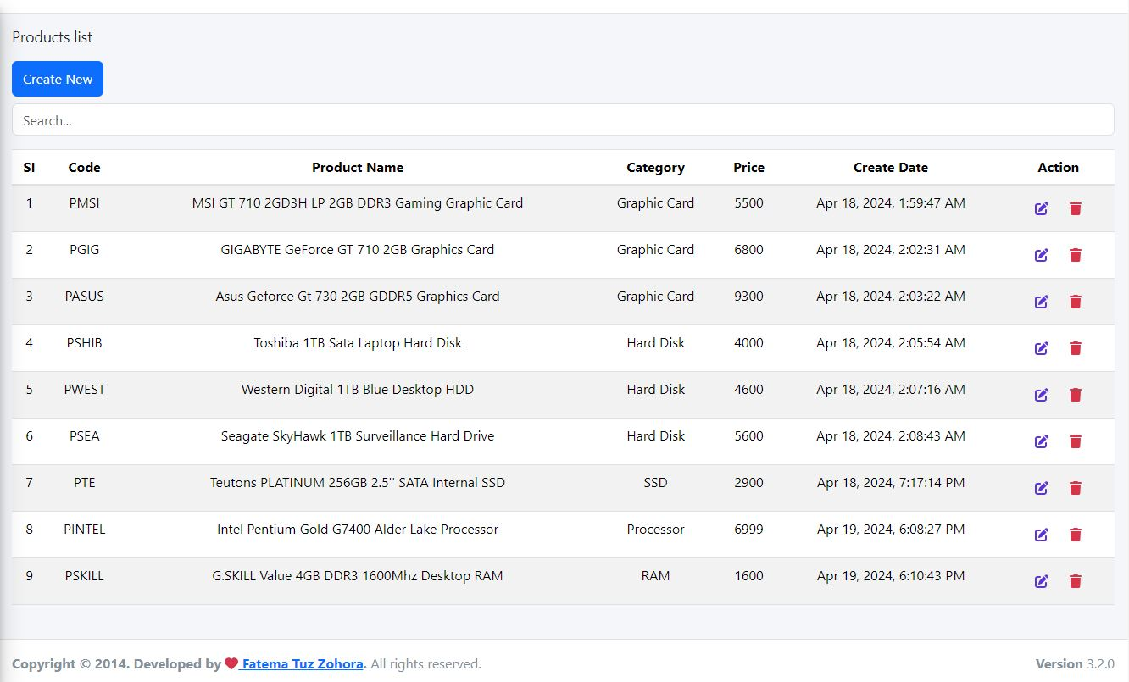

#### Compare Data Change

##### Before



##### After



### Extra Feature

#### Search by Product Code

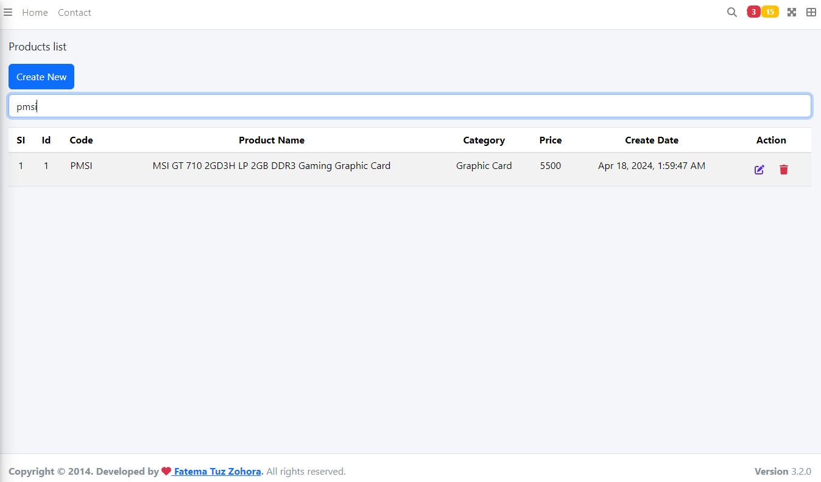

#### Search By Product Name

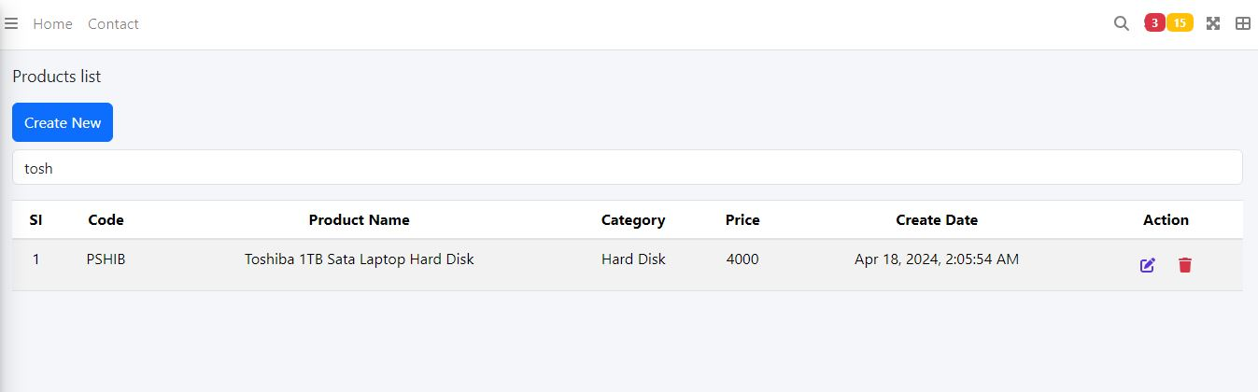

#### Search By Product Categories

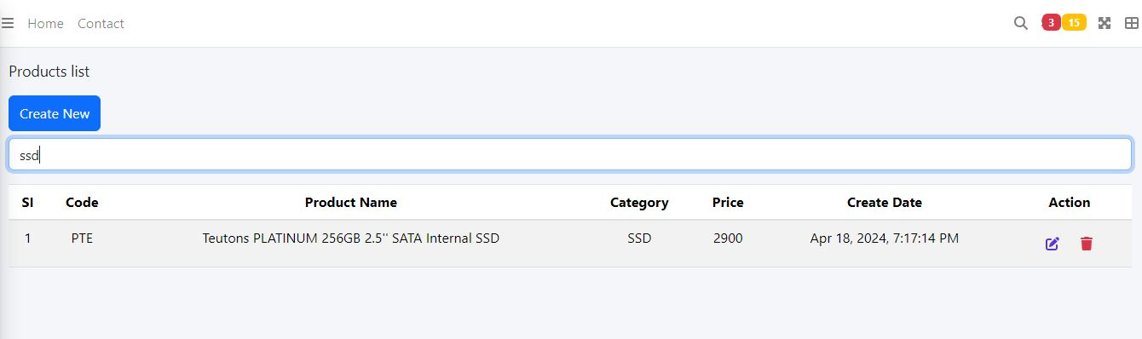

#### Search By Price

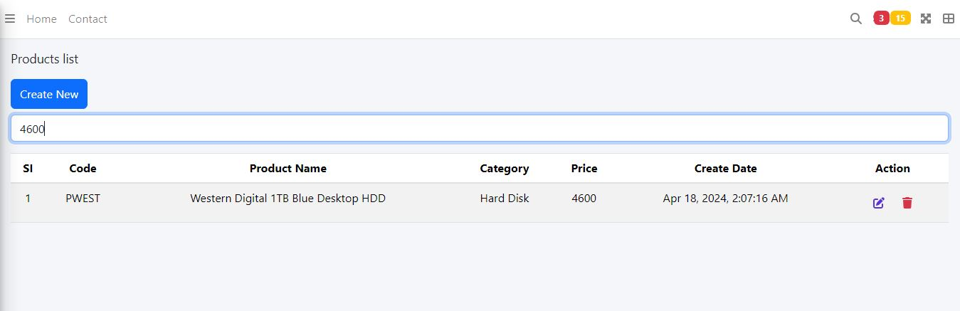

## Order Details Table

### Create new Order

3

4

2

1

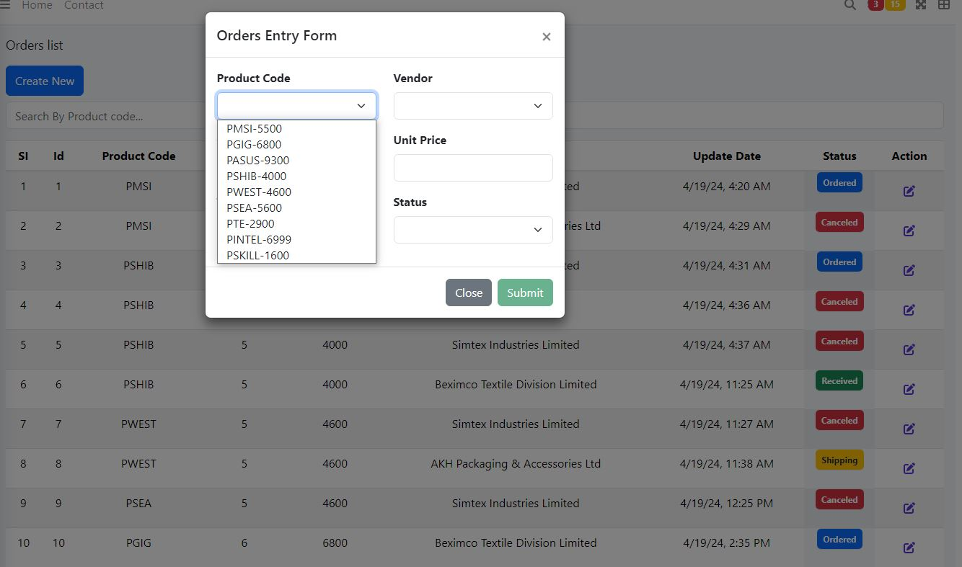

#### New Order Details View

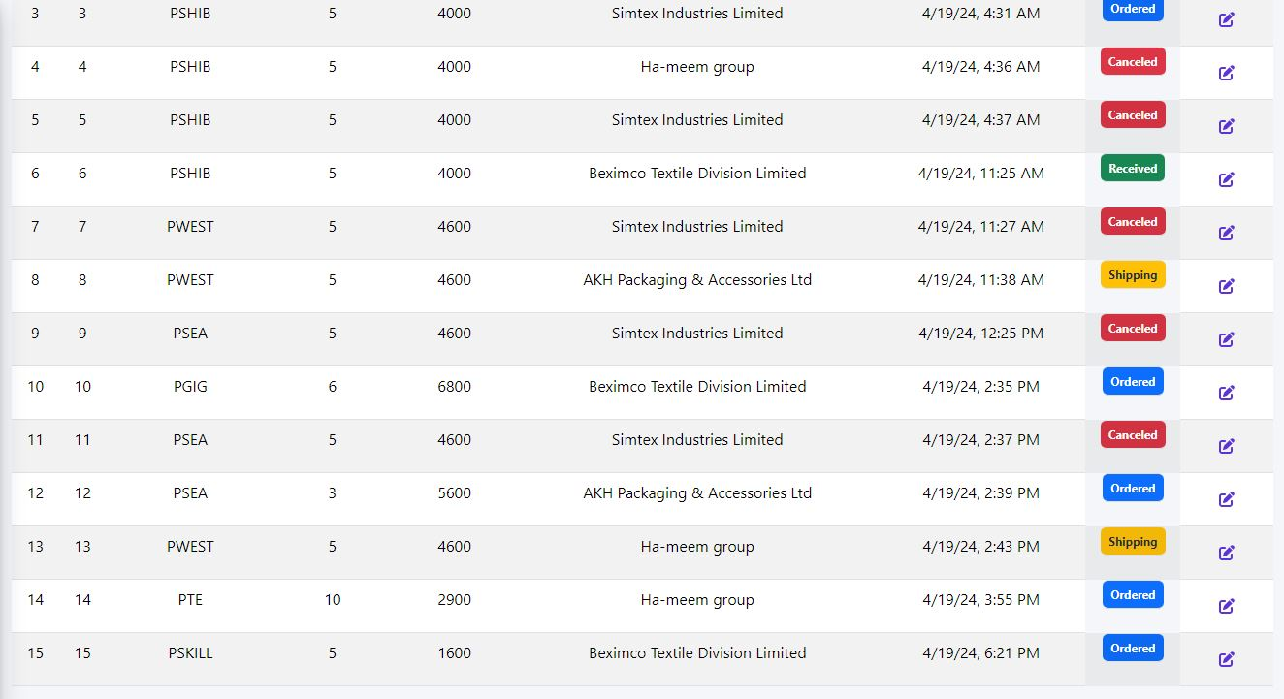

### Stocks table Change according to new Order Creation (quantity add)

##### Before

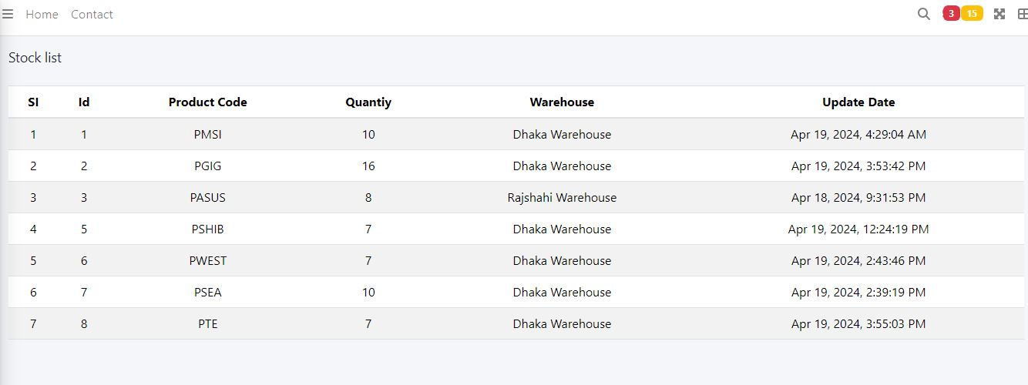

##### After

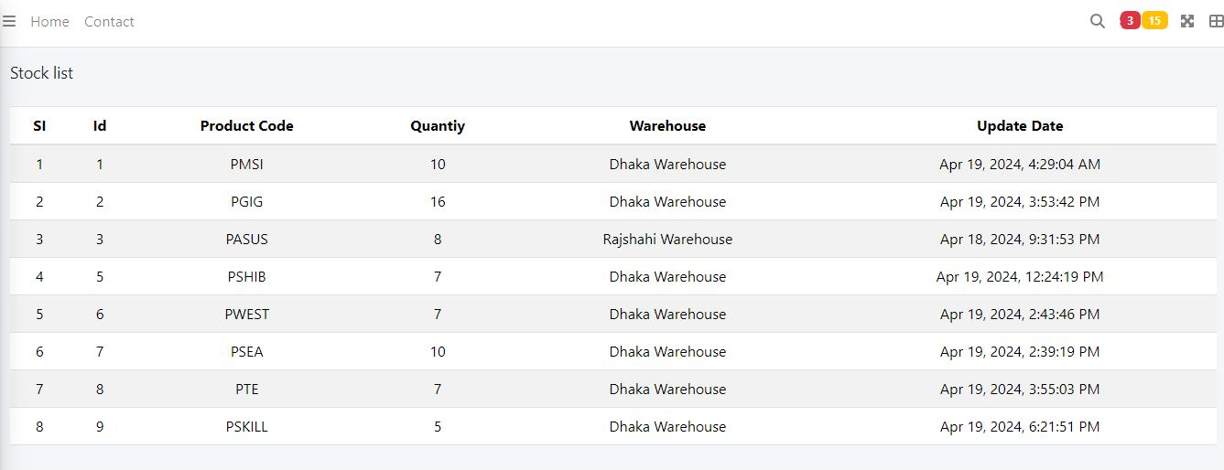

Product code PSKIll did not exist in Stock Table. After PSKIll product purchase, it is automatically added in Stock table.

### Update Operation on Order Table

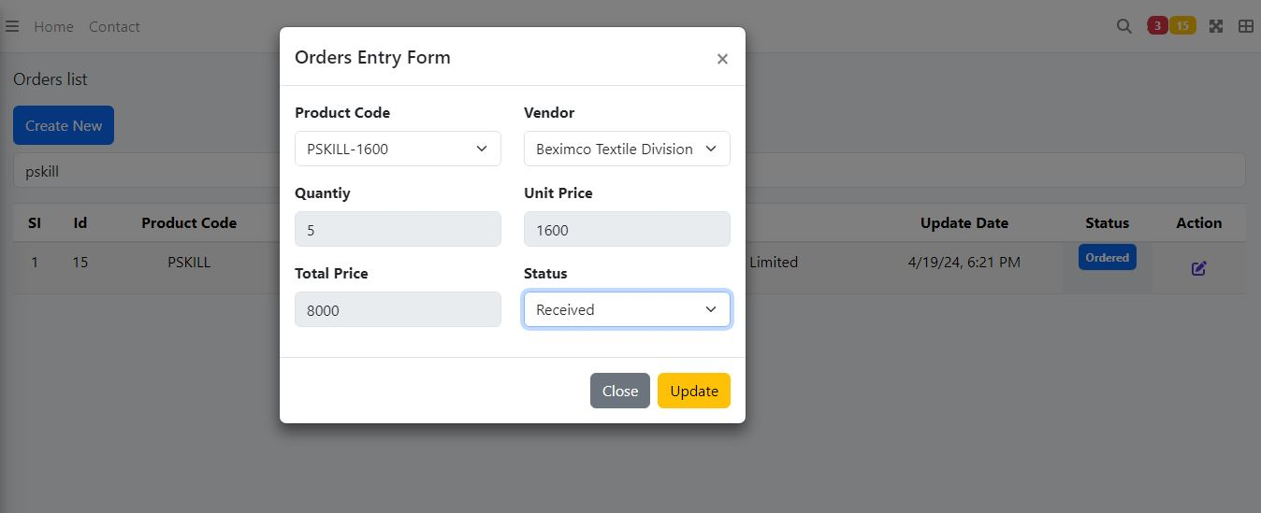

#### Confirmation Message

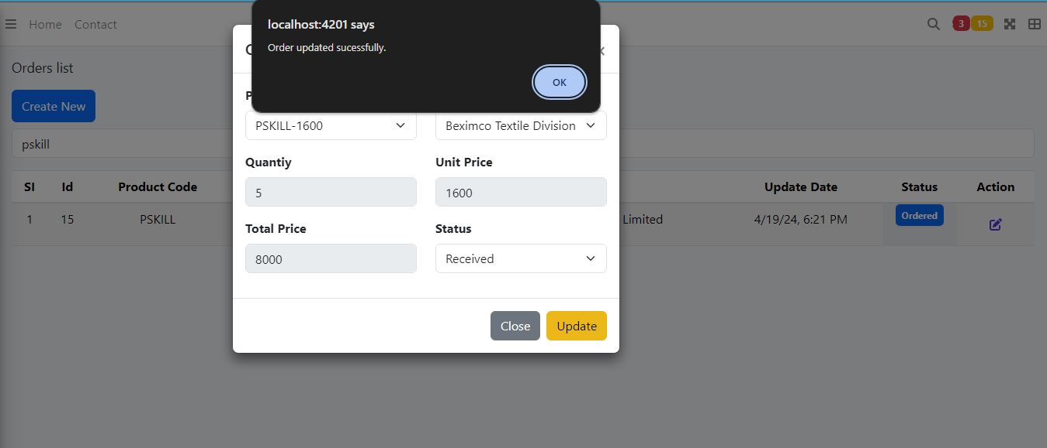

### Extra Feature (Search by Product Code)

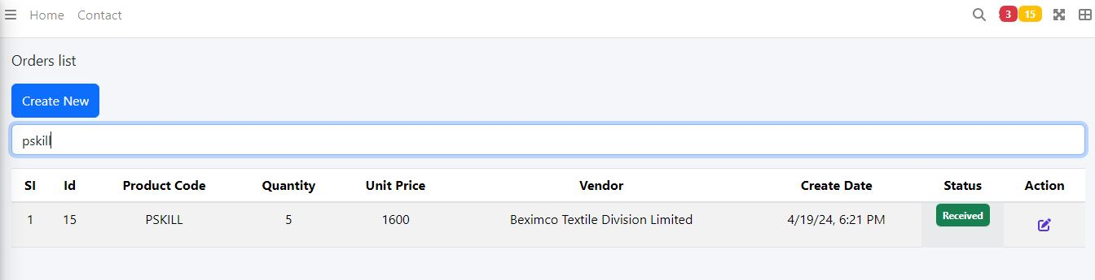

## Delivery Details Table

### Delivery Table view

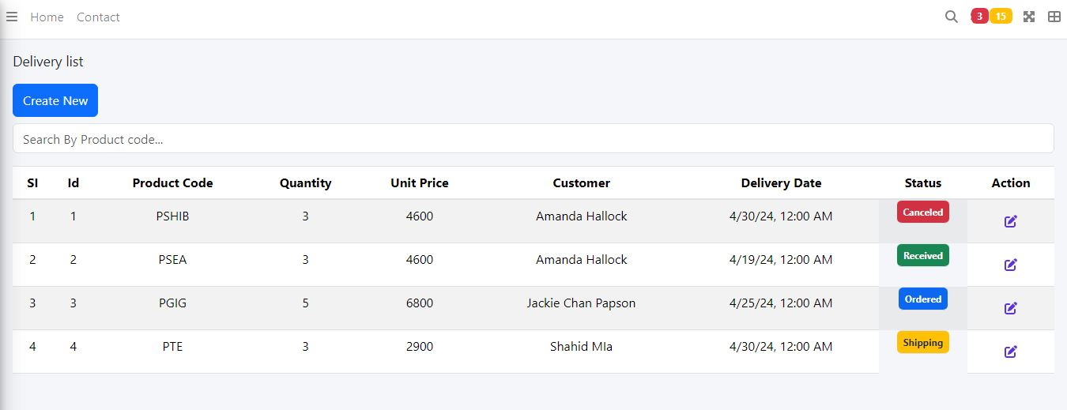

### Create new Delivery Record

4

3

2

1

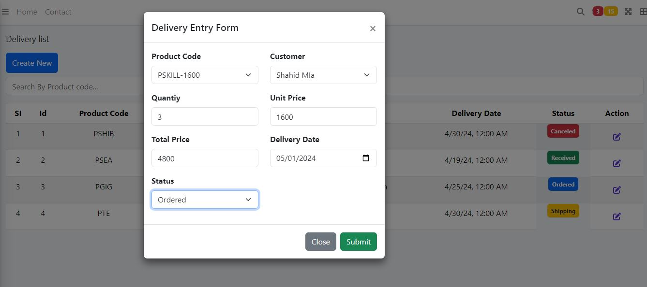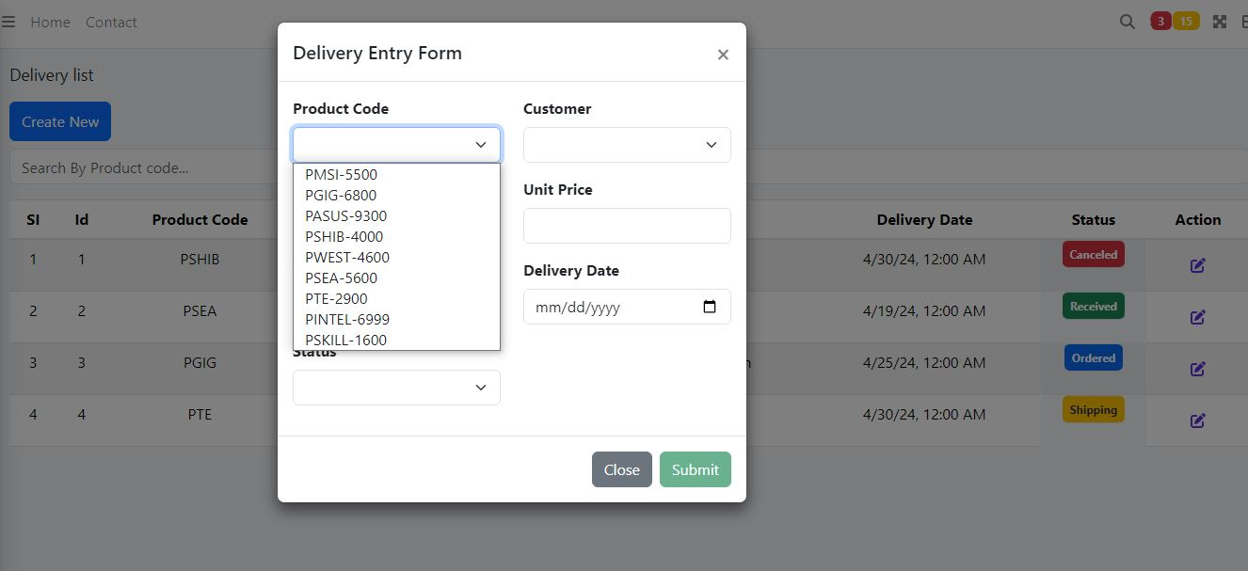

### Delivery Table View After Create Operation

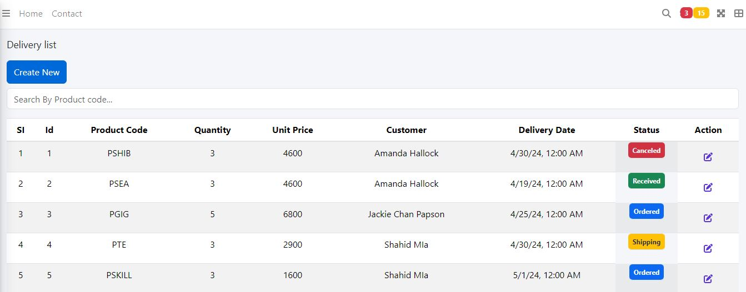

### Stock Table Change according to new Delivery (product quantity decrease)

#### Before



#### After

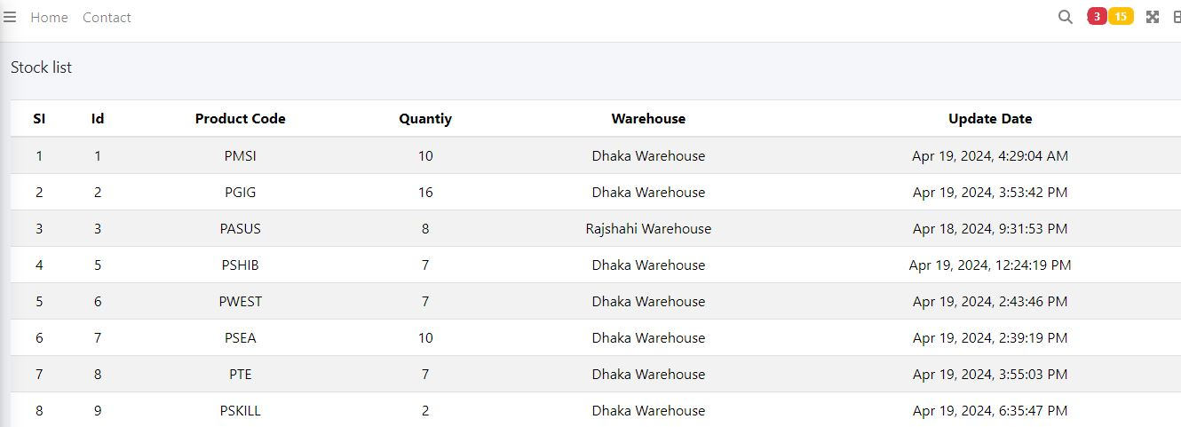

Product Code PSKILL quantity was 5. After 3 product (PSKIL) delivery, new quantity of PSKILL product is 2.

### Extra Feature (Search by Product code)

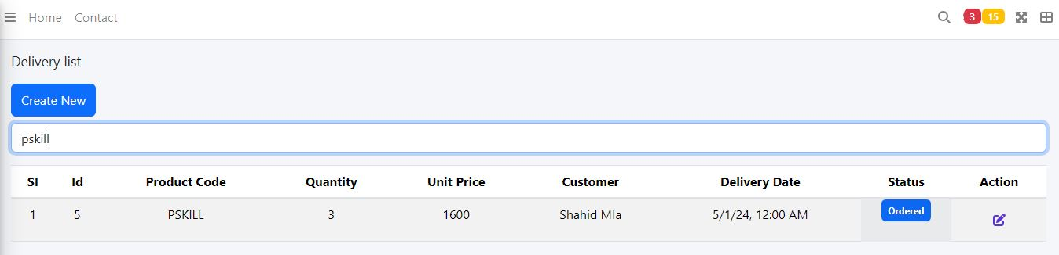

## Stock Table

### Stock Table View



## Customer Table

### Customer Table View

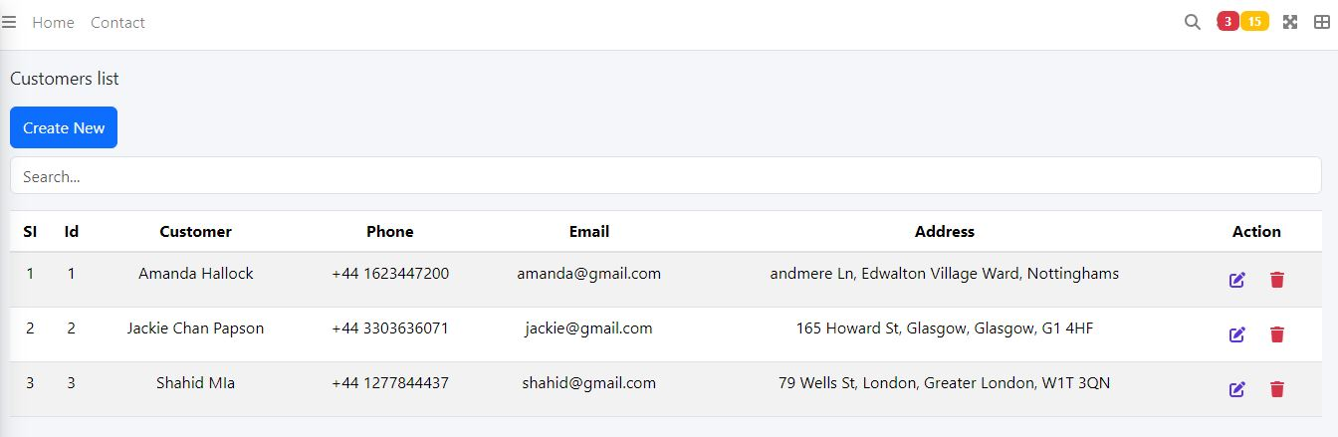

### Extra Feature

#### Search by Customer’s name or phone or email or address

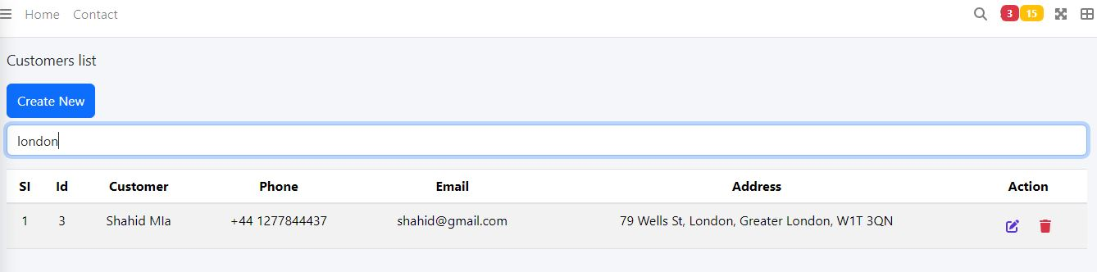

## Vendors Table

### Vendor Table view

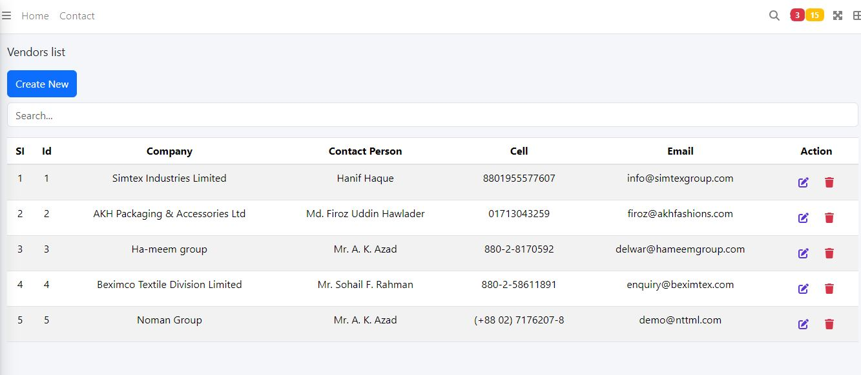

#### Extra Feature (search by company or contact person or cell or email)

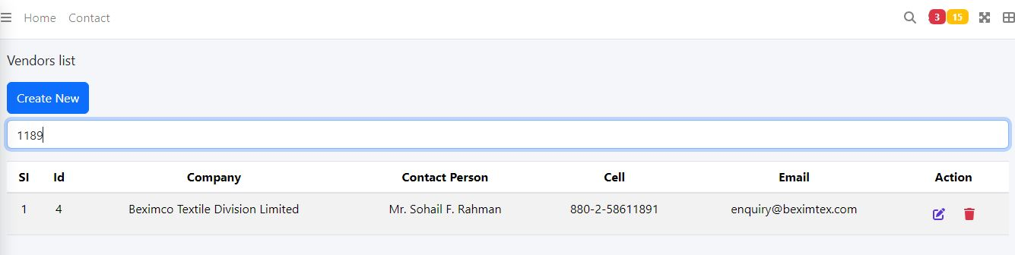

## Warehouse Table

### Warehouse Table view

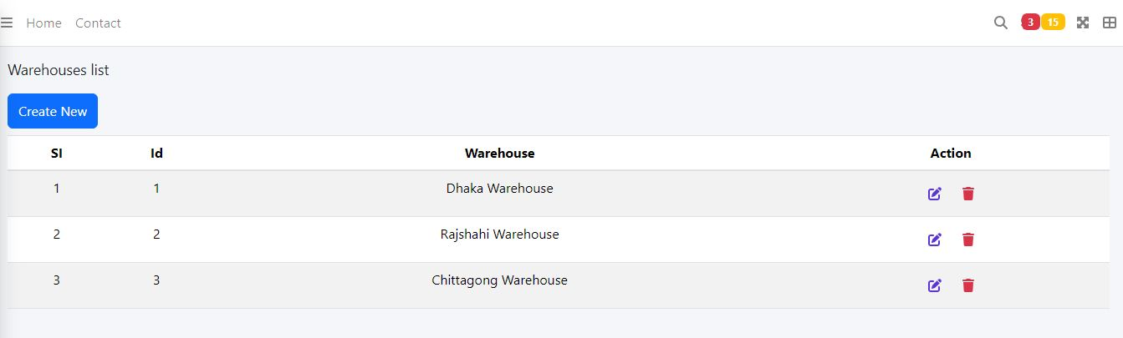

## Status Table

### Status Table view

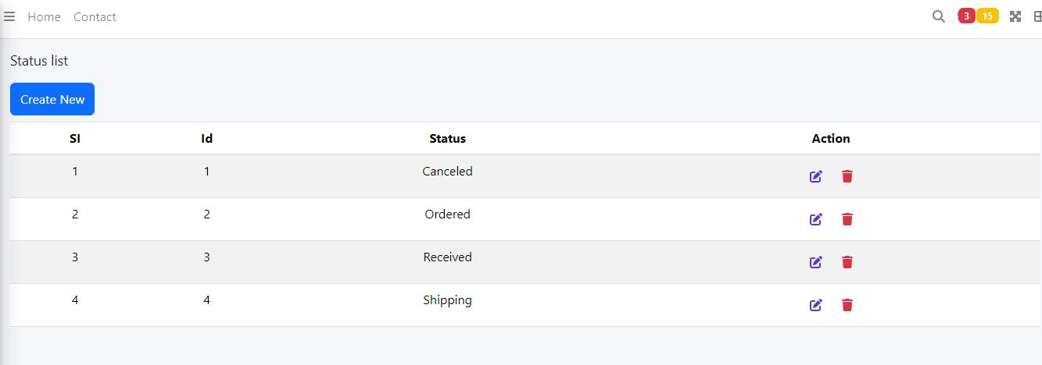

## Categories Table

### Categories Table view

