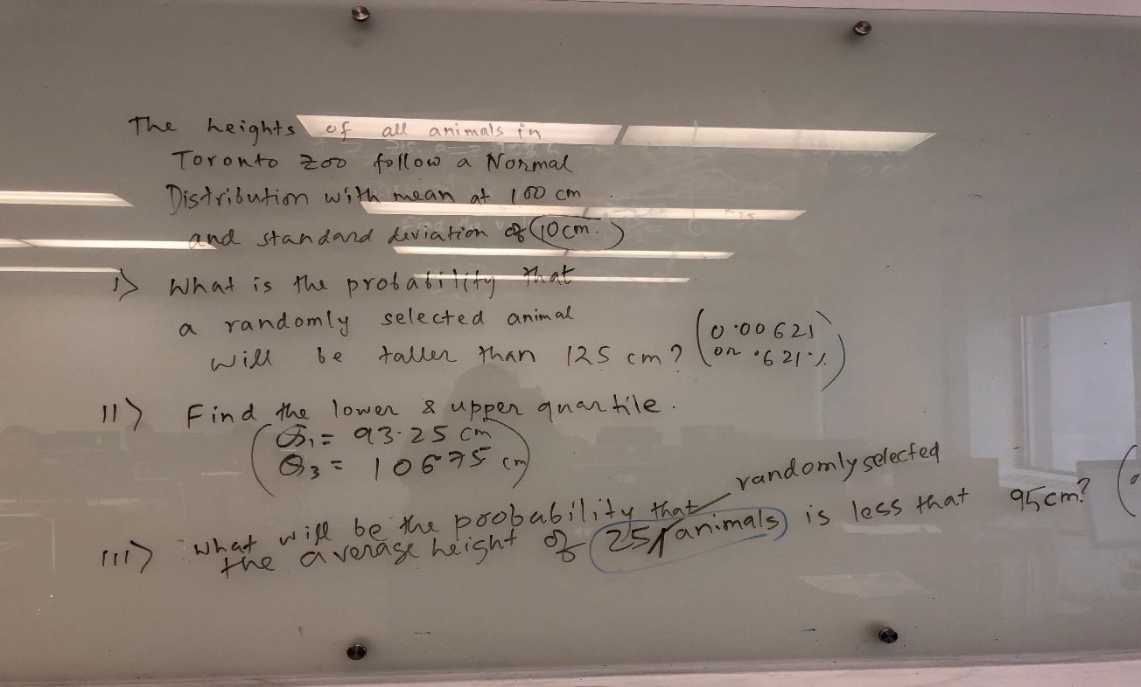

1. You draw a sample of 30 screws and calculate their mean length. The mean for your sample is 4.8, and the standard deviation of your sample (*s*) is 0.4 centimeters. What is the 95% confidence interval for the population mean?
2. A random sample of 25 people is surveyed, and it was found that they spent an average of 32 hours a week watching TV. The standard deviation of their sample was 6 hours. Calculate a 95% confidence interval for the average number of hours spent watching TV per week.

Design the hypotheses for the following:

1. A simple random sample of 10 people from a certain population has a mean age of 27. Can we conclude that the mean age of the population is not 30? The variance is known to be 20. Let alpha = .05.
2. The Centers for Disease Control (CDC) reported on trends in weight, height and body mass index from the 1960's through 2002.1 The general trend was that Americans were much heavier and slightly taller in 2002 as compared to 1960; both men and women gained approximately 24 pounds, on average, between 1960 and 2002. In 2002, the mean weight for men was reported at 191 pounds. Suppose that an investigator hypothesizes that weights are even higher in 2006 (i.e., that the trend continued over the subsequent 4 years).
3. The National Center for Health Statistics (NCHS) published a report in 2005 entitled Health, United States, containing extensive information on major trends in the health of Americans. Data are provided for the US population as a whole and for specific ages, sexes and races. The NCHS report indicated that in 2002 Americans paid an average of $3,302 per year on health care and prescription drugs. An investigator hypothesizes that in 2005 expenditures have decreased primarily due to the availability of generic drugs.