question 1

part a
t = -1:0.001:10;
x = 2*exp(-3*t);
u = heaviside(t);
y = x.*u;
figure(1);
plot(t,y);
axis tight;
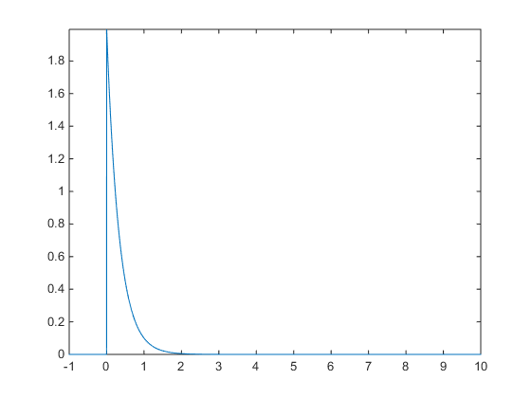

part b
figure(2);
t = -1:0.001:10;
x = exp(-2*t);
s= sin(3*t-1);
u = heaviside(t);
y = s.*x.*u;
plot(t,y);
axis tight;
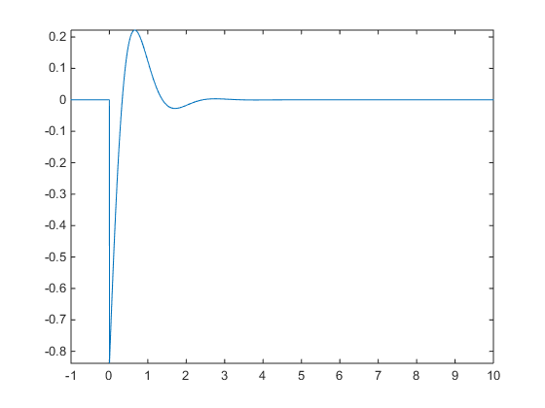

part c
figure(3);
t = -1:0.001:10;
x = exp(-1*t);
s= 4*cos(2*t-2);
u = heaviside(t);
y = x.*u + s;
plot(t,y);
axis tight;
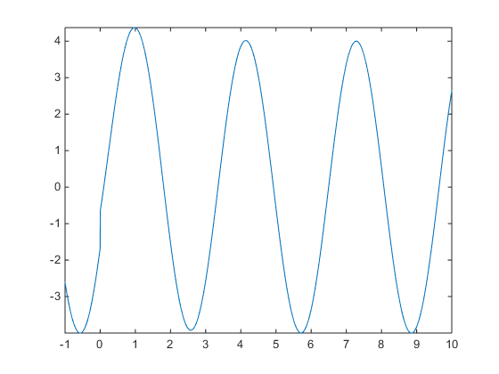

part d
figure(4);
t1 = 0:0.001:10;
t2 = -1:0.001:0;
x1 = exp(-3*t1) - exp(-6*t1);
x2 = 0*t2;
t = [t2 t1];
x = [x2 x1];
plot(t,x);
axis tight;
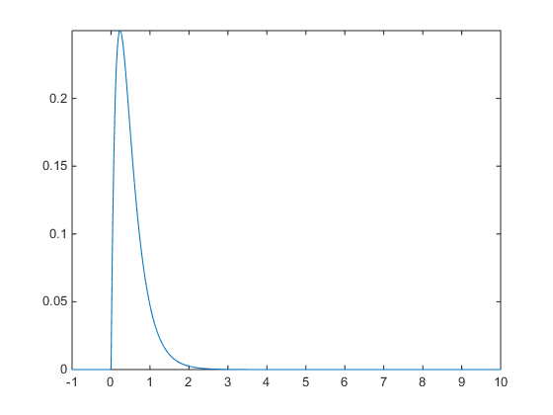

question 2

part a
t = -10:1:50;
x = 0.5.^t;
s = sin(pi*t/4) + cos(pi*t/4);
y = x.*s;
figure(1);
stem(t,y);
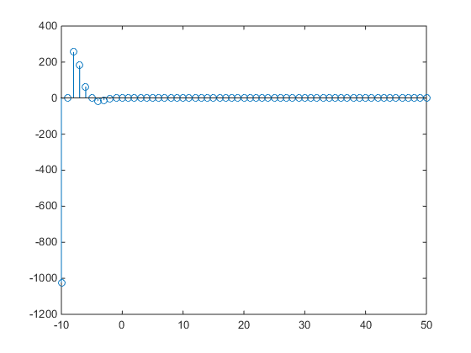

part b
figure(2);
t = -10:1:50;
x = 1-exp(0.2*t);
u = heaviside(t-2);
u1 = heaviside(-t+1);
y = 3*u+x.*u1 ;
stem(t,y);
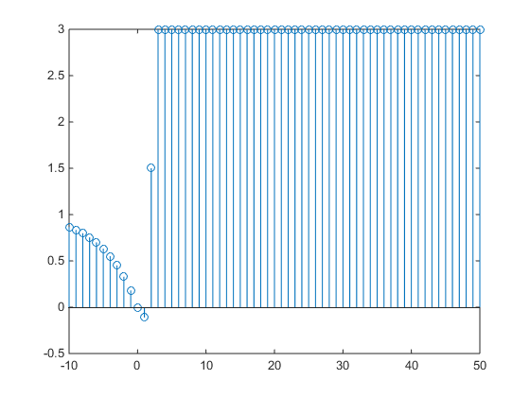

question 3
m is 0.02
first figure is real part
second figure is imaginary part

n = 0 : 1 : 100;
A = 5*cos(pi * n / 12);
for M = 0 : +0.001 : 1
a = -( M + (M/2)*1i);
x = A.*exp(a.*n);
square = x.^2;
energy = sum(square);
iterate = M;
absEnergy = (real(energy) ^2 + imag(energy) ^2)^0.5;
if(absEnergy < 300)
figure(1);
stem(n,real(x));
figure(2);
stem(n,imag(x));
break;
end
end
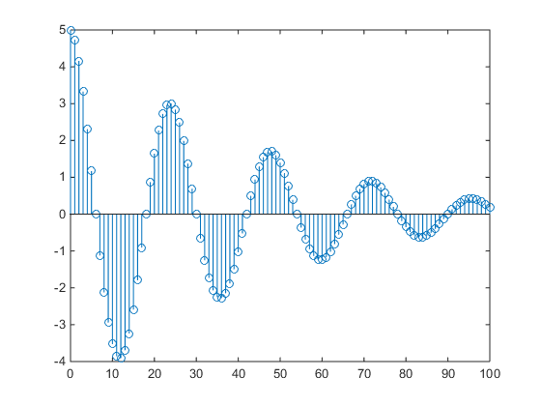
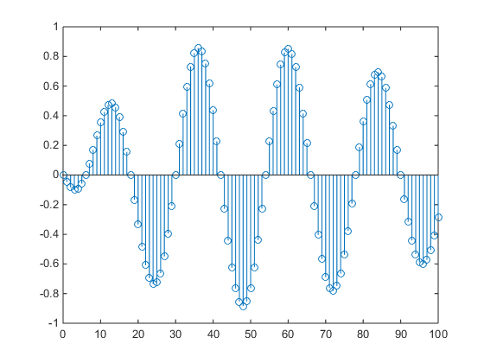

Question 4
Output for a specified x as in picture below :
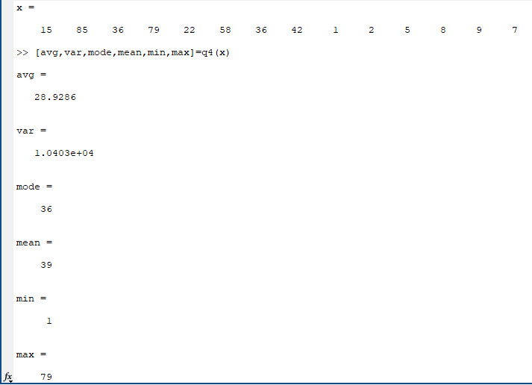

Question 5
First figure is right stereo data and second is left stereo data
با بیشتر شدن فرکانس نمونه برداری از حالت عادی صدای پخش شده زیر تر می شود که علت ان بیشتر شدن فرکانس صدای پخش شده است و اگر فرکانس نمونه برداری از فرکانس عادی آن کمتر باشد صدا بم میشود که به دلیل کمتر شدن فرکانس صدا است.
[y,Fs] = audioread('sound.mp3');
Fs = 100000;
sound(y,Fs);
rightData = y(:,1);
leftdata = y(:,2);
t = 0 : 1/44100 : length(y)/44100 - (1/44100) ;
figure(1);
plot(t, rightData);
figure(2);
plot(t,leftdata);
len = length(y);
fadePoint = int32(len * 7 / 10);
for i = drange(fadePoint : len)
coef = (len - i) / (len - fadePoint);
rightData(i) = rightData(i) * coef;
leftdata(i) = leftdata(i) * coef;
end
sound(y, 44100);
save('result.mat', 'y');
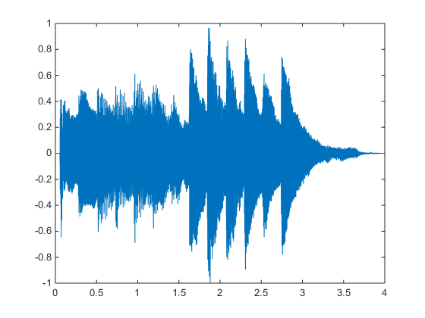
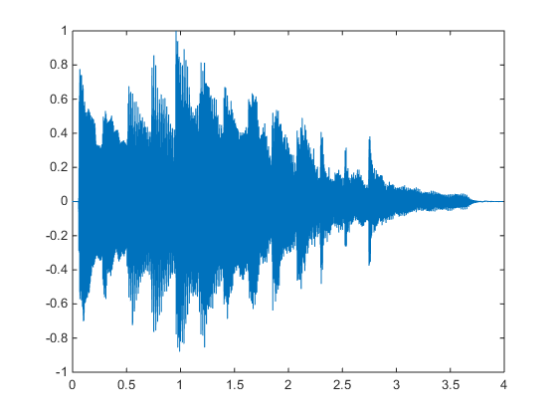
Published with MATLAB� R2014b

