This file is created to help the user to work with the algorithm. To make it easy to work with the parameters of the algorithm, we have designed a Graphical User Interface (GUI). The GUI collects all the parameters needed to run the program in one place. The GUI contains some text box and buttons that the use of them is defined as follow:

In each of the text box, you have to enter the parameter’s values based on the provided table (Table 1).

**TextBoxes**

**Wedge:** which is the parameter that controls the Snake behavior towards image edges.

**Wline:** which is the parameter to control the behavior of the Snake towards the lines in the image.

**Wterm:** which is a parameter to control the behavior of the Snake towards terminations.

**Alpha:** which is a parameter that controls the shrinkage of the Snake.( Increasing this parameter results in shrinking of the Snake).

**Beta:** an indicator of smoothness by increasing it the Snake will be smoother.

**Sigma:** which is the input of Gaussian smoothing filter.

**Gamma:** which is the time parameter or the step size.

**Image Reading URL:** it is the directory that the algorithm read the input data from.

**Volume Writing URL:** it is the directory that the algorithm write the results in and the visualization algorithm read the data from. The format considered here to save results is “.nii”.

**Start Slice Number:** itis the slice in which the initial contour is drawn.

**End Slice Number:** itis the slice that the object of interest vanishes on that slice.

In case of considering two initial input contours, you need to assign values to the two next textboxes.

**Start Slice2 Number:** itis the slice in which the second initial contour is drawn.

**End Slice2 Number:** itis the slice that the second object of interest vanishes on that slice.

**Counter Down:** it is a flag for the algorithm. It is used in case the initial Snake is drawn in the middle of volume and we need it to segment the slices down to the first slice. If this situation has happened we have to set the flag to one.

**Buttons**

**Execute:** itis for running the program. After drawing the initial Snake. You are supposed to close all the windows even the GUI window.(because it is probable to open extra windows)

**Execute_multiple:** it is used for running the program in the mood that gives you the permission to draw two contours (Snake). The program will open the first window and you are supposed to draw the first contour and draw all the windows including the GUI window. Then the algorithm will open the second window and you are supposed to draw the second contour. And then you have to close all the open windows. Then the algorithm will start calculating the segmented volume.

**Visualize:** it is used for visualizing the results of the previous run of the program, using marching cube and VTK.

**Exit:** itis for closing the program.

Figure 1 demonstrates the GUI program and the Table 1 introduces the parameters we need to give as input to our algorithm.

Between the codes you only need to run tk2.py program. Other parts are modules that are called in the program automatically.

**Demo videos also exists at the two last slides of my presentation. That shows how to run the program.**

The link for the segmented volumes is as below:

<https://uofc-my.sharepoint.com/:f:/g/personal/fatemeh_yazdanbakhsh_ucalgary_ca/EpLx_JfzYGpDmEwGF1v3qEgBPv2idOf3IfBsp4PMUTzW8g?e=pz8onJ>

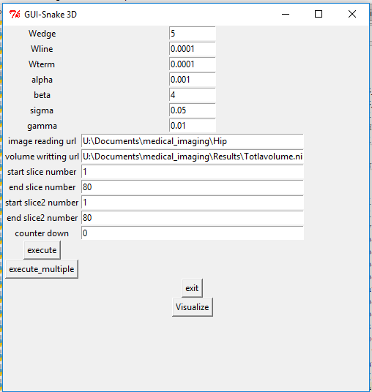

Figure graphic user interface (GUI) for the proposed algorithm

Table Parameters needed to run the program

|  |  |  |  |  |  |  |  |  |  |  |  |  |  |
| --- | --- | --- | --- | --- | --- | --- | --- | --- | --- | --- | --- | --- | --- |
| ID | Wedge | Wline | Wterm | alpha | beta | sigma | gamma | n-iteration | dataset | Start slice | End slice | Counter down | reference |
| 1 | 5 | 0.0001 | 0.0001 | 0.001 | 4 | 0.5 | 0.01 | 100 | Hip | 1 | 80 | 0 | Hip dataset |
| 2 | 5 | 0.0001 | 0.0001 | 0.001 | 4 | 0.5 | 0.01 | 100 | Hip | 1 | 80 | 0 | Hip dataset |
| 3 | 5 | 0.0001 | 0.0001 | 0.001 | 4 | 0.5 | 0.01 | 100 | \OsiriX\Beaufix\study\dyn_echo_bh_perfusion_SUB_MIP_COR | 10 | 15 | 0 | [8] |
| 4 | 5 | 0.0001 | 0.0001 | 10 | 40 | 0.5 | 0.01 | 100 | \OsiriX\Beaufix\study\SUB_arterial | 38 | 70 | 0 | [8] |
| 5 | 5 | 0.0001 | 0.0001 | 0.001 | 4 | 0.05 | 0.01 | 100 | \OsiriX\Keskonrix\study\AngioRunOff_20_B30f | 498 | 829 | 0 | [8] |
| 6 | 5 | 0.0001 | 0.0001 | 0.001 | 4 | 0.05 | 0.01 | 100 | \OsiriX\Keskonrix\study\AngioRunOff_20_B30f | 498 | 829 | 1 | [8] |
| 7 | 5 | 0.0001 | 0.0001 | 1 | 4 | 0.05 | 0.01 | 100 | Calgary\TBone-2015\MicroCT\L2501L_EDITED | 236 | 270 | 0 | University of Calgary |