TASK 1

FIGURE 1
- Simulasi
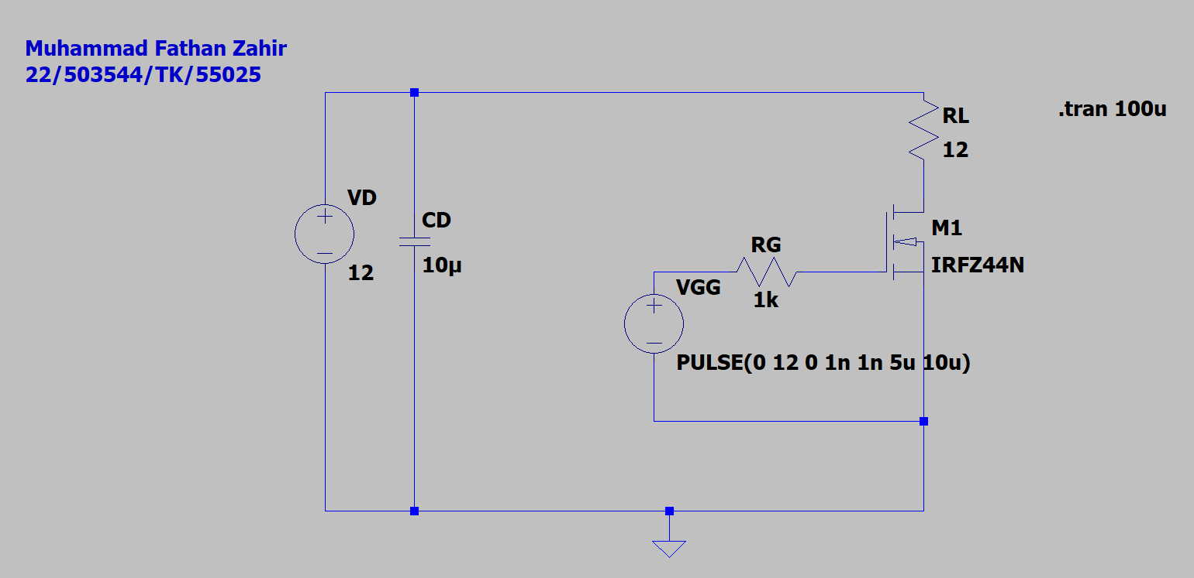
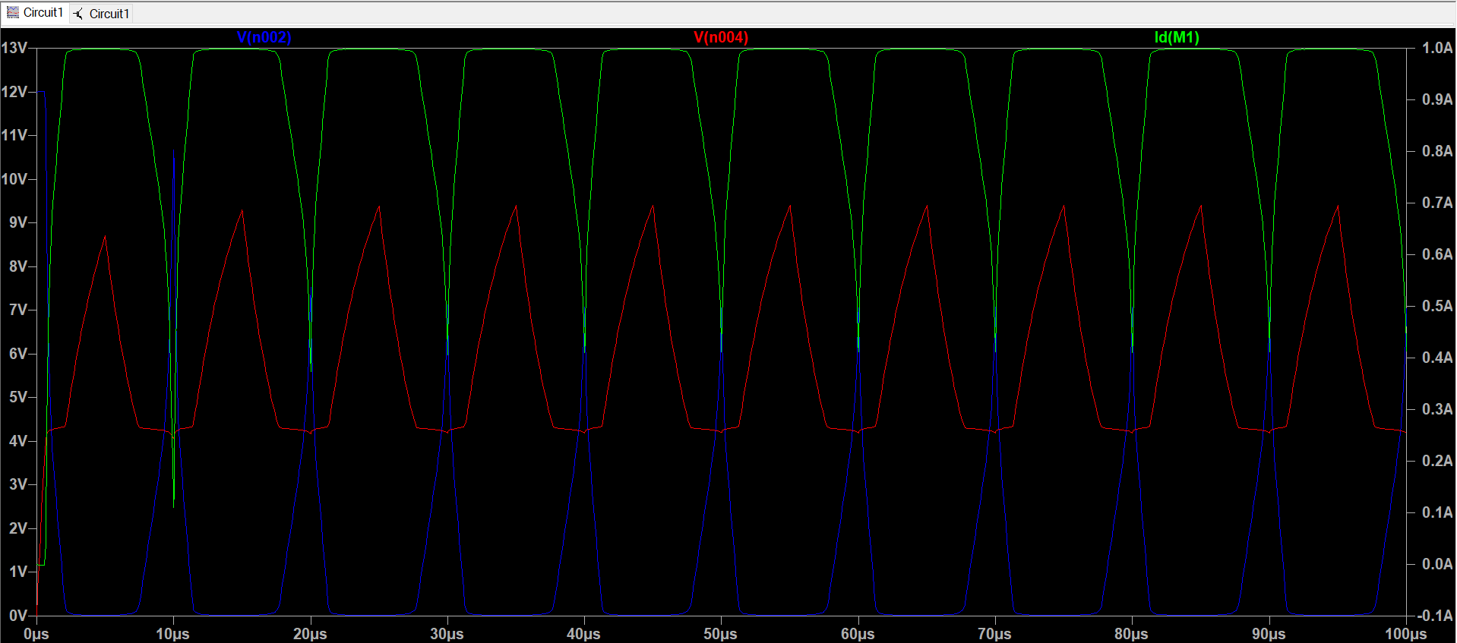
Biru: VDS
Merah: VGS
Hijau: Id

- Turn on delay
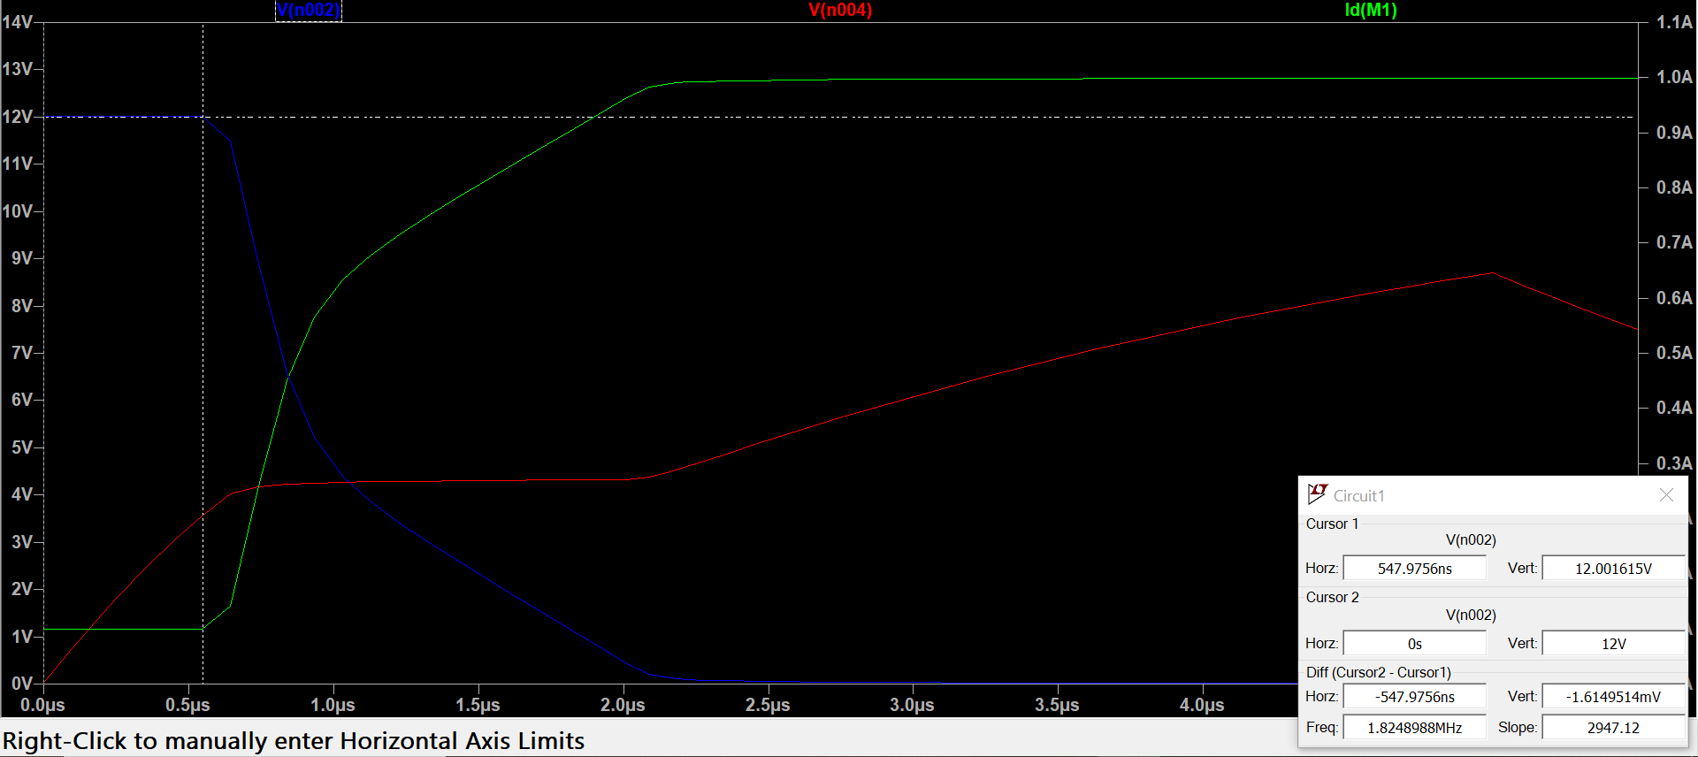
547,9756ns
- Turn off delay
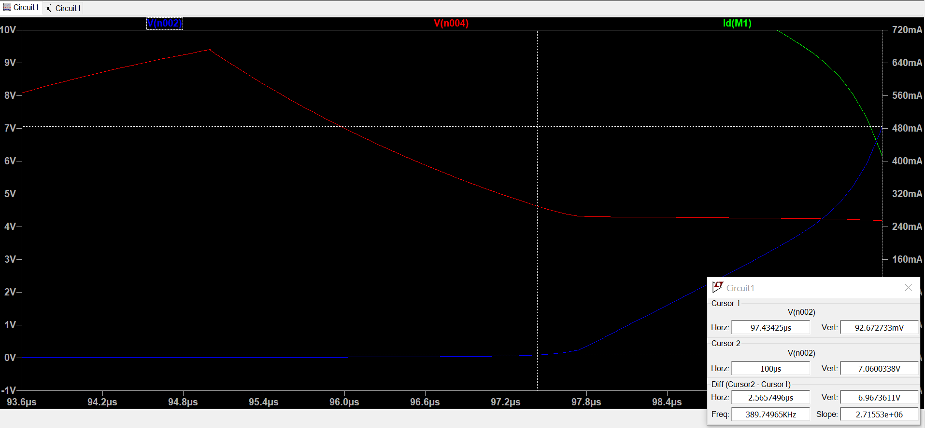

- rise time
Id
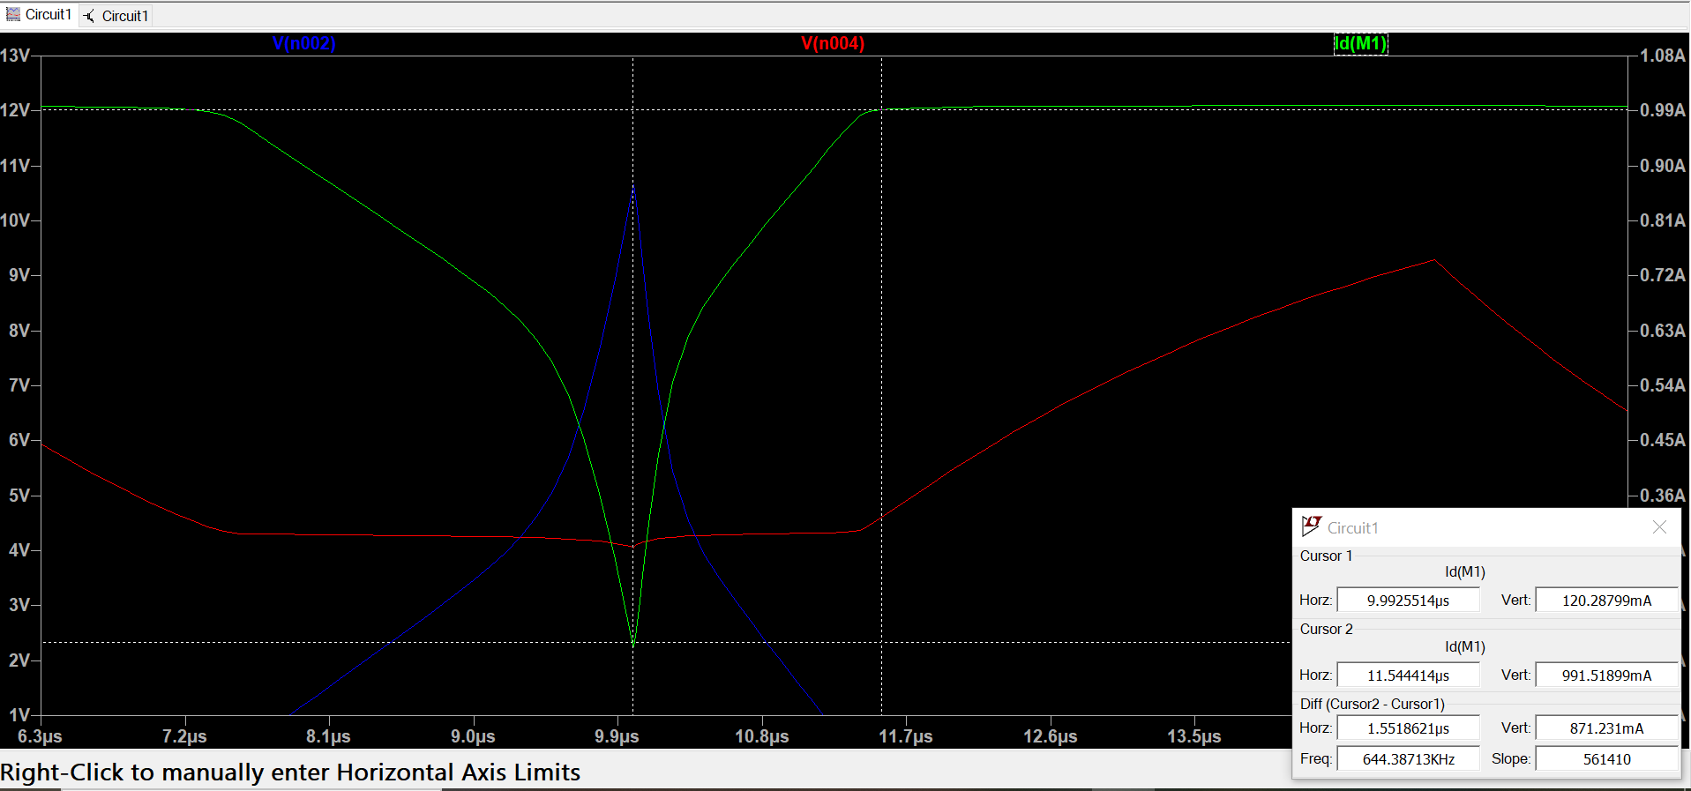
Vds
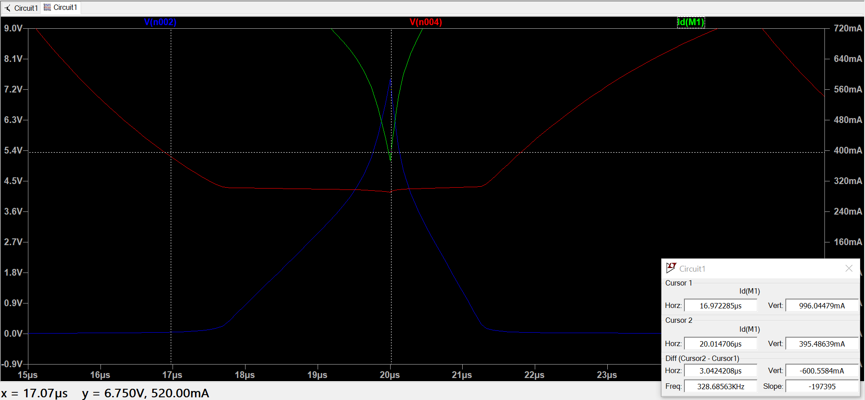
Vgs
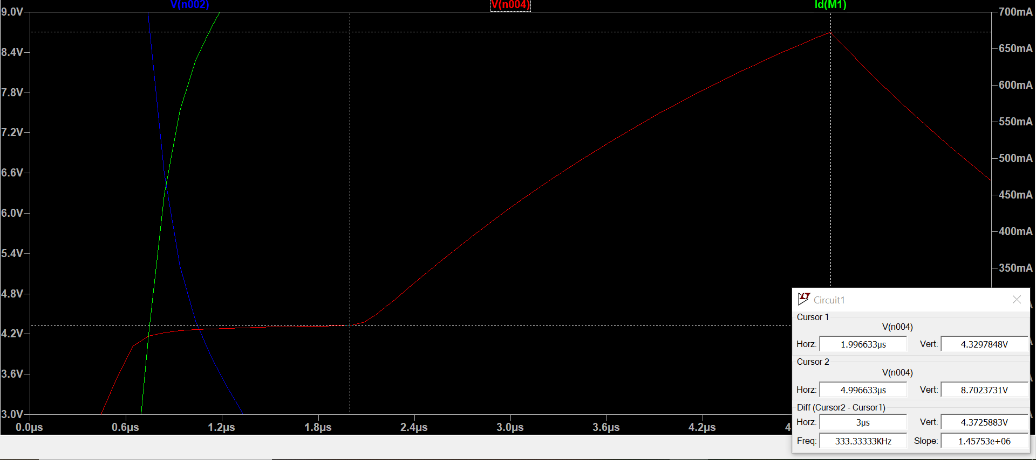
- fall time
Id
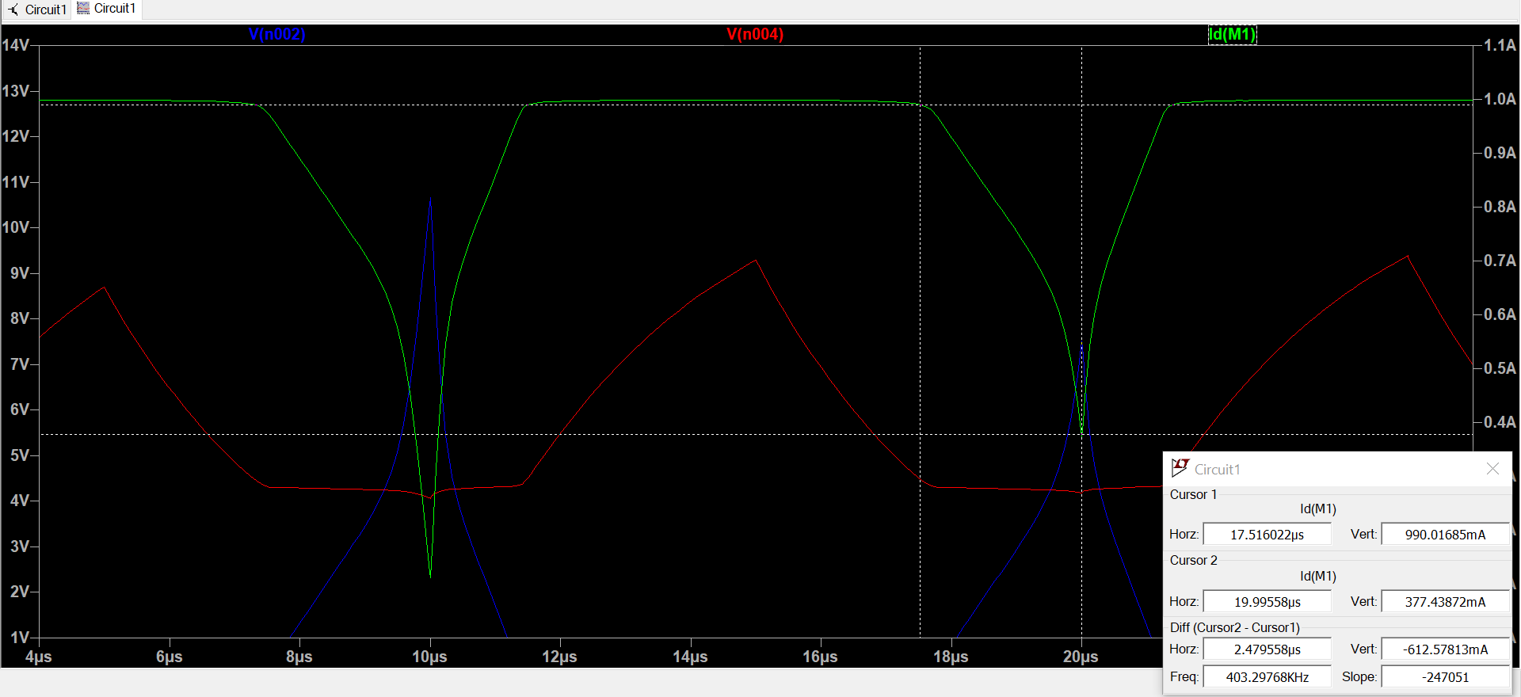
Vds
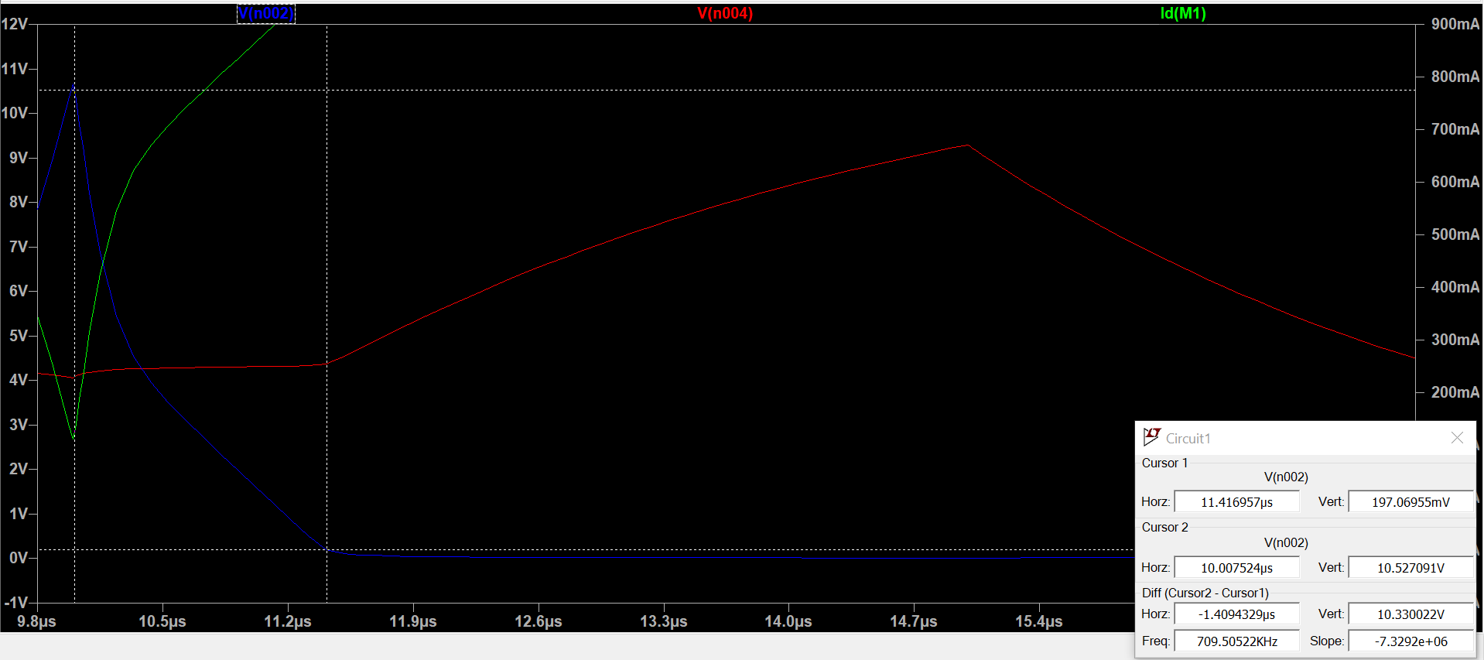
Vgs
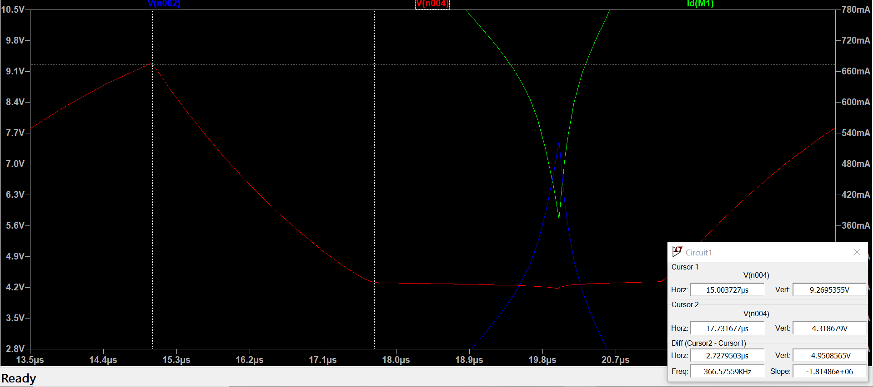
- turn-on plateau
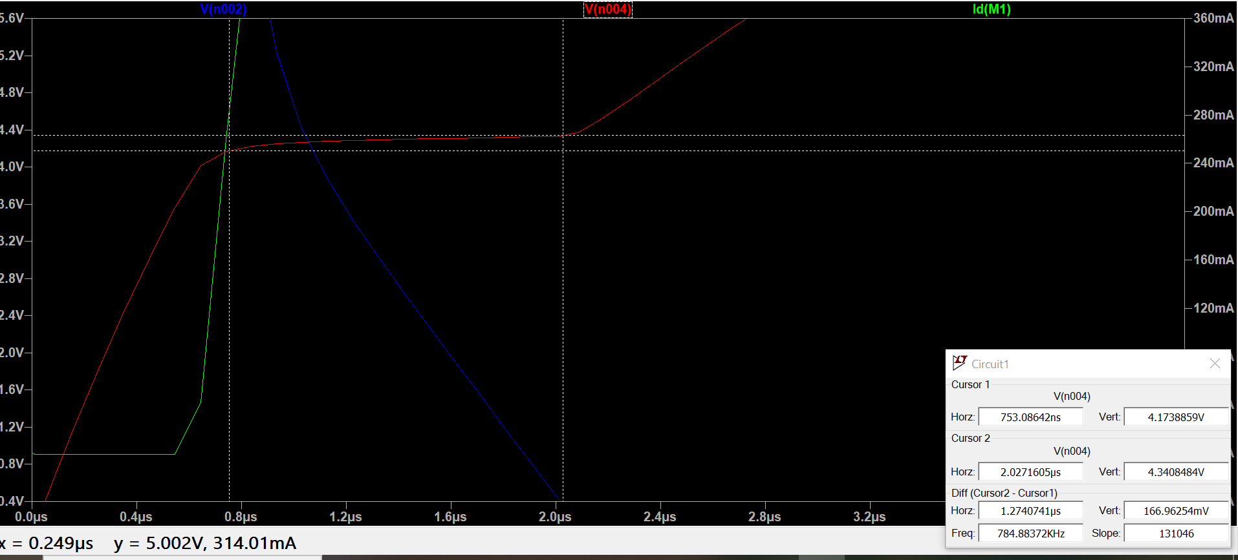
- turn-off plateau,
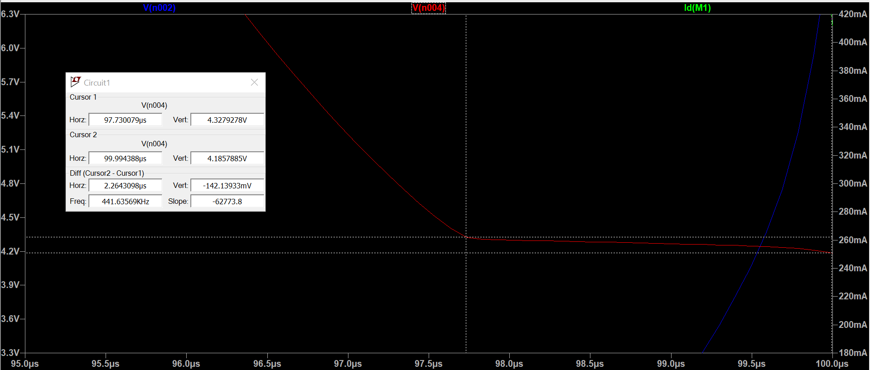
- and any overshoot or oscillation due to parasitics.
Current overshoot
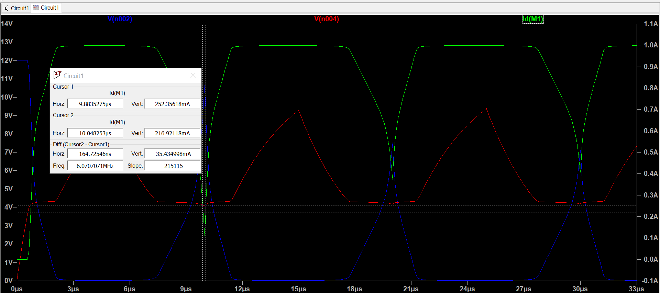

Vds overshoot
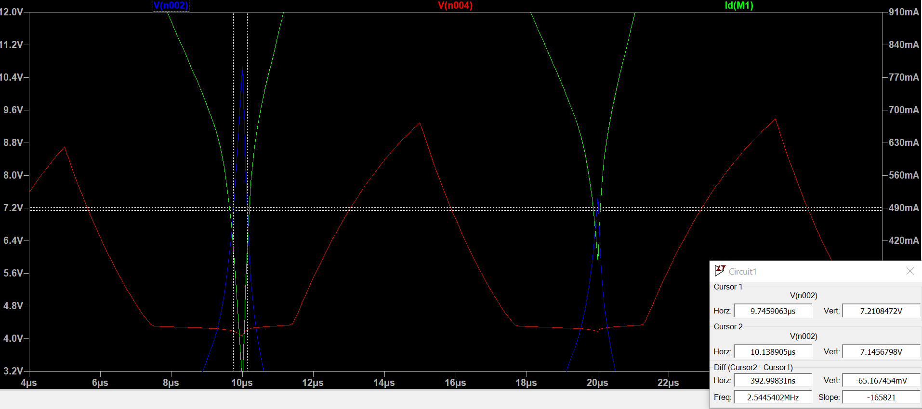

- Eksperimental
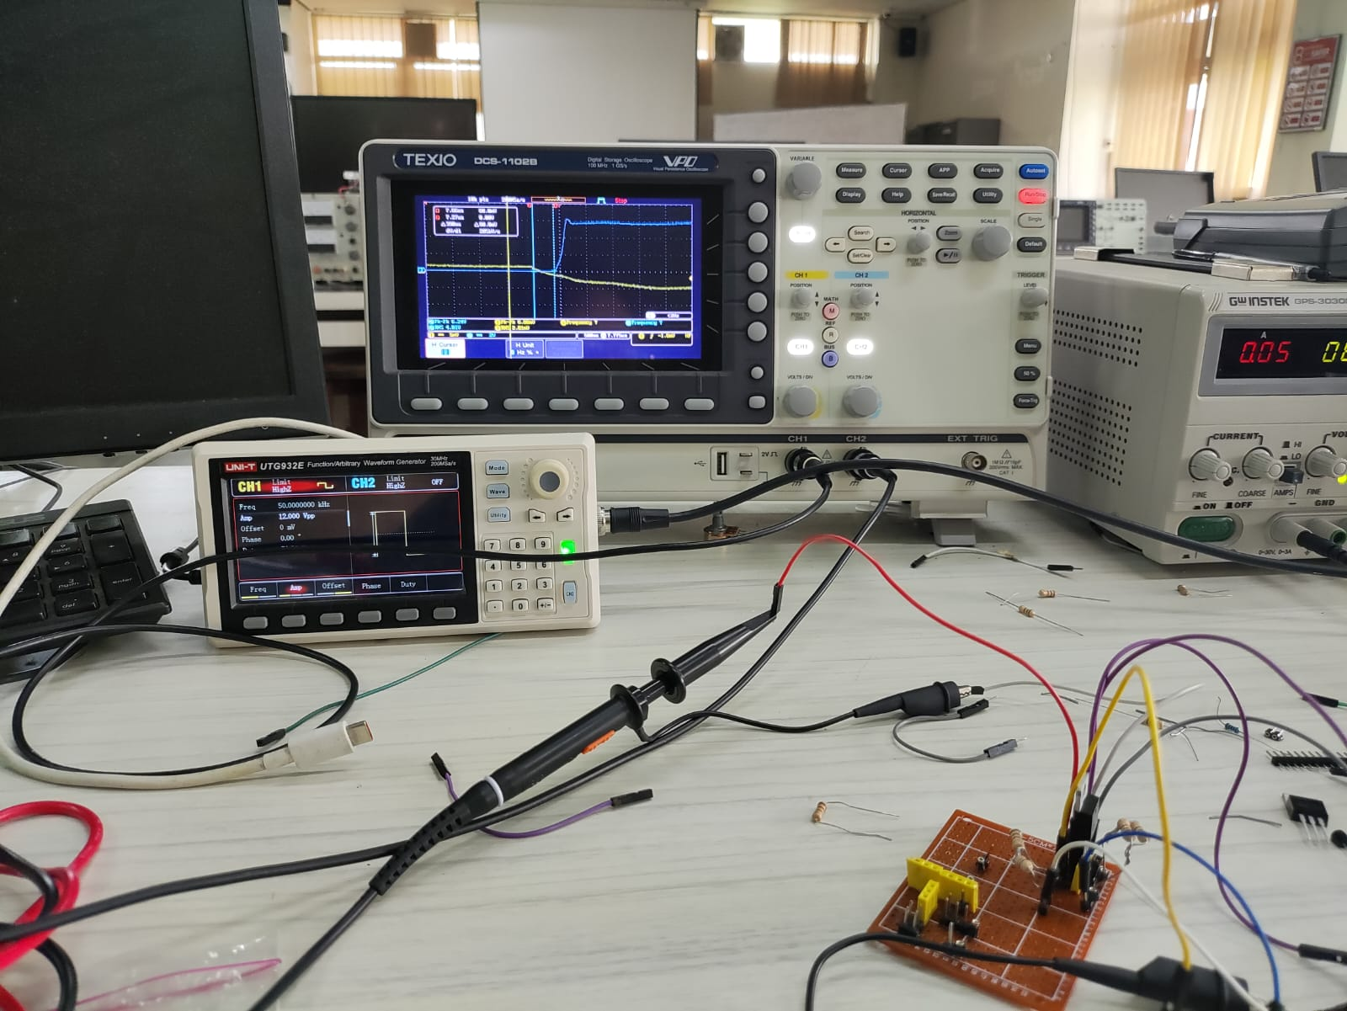
- Turn on delay
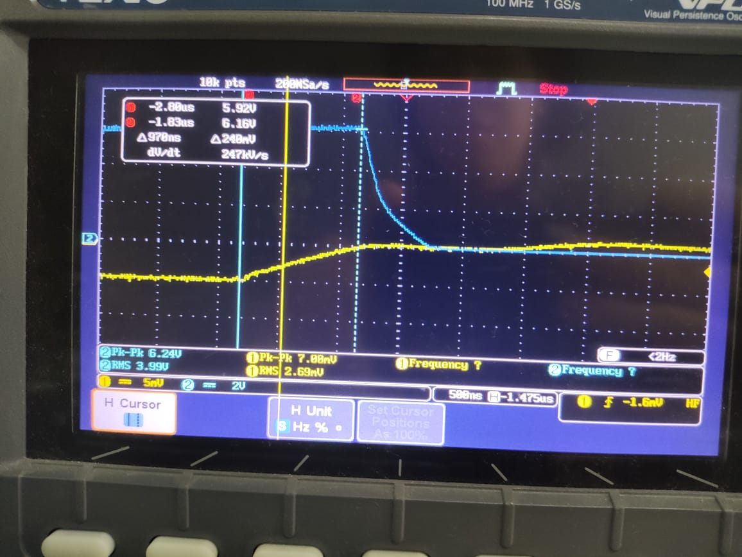
- Turn off delay
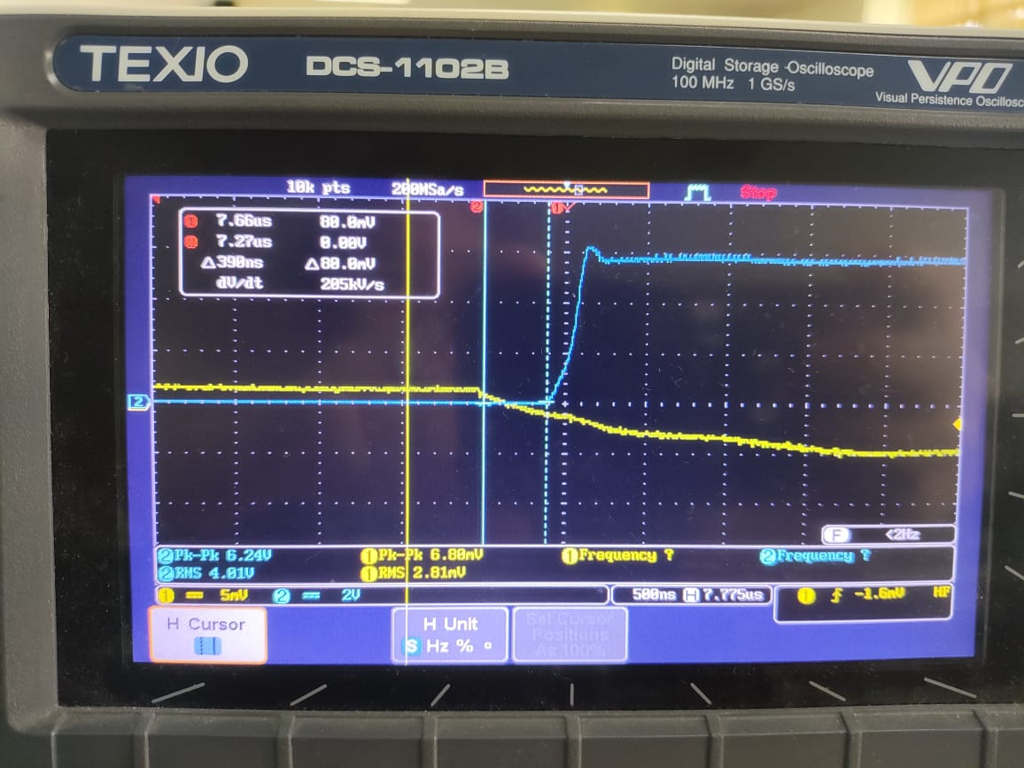
- Plateau
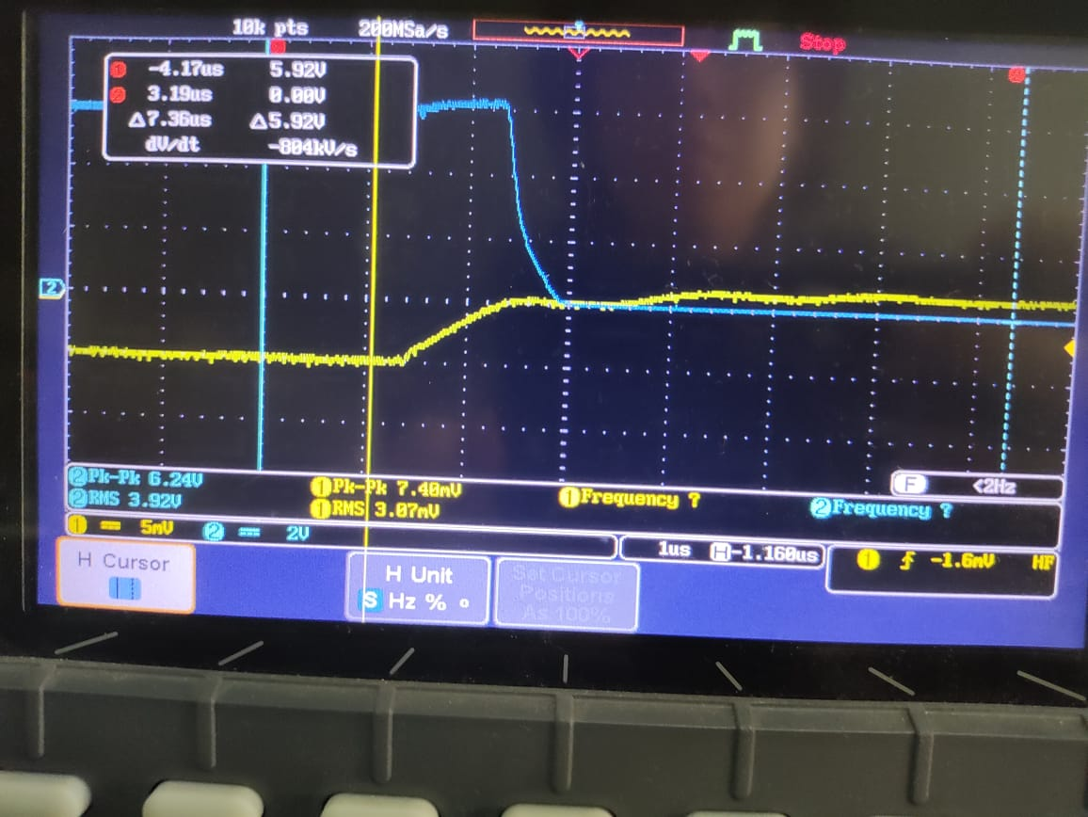
- Rise time fall time
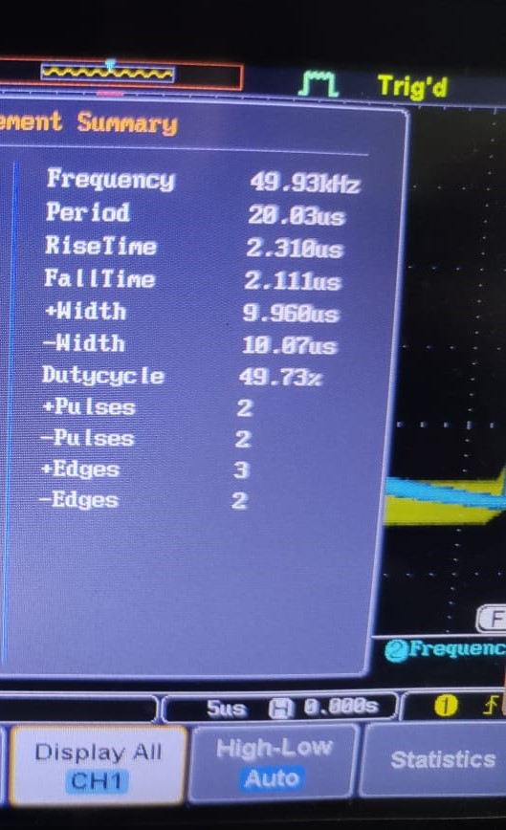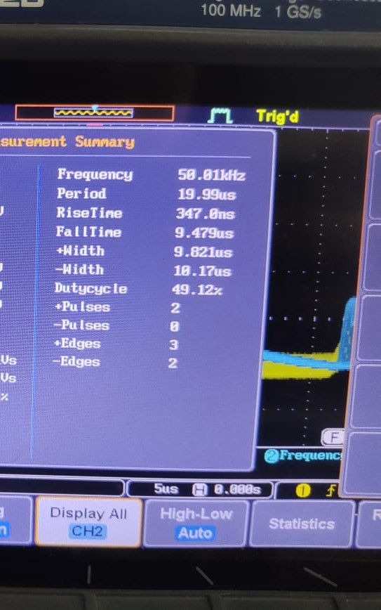

FIGURE 2
- Simulasi
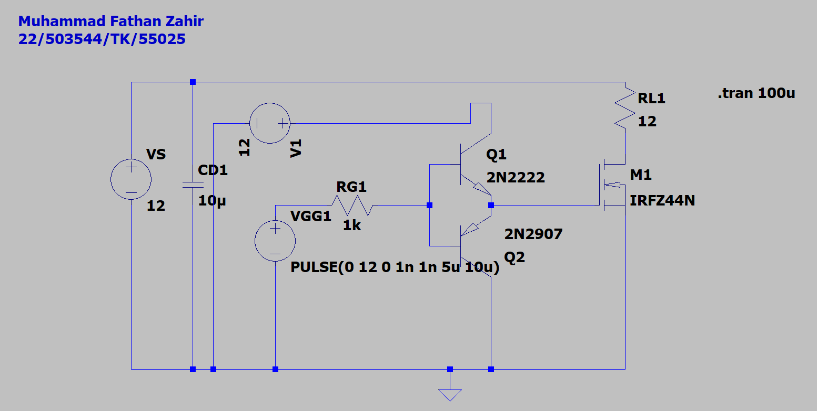

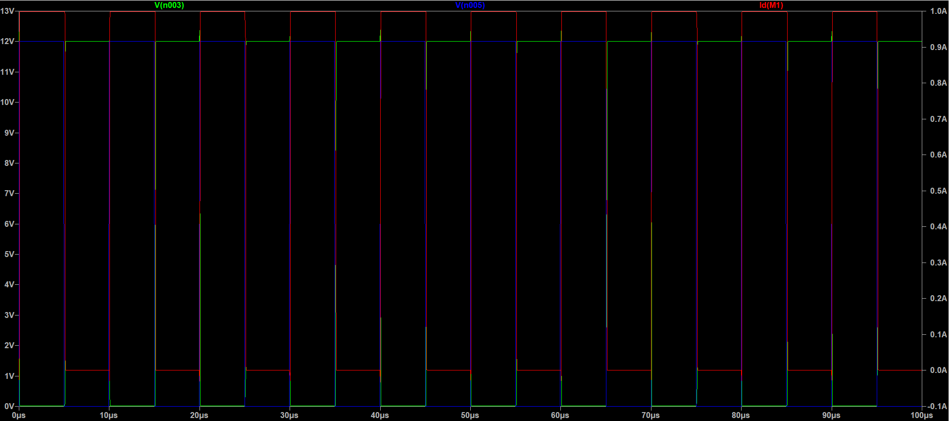
Hijau: VDS
Biru: VGS
Merah: Id

- Turn on delay
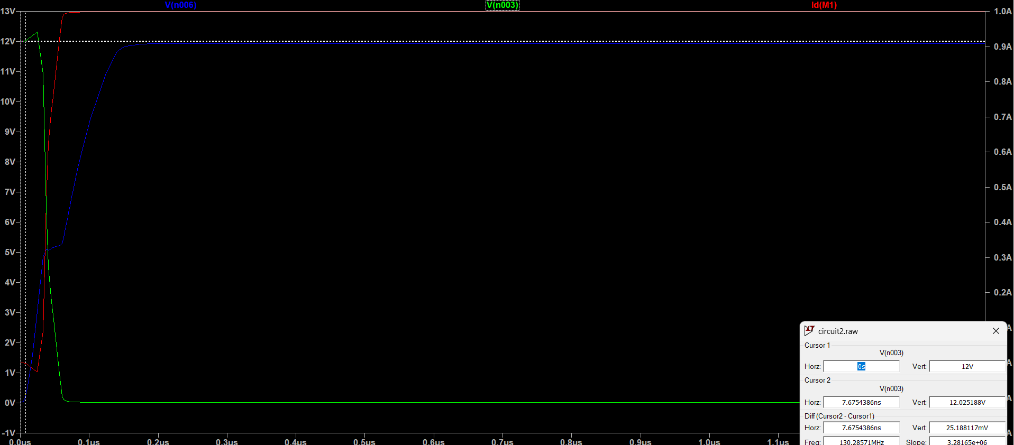
7,6754386ns
- Turn off delay
- 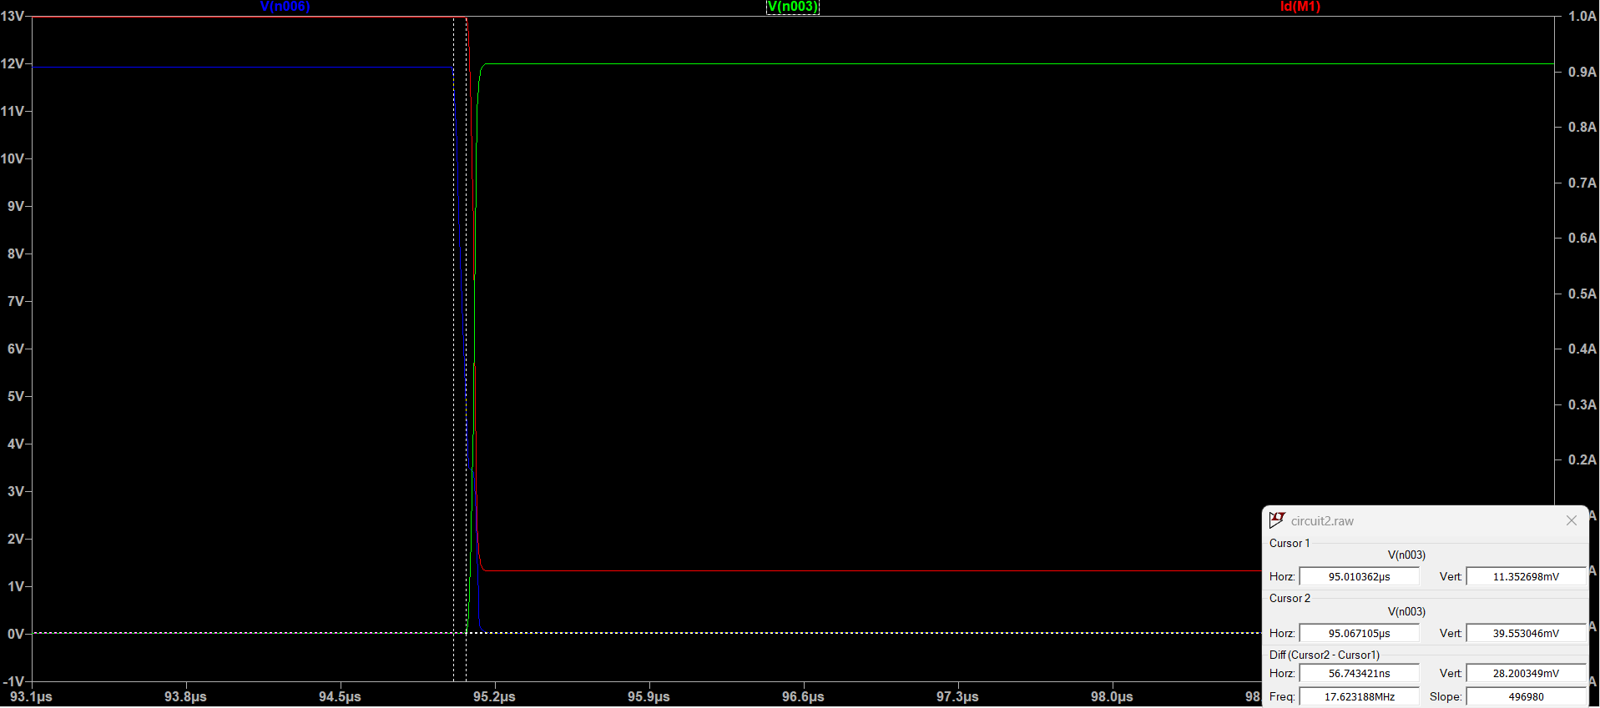
- Rise time
Id
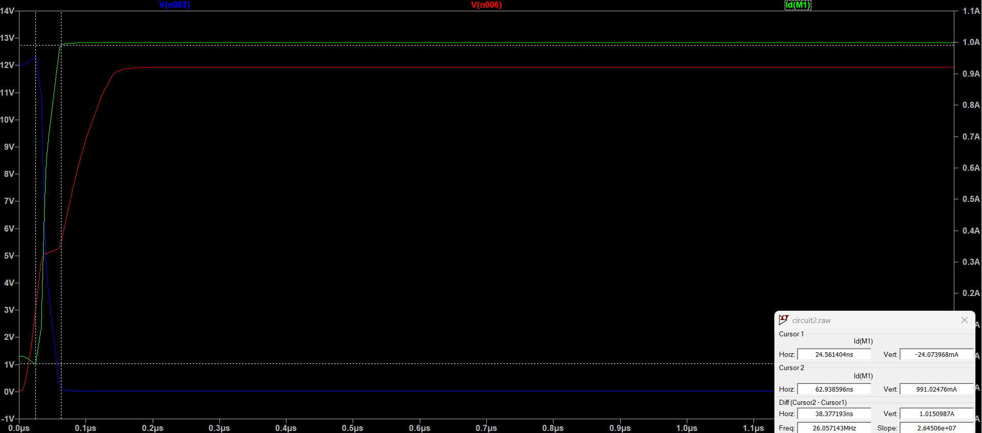
Vds
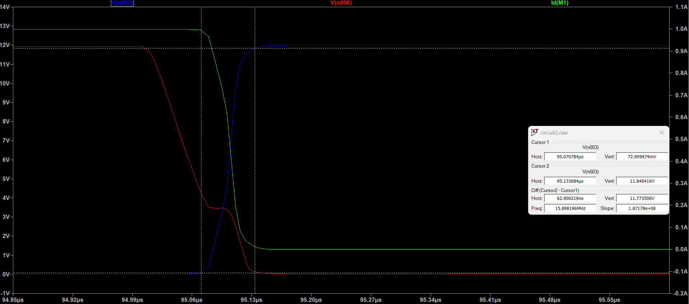
Vgs
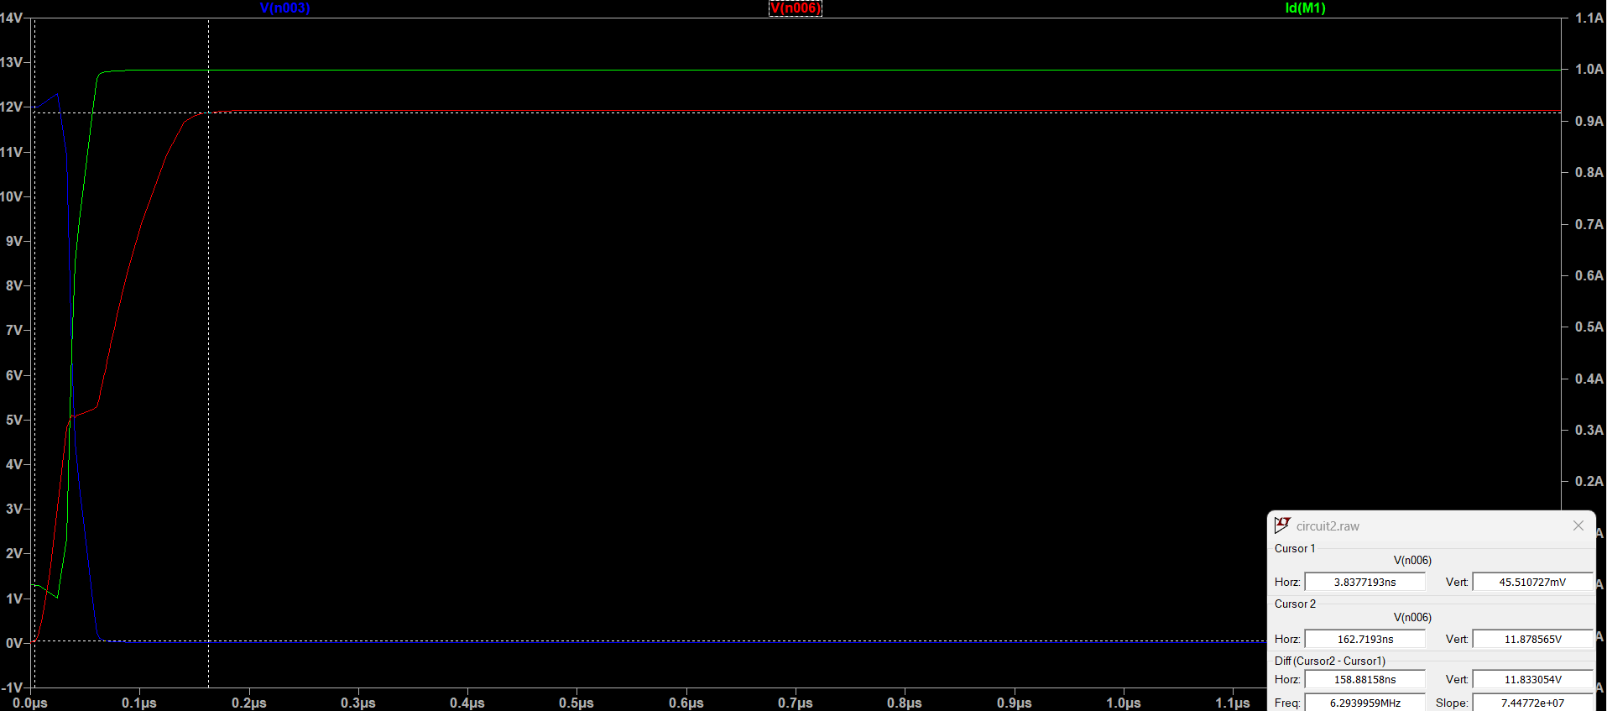
- Fall time
Id
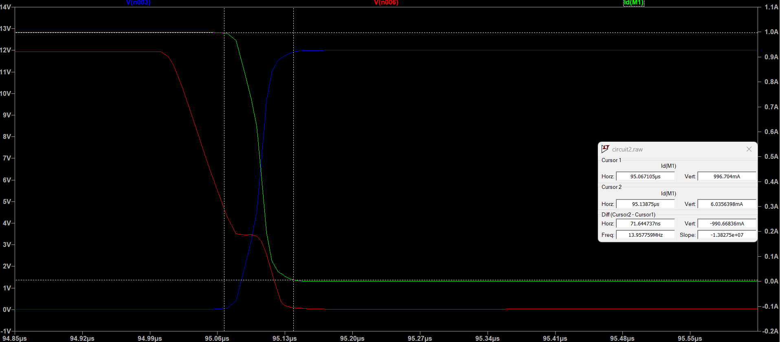
Vds
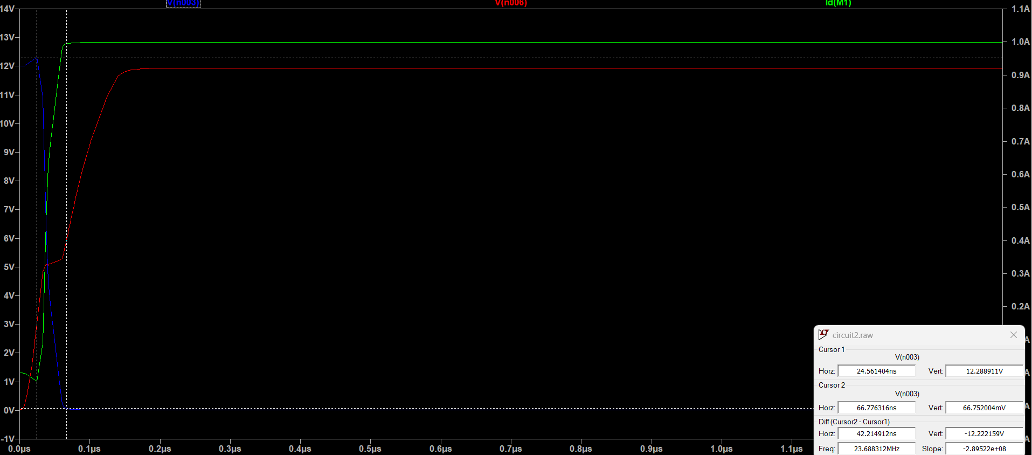
Vgs
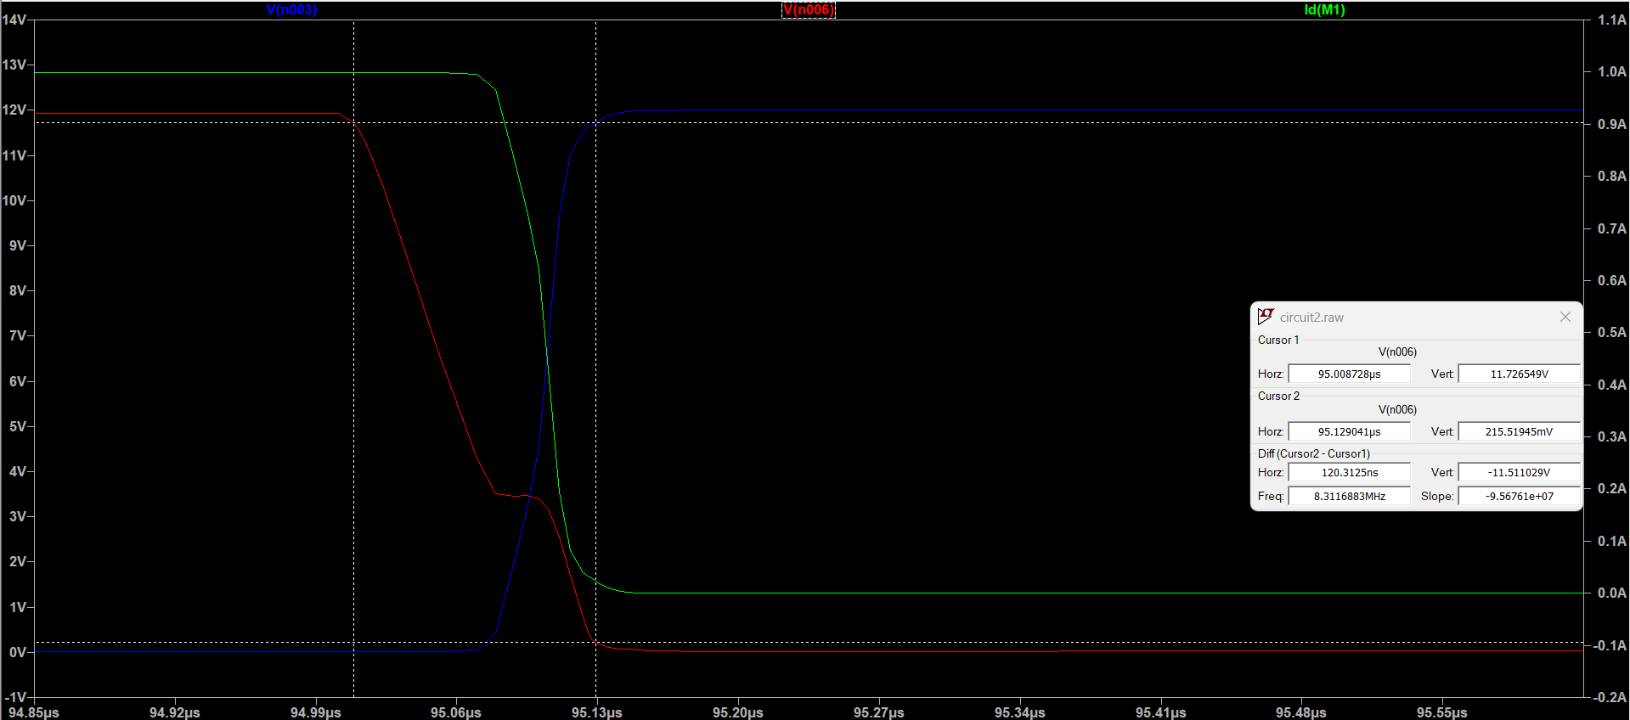
- Turn on plateau
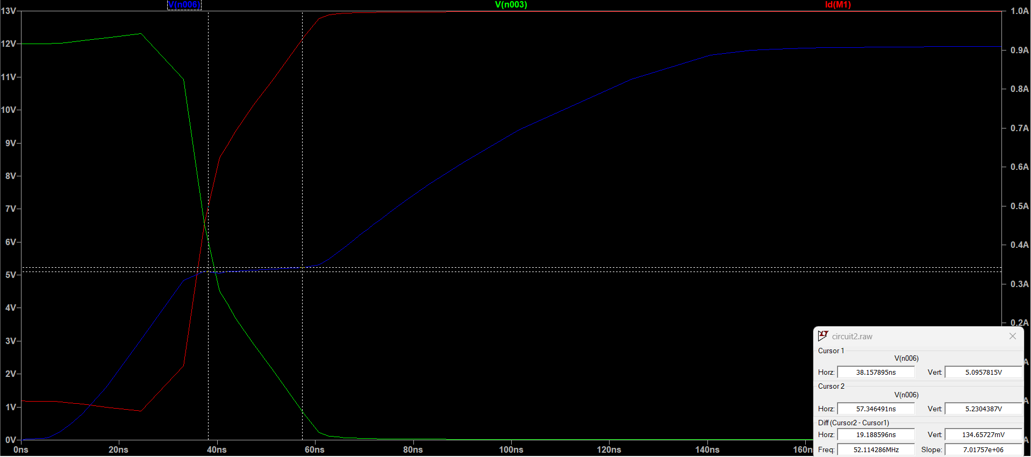
- Turn off plateau
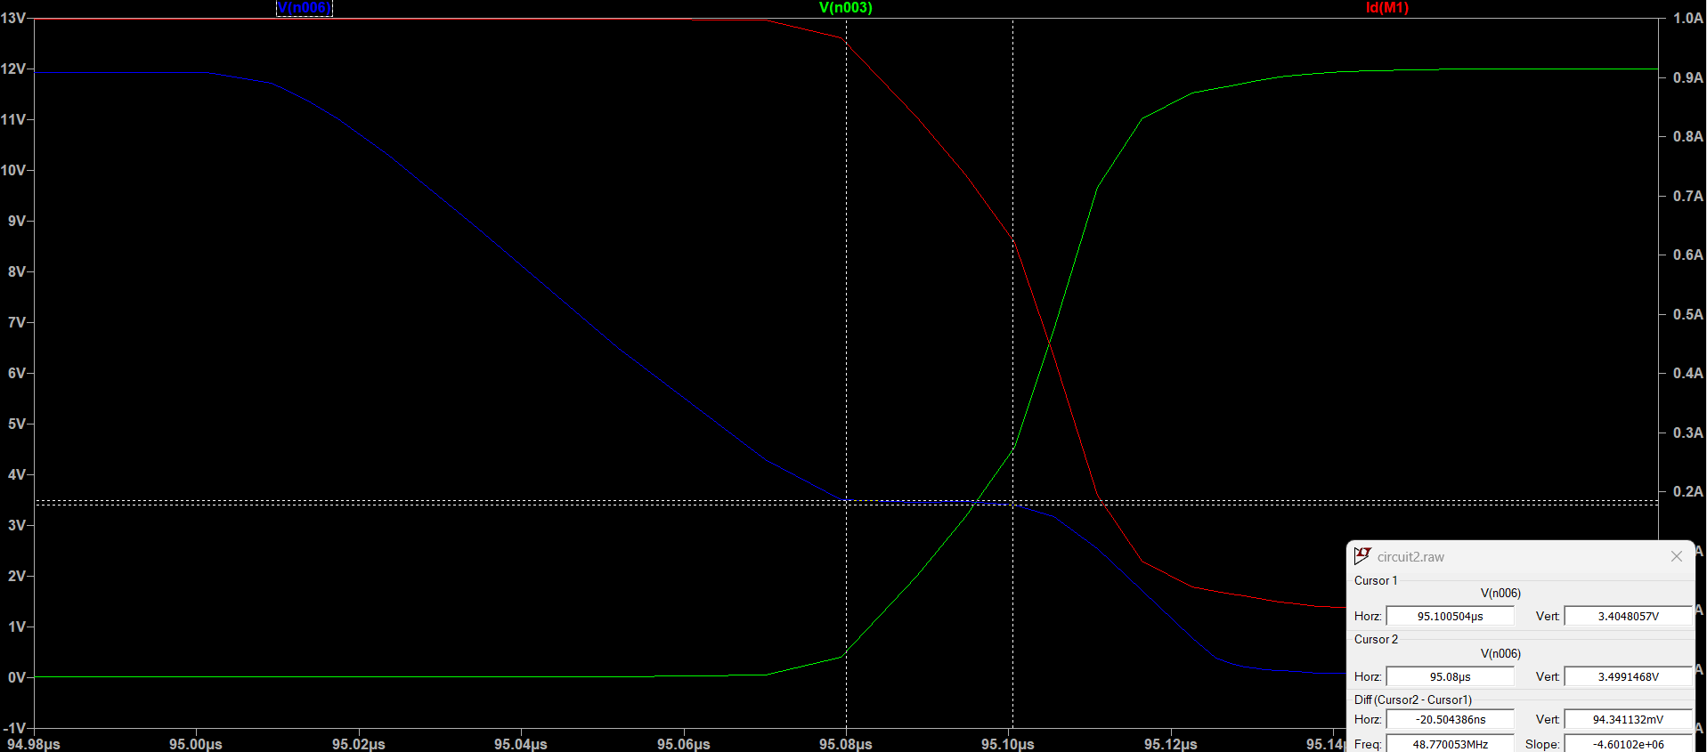
- Overshoot
Current overshoot
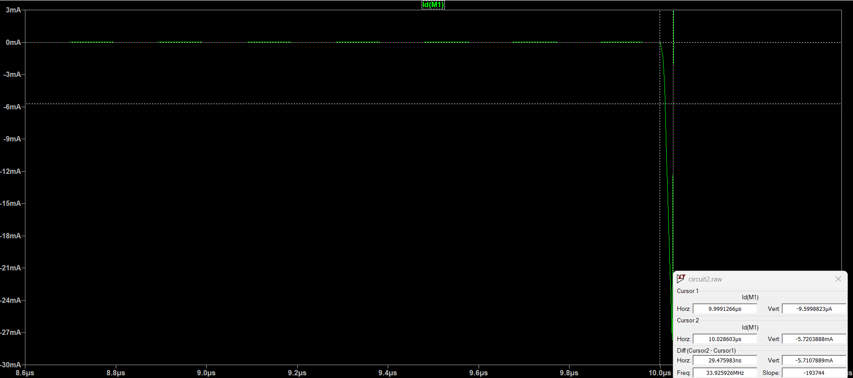
Vds overshoot
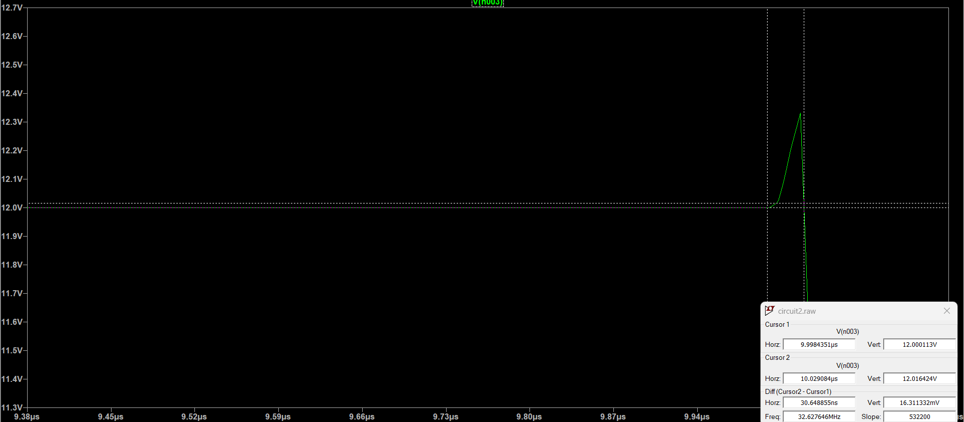

- Eksperimental
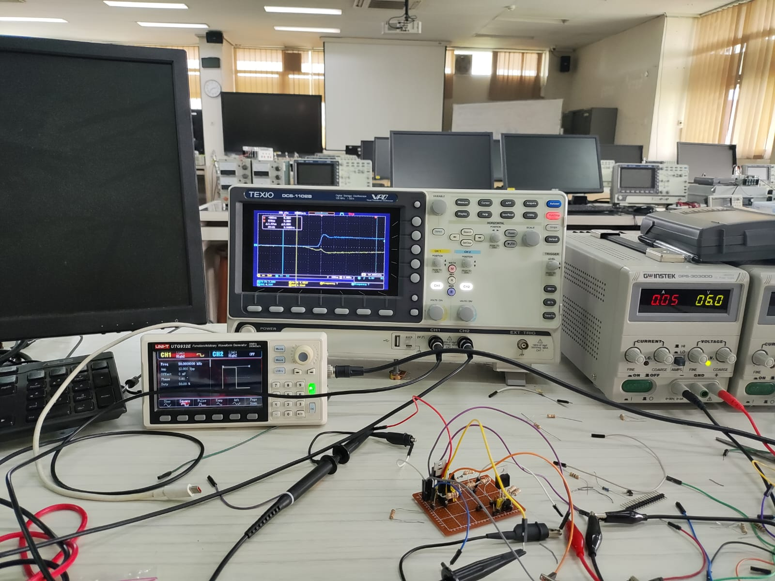
- Turn on delay
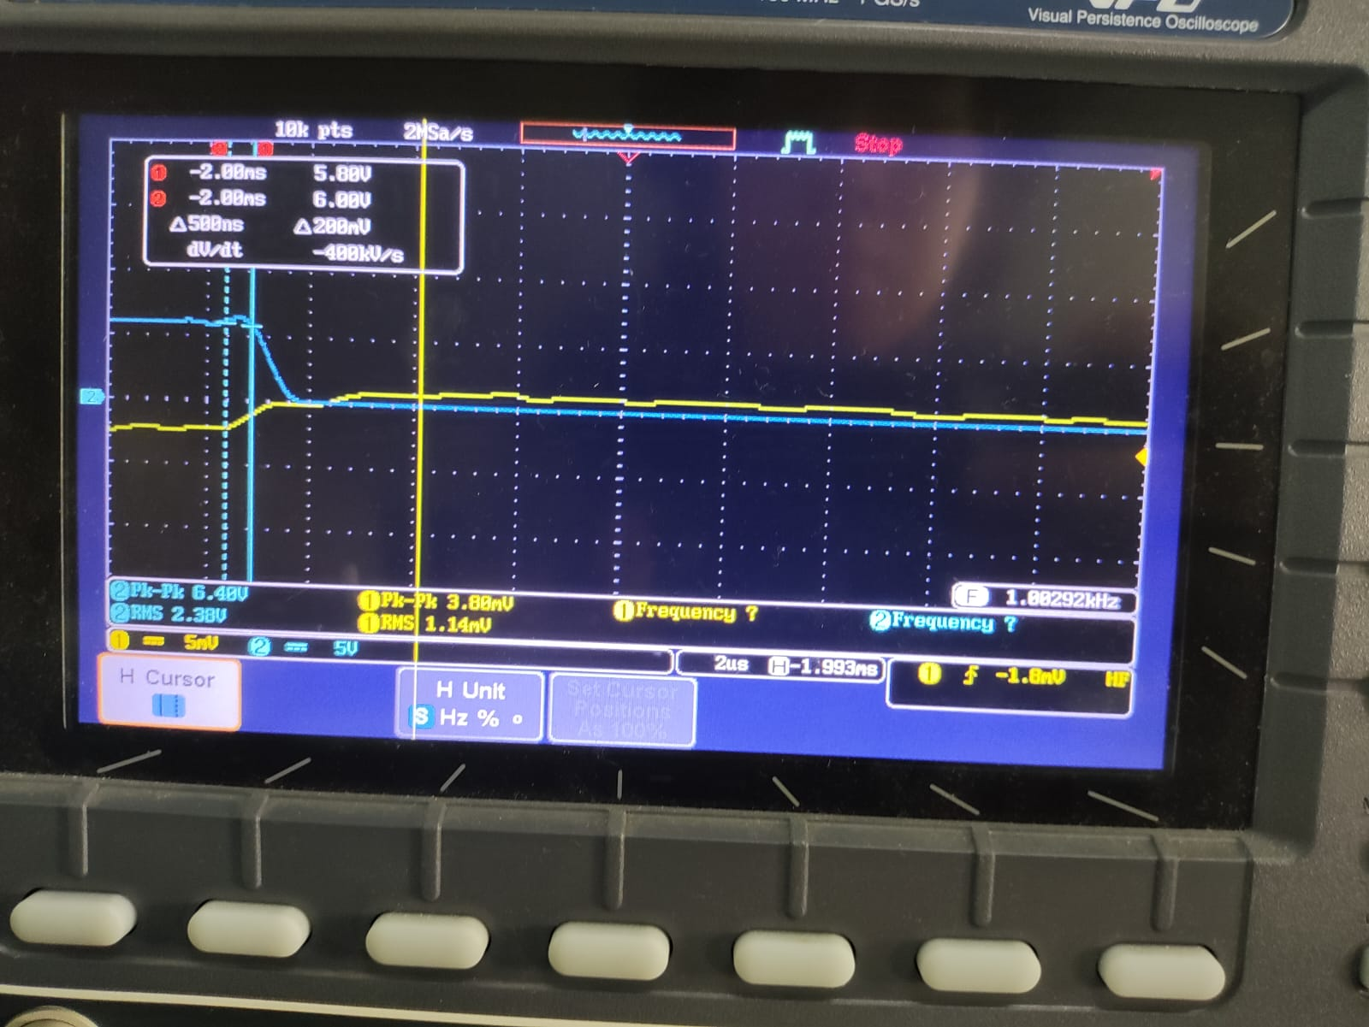
- Turn off delay
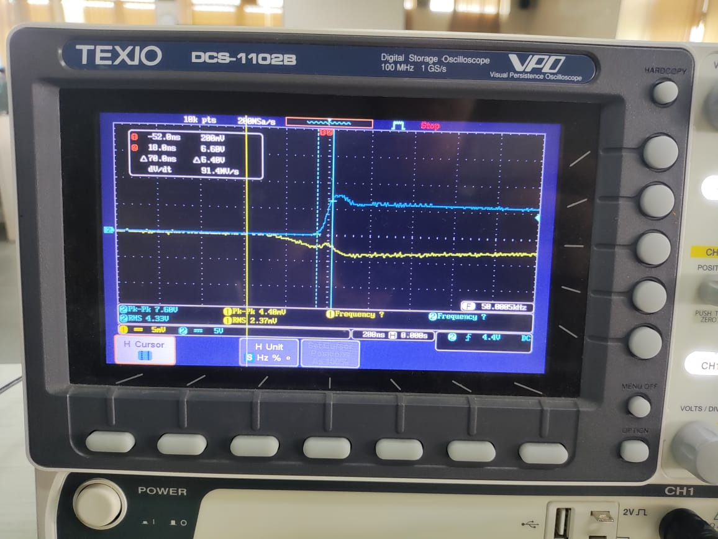
- Plateau
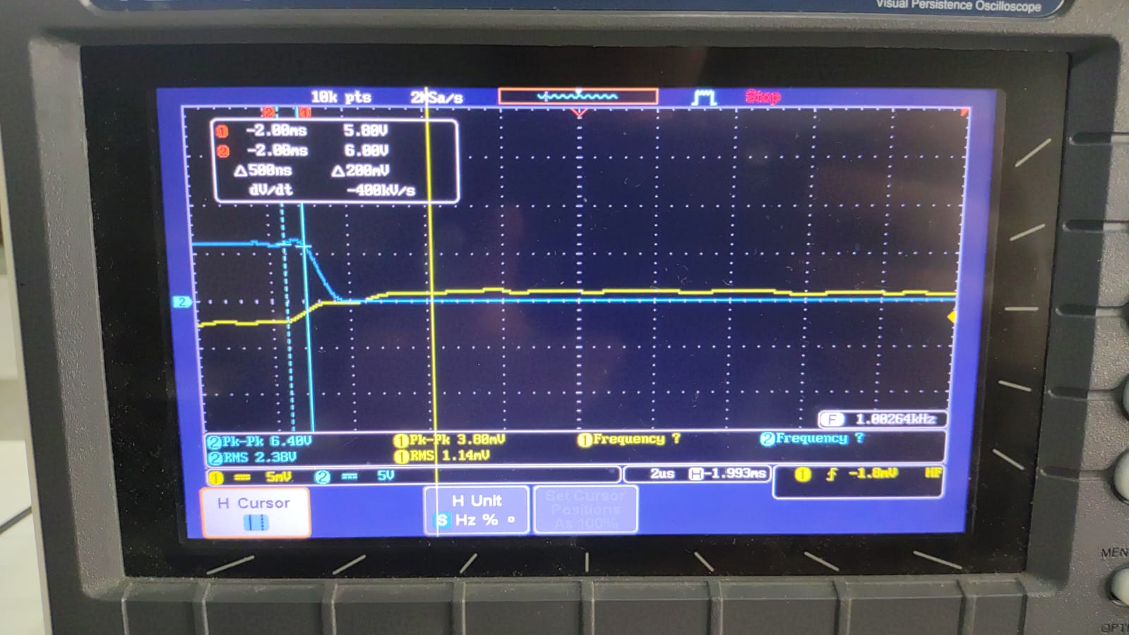
- Rise time
Vgs
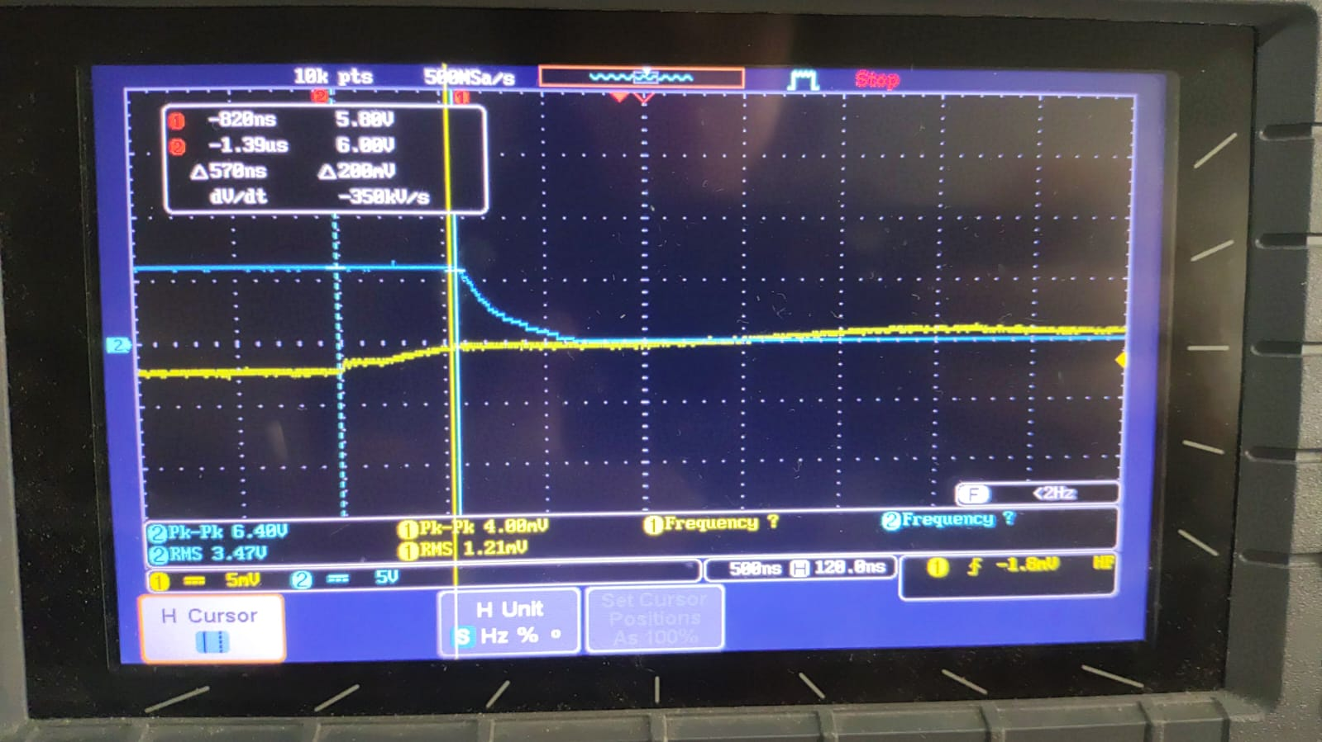
Vds
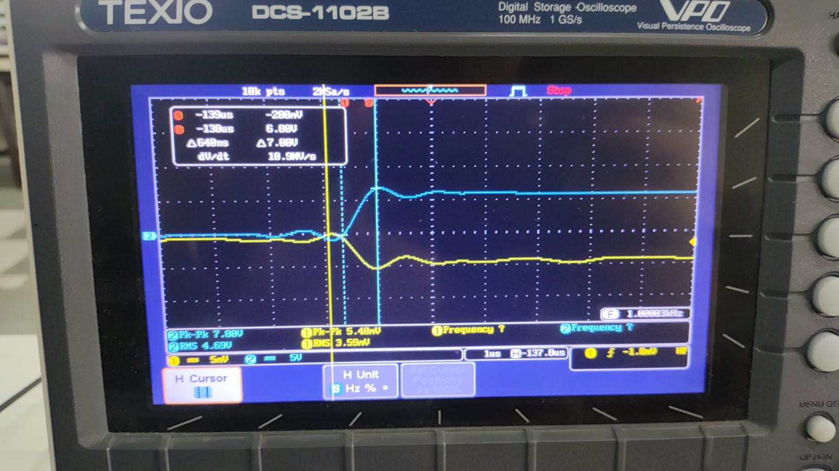
- Fall time
Vgs
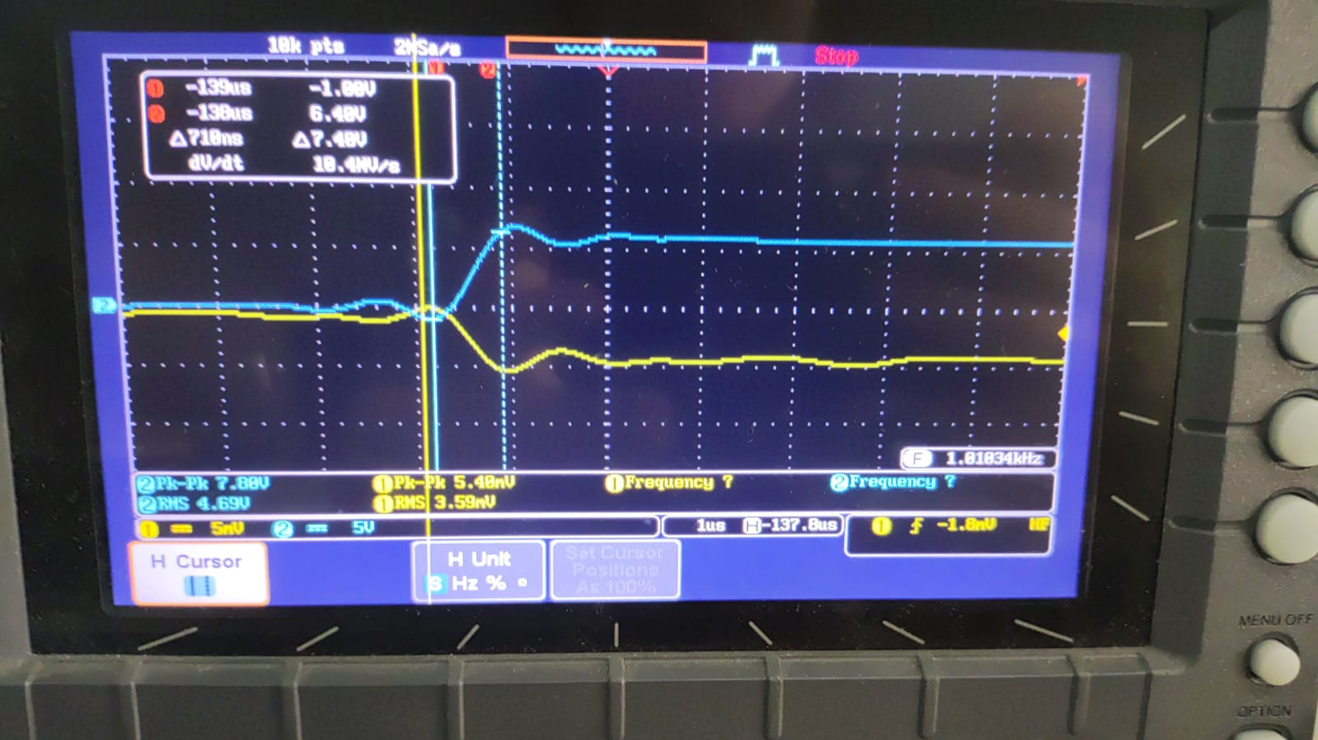
Vds
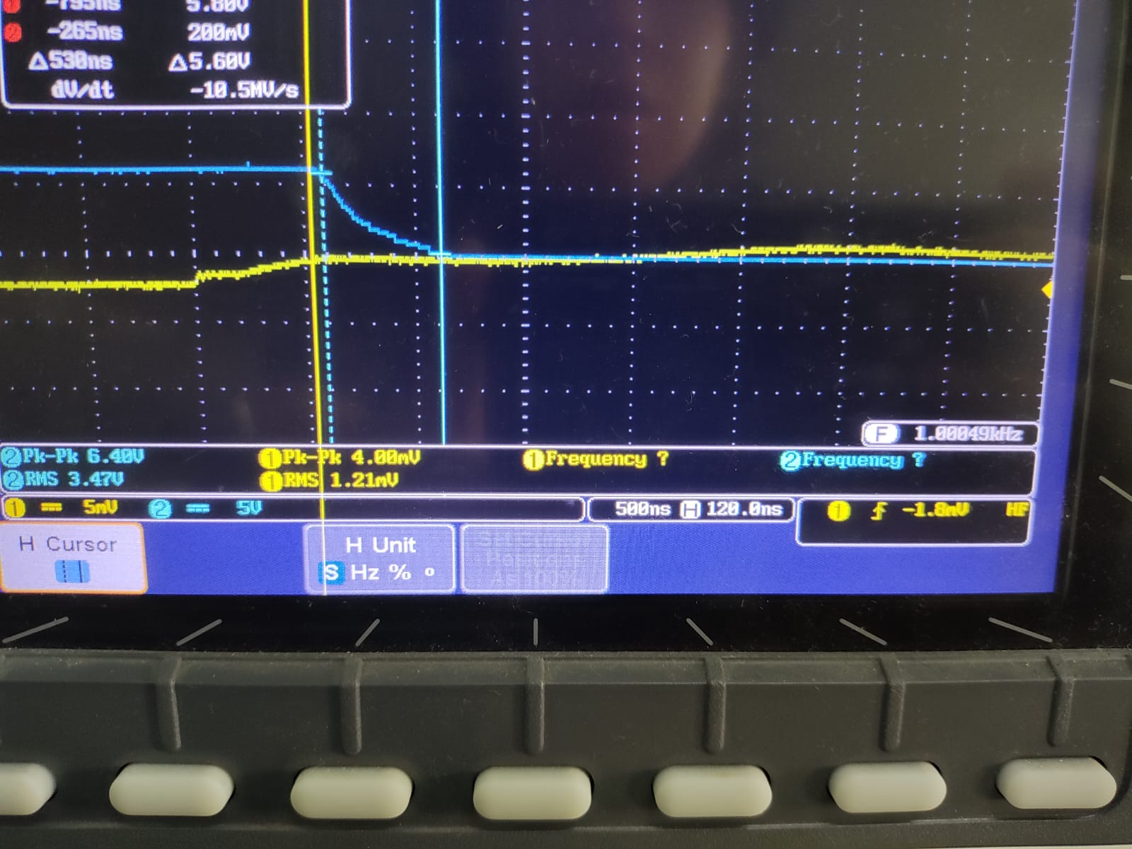

ANALISIS

1. How does the totem-pole driver improve MOSFET switching performance compared to using only a gate resistor and voltage source?
Ans:
The circuit that utilises totem-pole driver for MOSFET on top of the gate resistor and voltage have faster switching performance. This is done by decoupling the gate current limits from the logic signal source. The totem-pole acts as a current buffer that can rapidly source (push) and sink (pull) high currents to charge and discharge the MOSFET's gate capacitance. The top NPN connects the gate directly to Vcc, and the bottom to the ground. This allows it to have higher current.
Using only simple gate resistor and voltage source make it limited by the weak current capability of the source. The totem-pole dumps high current to fill the capacitor instantly.
Based on the result from simulation and experimentation, the shape of the plot appears more triangular or like a sawtooth. This shows that there is high impedance. Since the MOSFET spends a lot of its time being halfway on, this generates heat and make the MOSFET hot. The one with totem pole is more stable with its square wave (with the plateau and some transition still visible in lower time delay). The voltage went to 12 V faster which show low impedance. Because the MOSFET in the totem-pole circuit is fully on and fully off, it generates less heat.

2. Explain how the sourcing and sinking currents of the BJTs affect the switching speed.
Ans:
Sourcing and sinking currents affect switching speed by controlling the rate of change of the gate voltage. When the driver switches high, the top NPN transistor activates to source current. It connects the gate to Vcc 12 V. The NPN transistor amplifies the input current, dumping current into the gate so the gate voltage increases quickly. The MOSFET turns on fast. When the driver switches low, the bottom PNP transistor activates to sink current. It connects gate to the ground by providing low resistance drain. It sucks the charge out of the gate immediately. This is visualised by the difference between the more triangular or the more apparent slope that going up and going down in the gate resistor only circuit compared to the one with totem-pole which shows more square shaped wave.

3. Analyze the effect of gate resistance Rg on: (a) Switching speed (b) dv/dt and di/dt (c) Switching energy/losses.
Ans:
a). The effect of gate resistance on switching speed reflects that of an inverse relationship. Increasing gate resistance slows down switching speed. MOSFET gate acts like a capacitor. Together with the gate resistor, they form an RC circuit with a time constant Tau = Rg x Ciss.
b). There is an inverse relationship: Increasing Rg reduces the rates of change dv/dt and di/dt. Low Rg causes current changes extremely fast. While efficient, this interacts with parasitic inductance L in the circuit traces to create voltage spikes.
c). Gate resistance Rg have direct relationship with switching losses where increasing gate resistance increases switching loss and generates more heat. Switching loss occurs only during the crossover period where it’s a brief moment when the MOSFET has both high voltage across it and high current flowing through it simultaneously.

TASK 2

OBJECTIVE 1

OBJECTIVE 2
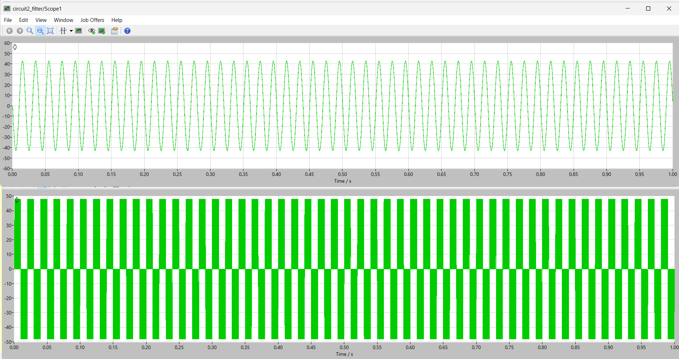
- Power MOSFET gate driver fundamentals - Nexperia, diakses Desember 24, 2025, https://assets.nexperia.com/documents/application-note/AN90059.pdf
- IRF540N 33A, 100V, 0.040 Ohm, N-Channel, Power MOSFET - uri=media.digikey, diakses Desember 24, 2025, https://media.digikey.com/pdf/Data%20Sheets/Fairchild%20PDFs/IRF540N.pdf
- IRF540 Power MOSFET - Vishay, diakses Desember 24, 2025, https://www.vishay.com/docs/91021/irf540.pdf
- Data Sheet - IRF540N - Infineon Technologies, diakses Desember 24, 2025, https://www.infineon.com/dgdl/Infineon-IRF540N-DataSheet-v01_01-EN.pdf?fileId=5546d462533600a4015355e39f0d19a1
- APPLICATION NOTE U-137 - Texas Instruments, diakses Desember 24, 2025, https://www.ti.com/lit/pdf/slua105
- Power MOSFET Basics: Understanding Gate Charge and Using it to Assess Switching Performance - Vishay, diakses Desember 24, 2025, https://www.vishay.com/docs/73217/an608a.pdf
- PRACTICAL CONSIDERATIONS FOR MOSFET SLEW-RATE CONTROL IN SMART GATE-DRIVER APPLICATIONS - Allegro MicroSystems, diakses Desember 24, 2025, https://www.allegromicro.com/-/media/files/application-notes/an296347-mosfet-slew-rate-control.pdf?sc_lang=en
- Why is the gate charge curve (Miller plateau) of MOSFETs dependent on Vds?, diakses Desember 24, 2025, https://electronics.stackexchange.com/questions/66660/why-is-the-gate-charge-curve-miller-plateau-of-mosfets-dependent-on-vds
- Seminar 1400 Topic 2 APDX Estimating MOSFET Parameters from the Data Sheet - Texas Instruments, diakses Desember 24, 2025, https://www.ti.com/lit/pdf/slup170
- Isolated Gate Drivers—What, Why, and How? - Analog Devices, diakses Desember 24, 2025, https://www.analog.com/en/resources/analog-dialogue/articles/isolated-gate-drivers-what-why-and-how.html
- Totem Pole use as a Mosfet Driver Circuit - Microcontrollers Lab, diakses Desember 24, 2025, https://microcontrollerslab.com/totem-pole-tutorial/
- Practical Considerations in High Performance MOSFET, IGBT, and MCT Gate Drive Circuits, diakses Desember 24, 2025, https://www.engr.colostate.edu/ECE461/chapter_supplements/ch21_supp2.pdf
- When to NOT use Totem Pole Drivers? - Electrical Engineering Stack Exchange, diakses Desember 24, 2025, https://electronics.stackexchange.com/questions/17810/when-to-not-use-totem-pole-drivers
- A Comparison Review of the Resonant Gate Driver in the Silicon MOSFET and the GaN Transistor Application - DTU Research Database, diakses Desember 24, 2025, https://orbit.dtu.dk/files/177200330/1_reference_copy.pdf
- Turn-ON and OFF dv/dt and di/dt of SiC MOSFET at different gate resistance, Rg at T j = 30 • C. - ResearchGate, diakses Desember 24, 2025, https://www.researchgate.net/figure/Turn-ON-and-OFF-dv-dt-and-di-dt-of-SiC-MOSFET-at-different-gate-resistance-Rg-at-T-j_fig5_322244871
- Optimisation of dV/dt – Losses Trade Off Using Switchable Gate Resistance - EEPower, diakses Desember 24, 2025, https://eepower.com/technical-articles/optimization-of-dvdt-losses-trade-off-using-switchable-gate-resistance/
- MOSFET power losses and how they affect power-supply efficiency - Texas Instruments, diakses Desember 24, 2025, https://www.ti.com/lit/pdf/slyt664
- Bookkeeping Your MOSFET Losses, With Formulas! - Cadence PCB Design & Analysis, diakses Desember 24, 2025, https://resources.pcb.cadence.com/blog/bookkeeping-your-mosfet-losses-with-formulas
- Power quality comparison of single-phase and three-phase inverter topologies for renewable energy systems, diakses Desember 24, 2025, https://www.ijsgce.com/uploadfile/2019/0215/20190215032000860.pdf
- Comparative Simulation Study of Unipolar And Bipolar Pwm Strategies for Single-Phase Full-Bridge Inverters - Atlantis Press, diakses Desember 24, 2025, https://www.atlantis-press.com/article/126016764.pdf
- Unipolar and Bipolar PWM Inverter - IJIRST, diakses Desember 24, 2025, http://www.ijirst.org/articles/IJIRSTV1I7111.pdf
- Section 7. Three-phase inverter - WordPress.com, diakses Desember 24, 2025, https://ee504cbb.files.wordpress.com/2019/08/three-phase-inverters.pdf
- EN 206: Power Electronics and Machines - Inverters - Department of Energy Science and Engineering, diakses Desember 24, 2025, https://www.ese.iitb.ac.in/~suryad/lectures/EN206/Lecture-Inverter
- LCL filter design for photovoltaic grid connected systems - cder.dz, diakses Desember 24, 2025, https://www.cder.dz/download/sienr2014_31.pdf
- Inverter Filter Design | PDF - Scribd, diakses Desember 24, 2025, https://www.scribd.com/document/396804827/Inverter-Filter-Design
- Which is the accurate method of calculating L and C of the LC filter for a single phase grid connected inverter? | ResearchGate, diakses Desember 24, 2025, https://www.researchgate.net/post/Which-is-the-accurate-method-of-calculating-L-and-C-of-the-LC-filter-for-a-single-phase-grid-connected-inverter
- LC Filter Calculator, diakses Desember 24, 2025, https://www.omnicalculator.com/physics/lc-filter
LC filter - single-phase inverter - Electrical Engineering Stack Exchange, diakses Desember 24, 2025, https://electronics.stackexchange.com/questions/705624/lc-filter-single-phase-inverter

