E-Commerce – Winter 2026
Teacher: Tiago Bortoletto Vaz
A Pet Adoption Web Platform
PetConnect

Important Information
Section – 00001
Kiara Bartuccio – 2393920
The Vinh Vuong – 6311228
Oliver Davino – 6252915
James Luciano - 6304894

Team lead
The team leader for deliverable 1, is Kiara Bartuccio

Git Repository
https://github.com/fatherxcracker/eCommerceProject.git

Possible domain names
- www.petconnect.ca
- www.petconnect.com
- www.adoptpetconnect.com
- www.petconnecthub.com

Project Description

Purpose

The purpose of PetConnect is to enhance the process of pet adoption by introducing a centralized online system in which people can easily find and adopt pets. Most shelters and individuals find it hard to find potential adopters since they have minimal exposure and old systems. This site will focus on raising awareness among more individuals about available pets and providing a more efficient, accessible, and user-friendly adoption process.

Target Users

The main target users of PetConnect are the people and families that look to adopt pets, and the young people or directors that handle the listings of the pets. Users can shop through the available animals, filter results in accordance with their preference and place adoption requests. The system will allow administrators to maintain pet data, examine adoption applications and ensure accuracy and security of the platform.

Scope

For this project, we will create a full-stack PHP web application that has a user-facing interface and an administrative dashboard. The platform will enable user registration, secure authentication, and two-factor authentication, pet browsing and search and filtering, and adoption request interface. The system will also have things like MVC architecture, database integration, and security like hash passwords and input validation.

Important Features

Pet Listings and categories
Users can browse pets organized into categories like dogs, cats, and other animals. Each listing has details like breed, age, description, and images, making it easier for users to explore their options. Every pet will also have their own pet page to see the details properly.

Search
Users can search for pets using keywords and apply filters such as age, size, breed, and location. AJAX-based live search will allow results to update instantly without reloading the page.

2FA
Users can register accounts, log in, and have two-factor authentication for data protection.

Adoption request form
Users can submit adoption requests for pets they are interested in. The system tracks request status (pending, approved, rejected) and provides confirmation messages to users.

Adopted Pets view
After adopting a pet, the adoption history will be saved into the database and viewed by the owner and the client who adopted the pet.

Admin dashboard
Administrators can log in to manage pet listings, approve or reject adoption requests, and monitor user activity.

Ai Assistant
Users have access to an AI assistant that can answer FAQs.

ERD (UML Diagram)
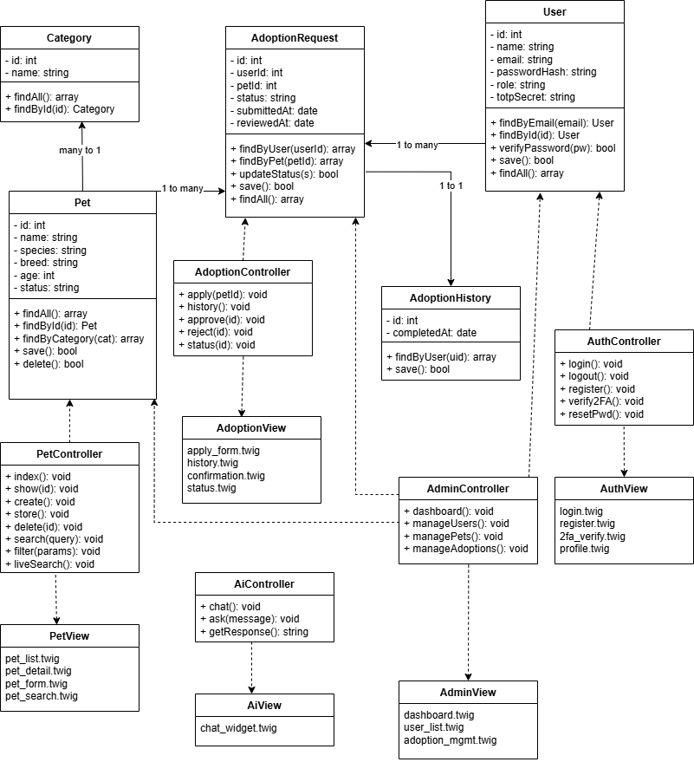

Deployment plan
The PetConnect application will be hosted on a Vercel for the front-end part, and the back-end will be on Railway. The database (MariaDB/MySQL) will be hosted either locally during development or through a managed service while in the making, there is also a possibility that the database can also be managed by railway.

Deployment Workflow
- Create mock-up for our website
- Develop the application locally using PHP
- Push the project to the GitHub repository
- Connect the repository to the hosting platform
- Configure environment variables (database credentials,..)
- Deploy the application
- Test the application and fix any issues

Team Workflow
We will use GitHub for collaboration and version control and Google Docs + Microsoft Word for documentation. Each team member will contribute using their own account, and tasks will be tracked using GitHub.

