PROJECT DEMONSTRATION PHASE
AI FAQ Assistant API

1. Purpose of Demonstration
This document walks through the working demonstration of the AI FAQ Assistant API, showing that all core modules — authentication, FAQ management, keyword search, and AI-assisted content generation — function correctly end to end. Each endpoint was tested using Postman inside Visual Studio Code, with the live server running locally on port 5000.

2. Environment Setup

2.1 Install Dependencies
npm install

2.2 Configure Environment Variables (.env)
PORT=5000 MONGO_URI=mongodb://127.0.0.1:27017/ai_faq_assistant JWT_SECRET=your_jwt_secret_key_here GEMINI_API_KEY=your_google_gemini_api_key_here

2.3 Start the Server
Development mode (auto-reload on file changes):
npm run dev
Production mode:
npm start
On a successful start, the terminal confirms the database connection and prints: "Server running in development mode on port 5000".

3. Testing Methodology
A pre-built Postman collection (AI_FAQ_Assistant_API.postman_collection.json) is included with the project. It defines two collection variables — baseUrl (http://localhost:5000) and token — and includes a test script on the Login request that automatically captures the returned JWT into {{token}}, so every subsequent protected request is authorised automatically.

- Public endpoints (register, login, list/search FAQs) were tested with no Authorization header.
- Protected endpoints (create/update/delete FAQ, AI routes) were tested with an Authorization: Bearer <token> header.

4. Step-by-Step Demonstration

Step 1 — User Registration
- Endpoint: POST /api/auth/register
- Access: Public
A new user is registered with a name, email, and password. The server hashes the password with bcrypt, stores the user, and immediately returns a signed JWT token.
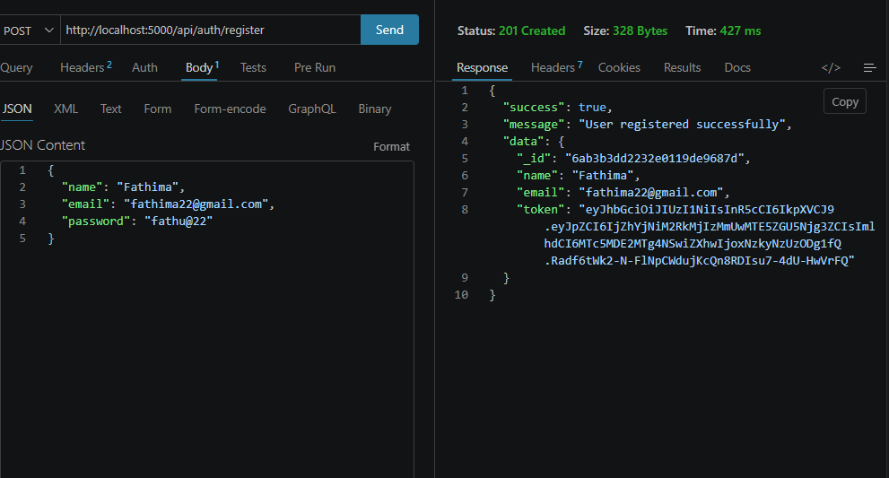

Step 2 — User Login
- Endpoint: POST /api/auth/login
- Access: Public
The registered user logs in with the same email and password. The server verifies the bcrypt hash and returns a fresh JWT token used to authorise later requests.

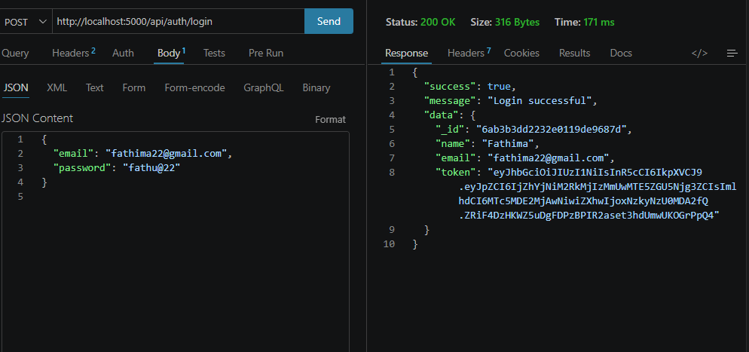

Step 3 — Create a FAQ (Protected)
- Endpoint: POST /api/faqs
- Access: Private — requires Bearer <token> from Step 2
An authenticated user submits a question, answer, and category. The FAQ is validated against the schema (category must be one of the allowed enum values) and saved with a createdBy reference to the logged-in user.
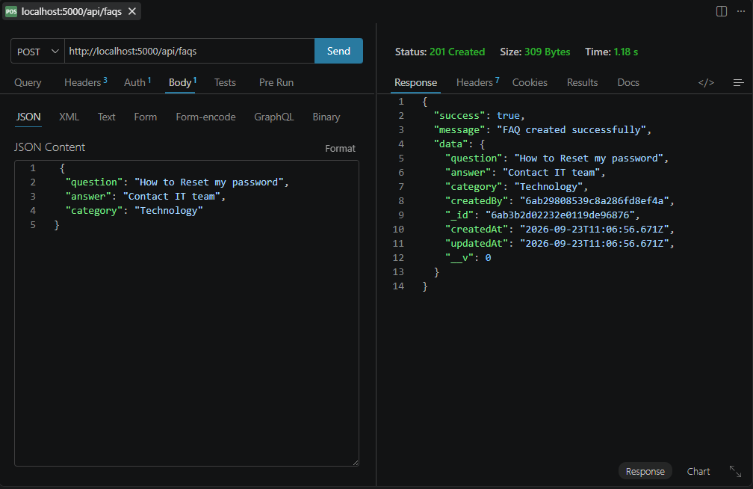
.

Step 4 — Retrieve All FAQs (Public)
- Endpoint: GET /api/faqs
- Access: Public
Any client — authenticated or not — can list published FAQs. The response includes the populated creator's name and email alongside each FAQ.

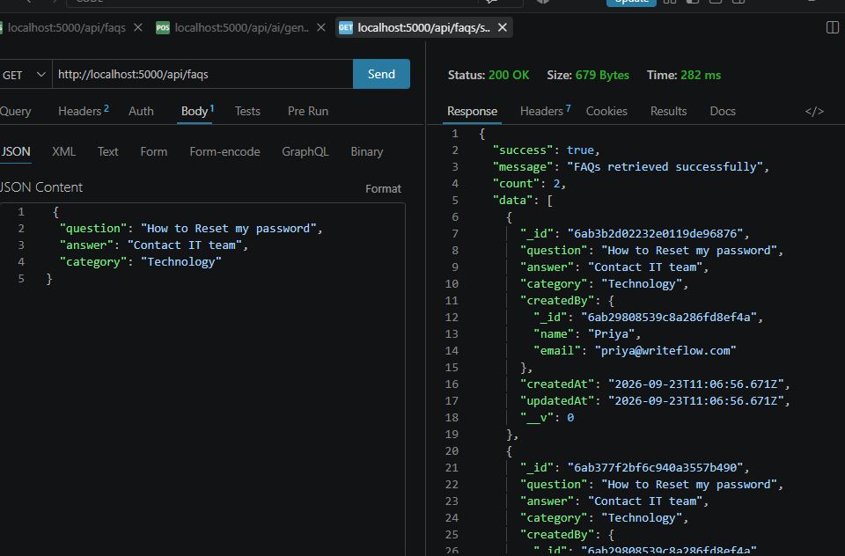

5. Additional Endpoints Verified
The following endpoints were also exercised via the Postman collection during the demonstration, confirming correct request/response behaviour:
Endpoint | Method | Access | Purpose
/api/auth/profile | GET | Private | Returns the logged-in user's profile details.
/api/faqs/:id | GET | Public | Fetches a single FAQ by its ID.
/api/faqs/:id | PUT | Private (owner) | Updates a FAQ's question/answer/category.
/api/faqs/:id | DELETE | Private (owner) | Deletes a FAQ owned by the requester.
/api/faqs/search?q= | GET | Public | Keyword search across question, answer, and category.
/api/ai/answer | POST | Private | Returns a direct AI-generated answer via Gemini (gemini-2.0-flash).
/api/ai/generate-faq | POST | Private | Generates a structured {question, answer} pair via Gemini (gemini-2.5-flash) for a given topic.

6. Results & Observations
- All authentication flows (register, login, protected profile access) returned the expected status codes and JWT-secured responses.
- FAQ CRUD operations correctly enforced ownership, schema validation rejected invalid data, and keyword search returned relevant matches.
- AI endpoints (backed by Google Gemini) returned well-formed answers and structured FAQ pairs, verifying the external AI integration works as designed.
- Centralised error handling returned consistent, sanitised JSON error responses for invalid or unauthorised requests.

7. Reference Links
API Testing Video: https://drive.google.com/file/d/1u_w1sigiOynhmqTDbj4NBm3CLlMunEWN/view?usp=sharing
Full Demo Video: https://drive.google.com/file/d/1ajAZGgOaowPdyW2x5otcsLI84NeomSYJ/view?usp=drive_link
Source Code Drive: https://drive.google.com/drive/folders/1aUqV5q25fE_iUPwWcLt02eJ-v-ytxpjz?usp=sharing

8. Conclusion
The demonstration confirms that the AI FAQ Assistant API is fully functional: secure authentication, complete FAQ CRUD operations, public search, and Gemini-powered AI content generation all behave as documented. The Postman collection provides a repeatable test suite that can be re-run at any time to validate the API before deployment or further development.

