Information & Access Required
Phase 1 Pilot
Response prepared by Suroor Mohammed | Sariah Facilities Management | 26 August 2026
Sariah’s responses are shown in red and highlighted in yellow for easy reference.
As part of the Phase 1 pilot, we would like to understand the current email-based workflow and configure the dashboard to reflect the organisation's existing processes.
To keep the pilot lightweight, we are requesting only the information and access required to analyse the last one month of email conversations.

1. Coordinator Roster
Please share the following for all 6 coordinators:
For Contactus@sariahfm.com email we have the following coordinators
- Full name - Alias Varghese, Vivek Vaithiyanathan, Salmanul Farisi
- A sample of their standard email signature –
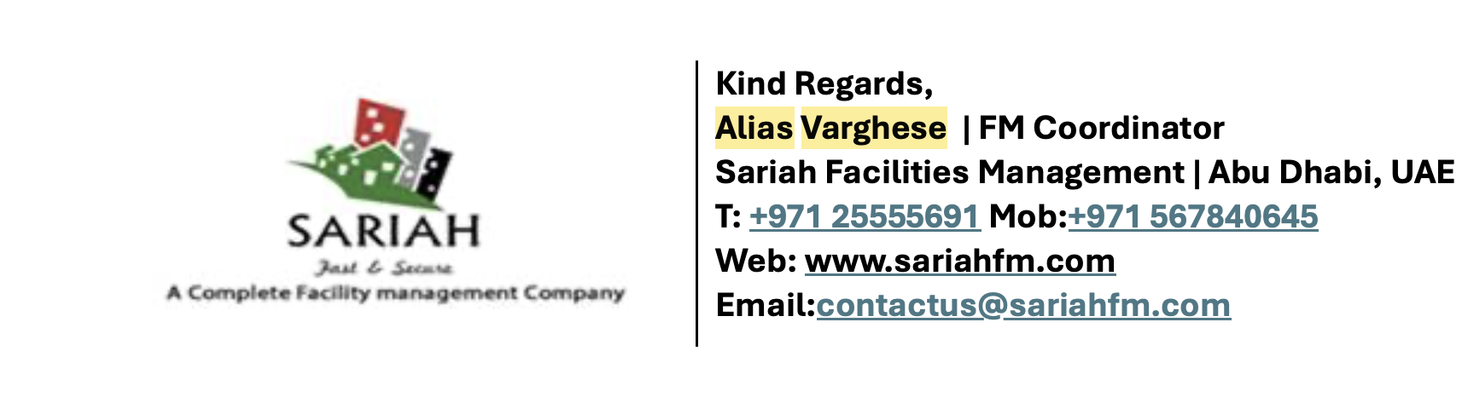
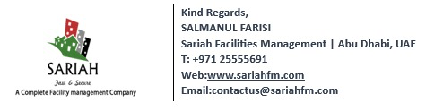
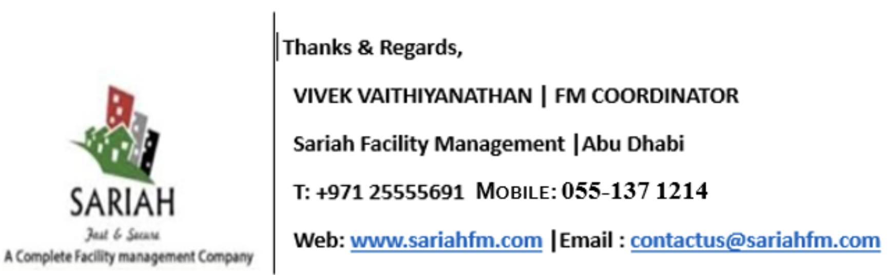

- Whether they are assigned to specific clients/sites or handle requests across all clients/sites – All the coordinators mentioned above deal with all clients all across.

For maintenance@sariahfm.com email we have the following coordinators – Sineesh S, Aneesh Kumar PS, Anandh K
- A sample of their standard email signature –

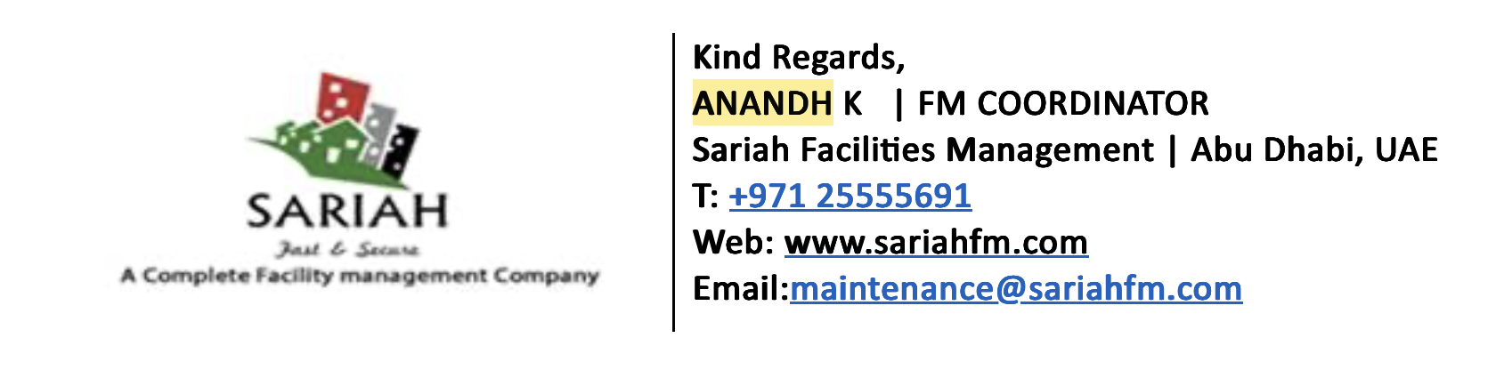
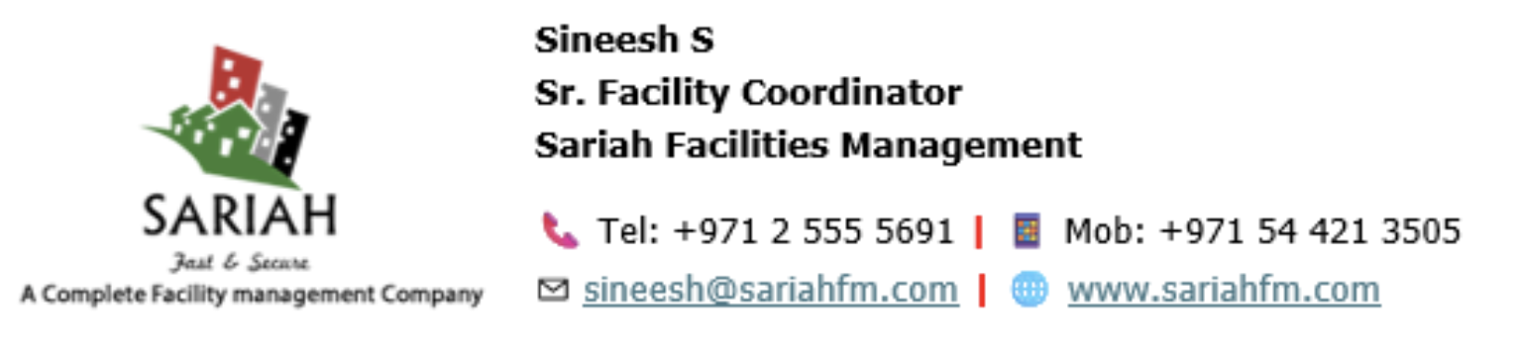

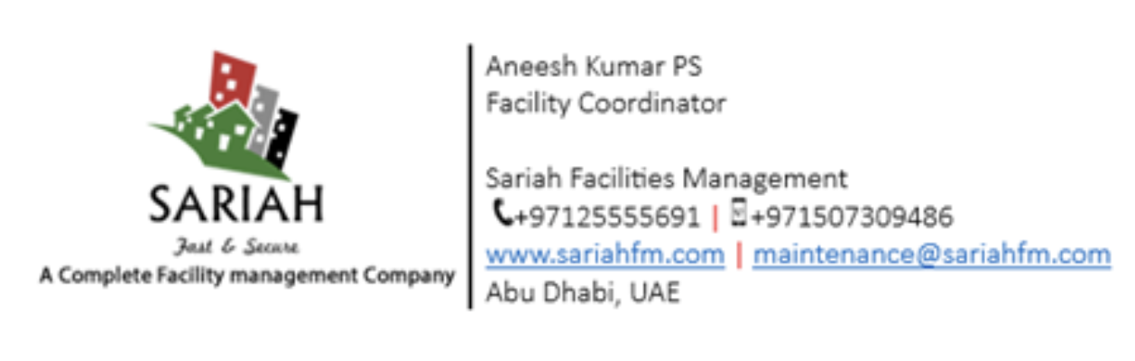
- Whether they are assigned to specific clients/sites or handle requests across all clients/sites – All the coordinators mentioned above deal with all clients all across.
The signature samples are particularly important because coordinator attribution will primarily be based on the signature within the email rather than the sender email address, as multiple coordinators are working through shared/general mailboxes.

2. Client List
Please share:
- Client/company name – Colliers (Asteco), Colliers (Fab), Relaam, MPM Properties, CC7, Halliburton, Saipem, Avison Young, Professional SD Real Estate, Etihad. {The clients list expands so there are chances that it can increase}
- Property/site names associated with each client – Submitted with the excel sheet
- Any existing naming conventions used in email subject lines – Varies depends on the email subject
For example, if emails typically follow a format such as:
“ABC Tower - AC Issue - Apartment 304”
or
“ABC | Tower 1 | Maintenance Request”
please share any such conventions. This will help us identify and associate email conversations with the correct client and property.

3. Property List
Please share:
- Property/unit reference – Submitted in the Excel Sheet
- Property manager or Point of Contact (name and contact details) – Submitted in the Excel Sheet
- Associated client - Submitted in the Excel Sheet
This will help us match complaints to the correct property, particularly where the email itself does not clearly mention the property or unit.
If a centralised property list is not currently maintained, please let us know. We can explore whether this information can be derived from the historical email conversations.

4. AMC Scope Definitions
Please share a simple description of:
- What is generally covered under the standard AMC
- What typically falls outside the AMC and requires a quotation
- Any client-specific differences in AMC coverage
A formal document is not required for the pilot. A plain-language summary or an existing reference document is sufficient. For example:
Client | Type of Issue | AMC Status | Quotation Required
Client A | AC maintenance | Covered | No
Client A | Major equipment replacement | Not covered | Yes
Client B | Plumbing repair | Covered | No

If you're comfortable doing so, sharing the AMC-scope clause(s) directly from the relevant contracts would also work in place of a summary, this is entirely optional, and we only need the section defining what's covered, not the full contract or any commercial/pricing terms.

All the scope of the above is actually included in the AMCs and much more since we look after the whole building maintenance. Any Damage done by tenants require quotation. Also each building has got a threshold value, for eg (500 AED, 1000 AED, 2500 AED. So any individual parts or works going above the threshold value will require quotation.)

Also there are many additional works which we do not have AMC (Annual Maintenance Contract) for those buildings it is all quotation works.

5.Mailbox Access
We understand that the current workflow operates through two shared/general mailboxes.
For the pilot, we would require read-only delegated access to both mailboxes through the organisation's Microsoft 365 administrator.

Access required
- Read email content – Access will be granted
- Read conversation/thread information - Access will be granted

Access NOT required
- Sending emails - Noted
- Modifying emails - Noted
- Deleting emails - Noted
- Moving emails - Noted
- Managing mailbox settings - Noted
We do not require individual staff passwords or credentials to be shared - Noted

6. Historical Data Window
For the initial pilot, we propose analysing the last one month of email conversations.
The initial analysis will focus on:
- Email subject - Noted
- Sender/recipient information - Noted
- Date/time - Noted
- Email body/content- - Noted
- Conversation/thread information - - Noted
- Mailbox information - Noted

Attachments
For Phase 1, we will not read or analyse the contents of PDF documents, quotations, job completion reports, images, videos, or other attachments. The primary focus will be on understanding the operational information contained within the email conversations themselves – Need to Discuss

7. SLA & Escalation Expectations
If there are any existing SLA expectations or informal rules of thumb, please share them with us. For example:
- What is considered an urgent/critical issue? Submitted as 2nd Attachment Excel Sheet
- How quickly should a coordinator respond to a complaint? Submitted as 2nd Attachment Excel Sheet
- When should an issue be escalated? When The timeline has exceeded and Job has not completed or job experienced some delay
- How long can an issue remain pending? Submitted as 2nd Attachment Excel Sheet
- When should a client/tenant follow-up be treated as an escalation? When The timeline has exceeded and Job has not completed or job experienced some delay
These do not need to be formally documented. Even informal guidance from the operations team would be useful for calibrating the initial Pending, Ongoing, Escalated, and Critical classifications rather than making assumptions.

8. Point of Contact
Please nominate one primary point of contact from the organisation for the pilot. This person can help us with:
- Clarifying business processes – Suroor
- Answering questions about clients/properties - Suroor
- Validating coordinator attribution - Suroor
- Clarifying AMC rules - Suroor
- Reviewing sample classifications - Suroor
- Confirming whether the dashboard reflects the actual operational process - Suroor

Data Privacy & Security
We understand that the email data may contain confidential client, tenant, staff, and operational information. Accordingly:
- Phase 1 will focus only on the information required for the agreed pilot - Noted
- PDF documents and other attachments will not be read or analysed during Phase 1. Need to Discuss
- We will require read-only access to the agreed mailboxes and will not require permission to send or modify emails. Noted
- Access to the data will be restricted to the requirements of the pilot. Noted
- We are happy to enter into an NDA/confidentiality agreement if required by the organisation before access is provided. Noted
The objective of Phase 1 is to first understand and validate the existing email-based workflow before introducing any additional automation or processing.

Summary of Information Required

Required
☐ Coordinator names and email signature samples for all 6 coordinators - Provided
☐ Coordinator-to-client/site assignment information – Odoo and whatsapp with the site team and Email with the client
☐ Client/company list - Provided
☐ Property/site list - Provided
☐ Existing email subject-line naming conventions – As mentioned earlier nothing fixed
☐ Tenant list, if available – Tenant names keep changing since there are Checkouts happening. If needed can provide the existing
☐ AMC scope definitions – Whole Building maintenance, but there are threshold values for each building if above the threshold value then quotation is submitted
☐ Read-only delegated access to the two shared mailboxes – Can be Provided
☐ Confirmation of the one-month historical data window - Confirmed
☐ Primary point of contact – Suroor/Shurouk

Helpful but Optional
☐ SLA expectations – Provided in the excel Sheet
☐ Escalation guidelines – If job completion or any obstacle faced during the work
☐ Existing complaint/service categories – MEP, Civil, ELV, FLS, HVAC, Soft Services, Garbage System, CCTV, Elevators (Whole Building Services)
☐ Existing maintenance or complaint trackers – In ERP Software can be shown if required
☐ Examples of typical escalated or delayed cases – Can Show Demo if required
Once these inputs are available, we can begin with the one-month historical analysis and use the findings to configure and validate the initial dashboard.

Our Understanding of the Client's Process
Based on our discussions, here is our current understanding of the complaint-to-resolution workflow, involving three parties — the Tenant, the Company (Sariah), and the Client:
- A tenant reports an issue by contacting the helpdesk or their coordinator directly.
- The Helpdesk representative logs the complaint with the company, which is created as a job card.
- Company staff visit the site to inspect the issue and take photographs.
- If the cost of resolution is within the standard AMC value, the issue is resolved directly on site. Any materials purchased are recorded and sent to the Accounts team for internal tracking.
- If the cost exceeds the AMC value, a quotation is created in the ERP system (Odoo) and sent to the client by email. The quotation may go through several rounds of review and revision until the client confirms and accepts it.
- Once confirmed — or immediately, for issues within the AMC — the job is executed and the issue is resolved for the tenant.
- In either case, a job report is created at the end, including before-and-after photos and, where necessary, signature from the tenant is needed on the job completion report if it is in flat or affecting the flat in any manner. If the maintenance is in the common area then we need the signature of either security or the site inspector of that particular property on the Job Completion Report in order for the Job to be considered as complete by the client
- There are checkout reports, that the client asks us to submit for the AMC properties which we have to send within 3 days, it will have line items for each activity based on AMC or quotation value, once we submit the quotation works the client then adjusts the value and sends us back with the approved amount and ask us to finish the work. This work completion depends on the size of the apartment or villa which can vary from 2 days to even a month. Sometimes the client mentions with the deadline that completely depends on the client.
- Once the checkout work is done the new tenant when they move in they will receive a checklist from Sariah regarding each asset of the apartment or villa, once they are convinced all assets are in good and working condition only then they put the signature – Normally the check in signature form has to be sent to the client within 2 to 3 days.
- Also there are snagging involved when Sariah take over a building from the client we do the snagging and propose a quotation for rectification works. (Meanwhile the contractors will get a defined deadline to which they have to finish the snagging works)
- Also if Sariah hands over a building to the landlord the landlord appointed contractors does snagging and proposes a quotation to Sariah (Meanwhile Sariah will get a defined deadline to which we have to finish the snagging works)
- Also for Colliers FAB and Colliers Asteco properties with AMC, all the additional works that are done will have individual email approval for each quotation that we send through email and towards the start of next month all the approved quotations are consolidated and the client issues one PO for the invoicing purpose.
- All the other properties where we do not have AMC have no consolidation process at all and once completed, the job completion report will then be signed by the site inspector and that will be used for the invoicing purpose.
- There are for some properties where the client sends us the site inspection reports on every quarter and we need to finish all the points in the report to be completed on site in order to receive the signature from the client on the site inspection report only after which they issue the KPI and only then we can do the invoice. (For Colliers Fab Property and Avision Young)
- For Colliers (Asteco) and (MPM properties) The client issues the KPI for the quarter based on the monthly report we send. Based on that they issue the KPI and we can invoice.
- There are also many additional works apart from the AMC properties that we have for which the client asks us to submit a proposal for the work and we provide quotation and once the client approves it we can start working and then do the invoicing.
- There is also for tendor requirements that we normally get invited for, for all those tenders they (The Client) specify a date actually and we normally submit it by the given deadline.

Please review the flowchart below and let us know if this accurately reflects your process, or if any step needs correcting – Flow Chart is Correct

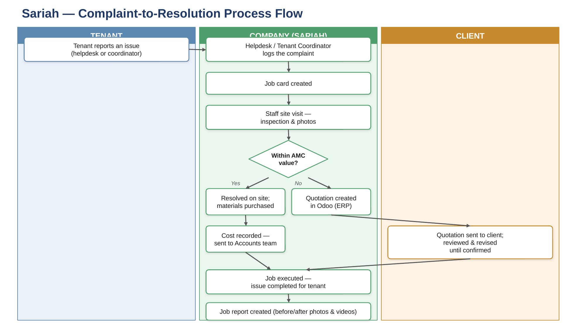
A fully editable version of this flowchart is provided separately as a PowerPoint file (sariah_process_flow.pptx) — boxes, arrows, and text can all be adjusted directly in PowerPoint if any part of this needs correcting.

