CAPSTONE PROJECT REPORT
Relational Database Design & Architecture: LinkedIn Case Study
Student Name: FATHIMA J | Subject: Relational Database Design Capstone
Target Platform: LinkedIn (Professional Networking) | Submission Deliverable: Report, SQL Schema & ER Diagram

1. Executive Summary & Platform Overview
LinkedIn is a professional networking platform where people can create profiles, connect with other professionals, share posts, and search for job opportunities.
In this project, I have designed a relational database model based on LinkedIn using PostgreSQL. The database contains seven tables: users, companies, jobs, job_applications, experiences, connections, and posts.
The main objective of this project is to understand how a professional networking platform can organize its data using tables and relationships. I have used primary keys, foreign keys, and other database constraints to maintain data consistency and avoid duplicate job applications.
I have also added sample data and written SQL queries to demonstrate how the database can be used to retrieve useful information about job openings, job applications, and professional connections.
2. Product Features & Workflows
LinkedIn is a professional networking platform that helps users connect with other professionals, explore job opportunities, and share content. In this project, I have focused on four main features.
- User Profiles and Work Experience: Users can store their basic profile details, professional headline, location, and resume link. The users table stores profile information, while the experiences table stores users' work experience and company details.
- Professional Connections: Users can establish professional connections with other users. The connections table records the two users involved, the connection status, and the dates when the connection was created or updated. The status can be pending, accepted, or rejected.
- Job Search and Applications: Companies can have multiple job openings, which are stored in the jobs table. Users can apply for these jobs, and the job_applications table records application details and statuses.
- Posts and Content Sharing: Users can share posts on the platform. The posts table stores the post content, the number of likes, the number of views, and the date the post was created.
These features demonstrate how the database organizes user profiles, professional connections, job opportunities, work experience, and posts through related tables.
3. Real-World Problems & Architectural Solutions
LinkedIn helps people build professional connections, find job opportunities, and share information. In this project, I have selected three common problems and explained how my database design helps organize the related information.
Problem 1: Difficulty in Managing Job Opportunities
Job seekers need a way to find job openings and track their applications. Companies also need to organize information about their available positions.
Database Solution: The companies, jobs, and job_applications tables store company details, job openings, and application information. Primary keys and foreign keys connect these tables and help maintain relationships between the records.
Problem 2: Difficulty in Maintaining Professional Connections
People may change jobs or companies but still want to maintain their professional relationships.
Database Solution: The connections table stores connections between users and their statuses, such as pending, accepted, or rejected. This allows the database to organize professional connections independently of a user's current company.
Problem 3: Difficulty in Organizing Professional Information and Posts
Users need a place to store their professional details, work experience, and shared content.
Database Solution: The users table stores profile information, while the experiences table stores work history linked to users and companies. The posts table stores content shared by users, including the number of likes and views.
Overall, the database uses related tables, primary keys, foreign keys, and constraints to organize information and maintain data consistency.
4. Relational Database Schema Design
The database contains seven related tables created using PostgreSQL. Each table stores a specific type of information. Primary keys identify records, while foreign keys connect related tables. These relationships help organize the data and maintain consistency.

Table Name | Primary Key | Foreign Keys | Business Function
Users | user_id | None | Stores user details, email, professional headline, location, and resume link.
Companies | company_id | None | Stores company names, industry, headquarters location, and website links.
Experiences | experience_id | user_id -> users, company_id -> companies | Stores users' work experience, job titles, employment types, and employment dates.
Connections | (user_id_1, user_id_2) | user_id_1 -> users, user_id_2 -> users | Stores connections between users, including their status and creation and update dates.
Jobs | job_id | company_id -> companies | Stores job titles, locations, workplace types, and active status.
job_applications | application_id | job_id -> jobs, user_id -> users | Stores job applications, application status, application date, and relocation preference. A unique constraint prevents duplicate applications for the same job by the same user.
Posts | post_id | user_id -> users | Stores posts shared by users, their content, likes, views, and creation dates.

5. PostgreSQL DDL Implementation Statements
Below are the PostgreSQL DDL statements used to create the seven tables, including primary keys, foreign keys, and constraints to maintain data consistency.
-- ========================================================
-- PROFESSIONAL NETWORKING PLATFORM DATABASE SCHEMA (DDL)
-- ========================================================

-- Drop tables if they already exist (in reverse dependency order)
DROP TABLE IF EXISTS job_applications CASCADE;
DROP TABLE IF EXISTS connections CASCADE;
DROP TABLE IF EXISTS experiences CASCADE;
DROP TABLE IF EXISTS posts CASCADE;
DROP TABLE IF EXISTS jobs CASCADE;
DROP TABLE IF EXISTS companies CASCADE;
DROP TABLE IF EXISTS users CASCADE;

-- 1. PARENT TABLE: users
CREATE TABLE users (
user_id SERIAL PRIMARY KEY,
first_name VARCHAR(50) NOT NULL,
last_name VARCHAR(50) NOT NULL,
email VARCHAR(100) UNIQUE NOT NULL,
headline VARCHAR(200),
city VARCHAR(50),
country VARCHAR(50),
resume_url VARCHAR(255),
created_at TIMESTAMP DEFAULT CURRENT_TIMESTAMP
);

-- 2. PARENT TABLE: companies
CREATE TABLE companies (
company_id SERIAL PRIMARY KEY,
company_name VARCHAR(120) NOT NULL,
industry VARCHAR(80),
headquarters_city VARCHAR(50),
headquarters_country VARCHAR(50),
website_url VARCHAR(255),
created_at TIMESTAMP DEFAULT CURRENT_TIMESTAMP
);

-- 3. CHILD TABLE: jobs (references companies)
CREATE TABLE jobs (
job_id SERIAL PRIMARY KEY,
company_id INT NOT NULL,
title VARCHAR(120) NOT NULL,
location VARCHAR(120),
workplace_type VARCHAR(20), -- e.g., 'Remote', 'On-site', 'Hybrid'
is_active BOOLEAN DEFAULT TRUE,
posted_at TIMESTAMP DEFAULT CURRENT_TIMESTAMP,
CONSTRAINT fk_jobs_company
FOREIGN KEY (company_id)
REFERENCES companies (company_id)
ON DELETE CASCADE
);

-- 4. CHILD TABLE: posts (references users)
CREATE TABLE posts (
post_id SERIAL PRIMARY KEY,
user_id INT NOT NULL,
content TEXT NOT NULL,
likes_count INT DEFAULT 0,
views_count INT DEFAULT 0,
created_at TIMESTAMP DEFAULT CURRENT_TIMESTAMP,
CONSTRAINT fk_posts_user
FOREIGN KEY (user_id)
REFERENCES users (user_id)
ON DELETE CASCADE
);

-- 5. JUNCTION / CHILD TABLE: experiences (references users and companies)
CREATE TABLE experiences (
experience_id SERIAL PRIMARY KEY,
user_id INT NOT NULL,
company_id INT NOT NULL,
job_title VARCHAR(100) NOT NULL,
employment_type VARCHAR(30), -- e.g., 'Full-time', 'Contract', 'Internship'
start_date DATE NOT NULL,
end_date DATE,
is_current BOOLEAN DEFAULT FALSE,
CONSTRAINT fk_experiences_user
FOREIGN KEY (user_id)
REFERENCES users (user_id)
ON DELETE CASCADE,
CONSTRAINT fk_experiences_company
FOREIGN KEY (company_id)
REFERENCES companies (company_id)
ON DELETE CASCADE
);

-- 6. JUNCTION TABLE: connections (self-referencing users)
CREATE TABLE connections (
user_id_1 INT NOT NULL,
user_id_2 INT NOT NULL,
status VARCHAR(20) DEFAULT 'pending', -- 'pending', 'accepted', 'rejected'
created_at TIMESTAMP DEFAULT CURRENT_TIMESTAMP,
updated_at TIMESTAMP DEFAULT CURRENT_TIMESTAMP,
PRIMARY KEY (user_id_1, user_id_2),
CONSTRAINT fk_connections_user1
FOREIGN KEY (user_id_1)
REFERENCES users (user_id)
ON DELETE CASCADE,
CONSTRAINT fk_connections_user2
FOREIGN KEY (user_id_2)
REFERENCES users (user_id)
ON DELETE CASCADE,
CONSTRAINT chk_no_self_connect
CHECK (user_id_1 <> user_id_2)
);

-- 7. CHILD / JUNCTION TABLE: job_applications (references jobs and users)
CREATE TABLE job_applications (
application_id SERIAL PRIMARY KEY,
job_id INT NOT NULL,
user_id INT NOT NULL,
willing_to_relocate BOOLEAN DEFAULT FALSE,
status VARCHAR(50) DEFAULT 'submitted', -- 'submitted', 'in_review', 'interview', 'rejected', 'hired'
applied_at TIMESTAMP DEFAULT CURRENT_TIMESTAMP,
CONSTRAINT fk_applications_job
FOREIGN KEY (job_id)
REFERENCES jobs (job_id)
ON DELETE CASCADE,
CONSTRAINT fk_applications_user
FOREIGN KEY (user_id)
REFERENCES users (user_id)
ON DELETE CASCADE,
CONSTRAINT uq_user_job_application
UNIQUE (job_id, user_id) -- prevents duplicate applications for the same job
);

6. Entity-Relationship (ER) Diagram Architecture
The Entity Relationship (ER) diagram shows the structure of the database and the relationships between its seven tables.
- Users and Companies: These tables store user profile information and company details.
- Companies and Jobs: One company can have multiple job openings. Each job is linked to one company.
- Users and Job Applications: A user can apply for different jobs. Each application is linked to one user and one job.
- Users and Experiences: A user can have multiple work experience records. Each record is linked to a user and a company.
- Users and Connections: The connections table links two users and stores the connection status.
- Users and Posts: A user can create multiple posts, and each post belongs to one user.
The relationships are implemented using primary keys and foreign keys in PostgreSQL. The diagram provides a visual overview of how information is organized and connected in the database.

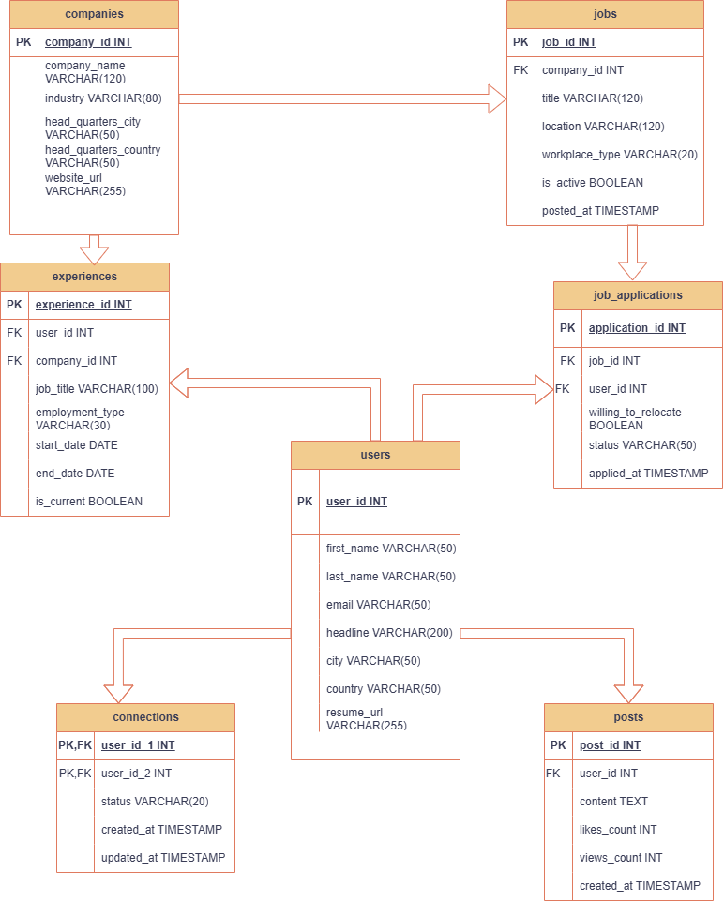

7. Architectural Rationale & Normalization (3NF)
The database uses relational database design principles to organize information into seven related tables. This structure helps reduce unnecessary duplication and makes the data easier to manage.
1. Organizing Data into Separate Tables
User details, company information, job openings, applications, work experiences, connections, and posts are stored in separate tables. For example, company information is stored in the companies table rather than being repeated in every job record.
2. Primary and Foreign Keys
Primary keys uniquely identify records, while foreign keys connect related tables. For example, the jobs table references the companies table, and the experiences table references both users and companies.
3. Preventing Duplicate Records
The users table uses a unique constraint on email addresses. The job_applications table uses a unique constraint on the combination of job_id and user_id to prevent duplicate applications for the same job by the same user.
4. Data Validation
The connections table includes a check constraint that prevents a user from connecting with themselves. The schema also uses NOT NULL constraints and default values on selected columns.
5. Deleting Related Records
The database uses ON DELETE CASCADE on foreign-key relationships. This means that when a referenced user or company is deleted, related records in the dependent tables can also be deleted automatically.
These design choices demonstrate how relational database principles and constraints can help organize data, maintain relationships, and reduce duplication.
8. Sample Business Analytics Queries
This section presents five sample SQL queries designed to analyze job openings, job application outcomes, post engagement, active job opportunities by location, and company-wise application trends.
Query 1: Active Job Openings by Company
Business Scenario: LinkedIn wants to identify companies with the highest number of active job openings to understand hiring activity across organizations and help job seekers discover companies that are currently recruiting.

SELECT c.company_name, c.industry, COUNT(j.job_id) AS total_active_jobs
FROM companies c
INNER JOIN jobs j ON c.company_id = j.company_id
WHERE j.is_active = TRUE
GROUP BY c.company_id, c.company_name, c.industry
ORDER BY total_active_jobs DESC
LIMIT 5;
Query 2: Job Application Outcomes and Hiring Rate by Company
Business Scenario: LinkedIn wants to evaluate application volume and hiring outcomes across companies. This analysis helps recruiters compare the total number of applications received by each company, the number of applicants hired, and the hiring rate.
SELECT c.company_name,COUNT(a.application_id) AS total_applications,COUNT(CASE WHEN a.status = 'hired' THEN 1 END)
AS hired_applicants,
ROUND(COUNT(CASE WHEN a.status = 'hired' THEN 1 END) * 100.0/ NULLIF(COUNT(a.application_id), 0),2) AS hiring_rate_percent
FROM companies c
JOIN jobs j
ON c.company_id = j.company_id
LEFT JOIN job_applications a
ON j.job_id = a.job_id
GROUP BY c.company_id, c.company_name
HAVING COUNT(a.application_id) > 0
ORDER BY hiring_rate_percent DESC;
Query 3: LinkedIn Post Engagement Analysis
Business Scenario: LinkedIn wants to identify posts that receive a high number of likes relative to their views. This analysis helps the platform understand which posts attract user engagement and helps content creators evaluate how their posts are performing.
SELECT
p.post_id,
CONCAT(u.first_name, ' ', u.last_name) AS user_name,
p.likes_count,
p.views_count,
ROUND(p.likes_count * 100.0 / NULLIF(p.views_count, 0),2) AS engagement_rate_percent
FROM posts p
INNER JOIN users u
ON p.user_id = u.user_id
ORDER BY engagement_rate_percent DESC;

Query 4: Active Job Opportunities by Location
Business Scenario: LinkedIn wants to understand the distribution of active job opportunities across companies and locations so that job seekers can identify where openings are available and recruiters can assess their hiring presence in different locations.
WITH active_jobs AS(
SELECT company_id,location FROM jobs
WHERE is_active=TRUE --keeps only active jobs
)
SELECT company_id,location,
COUNT (company_id) AS total_active_jobs --counts job in each group
FROM active_jobs
GROUP BY company_id,location--groups job by company and location
ORDER BY total_active_jobs DESC;

Query 5: Company-wise Job Application Analysis
Business Scenario: LinkedIn wants to analyze the number of applications received by each company while retaining the details of every individual application. This enables recruiters and analysts to review application statuses alongside the overall application volume for each company.
WITH application_status AS(
SELECT
c.company_id,c.company_name,j.job_id,a.application_id,a.status
FROM companies c
JOIN jobs j
ON c.company_id=j.company_id
JOIN job_applications a
ON j.job_id=a.job_id
)
SELECT
company_id,company_name,job_id,application_id,status,
COUNT(*)OVER (PARTITION BY company_id)AS total_company_applications
FROM application_status
ORDER BY company_id;
10. Capstone Submission Links
Video Presentation Link: | [Insert YouTube Unlisted or Google Drive Link with 'Anyone with link can view']
ER Diagram Tool Link: | [https://drive.google.com/file/d/1TqfV3bK_3Ggms5j8KiGLqBoA7tACeBea/view?usp=sharing]
GitHub / SQL File Repository: | [SCHEMA FILE]: https://drive.google.com/file/d/1adWrugz-SCDouStQTmaAOgd4e9igZB4T/view?usp=sharing

