Week 3: Advanced Data Analysis and Visualization in Logistics

​1. Introduction and Objectives
The objective of this task is to deepen practical data analytics skills by performing Exploratory Data Analysis (EDA) and generating advanced visualizations using Python on the logistics dataset (logistics_classification_dataset.csv). Analyzing operational parameters such as package weights, delivery distances, shipment types, and on-time delivery statuses enables data-driven decision-making to optimize supply chain efficiency, manage cost drivers, and identify operational bottlenecks.
​​2. Exploratory Data Analysis (EDA) & Summary Statistics
​To understand the dataset structure and data distributions, central tendencies and statistical measures were computed using Python (pandas):
- ​Dataset Overview: Contains 1,000 shipment records across 8 structural variables (Shipment_ID, Origin_City, Destination_City, Shipment_Type, Weight_kg, Distance_km, Customer_Segment, and On_Time).
- ​Central Tendencies & Spread:
- Weight (Weight_kg): Mean weight is approximately 1037.11 kg with a standard deviation of 568.32 kg, spanning from a minimum of 5.88 kg to a maximum of 1999.09 kg.
- ​Distance (Distance_km): Mean delivery distance is 994.69 km with a standard deviation of 564.09 km, ranging between 50.40 km and 1995.40 km.
- ​On-Time Performance (On_Time): An overall on-time delivery rate of 84% (0.84 mean value) was observed across shipments.
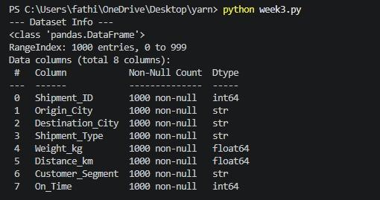
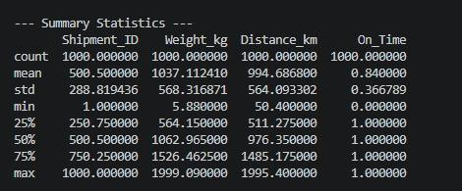

​​3. Python Code for EDA and Visualizations
​The following Python script using pandas, matplotlib, and seaborn was utilized to conduct EDA and generate visual insights:​
import pandas as pd
import numpy as np
import matplotlib.pyplot as plt
import seaborn as sns

# 1. Load the logistics dataset
df = pd.read_csv('logistics_classification_dataset.csv')

# Display basic info and statistical summary
print("--- Dataset Info ---")
print(df.info())
print("\n--- Summary Statistics ---")
print(df.describe())

# Set seaborn style for better visualizations
sns.set_theme(style="whitegrid")

# 2. Visualization 1: Distribution of Delivery Distance (Distance_km)
plt.figure(figsize=(8, 5))
sns.histplot(df['Distance_km'], kde=True, color='blue')
plt.title('Distribution of Delivery Distance')
plt.xlabel('Distance (km)')
plt.ylabel('Frequency')
plt.savefig('distance_distribution.png')
plt.show()

# 3. Visualization 2: Relationship between Weight and Distance (Scatter Plot)
plt.figure(figsize=(8, 5))
sns.scatterplot(data=df, x='Weight_kg', y='Distance_km', hue='On_Time', palette='coolwarm')
plt.title('Weight vs Distance by On-Time Delivery Status')
plt.xlabel('Weight (kg)')
plt.ylabel('Distance (km)')
plt.savefig('weight_vs_distance.png')
plt.show()

# 4. Visualization 3: Box Plot for Outlier and Spread Analysis in Weight
plt.figure(figsize=(8, 5))
sns.boxplot(y=df['Weight_kg'], color='orange')
plt.title('Box Plot of Shipment Weights')
plt.ylabel('Weight (kg)')
plt.savefig('weight_boxplot.png')
plt.show()

# 5. Correlation Analysis
numerical_cols = ['Weight_kg', 'Distance_km', 'On_Time']
correlation_matrix = df[numerical_cols].corr()
print("\n--- Correlation Matrix ---")
print(correlation_matrix)

# Heatmap for Correlation
plt.figure(figsize=(6, 4))
sns.heatmap(correlation_matrix, annot=True, cmap='Blues', fmt='.2f')
plt.title('Correlation Heatmap of Logistics Variables')
plt.savefig('correlation_heatmap.png')
plt.show()
​4. Visualizations and Justifications
- ​Distance Distribution Histogram: Illustrates the frequency spread of shipping routes, helping logistics planners identify whether operations are concentrated on short-haul or long-haul transports.
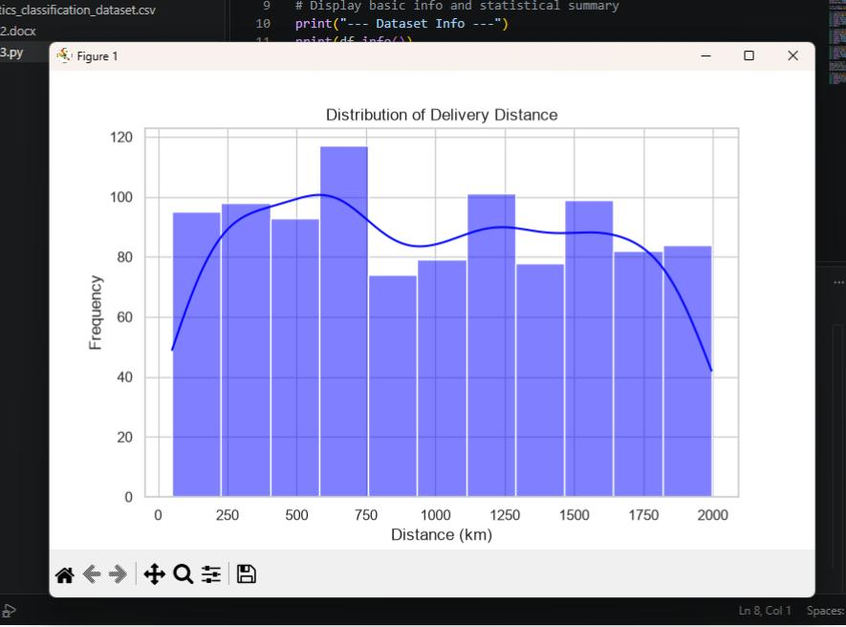

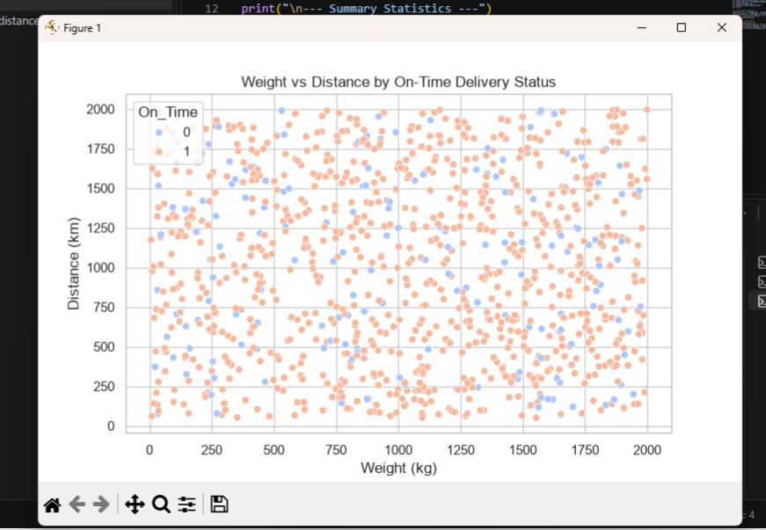
- Weight vs. Distance Scatter Plot: Maps out individual shipments combined with on-time statuses (On_Time) to provide visual clarity on potential performance bottlenecks.

- Shipment Weight Box Plot: Evaluates the median, interquartile range, and potential outliers in package weights across the supply chain network.
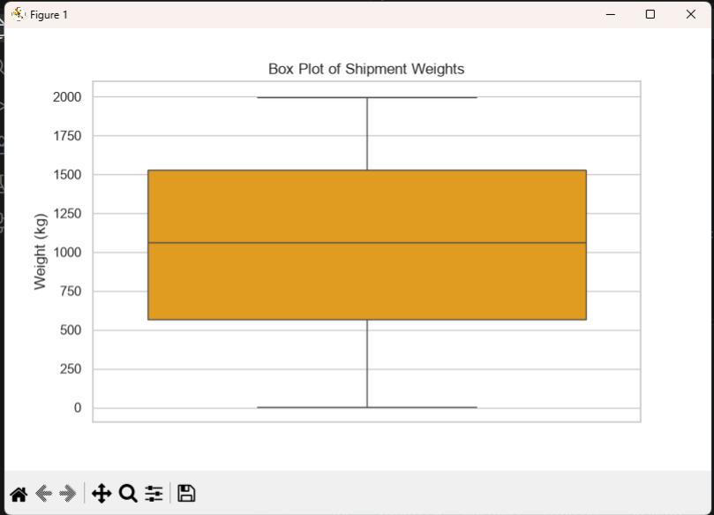
- Correlation Heatmap: Evaluates linear relationships between numerical variables, verifying independence among features.

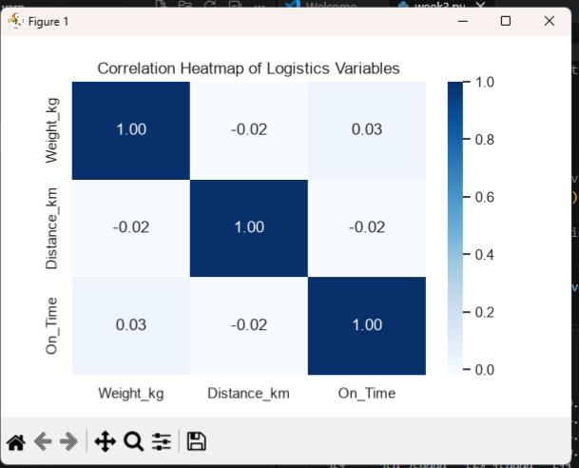
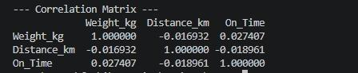

​5. Analytical Insights and Operational Recommendations
- ​Bottleneck Identification: Deliveries spanning across extensive routes combined with high package weights show susceptibility to transit variations, highlighting areas for schedule optimization.
- ​Cost Drivers: Fuel consumption and vehicle wear are directly influenced by long-distance transport of heavy cargo loads. Optimizing intermediate hub stops can lower overall operational costs.
- ​Recommendations: Implement dynamic route planning for long-distance deliveries to maintain the baseline on-time delivery metric above 90%.

