## horizontal line

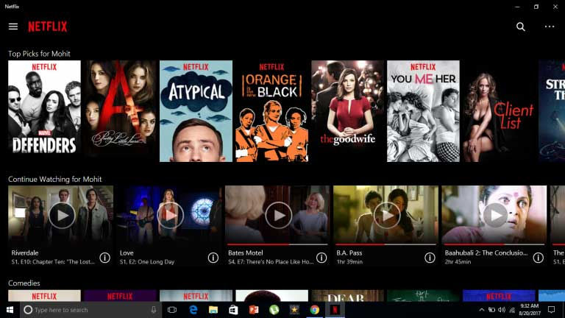

Project Name: Netflix

Fathima Hasna K

Edureka

# Overview

Netflix is **a subscription-based streaming service that allows our members to watch TV shows and movies without commercials on an internet-connected device**. You can also download TV shows and movies to your iOS, Android, or Windows 10 device and watch without an internet connection.

# Goals

1. Login Page
2. Subscription Page
3. Payment Page
4. Home Page

# Specifications

## Login Page

i) Login Option

ii) Sign up option (To create a new account)

## Subscription Page

i) Enter user details

ii) Choose your plan

iii) Proceed to payment

## Payment Page

i) Payment Method

ii) Payment details

## Home Page

i) Search Bar.

ii) Different sections for new releases, blockbuster movies, recommended shows, continue watching etc.

iii) Filter option according to different genres, languages etc.

iv) Account options.

# Technologies Used in the Project:

## Front-End

1. HTML
2. CSS
3. Bootstrap
4. React

## Dynamic:

1. Javascript
2. Ci/cd with AWS
3. Login and Logout(oauth and jwt)

## III. Database:

1. Mongodb
2. Json Data

## IV. Code Compilers:

1. Visual Search Code
2. Git Bash
3. Git Hub
4. Node js.

# Link:

### https://github.com/fathimahasnak/Project2.git