Q1.

Code:

|  |
| --- |
| package Q_01; import javax.swing.*;   public class Number1 {  public static void main(String[] args) {  JFrame myWindow;  myWindow = new JFrame();  myWindow.setSize(800,600);  myWindow.setTitle("Welcome to Java");  myWindow.setVisible(true);   } } |

Output:

package Q_02;  
  
public class Number2 {  
 public static void main(String[] args) {  
 Scanner scanner = new Scanner(System.*in*);  
 String firstname , lastname , fullname;  
 System.*out*.println("Enter your firstname : ");  
 firstname = scanner.next();  
 System.*out*.println("Enter your lastname : ");  
 lastname = scanner.next();  
 fullname = firstname + " " + lastname ;  
  
 JFrame myWindow;  
 myWindow = new JFrame();  
 myWindow.setSize(800,600);  
 myWindow.setTitle(fullname);  
 myWindow.setVisible(true);  
 }  
}

package Q_3;  
  
import java.util.Scanner;  
  
public class Number3 {  
 public static void main(String[] args) {  
  
 Scanner scanner = new Scanner(System.*in*);  
 String firstname, lastname,middlename , fullname;  
 char middle_name_initial;  
 System.*out*.println("Enter your firstname : ");  
 firstname = scanner.next();  
  
 System.*out*.println("Enter your middlename : ");  
 middlename = scanner.next();  
 middle_name_initial = middlename.charAt(0);  
  
 System.*out*.println("Enter your lastname : ");  
 lastname = scanner.next();  
  
 fullname = firstname+" "+ middle_name_initial +". "+ lastname +"." ;  
 System.*out*.println(fullname);  
  
 }  
}

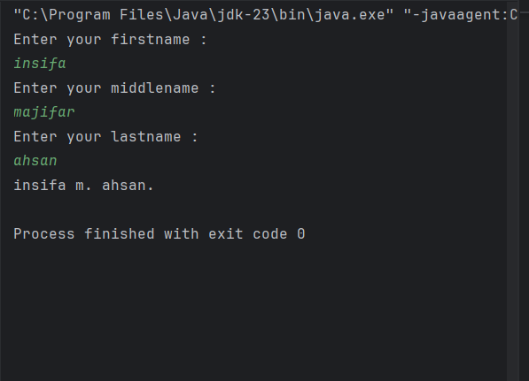

package Q_4;  
import java.text.SimpleDateFormat;  
import java.util.*;  
  
public class Number45 {  
 public static void main(String[] args) {  
  
 Date today;  
 SimpleDateFormat sdf;  
 today = new Date( );  
 sdf = new SimpleDateFormat("dd MMM yyyy");  
 System.*out*.println(sdf.format(today));  
 }  
}

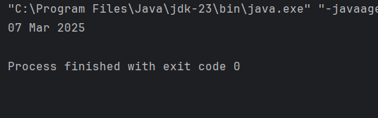

package Q_5;  
import java.text.SimpleDateFormat;  
import java.util.*;  
  
  
public class Number5 {  
 public static void main(String[] args) {  
 Date today;  
 SimpleDateFormat sdf;  
 today = new Date( );  
 sdf = new SimpleDateFormat("EEEE, MMM dd,yyyy");  
 System.*out*.println(sdf.format(today));  
 }  
}

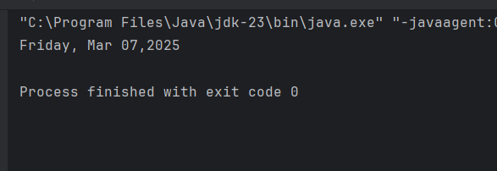

package Q_6;  
  
import javax.swing.*;  
import java.util.*;  
  
public class Number6 {  
 public static void main(String[] args) {  
 Scanner scanner = new Scanner(System.*in*);  
  
 //getting user input  
 int w ,h ;  
 String title;  
 System.*out*.println("enter the Title of the window :");  
 title = scanner.nextLine();  
 System.*out*.println("enter the width :");  
 w = scanner.nextInt();  
 System.*out*.println("enter the height :");  
 h = scanner.nextInt();  
  
 //window process  
 JFrame myWindow;  
 myWindow = new JFrame();  
 myWindow.setSize(w,h);  
 myWindow.setTitle(title);  
 myWindow.setVisible(true);  
 }  
}

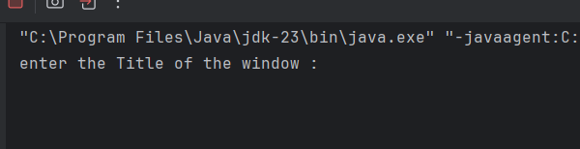

package Q_7;  
import java.text.SimpleDateFormat;  
import java.util.*;  
import javax.swing.*;  
  
public class Number7 {  
 public static void main(String[] args) {  
  
 Date today;  
 SimpleDateFormat sdf;  
 today = new Date( );  
 sdf = new SimpleDateFormat("hh:mm:ss a.");  
 //System.out.println(sdf.format(today));  
  
 JFrame myWindow;  
 myWindow = new JFrame();  
 myWindow.setSize(600,400);  
 myWindow.setTitle(sdf.format(today));  
 myWindow.setVisible(true);  
 }  
}

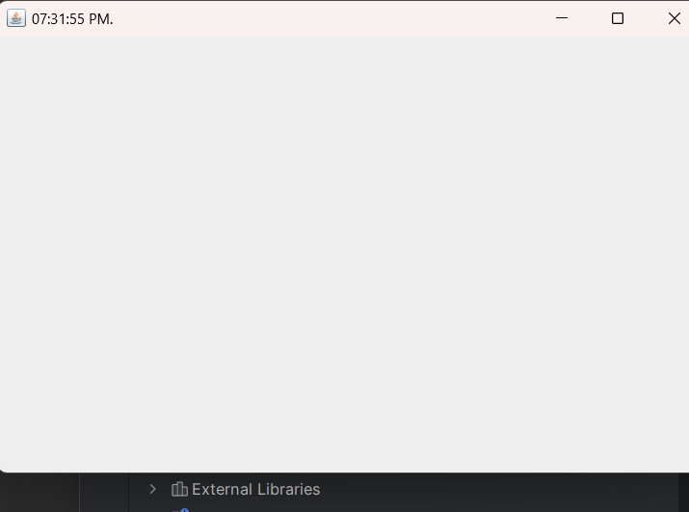

package Q_8;  
import java.util.*;  
  
public class Number8 {  
 public static void main(String[] args) {  
 String word ,a,b ;  
 //new array  
 Scanner scanner = new Scanner(System.*in*);  
 System.*out*.println("Enter the word :");  
 word = scanner.nextLine();  
  
 String[] sentence = word.split("!",2);  
  
 if (sentence.length == 2){  
 System.*out*.println(sentence[0].trim());  
 System.*out*.println(sentence[1].trim());  
 }  
 }  
}

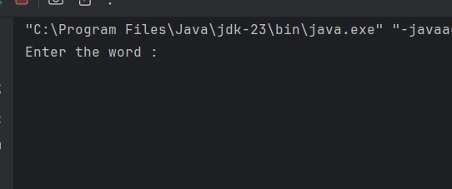

package Q_9;  
  
import java.util.*;  
  
public class Number9 {  
 public static void main(String[] args) {  
 Scanner scanner = new Scanner(System.*in*);  
 System.*out*.println("Enter the text : ");  
 String text = scanner.nextLine();  
 int length = text.length();  
  
 System.*out*.println(length);  
 System.*out*.println(text.charAt(0));  
 System.*out*.println(text.charAt(length-1));  
  
 }  
}

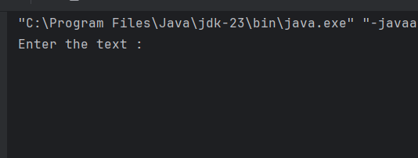

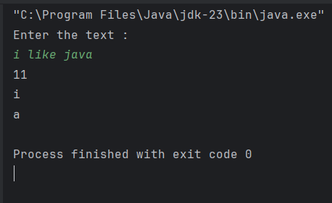

package Q_10;  
import java.util.Scanner;  
  
public class Number10 {  
 public static void main(String[] args) {  
 Scanner scanner =new Scanner(System.*in*);  
 System.*out*.println("Enter the odd length String : ");  
 String text = scanner.nextLine();  
  
 int length = text.length();  
 char middle_letter;  
 middle_letter = text.charAt((length / 2));  
 System.*out*.println(middle_letter);  
  
  
 }  
}

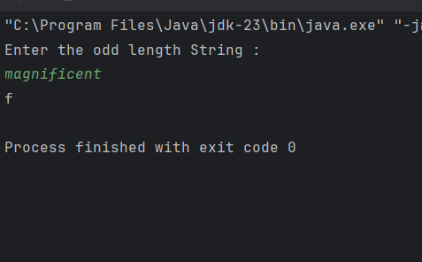

package Q_11;  
import java.util.*;  
  
public class Number11 {  
 public static void main(String[] args) {  
 Scanner scanner = new Scanner(System.*in*);  
 System.*out*.println("Enter the full name (first middle last) with spaces :");  
 String text = scanner.nextLine();  
 System.*out*.println(text);  
  
 String[] parts = text.split(" ");  
 String fname = parts[0];  
 String mname = parts[1];  
 String lname = parts[2];  
  
 System.*out*.println(lname+","+" "+fname+" "+mname.charAt(0)+".");  
  
 }  
}

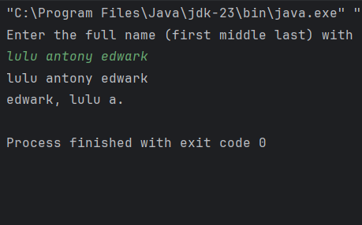

package Q_12;  
import javax.swing.*;  
  
public class NUmber12 {  
 public static void main(String[] args) {  
 JFrame myWindow;  
 myWindow = new JFrame();  
 myWindow.setSize(300,200);  
 myWindow.setLocation(50,100);  
 myWindow.setTitle("My First Frame");  
 myWindow.setVisible(true);  
  
 }  
}



