a)

package Q_1;  
  
public class Number1 {  
 public static void main(String[] args) {  
 double A = 1.0;  
 double B = 2.0;  
 double C = 3.0;  
 double result = Math.*sqrt*(Math.*pow*(B,2)+4*A*C);  
 System.*out*.println("Result of sqrt(B^2+4AC):"+result);  
   
 }  
}

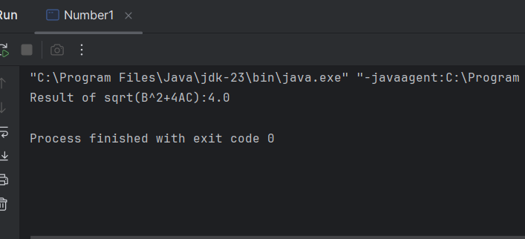

b)

package Q_1;  
  
public class Apple {  
 public static void main(String[] args) {  
 double X = 10.0;  
 double Y = -2.0;  
  
 double expression = X + 4 * Math.*pow*(Y, 3);  
  
 if (expression < 0) {  
 System.*out*.println("Error: Square root of a negative number is not defined in real numbers.");  
 } else {  
 double result = Math.*sqrt*(expression);  
 System.*out*.println("Result of sqrt(X + 4Y^3): " + result);  
 }  
 }  
}

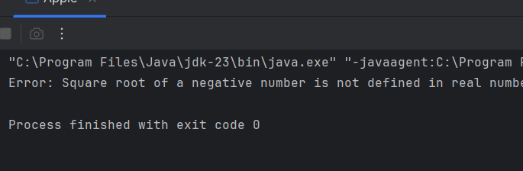

c)

package Q_1;  
  
public class Apple {  
 public static void main(String[] args) {  
 double X = 4.0;  
 double Y = 8.0;  
 double result = Math.*cbrt*(X * Y);  
 System.*out*.println("Result of cube root of (X*Y):" + result);  
 }  
}

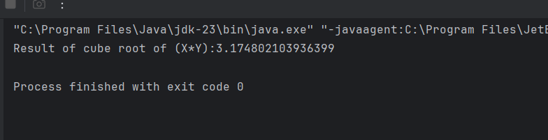

d)

package Q_1;  
  
public class Apple {  
 public static void main(String[] args) {  
 double r = 5.0;  
 double area = Math.*PI*\*Math.*pow*(r,2);  
 System.*out*.println("Area of the circle with radius"+r+":"+area);  
 }  
}

2)

import java.util.Scanner;  
package Q_2;  
public class Number2 {  
 public static void main(String[] args) {  
 Scanner sc = new Scanner(System.*in*);  
 System.*out*.print("Enter length in centimeters: ");  
 double cm = sc.nextDouble();  
 double totalInches = cm / 2.54;  
 int feet = (int) (totalInches / 12);  
 double inches = totalInches % 12;  
 System.*out*.println("Equivalent length: " + feet + " feet and " + String.*format*("%.2f", inches) + " inches");  
 sc.close();  
  
 }  
}

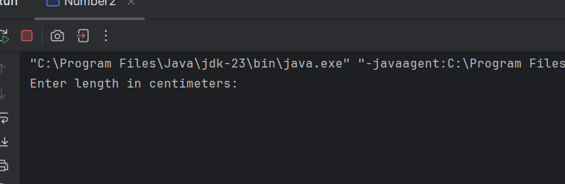

3)

package Q_3;  
import java.util.Scanner;  
public class Number3 {  
 public static void main(String[] args) {  
 Scanner sc = new Scanner(System.*in*);  
 System.*out*.print("Enter temperature in Celsius: ");  
 double celsius = sc.nextDouble();  
 double fahrenheit = (1.8 * celsius) + 32;  
 System.*out*.println("Temperature in Fahrenheit: " + fahrenheit);  
 sc.close();  
 }  
 }

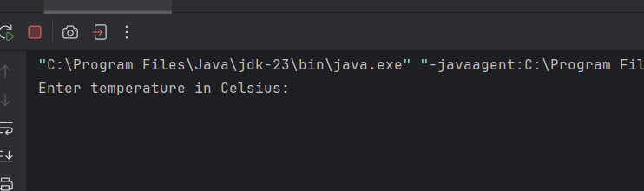

4)

package Q_4;  
  
  
import java.util.Scanner;  
  
public class Number4 {  
 public static void main(String[] args) {  
 Scanner sc = new Scanner(System.*in*);  
 System.*out*.print("Enter body weight in pounds: ");  
 double bodyWeight = sc.nextDouble();  
 double calories = bodyWeight * 19;  
 System.*out*.println("Calories needed per day: " + calories);  
 sc.close();  
 }  
}

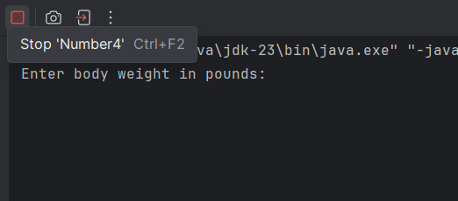

5)

package Q_5;  
  
import java.util.Scanner;  
  
public class Number5 {  
 public static void main(String[] args) {  
 Scanner sc = new Scanner(System.*in*);  
 System.*out*.print("Enter temperature in Fahrenheit: ");  
 double fahrenheit = sc.nextDouble();  
 double celsius = (5.0 / 9) * (fahrenheit - 32);  
 System.*out*.println("Temperature in Celsius: " + celsius);  
 sc.close();  
 }  
}

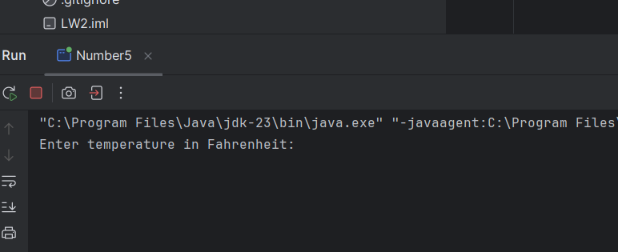

6)

package Q_6;  
import java.util.Scanner;  
import java.time.Year;  
public class Number6 {  
 public static void main(String[] args) {  
 Scanner sc = new Scanner(System.*in*);  
 System.*out*.print("Enter your birth year: ");  
 int birthYear = sc.nextInt();  
 int currentYear = Year.*now*().getValue();  
 int age = currentYear - birthYear;  
 System.*out*.println("You were born in " + birthYear + " and will be (are) " + age + " this year.");  
 sc.close();  
  
 }  
}

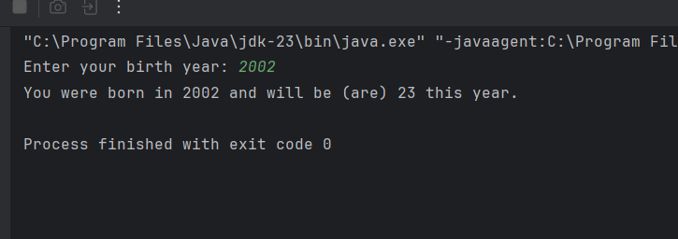

7)

package Q_7;  
import java.util.Scanner;  
public class Number7 {  
 public static void main(String[] args) {  
 Scanner sc = new Scanner(System.*in*);  
 System.*out*.print("Enter weight in kilograms: ");  
 int weight = sc.nextInt();  
 System.*out*.print("Enter height in centimeters: ");  
 int height = sc.nextInt();  
 double bmi = weight / Math.*pow*(height / 100.0, 2);  
 System.*out*.println("Your BMI is: " + String.*format*("%.2f", bmi));  
 sc.close();   
 }  
}

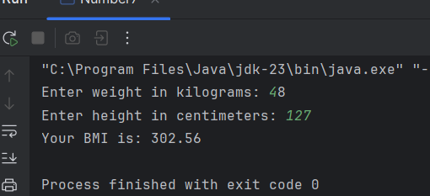

8)

package Q_8;  
import java.util.Scanner;  
public class Number8 {  
 public static void main(String[] args) {  
 Scanner sc = new Scanner(System.*in*);  
 System.*out*.print("Enter the radius of the sphere: ");  
 double radius = sc.nextDouble();  
 double volume = (4.0 / 3) * 3.14 * Math.*pow*(radius, 3);  
 System.*out*.println("Volume of the sphere is: " + String.*format*("%.2f", volume));  
 sc.close();  
 }  
}

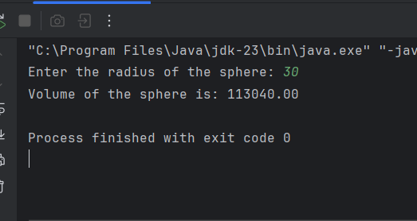

9)

package Q_9;  
import java.util.Scanner;  
public class Number9 {  
 public static void main(String[] args) {  
 Scanner sc = new Scanner(System.*in*);  
 System.*out*.print("Enter principal amount (P): ");  
 double principal = sc.nextDouble();  
 System.*out*.print("Enter annual interest rate (R) in percent: ");  
 double rate = sc.nextDouble();  
 System.*out*.print("Enter number of years (N): ");  
 int years = sc.nextInt();  
 double amount = principal * Math.*pow*(1 + (rate / 100), years);  
 System.*out*.println("Amount after " + years + " years: " + String.*format*("%.2f", amount));  
 sc.close();   
 }  
}

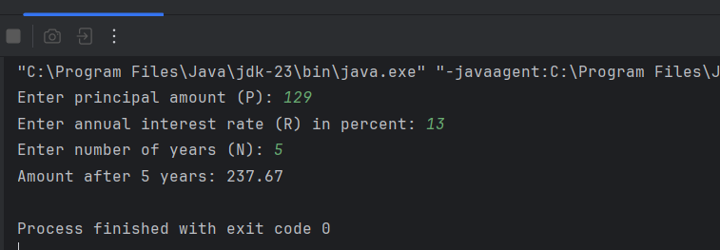

10)

package Q_10;  
import java.util.Scanner;  
public class Number10 {  
 public static void main(String[] args) {  
 final int MONTHS_IN_YEAR = 12;  
 Scanner sc = new Scanner(System.*in*);  
 System.*out*.print("Enter loan amount: ");  
 double loanAmount = sc.nextDouble();  
 System.*out*.print("Enter annual interest rate (in %): ");  
 double annualInterestRate = sc.nextDouble();  
 System.*out*.print("Enter loan period (in years): ");  
 int loanPeriod = sc.nextInt();  
  
 double monthlyInterestRate = annualInterestRate / 100.0 / MONTHS_IN_YEAR;  
 int numberOfPayments = loanPeriod * MONTHS_IN_YEAR;  
  
 double monthlyPayment = (loanAmount * monthlyInterestRate) /  
 (1 - 1 / Math.*pow*(1 + monthlyInterestRate, numberOfPayments));  
 double totalPayment = monthlyPayment * numberOfPayments;  
  
 System.*out*.println("Monthly Payment: " + String.*format*("%.2f", monthlyPayment));  
 System.*out*.println("Total Payment: " + String.*format*("%.2f", totalPayment));  
  
 sc.close();  
 }  
}

