LW4

CT/2021/075

Q1)

package Q_1;  
import java.util.Scanner;  
public class Num1 {  
 public static void main(String[] args) {  
 Scanner scanner = new Scanner(System.*in*);  
 System.*out*.print("Enter the first number: ");  
 int a = scanner.nextInt();  
  
 System.*out*.print("Enter the second number: ");  
 int b = scanner.nextInt();  
  
 System.*out*.print("Enter the third number: ");  
 int c = scanner.nextInt();  
  
 int smallest;  
 if (a <= b && a <= c) {  
 smallest = a;  
 } else if (b <= a && b <= c) {  
 smallest = b;  
 } else {  
 smallest = c;  
 }  
 System.*out*.println("The smallest number is: " + smallest);  
  
 scanner.close();  
 }  
 }

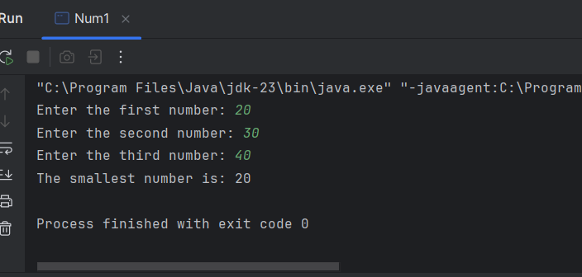

Q2)

package Q_2;  
import java.util.Scanner;  
  
public class Switch {  
 public static void main(String[] args) {  
 Scanner scanner = new Scanner(System.*in*);  
  
 System.*out*.println("0. Magenta");  
 System.*out*.println("1. Cyan");  
 System.*out*.println("2. Red");  
 System.*out*.println("3. Blue");  
 System.*out*.println("4. Green");  
 System.*out*.println("Select one color from the above list:");  
  
 int selection = scanner.nextInt();  
  
 switch (selection) {  
 case 0:  
 System.*out*.println("You selected Magenta");  
 break;  
 case 1:  
 System.*out*.println("You selected Cyan");  
 break;  
 case 2:  
 System.*out*.println("You selected Red");  
 break;  
 case 3:  
 System.*out*.println("You selected Blue");  
 break;  
 case 4:  
 System.*out*.println("You selected Green");  
 break;  
 default:  
 System.*out*.println("Invalid selection");  
 }  
  
 scanner.close();  
 }  
 }

Q3)

package Q_3;  
import java.util.Scanner;  
public class Power {  
 public static void main(String[] args) {  
 Scanner scanner = new Scanner(System.*in*);  
 System.*out*.print("Enter a power of 10 (e.g., 6, 9, 12...): ");  
 int power = scanner.nextInt();  
  
 switch (power) {  
 case 6:  
 System.*out*.println("Million");  
 break;  
 case 9:  
 System.*out*.println("Billion");  
 break;  
 case 12:  
 System.*out*.println("Trillion");  
 break;  
 case 15:  
 System.*out*.println("Quadrillion");  
 break;  
 case 18:  
 System.*out*.println("Quintillion");  
 break;  
 case 21:  
 System.*out*.println("Sextillion");  
 break;  
 case 30:  
 System.*out*.println("Nonillion");  
 break;  
 case 100:  
 System.*out*.println("Googol");  
 break;  
 default:  
 System.*out*.println("No standard name for 10 to the power of " + power);  
 }  
  
 scanner.close();  
 }  
 }

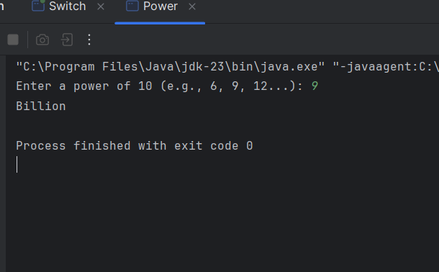

Q4)

package Q_4;  
import java.util.Scanner;  
public class Leap {  
 public static void main(String[] args) {  
 Scanner scanner = new Scanner(System.*in*);  
 System.*out*.print("Enter a year: ");  
 int year = scanner.nextInt();  
   
 if ((year % 4 == 0 && year % 100 != 0) || (year % 400 == 0)) {  
 System.*out*.println("Leap Year");  
 } else {  
 System.*out*.println("Not a Leap Year");  
 }  
  
 scanner.close();  
 }  
 }

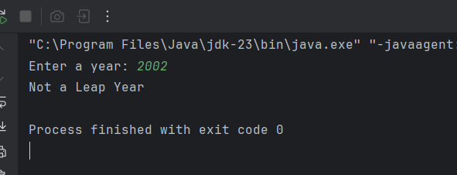

Q5)

package Q_5;  
import java.util.Scanner;  
public class MyJavaLoFatBurgers {  
 public static void main(String[] args) {  
 Scanner scanner = new Scanner(System.*in*);  
  
 String[] entrees = {"Tofu Burger", "Cajun Chicken", "Buffalo Wings", "Rainbow Fillet"};  
 double[] entreePrices = {3.49, 4.59, 3.99, 2.99};  
  
 String[] sides = {"Rice Cracker", "No-Salt Fries", "Zucchini", "Brown Rice"};  
 double[] sidePrices = {0.79, 0.69, 1.09, 0.59};  
  
 String[] drinks = {"Cafe Mocha", "Cafe Latte", "Espresso", "Oolong Tea"};  
 double[] drinkPrices = {1.99, 1.90, 2.49, 0.99};  
  
 System.*out*.println("Welcome to MyJava Lo-Fat Burgers!");  
   
 System.*out*.println("\nEntree Menu:");  
 for (int i = 0; i < entrees.length; i++) {  
 System.*out*.printf("%d. %s - $%.2f\n", i + 1, entrees[i], entreePrices[i]);  
 }  
 System.*out*.print("Please select an entree (1-4): ");  
 int entreeChoice = scanner.nextInt() - 1;  
   
 System.*out*.println("\nSide Dish Menu:");  
 for (int i = 0; i < sides.length; i++) {  
 System.*out*.printf("%d. %s - $%.2f\n", i + 1, sides[i], sidePrices[i]);  
 }  
 System.*out*.print("Please select a side dish (1-4): ");  
 int sideChoice = scanner.nextInt() - 1;  
   
 System.*out*.println("\nDrink Menu:");  
 for (int i = 0; i < drinks.length; i++) {  
 System.*out*.printf("%d. %s - $%.2f\n", i + 1, drinks[i], drinkPrices[i]);  
 }  
 System.*out*.print("Please select a drink (1-4): ");  
 int drinkChoice = scanner.nextInt() - 1;  
   
 double total = entreePrices[entreeChoice] + sidePrices[sideChoice] + drinkPrices[drinkChoice];  
   
 System.*out*.println("\n--- Order Summary ---");  
 System.*out*.printf("Entree: %s - $%.2f\n", entrees[entreeChoice], entreePrices[entreeChoice]);  
 System.*out*.printf("Side Dish: %s - $%.2f\n", sides[sideChoice], sidePrices[sideChoice]);  
 System.*out*.printf("Drink: %s - $%.2f\n", drinks[drinkChoice], drinkPrices[drinkChoice]);  
 System.*out*.printf("Total: $%.2f\n", total);  
  
 scanner.close();  
 }  
 }

