PRACTICAL-6

Name: B. PEMESH
Rollno: 2520030388

Section: 8

Part A: Client-Server Communication Using Named Pipes (FIFOs)

Aim:
To create a client-server application using Named Pipes (FIFOs) where the client sends messages to
the server, and the server processes and responds to the client.

Objective
- To understand IPC using Named Pipes.
- To implement client-server communication.
- To observe FIFO behavior with multiple clients.

Problem Statement
Create a client-server application using FIFOs. The client sends a message through a FIFO, the server reads and processes it, and sends a response back.

Theory
A FIFO (First In, First Out) is a named pipe used for communication between processes. Unlike an ordinary pipe, a FIFO has a name in the filesystem and can be used by unrelated processes.
Client → server_fifo → Server
Client ← response_fifo ← Server
When multiple clients use the same FIFO, messages are received according to the order in which their writes are completed. For reliable multiple-client communication, separate response FIFOs are preferable.

Algorithm

Server:
- Create the FIFOs.
- Open the server FIFO for reading.
- Read the client message.
- Process the message.
- Send a response.
- Repeat.

Client:
- Open the server FIFO.
- Enter a message.
- Send the message.
- Read the server response.
- Display the response.

C Program – Server #include <stdio.h> #include <stdlib.h> #include <string.h> #include <fcntl.h> #include <unistd.h> #include <sys/stat.h>

#define SERVER_FIFO "server_fifo"
#define RESPONSE_FIFO "response_fifo"

int main()
{
char buffer[100], response[150]; int fd, response_fd;

mkfifo(SERVER_FIFO, 0666);
mkfifo(RESPONSE_FIFO, 0666);
printf("Server started...\n"); while (1)
{
fd = open(SERVER_FIFO, O_RDONLY);
int bytes = read(fd, buffer, sizeof(buffer) - 1); if (bytes > 0)
{
buffer[bytes] = '\0';
printf("Client Message: %s\n", buffer); snprintf(response, sizeof(response),
"Server processed: %s", buffer); close(fd);
response_fd = open(RESPONSE_FIFO, O_WRONLY); write(response_fd, response, strlen(response) + 1); close(response_fd);
printf("Response sent.\n\n");
}
}

return 0;
}

OUTPUT:

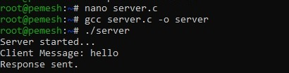

C Program – Client

#include <stdio.h>
#include <stdlib.h>
#include <string.h> #include <fcntl.h> #include <unistd.h>

#define SERVER_FIFO "server_fifo" #define RESPONSE_FIFO "response_fifo"

int main()
{
char message[100], response[150]; int fd, response_fd;

printf("Enter message: "); fgets(message, sizeof(message), stdin);

message[strcspn(message, "\n")] = '\0'; fd = open(SERVER_FIFO, O_WRONLY);
write(fd, message, strlen(message) + 1); close(fd);
response_fd = open(RESPONSE_FIFO, O_RDONLY);
int bytes = read(response_fd, response, sizeof(response) - 1); if (bytes > 0)
{
response[bytes] = '\0';
printf("Server Response: %s\n", response);
}

close(response_fd);

return 0;
}

OUTPUT:

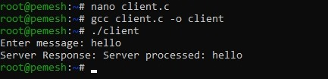

Observation
- Client successfully sent messages to the server.
- Server successfully processed and responded to messages.
- Multiple clients can use the same FIFO.
- The order of messages depends on the order of writes.
- A shared response FIFO can cause response-matching problems with multiple simultaneous clients.

Result
The client-server application was successfully implemented using Named Pipes (FIFOs), and FIFO behavior with multiple clients was observed.

Part B: POSIX Signal Handling

Aim
To create a POSIX signal handling program that captures SIGINT, SIGTERM, and SIGUSR1,
demonstrating asynchronous event handling.

Objective
- To understand POSIX signals.
- To implement signal handlers.
- To handle SIGINT, SIGTERM, and SIGUSR1.
- To understand asynchronous event handling.

Problem Statement
Create a C program that handles SIGINT, SIGTERM, and SIGUSR1 using POSIX signal handling.

Theory
A signal is an asynchronous notification sent to a process.
Signal | Meaning | How to  generate
SIGINT | Interrupt | Ctrl + C
SIGTERM | Termination | kill -TERM PID
SIGUSR1 | User-  defined | kill -USR1 PID
A signal handler is a function that executes automatically when the corresponding signal is received.

Algorithm
- Start the program.
- Register handlers for the three signals.
- Display the process PID.
- Wait for signals.
- Handle the received signal.
- Continue or terminate depending on the signal.

C Program #include <stdio.h> #include <stdlib.h> #include <unistd.h> #include <signal.h>

void signal_handler(int signal)
{
if (signal == SIGINT)

{
printf("\nSIGINT received (Ctrl+C)\n"); printf("Program is still running.\n");
}
else if (signal == SIGUSR1)
{
printf("\nSIGUSR1 received.\n"); printf("User-defined signal handled.\n");
}
else if (signal == SIGTERM)
{
printf("\nSIGTERM received.\n"); printf("Terminating program...\n"); exit(0);
}
}

int main()
{
struct sigaction action;

action.sa_handler = signal_handler; sigemptyset(&action.sa_mask); action.sa_flags = 0;

sigaction(SIGINT, &action, NULL); sigaction(SIGTERM, &action, NULL); sigaction(SIGUSR1, &action, NULL);

printf("Signal handling program started.\n"); printf("Process PID: %d\n", getpid());
printf("Waiting for signals...\n"); while (1)
{
pause();
}

return 0;
}

OUTPUT:

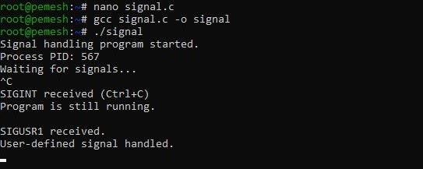

Observation
- SIGUSR1 was successfully handled asynchronously.
- SIGINT was captured when Ctrl+C was pressed.
- SIGTERM was captured and used to terminate the program.
- Signal handlers allow a process to respond to events without continuously checking for them.

Result
The POSIX signal handling program was successfully implemented and tested for SIGINT, SIGTERM, and SIGUSR1. The experiment demonstrated asynchronous event handling and the role of signal handlers.

