PRACTICAL-10

Name: B.PEMESH
Roll Number: 2520030388
Section: 08
EXPERIMENT – Inode Structures, Hard Links, Symbolic Links and Memory-Mapped File I/O
Aim:
To investigate inode structures using Linux commands such as ls -i, stat, and find, create hard and symbolic links, and implement a program using mmap() for file reading and writing
Objective:
- To understand inode structures in Linux.
- To examine inode numbers using ls -i and stat.
- To create and analyze hard links and symbolic links.
- To understand the effect of links on inode allocation.
- To implement file reading and writing using mmap().
- To compare memory-mapped I/O with traditional read() and write() operations.
Problem statement:
Investigate inode structures using commands such as ls -i, stat, and find. Create hard links and symbolic links and explain their impact on inode allocation.
Design a program using mmap() to perform file reading and writing and compare memory-mapped I/O with traditional read() and write() operations.
Theory:
An inode is a data structure used by the Linux file system to store information about a file. It contains information such as file permissions, ownership, file size, timestamps, and references to the blocks containing the file data.
The ls -i command displays the inode number of a file. The stat command displays detailed information about a file, including its inode number. The find command can be used to locate files and directories.
A hard link creates another directory entry that refers to the same inode as the original file. Therefore, both the original file and hard link refer to the same file data.
A symbolic link is a separate file that stores a path to another file. It has its own inode and points to the target file.
mmap() maps a file into the virtual address space of a process. The file can then be accessed through memory addresses instead of repeatedly using read() and write() system calls.
Algorithm:
Part A – Inode and Links
- Create a sample file.
- Display its inode number using ls -i.
- Display detailed file information using stat.
- Create a hard link to the file.
- Display the inode numbers of the original file and hard link.
- Create a symbolic link to the original file.
- Display the inode information of the symbolic link.
- Use find to locate the files.
- Observe the difference between hard links and symbolic links.
Part B – mmap()
- Start the program.
- Open the file using open().
- Determine the file size using fstat().
- Map the file into memory using mmap().
- Read the file contents through the mapped memory.
- Modify the mapped memory.
- Synchronize the changes using msync().
- Unmap the memory using munmap().
- Close the file.
- Display the result

Commands used:
- ls -i: Displays the inode number of a file.
- stat: Displays detailed information about a file.
- find: Searches for files and directories.
- ln: Creates a hard link.
- ln -s: Creates a symbolic link.
- mmap(): Maps a file into the process's virtual memory.
- munmap(): Removes a memory mapping.
- msync(): Synchronizes changes made to mapped memory with the file.
PROGRAM 1 – INODE STRUCTURES AND LINKS
Output:
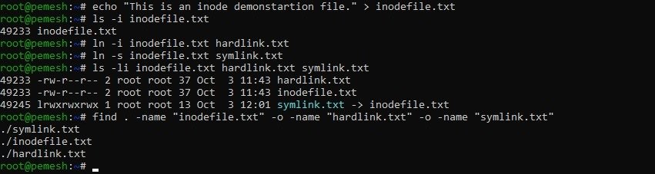

Observation:
The original file and hard link have the same inode number because both directory entries refer to the same inode.
The symbolic link has a different inode number because it is a separate file that contains a reference to the target file.
The ls -i and stat commands provide inode information, while find is used to locate the files.
PROGRAM 2 – FILE READING AND WRITING USING mmap()
C Program:
#include <stdio.h>
#include <stdlib.h>
#include <fcntl.h>
#include <unistd.h>
#include <sys/mman.h>
#include <sys/stat.h>
#include <string.h>

int main()
{
int fd;
struct stat st;
char *data;

fd = open("mmapfile.txt", O_RDWR);

if (fd < 0)
{
perror("Error opening file");
return 1;
}

if (fstat(fd, &st) < 0)
{
perror("fstat failed");
close(fd);
return 1;
}

if (st.st_size == 0)
{
printf("File is empty.\n");
close(fd);
return 0;
}

data = mmap(NULL, st.st_size,
PROT_READ | PROT_WRITE,
MAP_SHARED, fd, 0);

if (data == MAP_FAILED)
{
perror("mmap failed");
close(fd);
return 1;
}

printf("Original file contents:\n");
write(STDOUT_FILENO, data, st.st_size);

memcpy(data, "Modified using mmap()\n", 22);

msync(data, st.st_size, MS_SYNC);

printf("\nFile modified successfully using mmap().\n");

munmap(data, st.st_size);
close(fd);

return 0;
}
Output:
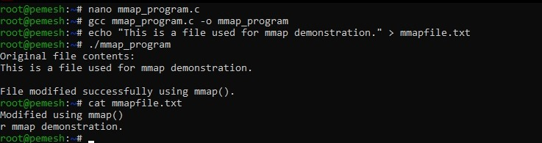
Program Explanation:
- The program opens mmapfile.txt using open().
- The fstat() function obtains the size of the file.
- The mmap() system call maps the file into the process's virtual memory. The contents of the file can then be accessed through the memory address returned by mmap().
- The program displays the original contents and modifies the mapped memory using memcpy().
- The msync() function synchronizes the modified memory with the file.
- Finally, munmap() removes the mapping and close() closes the file descriptor.

Analysis:
The inode commands showed the information maintained by the Linux file system for files. The original file and hard link referred to the same inode, while the symbolic link had its own inode.
The mmap() program accessed the file through a memory mapping. Instead of explicitly reading the file into a buffer using read(), the file was mapped into the process address space. Changes made to the mapped memory were synchronized with the file using msync().
Test Cases:
Test Case | Input / Action | Expected Result
1 | Run ls -i inodefile.txt | Inode number is displayed
2 | Run stat inodefile.txt | Detailed inode information is displayed
3 | Create hardlink.txt | Hard link is created successfully
4 | Compare inode numbers of original and hard link | Same inode number is displayed
5 | Create symlink.txt | Symbolic link is created successfully
6 | Compare inode numbers of symbolic link and original | Different inode numbers are displayed
7 | Run ./mmap_program | File contents are mapped and displayed
8 | Run cat mmapfile.txt | Modified file contents are displayed

Observation:
  - The inode number of the original file was displayed using ls -i.
  - Detailed file information was obtained using stat.
  - The hard link and original file had the same inode number.
  - The symbolic link had a different inode number.
  - The files were successfully located using find.
  - The mmap() program successfully mapped the file into memory.
  - The file contents were accessed through the memory mapping.
  - The file was successfully modified using the mapped memory.
Result:
The inode structure of files was successfully investigated using ls -i, stat, and find. Hard and symbolic links were successfully created and their inode differences were observed.
The mmap() program was successfully implemented to read and modify a file using memory mapping.
Conclusion:
The experiment demonstrated how Linux uses inodes to manage files and how hard links and symbolic links differ in their inode allocation. It also demonstrated memory-mapped file I/O using mmap() and showed how a file can be accessed and modified through the process's virtual memory.

