PRACTICAL-2

Name: B.PEMESH
Roll Number: 2520030388
Section: 08
EXPERIMENT – File Copy Using System Calls and System Call Tracing Using strace
Aim:
To develop a C program using the system calls open(), read(), write(), and close() to copy the contents of one file to another, and to trace the system calls generated by the cat command using strace.
Objective:
- To understand file handling using Linux system calls.
- To copy data from one file to another using open(), read(), write(), and close().
- To understand the transition between user space and kernel space during system call execution.
- To use strace to trace system calls.
- To analyze the system calls used by the cat command.
Problem statement:
Develop a C program that copies the contents of one file to another using the system calls open(), read(), write(), and close(). Also, use the strace utility to trace the system calls generated while executing cat sample.txt and identify the kernel services involved.
Theory:
Linux provides system calls that allow user programs to request services from the operating system kernel. File operations such as opening, reading, writing, and closing files can be performed using system calls.
The open() system call opens a file and returns a file descriptor. The read() system call reads data from the file into a buffer. The write() system call writes data from the buffer to another file. The close() system call closes the opened file.
During execution, a user program runs in user space. When it needs an operating system service, it makes a system call and control is transferred to kernel space. The kernel performs the requested operation and returns the result to the program.
The strace utility is used to trace system calls made by a Linux program. It helps in understanding how commands interact with the operating system.
System calls used:
1. open() - Used to open a file and obtain a file descriptor.
2. read() - Used to read data from a file into a buffer.
3. write() - Used to write data from a buffer to a file.
4. close() - Used to close an opened file.
Algorithm:
- Start the program.
- Open the source file using open().
- Check whether the source file was opened successfully.
- Create or open the destination file using open().
- Read data from the source file using read().
- Write the data into the destination file using write().
- Repeat the read and write operations until the complete file is copied.
- Close both files using close().
- Display a success message.
- Use strace to trace the system calls generated by cat sample.txt.
- Stop the program.
C Program:
#include <stdio.h>
#include <stdlib.h>
#include <fcntl.h>
#include <unistd.h>

int main()
{
int source, destination;
char buffer[1024];
int bytes_read;

source = open("source.txt", O_RDONLY);

if (source < 0)
{
perror("Error opening source file");
return 1;
}

destination = open("destination.txt",
O_WRONLY | O_CREAT | O_TRUNC,
0644);

if (destination < 0)
{
perror("Error creating destination file");
close(source);
return 1;
}

while ((bytes_read = read(source, buffer, sizeof(buffer))) > 0)
{
if (write(destination, buffer, bytes_read) != bytes_read)
{
perror("Error writing to destination file");
close(source);
close(destination);
return 1;
}
}

close(source);
close(destination);

printf("File copied successfully.\n");

return 0;
}

Output:
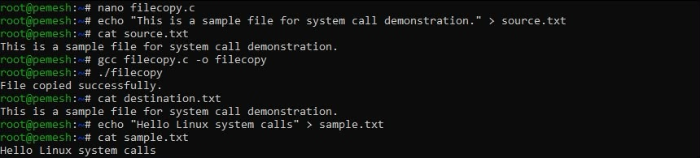
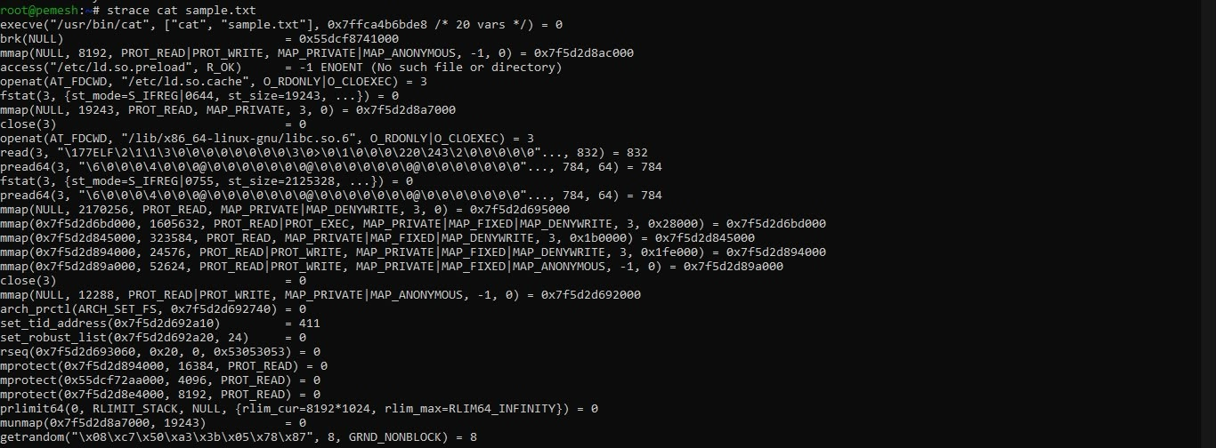
Program Explanation:
The program first opens source.txt in read-only mode using the open() system call. The file descriptor returned by open() is stored in the variable source.
The destination file is then opened using open(). The file is created if it does not exist and its previous contents are removed if it already exists.
The read() system call reads the contents of the source file into a buffer. The write() system call writes the data from the buffer into the destination file. This process continues until the complete file is copied.
Finally, the close() system call closes both files and releases their file descriptors.
During system call execution, the program running in user space requests file-related services from the Linux kernel. The kernel performs the requested operation and returns the result to the program.
The strace utility is used to observe the system calls generated by the cat command.
Analysis:
The experiment successfully demonstrated the use of Linux file-related system calls. The file-copy program used open(), read(), write(), and close() to transfer data from the source file to the destination file. The strace output showed the system calls involved when cat accessed and displayed sample.txt.
The experiment also demonstrated that system calls provide a mechanism for a user-level program to request file-related services from the Linux kernel.
Test Cases:
Test Case | Input / Action | Expected Result
1 | Run ./filecopy | File copied successfully message is displayed
2 | Run cat source.txt | Source file contents are displayed
3 | Run cat destination.txt | Destination file contains the same contents
4 | Run the strace command | File-related system calls are displayed
5 | Run cat sample.txt | Contents of sample.txt are displayed

Observation:
- The source file was successfully opened using the open() system call.
- The contents of the source file were read using read().
- The data was written into the destination file using write().
- Both files were closed using close().
- The source and destination files contained the same data.
- The strace utility displayed the system calls generated while executing the cat command.
- The experiment demonstrated the interaction between the user program and the Linux kernel.
Result:
The C program was successfully implemented to copy the contents of one file to another using the open(), read(), write(), and close() system calls. The system calls generated by the cat command were successfully traced using the strace utility.
Conclusion:
The experiment demonstrated file operations using Linux system calls and showed how a user program interacts with the Linux kernel. The strace utility helped in understanding the sequence of system calls involved in reading and displaying the contents of a file.

