SKILL-01

Name: B. Pemesh
Rollno: 2520030388
Section: 8

Experiment No. 01 (Q1)
Title: Linux Environment Setup, Shell Architecture and Process Management
Aim:
To install and configure a Linux development environment with GCC and Git, understand basic shell architecture, create a project structure with a Makefile, and implement process creation and program execution using fork() and the exec() family of system calls. The experiment also demonstrates parent-child relationships, process trees, and system call tracing.
Objective:
Part 1 – Linux Environment and Shell Architecture
- To install and configure a Linux environment.
- To configure GCC for compiling C programs.
- To set up a Git repository.
- To create a basic project structure.
- To build an initial Make file.
- To understand basic shell architecture.

Part 2 – Process Management
- To understand process abstraction.
- To create a child process using fork().
- To understand the exec() family of functions.
- To analyze parent-child relationships.
- To inspect the process tree.
- To practice system call tracing.

Theory:

1. Linux Environment
Linux provides an operating system environment in which programs can be developed, compiled and executed. The terminal provides an interface for interacting with the operating system.

2. GCC Compiler
GCC (GNU Compiler Collection) is used to compile C programs and generate executable files. It allows source code written in C to be converted into an executable program.

3. Git Repository
Git is a version control system used to manage and track changes made to project files. A Git repository stores the project files and their version history.

4. Shell Architecture
A shell acts as an interface between the user and the operating system. It accepts commands from the user, interprets them and requests the operating system to perform the required operations.

5. Process Abstraction
A process is a program that is currently being executed. The operating system manages processes and assigns resources such as CPU time and memory to them.

6. fork()
The fork() system call creates a new child process from an existing parent process. The newly created process is called the child process, while the process that created it is called the parent process.

7. exec()
The exec() family of functions is used to execute another program. It replaces the current process image with the specified program.

8. Parent-Child Relationship
When a process creates another process using fork(), the original process becomes the parent and the newly created process becomes its child. The parent can monitor the child process using functions such as waitpid().

9. Process Tree
Linux processes are organized in a hierarchical structure. A parent process can create one or more child processes, forming a process tree.

10. System Call Tracing
System call tracing is used to observe the system calls made by a program during execution. In Linux, the strace command can be used to trace system calls.
Algorithm:
Part 1 – Linux Environment and Shell Setup
- Start the Linux environment.
- Install and configure GCC.
- Create a project directory.
- Initialize a Git repository.
- Create the required source files.
- Create an initial Makefile.
- Compile the program using GCC.
- Verify that the program executes successfully.

Part 2 – Process Management
- Start the program.
- Display the PID of the parent process.
- Call fork() to create a child process.
- Check the return value of fork().
- If fork() fails, display an error message.
- If the return value is zero, execute the child process.
- Use an exec() function to execute the required command.
- If exec() fails, display an error message.
- If the process is the parent, display the child process ID.
- Use waitpid() to wait for the child process.
- Display the completion of the child process.
- Stop the program.

Functions Used:

Function | Purpose
main() | Starting point of the program
fork() | Creates a child process
getpid() | Returns the process ID of the current process
getppid() | Returns the parent process ID
execlp() | Executes another program by replacing the current process
waitpid() | Waits for a child process to complete
perror() | Displays an error message
printf() | Displays output on the terminal

Hardware and Operating System Relationship
Hardware consists of physical components such as the CPU, RAM, storage devices, keyboard and display. The Operating System acts as an interface between application software and hardware.
Relationship
USER
↓
SHELL
↓
SYSTEM CALLS
fork(), exec(), waitpid()
↓
OPERATING SYSTEM
↓
CPU / RAM / I/O DEVICES
↓
STORAGE DEVICES
How OS Interacts with Hardware
- Process Management – The OS creates and manages parent and child processes.
- Memory Management – The OS manages memory required by processes.
- File Management – The OS manages program files and executable files.
- Device Management – The OS manages input and output devices.
- CPU Management – The OS schedules processes for execution.

Observation
The program successfully creates a child process using fork(). The child process executes another program using the exec() family of system calls, while the parent process waits for the child using waitpid(). The parent and child process IDs can be observed to understand their relationship. The process tree and system calls can also be inspected using Linux commands.
Result
The Linux environment was successfully configured with GCC and Git. Process creation using fork(), program execution using exec(), and parent-child synchronization using waitpid() were successfully implemented and observed.
Design / Flow
Process Creation Flow
Start
↓
Display Parent PID
↓
Call fork()
↓
Create Child Process
↓
Child Process → exec() → Execute Program
↓
Parent Process → waitpid() → Wait for Child
↓
Child Process Completes
↓
End
Shell Architecture Flow
User enters command
↓
Shell reads command
↓
Shell processes command
↓
fork() creates child process
↓
Child executes command using exec()
↓
Parent waits using waitpid()
↓
Command execution completed
CODE-
#include <stdio.h>
#include <stdlib.h>
#include <unistd.h>
#include <sys/types.h>
#include <sys/wait.h>

int main()
{
pid_t pid;

printf("Parent Process Started\n");
printf("Parent PID: %d\n", getpid());

pid = fork();

if (pid < 0)
{
perror("fork failed");
return 1;
}

if (pid == 0)
{
printf("\nChild Process Started\n");
printf("Child PID: %d\n", getpid());
printf("Parent PID: %d\n", getppid());

printf("Executing ls command using exec...\n");

execlp("ls", "ls", "-l", NULL);

perror("exec failed");
exit(1);
}
else
{
printf("\nParent Process\n");
printf("Child PID: %d\n", pid);

waitpid(pid, NULL, 0);

printf("Child process completed.\n");
}

return 0;
}
Sample Output
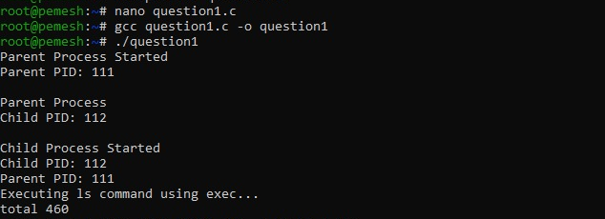
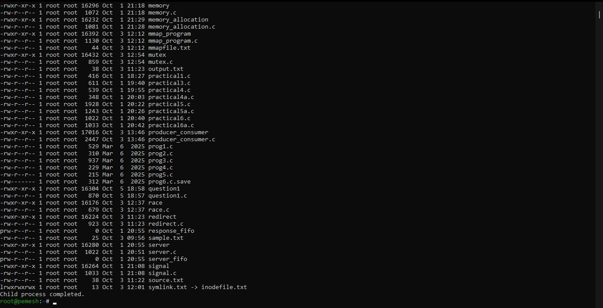
Conclusion
This experiment demonstrates Linux environment setup, shell architecture and process management. Process creation using fork(), program execution using exec(), and parent-child synchronization using waitpid() were successfully implemented. The experiment also provides an understanding of process relationships, process trees and system call tracing in Linux.

Experiment No. 02 (Q2)
Title: Interactive Shell Main Loop and Keyboard Input Handling
Aim:
To implement an interactive shell main loop that displays a prompt, reads user input, handles exit conditions, captures keyboard input, processes Backspace and Enter keys, manages an input buffer, and supports multi-character commands.
Objective:
Part 1 – Interactive Shell Loop
- To create the main shell loop.
- To display a command prompt.
- To read user input.
- To handle exit conditions.
- To design the control flow of the interactive loop.

To test the interactive shell loop.

Part 2 – Process Input Handling
- o capture keyboard input.
- To handle the Backspace key.
- To process the Enter key.
- To manage the input buffer.
- To support multi-character commands.

To test user interaction.

Theory:

1. Interactive Shell
An interactive shell continuously accepts commands from the user, processes the input and performs the required operation. The shell repeats this process until the user enters an exit command.

2. Shell Prompt
The shell prompt indicates that the shell is ready to receive a command from the user. After displaying the prompt, the shell waits for keyboard input.

3. Input Buffer
An input buffer is a memory area used to temporarily store characters entered by the user. The buffer allows multiple characters to be collected until the Enter key is pressed.

4. Keyboard Input
Keyboard input is captured character by character. Each character is added to the input buffer until the user presses Enter.

5. Backspace Handling
The Backspace key is used to remove the previously entered character. When Backspace is pressed, the last character is removed from the input buffer and the terminal display is updated.

6. Enter Key
The Enter key indicates that the user has completed entering a command. The contents of the input buffer are then processed as a complete command.

7. Exit Condition
The shell checks whether the entered command is an exit command. If the user enters exit, the shell terminates. Otherwise, the shell continues displaying the prompt and accepting commands
Algorithm:

Part 1 – Interactive Shell Loop
- Start the program.
- Display the shell prompt.
- Read a command from the user.
- Check whether the command is an exit command.
- If the command is exit, terminate the shell.
- Otherwise, process the entered command.
- Display the prompt again.
- Repeat until the user enters exit.

Part 2 – Keyboard Input Handling
- Start the program.
- Initialize the input buffer.
- Display the shell prompt.
- Read one character from the keyboard.
- If the character is Enter, terminate the current input.
- If the character is Backspace, remove the last character from the buffer.
- Otherwise, add the character to the input buffer.
- Continue reading characters until Enter is pressed.
- Add the null character to terminate the input string.
- Process the completed command.
- Repeat the process until the user enters exit.
Functions Used:

Function | Purpose
main() | Starting point of the program
read() | Reads keyboard input
write() | Displays characters on the terminal
strlen() | Finds the length of the input string
strcmp() | Compares the entered command with exit
memset() | Initializes the input buffer
printf() | Displays messages and the shell prompt
Function | Purpose

Hardware and Operating System Relationship
Hardware consists of physical components such as the keyboard, CPU, RAM and display. The Operating System provides the interface through which the shell receives keyboard input and displays output.
Relationship
USER
↓
KEYBOARD
↓
OPERATING SYSTEM
↓
SHELL
↓
INPUT BUFFER
↓
COMMAND PROCESSING
↓
DISPLAY
How OS Interacts with Hardware
- Input Management – The OS receives characters entered through the keyboard.
- Process Management – The OS manages the shell process.
- Memory Management – The OS provides memory for the input buffer.
- Device Management – The OS manages the keyboard and terminal.
- Output Management – The OS displays the shell prompt and entered characters.
Observation
The program successfully displays an interactive shell prompt and accepts keyboard input character by character. Multiple characters can be stored in the input buffer. The Backspace key removes the previously entered character, while the Enter key completes the command. The shell continues accepting commands until the user enters the exit command.
Result
The interactive shell main loop was successfully implemented. The program displays a prompt, captures keyboard input, handles Backspace and Enter keys, stores multi-character commands in an input buffer, and terminates when the user enters the exit command.
Design / Flow
Interactive Shell Flow
Start
↓
Initialize Input Buffer
↓
Display Shell Prompt
↓
Read Keyboard Character
↓
Is Character Enter?
→ No → Continue Reading Input
↓ Yes
Complete Input String
↓
Is Command exit?
→ Yes → Terminate Shell
↓ No
Process Command
↓
Display Prompt Again
↓
Repeat
Keyboard Input Flow
Keyboard Input
↓
Read Character
↓
Backspace?
→ Yes → Remove Last Character
↓ No
Enter?
→ Yes → Complete Command
↓ No
Add Character to Buffer
↓
Display Character
↓
Read Next Character
CODE-
#include <stdio.h>
#include <stdlib.h>
#include <string.h>
#include <unistd.h>
#include <termios.h>

#define MAX_INPUT 100

void enableRawMode(struct termios *original)
{
struct termios raw;

tcgetattr(STDIN_FILENO, original);
raw = *original;

raw.c_lflag &= ~(ICANON | ECHO);

tcsetattr(STDIN_FILENO, TCSAFLUSH, &raw);
}

void disableRawMode(struct termios *original)
{
tcsetattr(STDIN_FILENO, TCSAFLUSH, original);
}

int main()
{
char buffer[MAX_INPUT];
int length;
char ch;
struct termios original;

enableRawMode(&original);

while (1)
{
length = 0;
memset(buffer, 0, sizeof(buffer));

printf("\nshell> ");
fflush(stdout);

while (1)
{
read(STDIN_FILENO, &ch, 1);

if (ch == '\n' || ch == '\r')
{
buffer[length] = '\0';
printf("\n");
break;
}

if (ch == 127 || ch == '\b')
{
if (length > 0)
{
length--;
buffer[length] = '\0';

printf("\b \b");
fflush(stdout);
}
continue;
}

if (length < MAX_INPUT - 1)
{
buffer[length++] = ch;
write(STDOUT_FILENO, &ch, 1);
}
}

if (strcmp(buffer, "exit") == 0)
{
break;
}

if (length > 0)
{
printf("Command entered: %s\n", buffer);
}
}

disableRawMode(&original);

printf("Shell terminated.\n");

return 0;
}
Sample Output
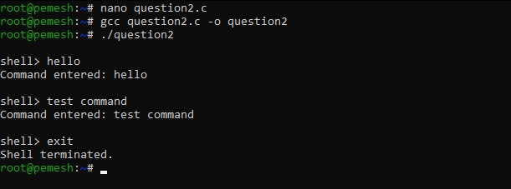
Conclusion
This experiment demonstrates the implementation of an interactive shell loop and keyboard input handling. The shell successfully displays a prompt, captures keyboard input, stores multi-character commands in an input buffer, handles Backspace and Enter keys, and terminates when the user enters the exit command.

