PRACTICAL-7

Name: P. Anuradha Nandini
Roll Number: 2520030171
Section: 08
EXPERIMENT – Memory Address Space and /proc//maps
Aim:
To write a C program that prints the addresses of code, global, static, heap, and stack variables, and analyse the Linux process address-space layout using /proc//maps.
Objective:
To understand the memory layout of a Linux process.
To identify code, global, static, heap, and stack regions.
To observe virtual memory mappings using /proc//maps.
To understand how Linux organizes memory for a running process.
Problem Statement:
Write a C program to display the addresses of different types of variables and use /proc//maps to study the virtual memory organization of the running process.
Theory:
A Linux process has its own virtual address space. Important regions include:
Memory Segment | Purpose
Code/Text | Contains program instructions
Global/Data | Contains initialized global variables
BSS | Contains uninitialized global/static variables
Heap | Used for dynamically allocated memory
Stack | Stores local variables and function information
Shared Libraries | Libraries mapped into the process address space

The /proc//maps file shows the virtual memory regions currently mapped into a process.
Example: 55a1...-55a1... r-xp ... /program
55a1...-55a1... rw-p ... /program
7f2...-7f2... r-xp ... /libc.so.6
7ffd...-7ffd... rw-p ... [stack]
Here:
r = Read
w = Write
x = Execute
p = Private mapping
Algorithm:
1. Declare a global variable.
2. Declare a static variable.
3. Create a local stack variable.
4. Create a function to represent the code segment.
5. Allocate memory dynamically using malloc().
6. Print the addresses of all variables.
7. Print the process PID.
8. Keep the program running.
9. Open /proc//maps from another terminal.
10. Analyse the virtual memory mappings.
11. identify the stack, heap, program, and shared-library regions.

C Program:
#include <stdio.h>
#include <stdlib.h>
#include <unistd.h>

int global_var = 10;
static int static_var = 20;

void code_function()
{
printf("Code address : %p\n", (void *)code_function);
}

int main()
{
int stack_var = 30;
int *heap_var;

heap_var = (int *)malloc(sizeof(int));

if (heap_var == NULL)
{
printf("Memory allocation failed\n");
return 1;
}

*heap_var = 40;

printf("Linux Process Memory Layout\n");
printf("----------------------------\n");

printf("PID : %d\n", getpid());

printf("Code address : %p\n", (void *)code_function);

printf("Global address : %p\n", (void *)&global_var);

printf("Static address : %p\n", (void *)&static_var);

printf("Heap address : %p\n", (void *)heap_var);

printf("Stack address : %p\n", (void *)&stack_var);

printf("\nProcess is running...\n");

printf("Use another terminal to check /proc/%d/maps\n", getpid());

while (1)
{
sleep(10);
}

free(heap_var);

return 0;
}

Output:
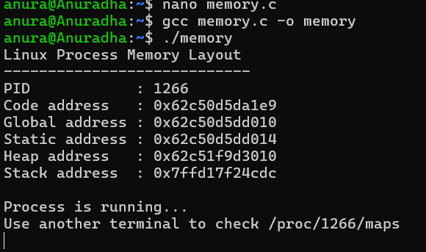
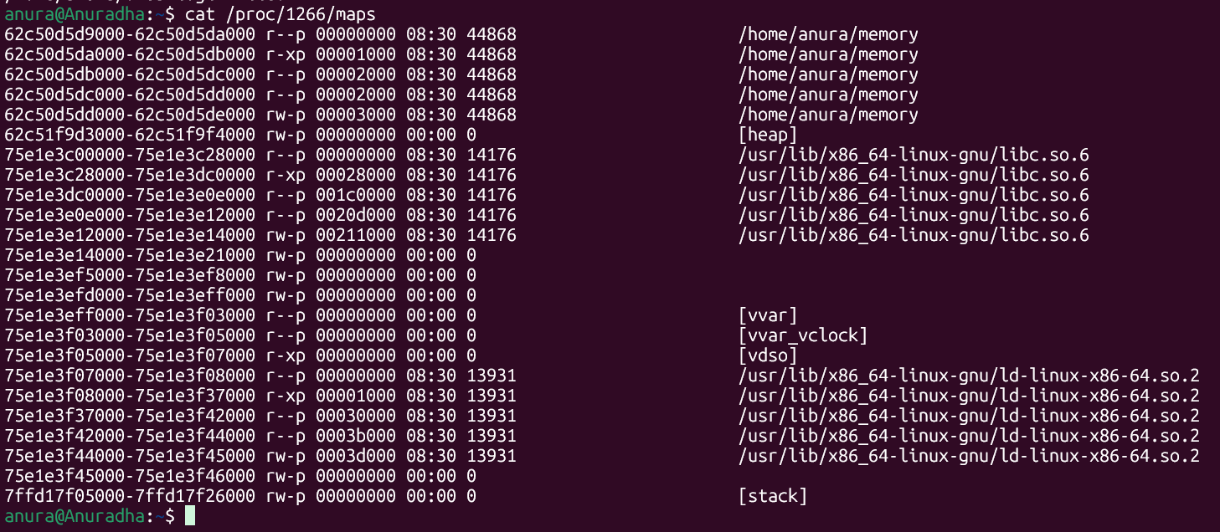
Program Explanation:
Code Segment
(void *)code_function
This displays the address of a function. Since program instructions are stored in the code/text segment, this represents the code region.
Global Segment
int global_var = 10;
The global variable is stored in the process's global data area.
Static Segment
static int static_var = 20;
The static variable has static storage duration and is stored in the program's data area
Heap
heap_var = (int *)malloc(sizeof(int));
malloc() dynamically allocates memory from the heap.
Stack
int stack_var = 30;
A local variable inside main() is stored on the stack.
Analysis:
The r-xp mapping of the executable corresponds to the code/text region.
The writable executable mapping contains data/global/static areas.
[heap] represents dynamically allocated memory.
[stack] represents the process stack.
libc.so.6 represents a shared library mapped into the process.
Each process sees these as virtual addresses, which Linux manages through virtual memory.
Test Cases:
Command/Action | Expected Result
Run program | PID and memory addresses displayed
Check code address | Address of function displayed
Check global/static address | Data-area addresses displayed
Check heap address | Dynamically allocated address displayed
Check stack address | Local-variable address displayed
cat /proc/PID/maps | Virtual memory mappings displayed
pmap PID | Process memory map displayed

Observation:
The program displayed different virtual addresses for code, global, static, heap, and stack variables.
The heap and stack appeared as separate regions in /proc/PID/maps.
The executable and shared libraries were also mapped into the process address space.
/proc/PID/maps provided information about the permissions and ranges of each virtual memory mapping.
Result:
The C program was successfully implemented to display addresses of the code, global, static, heap, and stack regions. The /proc//maps file was used to analyse the virtual memory organization of the running process.
Conclusion:
The experiment demonstrated how Linux organizes a process into different virtual memory regions. The memory addresses printed by the program, together with /proc//maps, helped identify the code, data, heap, stack, and shared-library mappings.

