SKILL-12
Name: B. Pemesh
Rollno: 2520030388
Section: 8

Experiment No. 23(Q23)
Title: Testing Large Pipelines, Multiple Jobs, Resource Monitoring and Performance Analysis.
Aim:
To execute large pipelines and multiple jobs, monitor system resources, detect failures, analyze performance, and document the shell architecture and execution flow.
Objective:
- To execute large pipelines.
- To launch multiple jobs.
- To monitor resource usage.
- To detect command failures.
- To analyze execution performance.
- To understand shell architecture.
- To document execution paths and system calls.
- To record design decisions.
Theory:
A pipeline connects the output of one command to the input of another command using the pipe operator |.
Large pipelines require multiple processes and pipe file descriptors. Multiple jobs can also execute simultaneously in the background.
Resource monitoring helps observe CPU and memory usage while processes are running. Performance can be analyzed by measuring execution time.
Failure detection is important because a command in a pipeline may fail even when other commands continue executing.
Algorithm:
- Start the shell.
- Accept a pipeline command from the user.
- Split the command into individual commands.
- Create pipes between consecutive commands.
- Create child processes using fork().
- Connect the processes using dup2().
- Execute each command using execvp().
- Close unused pipe descriptors.
- Wait for all pipeline processes.
- Check the exit status of each process.
- Measure execution time.
- Run multiple background jobs.
- Monitor running processes using system commands.
- Detect failed commands.
- Record the observations and performance results.
C Program:
#include <stdio.h>
#include <stdlib.h>
#include <string.h>
#include <unistd.h>
#include <sys/wait.h>
#include <sys/time.h>

#define MAX_COMMANDS 10
#define MAX_ARGS 20

int main() {

char input[1024];

printf("Large Pipeline Testing Shell\n");
printf("Enter a pipeline command or type exit.\n\n");

while (1) {

printf("pipeline-test> ");
fflush(stdout);

if (fgets(input, sizeof(input), stdin) == NULL)
break;

input[strcspn(input, "\n")] = '\0';

if (strcmp(input, "exit") == 0)
break;

if (strlen(input) == 0)
continue;

char *commands[MAX_COMMANDS];
int command_count = 0;

char *part = strtok(input, "|");

while (part != NULL &&
command_count < MAX_COMMANDS) {

commands[command_count++] = part;

part = strtok(NULL, "|");
}

int pipes[MAX_COMMANDS - 1][2];
pid_t pids[MAX_COMMANDS];

for (int i = 0; i < command_count - 1; i++) {

if (pipe(pipes[i]) == -1) {

perror("pipe");
return 1;
}
}

struct timeval start, end;

gettimeofday(&start, NULL);

for (int i = 0; i < command_count; i++) {

pids[i] = fork();

if (pids[i] < 0) {

perror("fork");
return 1;
}

if (pids[i] == 0) {

if (i > 0) {

dup2(
pipes[i - 1][0],
STDIN_FILENO
);
}

if (i < command_count - 1) {

dup2(
pipes[i][1],
STDOUT_FILENO
);
}

for (int j = 0;
j < command_count - 1;
j++) {

close(pipes[j][0]);
close(pipes[j][1]);
}

char *args[MAX_ARGS];
int argc = 0;

char *token =
strtok(commands[i], " \t");

while (token != NULL &&
argc < MAX_ARGS - 1) {

args[argc++] = token;

token = strtok(NULL, " \t");
}

args[argc] = NULL;

execvp(args[0], args);

perror("Command execution failed");
exit(EXIT_FAILURE);
}
}

for (int i = 0; i < command_count - 1; i++) {

close(pipes[i][0]);
close(pipes[i][1]);
}

int failure = 0;

for (int i = 0; i < command_count; i++) {

int status;

waitpid(pids[i], &status, 0);

if (!WIFEXITED(status) ||
WEXITSTATUS(status) != 0) {

failure = 1;
}
}

gettimeofday(&end, NULL);

double time_taken =
(end.tv_sec - start.tv_sec) +
(end.tv_usec - start.tv_usec) / 1000000.0;

if (failure)
printf("\nPipeline completed with failure.\n");
else
printf("\nPipeline completed successfully.\n");

printf("Execution time: %.6f seconds\n",
time_taken);
}

return 0;
}
Output:
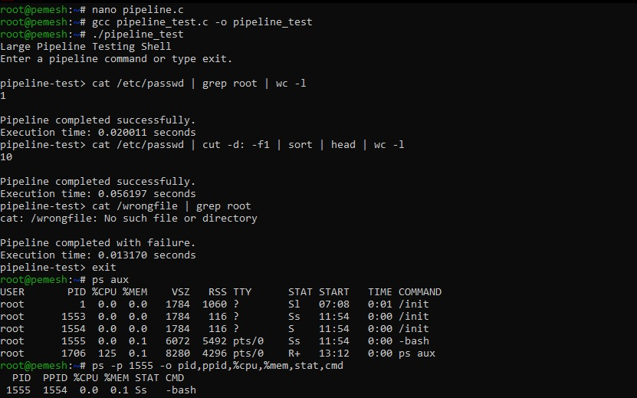
Observation:
- Multiple commands were connected using pipes.
- Multiple child processes were created for pipeline stages.
- Successful and failed commands were identified.
- Execution time was measured.
- System processes and resource information could be monitored.
- Large pipelines were tested for stability.
Result:
Thus, large pipelines and multiple processes were successfully tested, failures were detected, execution time was measured, and the shell execution architecture was documented.

Experiment No. 24(Q24)
Title: Project Organization, Build Management, Documentation and Final Review
Aim:
To organize the shell project source code, prepare build scripts and documentation, maintain the repository structure, create release tags, validate project deliverables, and demonstrate the implemented features.
Objective:
- To organize the source code into appropriate directories.
- To prepare a Makefile for building the project.
- To create project documentation using README.
- To maintain a proper repository structure.
- To create a Git release tag.
- To validate project deliverables.
- To prepare demonstration scenarios.
- To demonstrate pipeline execution.
- To demonstrate signal handling and job control.
- To perform a final review of the project.
Theory:
A well-organized project makes the source code, test scripts, compiled programs, documentation, and build files easy to manage.
The source files can be stored in a src directory, test scripts in a tests directory, and compiled programs in a bin directory. A Makefile can be used to simplify compilation and rebuilding of the project.
A README file provides information about the project, its features, project structure, compilation and testing procedures.
Git is used for version control. A release tag such as v1.0 can be created to identify a stable version of the project.
The final review verifies that important features such as pipelines, signals, job control, memory testing and error handling are functioning correctly.
Algorithm:
- Start the project organization process.
- Create directories for source files, header files, tests and compiled programs.
- Place the implemented C source files in the source directory.
- Place test scripts in the test directory.
- Create a Makefile for compiling the programs.
- Create a README file containing project information.
- Build and test the project.
- Initialize the Git repository.
- Add the project files to the repository.
- Commit the project.
- Create a release tag.
- Verify the repository structure.
- Demonstrate pipeline execution.
- Demonstrate signal handling and job control.
- Validate the project deliverables.
- Perform the final project review.
C Program –Make file
CC = gcc
CFLAGS = -Wall -Wextra -g

all: pipeline_test sigint sigtstp memory_test

pipeline_test:
$(CC) $(CFLAGS) src/pipeline_test.c -o bin/pipeline_test

sigint:
$(CC) $(CFLAGS) src/sigint.c -o bin/sigint

sigtstp:
$(CC) $(CFLAGS) src/sigtstp.c -o bin/sigtstp

memory_test:
$(CC) $(CFLAGS) src/memory_test.c -o bin/memory_test

clean:
rm -f bin/pipeline_test
rm -f bin/sigint
rm -f bin/sigtstp
rm -f bin/memory_test

test:
./bin/memory_test

C Program –README
# OSSP Shell Project

## Description

This project demonstrates Linux system programming concepts
including pipelines, process control, signal handling, memory
management and automated testing.

## Features

- Large pipeline execution
- Multiple process execution
- SIGINT signal handling
- SIGTSTP signal handling
- Process groups
- Job suspension and resumption
- Memory leak detection using Valgrind
- Automated testing

## Project Structure

src - C source files
include - Header files
tests - Test scripts
bin - Compiled programs
README.md - Project documentation
Makefile - Build script

## Compilation

Use the Makefile to build the project.

make

## Testing

The project can be tested using the programs available
in the src directory and the test scripts in the tests directory.

## Tools Used

- Linux
- GCC
- C
- Git
- Make
- Valgrind

Execution:
Create project-
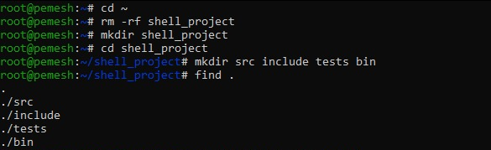

Copy existing programs-
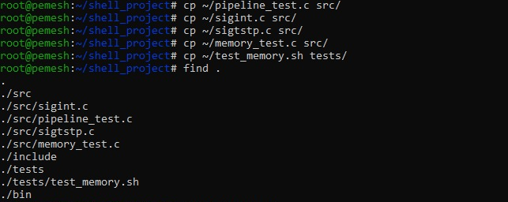

Create README and Makefile-
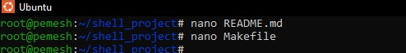

Build-
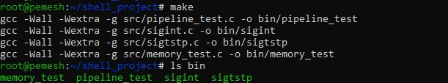

TEST THE PROJECT-
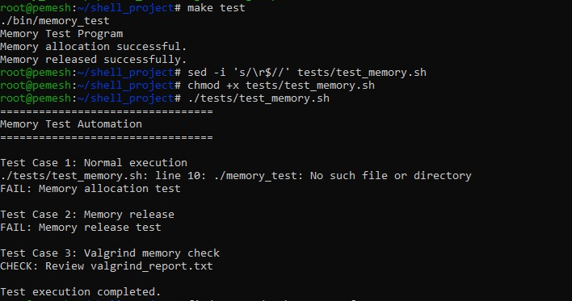

REPOSITORY STRUCTURE-
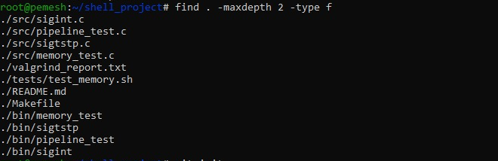

GIT REPOSITORY-

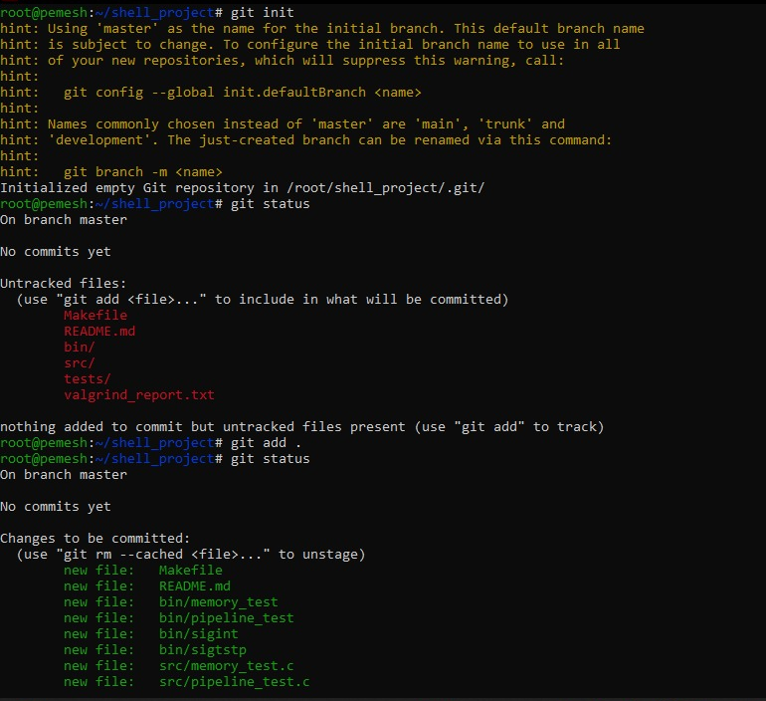

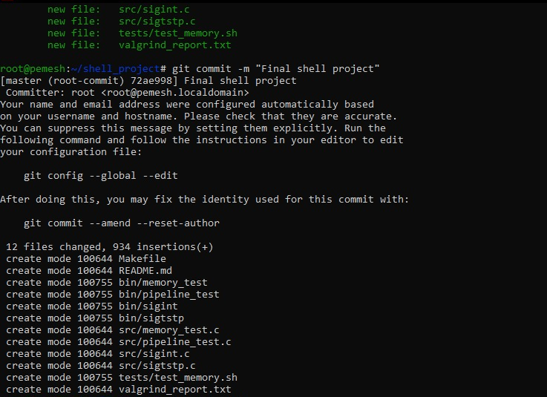

RELEASE TAG-

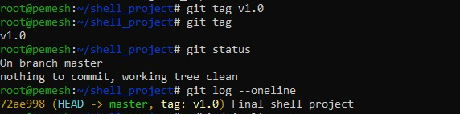

FINAL PIPELINE DEMONSTRATION-

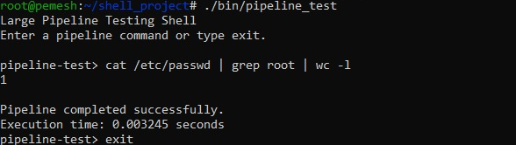

FINAL SIGINT DEMONSTRATION-

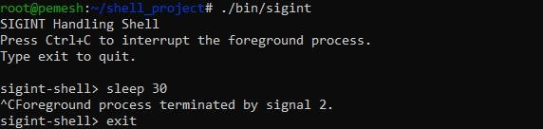

FINAL SIGTSTP DEMONSTRATION-

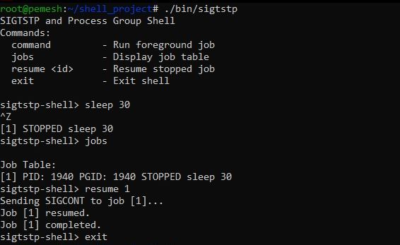

DELIVERABLE VALIDATION:
The following deliverables were verified:
- Source files organized under src/.
- Test scripts organized under tests/.
- Compiled programs stored under bin/.
- README documentation created.
- Makefile created.
- Project successfully compiled.
- Automated tests executed.
- Git repository initialized.
- Project committed.
- Release tag v1.0 created.
- Pipeline functionality demonstrated.
- Signal handling demonstrated.
- Job control demonstrated.
Observation:
- Source files and test scripts were organized into separate directories.
- The Makefile successfully compiled the project programs.
- README documentation was created.
- The repository structure was verified.
- Git was used to maintain the project.
- A release tag was successfully created.
- Pipeline execution was demonstrated.
- SIGINT and SIGTSTP handling were demonstrated.
- Job suspension and resumption were verified.
- Project deliverables were reviewed successfully.
Result:
Thus, the shell project was successfully organized, documented and built. The source files, test scripts, Makefile and README were maintained in a structured repository. The implemented pipeline, signal handling, job-control and memory-testing features were demonstrated, and the project deliverables were successfully validated.

