SKILL-11
Name: B. Pemesh
Rollno: 2520030388
Section: 8

Experiment No. 21(Q21)
Title: Integration Testing, Error Handling and Reliability of Shell Modules
Aim:
To integrate shell modules, validate their interfaces, perform end-to-end execution, handle runtime and syntax errors, and improve the reliability of the shell.
Objective:
- To connect different shell modules.
- To validate module interfaces.
- To test end-to-end execution.
- To handle runtime errors.
- To generate meaningful error messages.
- To handle invalid syntax.
- To recover from errors gracefully.
- To improve shell reliability.
Theory:
A shell consists of multiple modules such as input handling, command parsing, process creation, command execution, and error handling.
Integration testing verifies that these modules work correctly when connected together.
Error handling is required to prevent the shell from terminating unexpectedly when invalid commands, incorrect syntax, or execution failures occur.
The shell should display an appropriate error message and return to the command prompt so that another command can be executed.
Algorithm:
- Start the shell.
- Read a command from the user.
- Validate the input.
- Parse the command into tokens.
- Validate the parsed command.
- Create a child process using fork().
- Execute the command using execvp().
- Monitor the child process using waitpid().
- Detect execution errors.
- Display an appropriate error message.
- Return to the shell prompt after an error.
- Continue accepting commands.
- Exit when exit is entered.
C Program:
#include <stdio.h>
#include <stdlib.h>
#include <string.h>
#include <unistd.h>
#include <sys/wait.h>
#include <errno.h>

#define MAX_INPUT 1024
#define MAX_ARGS 50

/* Module 1: Input handling */
int read_input(char *input, int size) {

printf("integration-shell> ");
fflush(stdout);

if (fgets(input, size, stdin) == NULL)
return 0;

input[strcspn(input, "\n")] = '\0';

return 1;
}

/* Module 2: Command parsing */
int parse_command(char *input, char **args) {

int argc = 0;

char *token = strtok(input, " \t");

while (token != NULL && argc < MAX_ARGS - 1) {

args[argc++] = token;

token = strtok(NULL, " \t");
}

args[argc] = NULL;

return argc;
}

/* Module 3: Command validation */
int validate_command(char **args, int argc) {

if (argc == 0) {
printf("Error: Empty command.\n");
return 0;
}

if (args[0] == NULL) {
printf("Error: Invalid command syntax.\n");
return 0;
}

return 1;
}

/* Module 4: Command execution */
void execute_command(char **args) {

pid_t pid = fork();

if (pid < 0) {

perror("Error: fork failed");
return;
}

if (pid == 0) {

execvp(args[0], args);

perror("Error: command execution failed");
exit(EXIT_FAILURE);
}

else {

int status;

if (waitpid(pid, &status, 0) == -1) {

perror("Error: waitpid failed");
return;
}

if (WIFEXITED(status)) {

if (WEXITSTATUS(status) != 0) {

printf("Command exited with status %d.\n",
WEXITSTATUS(status));
}
}

else if (WIFSIGNALED(status)) {

printf("Command terminated by signal %d.\n",
WTERMSIG(status));
}
}
}

int main() {

char input[MAX_INPUT];
char *args[MAX_ARGS];

printf("Integrated Shell\n");
printf("Type commands or exit.\n\n");

while (1) {

if (!read_input(input, sizeof(input)))
break;

/* Empty input */
if (strlen(input) == 0)
continue;

/* Exit command */
if (strcmp(input, "exit") == 0) {

printf("Exiting shell.\n");
break;
}

/* Parse command */
int argc = parse_command(input, args);

/* Validate command */
if (!validate_command(args, argc))
continue;

/* Execute command */
execute_command(args);
}

return 0;
}
Output:
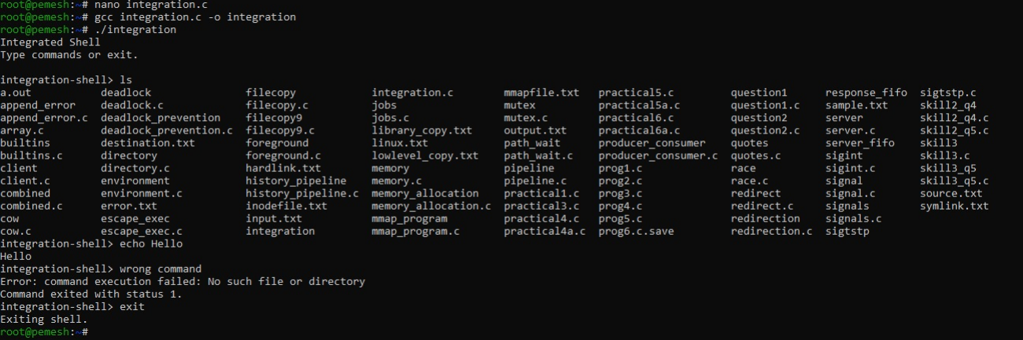
Observation:
- Different shell modules were integrated successfully.
- Input was read and parsed correctly.
- Valid commands were executed successfully.
- Invalid commands generated error messages.
- Runtime errors did not terminate the shell.
- The shell returned to the prompt after errors.
- End-to-end command execution was verified.
Result:
Thus, the shell modules were successfully integrated and tested end-to-end with appropriate runtime and syntax error handling.

Experiment No. 22(Q22)
Title: Memory Leak Detection and Automated Testing Using Valgrind
Aim:
To analyze the shell program using Valgrind, identify memory leaks and memory errors, release allocated resources, verify memory cleanup, and automate test cases for validating program outputs.
Objective:
- To run Valgrind on a C program.
- To identify memory leaks.
- To detect memory errors.
- To release allocated memory.
- To verify resource cleanup.
- To design test cases.
- To create a test script.
- To automate program execution.
- To verify and compare outputs.
Theory:
Valgrind is a debugging and profiling tool used to detect memory-related problems in C programs.
It can detect:
- Memory leaks.
- Invalid memory access.
- Use of uninitialized memory.
- Incorrect memory deallocation.
Dynamic memory allocated using malloc() should be released using free() after use.
Automated test scripts can execute multiple test cases and compare the actual output with the expected output.
Algorithm:
- Start the program.
- Allocate dynamic memory.
- Use the allocated memory.
- Release the allocated memory using free().
- Compile the program.
- Run the program normally.
- Run the program using Valgrind.
- Check the Valgrind report.
- Verify that all allocated memory is released.
- Create test cases for normal and invalid inputs.
- Automate the test cases using a shell script.
- Compare actual and expected outputs.
- Generate a test report.
C Program – Memory_test
#include <stdio.h>
#include <stdlib.h>
#include <string.h>

#define SIZE 100

int main() {

char *message;

printf("Memory Test Program\n");

/* Allocate memory */
message = malloc(SIZE * sizeof(char));

if (message == NULL) {

printf("Memory allocation failed.\n");
return 1;
}

/* Use allocated memory */
strcpy(message, "Memory allocation successful.");

printf("%s\n", message);

/* Release memory */
free(message);

message = NULL;

printf("Memory released successfully.\n");

return 0;
}
Output:
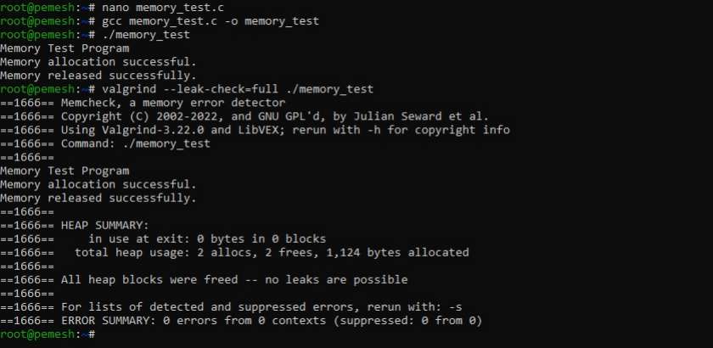
C Program – Automated testing
#!/bin/bash

echo "================================="
echo "Memory Test Automation"
echo "================================="

echo ""
echo "Test Case 1: Normal execution"

OUTPUT=$(./memory_test)

if echo "$OUTPUT" | grep -q "Memory allocation successful."; then
echo "PASS: Memory allocation test"
else
echo "FAIL: Memory allocation test"
fi

echo ""
echo "Test Case 2: Memory release"

if echo "$OUTPUT" | grep -q "Memory released successfully."; then
echo "PASS: Memory release test"
else
echo "FAIL: Memory release test"
fi

echo ""
echo "Test Case 3: Valgrind memory check"

valgrind --leak-check=full ./memory_test > valgrind_report.txt 2>&1

if grep -q "All heap blocks were freed" valgrind_report.txt; then
echo "PASS: No memory leaks detected"
else
echo "CHECK: Review valgrind_report.txt"
fi

echo ""
echo "Test execution completed."
Output:
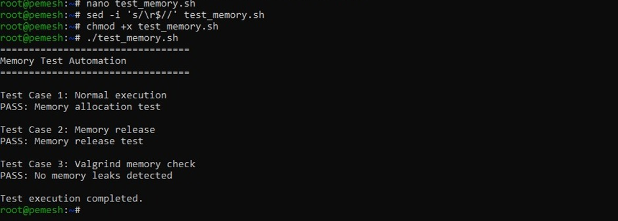

Observation:
- Memory was allocated and released successfully.
- Valgrind detected no memory leaks.
- No memory errors were reported.
- Test cases were automated using a shell script.
- Program output was verified automatically.
- Valgrind results were stored in a report file.
Result:
Thus, memory cleanup was verified using Valgrind and automated test cases were created to verify program execution and memory management.

