SKILL-02
Name: B. Pemesh
Rollno: 2520030388
Section: 8

Experiment No. 03 (Q3)
Title: Command History, Escape Sequences and Dynamic Memory Management.
Aim:
To implement command history using escape sequences, navigate previous and next commands, manage dynamic input buffers, use linked lists, prevent buffer overflow, and release memory correctly.
Objective:
- To apply escape sequences for keyboard navigation.
- To store command history.
- To navigate previous and next commands.
- To update the input buffer during command recall.
- To allocate and resize buffers dynamically.
- To prevent buffer overflow.
- To manage command history using linked lists.
- To release dynamically allocated memory.
- To verify memory usage using Valgrind.
Theory:
Command history allows previously entered commands to be stored and recalled. Escape sequences generated by keys such as the Up and Down arrow keys can be processed to navigate through stored commands.
Dynamic memory allocation allows the input buffer to grow when the entered command becomes larger than its initial size. A linked list can be used to store commands dynamically without requiring a fixed number of entries.
Proper memory management is important because dynamically allocated memory must be released after use. Valgrind can be used to detect memory leaks and memory-related errors.
Algorithm:
- Start the program.
- Allocate an initial input buffer dynamically.
- Enable terminal input processing.
- Read characters entered by the user.
- Detect Backspace and update the input buffer.
- Detect Up and Down arrow escape sequences.
- Navigate through previously stored commands.
- Store completed commands in a linked list.
- Increase the buffer size when required.
- Prevent the buffer from exceeding its allocated memory.
- Continue until the user enters exit.
- Release the input buffer.
- Release all nodes of the history linked list.
- Verify memory usage using Valgrind.
- Stop the program.

C Program:
#include <stdio.h>
#include <stdlib.h>
#include <string.h>
#include <unistd.h>
#include <termios.h>

#define INITIAL_BUFFER_SIZE 64

typedef struct HistoryNode
{
char *command;
struct HistoryNode *next;
} HistoryNode;

struct termios original_terminal;

void disable_raw_mode()
{
tcsetattr(STDIN_FILENO, TCSAFLUSH, &original_terminal);
}

void enable_raw_mode()
{
tcgetattr(STDIN_FILENO, &original_terminal);

atexit(disable_raw_mode);

struct termios raw = original_terminal;

raw.c_lflag &= ~(ICANON | ECHO);

tcsetattr(STDIN_FILENO, TCSAFLUSH, &raw);
}

void add_history(HistoryNode **head, const char *command)
{
HistoryNode *new_node = malloc(sizeof(HistoryNode));

if (new_node == NULL)
{
perror("malloc");
return;
}

new_node->command = malloc(strlen(command) + 1);

if (new_node->command == NULL)
{
free(new_node);
perror("malloc");
return;
}

strcpy(new_node->command, command);
new_node->next = NULL;

if (*head == NULL)
{
*head = new_node;
}
else
{
HistoryNode *temp = *head;

while (temp->next != NULL)
temp = temp->next;

temp->next = new_node;
}
}

int history_count(HistoryNode *head)
{
int count = 0;

while (head != NULL)
{
count++;
head = head->next;
}

return count;
}

char *get_history_command(HistoryNode *head, int index)
{
int i = 0;

while (head != NULL)
{
if (i == index)
return head->command;

i++;
head = head->next;
}

return NULL;
}

void free_history(HistoryNode *head)
{
HistoryNode *temp;

while (head != NULL)
{
temp = head;
head = head->next;

free(temp->command);
free(temp);
}
}

int main()
{
HistoryNode *history = NULL;

char *buffer = malloc(INITIAL_BUFFER_SIZE);

if (buffer == NULL)
{
perror("malloc");
return 1;
}

int buffer_size = INITIAL_BUFFER_SIZE;
int length = 0;
int history_position;

enable_raw_mode();

printf("Command History Shell\n");
printf("Use UP/DOWN arrows for history.\n");
printf("Type exit to quit.\n\n");

while (1)
{
printf("shell> ");
fflush(stdout);

length = 0;
history_position = history_count(history);

while (1)
{
char c;

if (read(STDIN_FILENO, &c, 1) != 1)
break;

if (c == '\n' || c == '\r')
{
buffer[length] = '\0';
printf("\n");
break;
}

if (c == 127 || c == 8)
{
if (length > 0)
{
length--;
printf("\b \b");
fflush(stdout);
}

continue;
}

if (c == 27)
{
char sequence[2];

if (read(STDIN_FILENO, &sequence[0], 1) != 1)
continue;

if (read(STDIN_FILENO, &sequence[1], 1) != 1)
continue;

if (sequence[0] == '[' && sequence[1] == 'A')
{
int count = history_count(history);

if (count > 0 && history_position > 0)
{
history_position--;

char *old_command =
get_history_command(history,
history_position);

if (old_command != NULL)
{
while (length > 0)
{
printf("\b \b");
length--;
}

int required =
strlen(old_command) + 1;

if (required > buffer_size)
{
char *temp =
realloc(buffer, required);

if (temp == NULL)
{
perror("realloc");
break;
}

buffer = temp;
buffer_size = required;
}

strcpy(buffer, old_command);

length = strlen(buffer);

printf("%s", buffer);
fflush(stdout);
}
}
}
else if (sequence[0] == '[' &&
sequence[1] == 'B')
{
int count = history_count(history);

if (history_position < count - 1)
{
history_position++;

char *old_command =
get_history_command(history,
history_position);

if (old_command != NULL)
{
while (length > 0)
{
printf("\b \b");
length--;
}

int required =
strlen(old_command) + 1;

if (required > buffer_size)
{
char *temp =
realloc(buffer, required);

if (temp == NULL)
{
perror("realloc");
break;
}

buffer = temp;
buffer_size = required;
}

strcpy(buffer, old_command);

length = strlen(buffer);

printf("%s", buffer);
fflush(stdout);
}
}
}

continue;
}

if (length + 1 >= buffer_size)
{
int new_size = buffer_size * 2;

char *temp = realloc(buffer, new_size);

if (temp == NULL)
{
perror("realloc");
break;
}

buffer = temp;
buffer_size = new_size;
}

buffer[length++] = c;

putchar(c);
fflush(stdout);
}

if (strcmp(buffer, "exit") == 0)
break;

if (length > 0)
add_history(&history, buffer);
}

free(buffer);
free_history(history);

return 0;
}
Output:
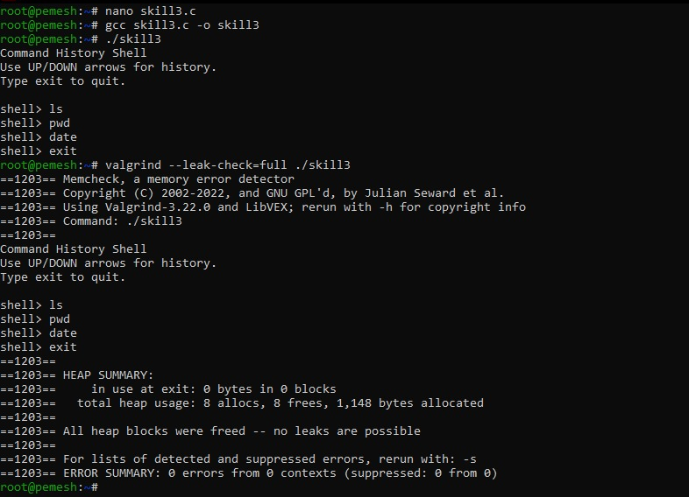
Observation:
The program successfully stores commands in a linked-list history, processes escape sequences for previous and next command navigation, dynamically resizes the input buffer, and releases allocated memory. Valgrind can be used to verify proper memory management.
Result:
Command history, escape-sequence navigation, dynamic buffer management, linked-list storage, buffer overflow prevention, and memory cleanup were successfully implemented.

Experiment No. 04 (Q4)
Title: Command Tokenization and Parser Logic
Aim:
To split command input into tokens, identify delimiters and whitespace, validate token streams, design parser logic, detect syntax errors, handle empty commands, and generate an execution structure.
Objective:
- To split input into tokens.
- To identify delimiters.
- To handle whitespace.
- To create token structures.
- To validate token streams.
- To debug parsing output.
- To design parser logic.
- To generate execution structures.
- To validate syntax.
- To detect syntax errors.
- To handle empty commands.
Theory:
Tokenization is the process of dividing command input into smaller meaningful units called tokens. Whitespace separates normal words, while symbols such as |, <, > and >> act as operators or delimiters.
A token structure stores information about each token. After tokenization, the token stream is validated to detect invalid operator positions, missing arguments and empty commands.
Parser logic processes the validated tokens and creates an execution structure containing the command and its input or output redirection information.
Algorithm:
- Start the program.
- Read the command entered by the user.
- Check each character of the input.
- Ignore spaces, tabs and newline characters.
- Identify delimiters such as |, <, > and >>.
- Store normal words as word tokens.
- Store operators as their corresponding token types.
- Validate the token stream.
- Detect empty commands.
- Detect operators at invalid positions.
- Detect operators that are not followed by a valid word.
- Parse the validated tokens.
- Generate the command execution structure.
- Display the tokens and execution structure.
- Continue until exit is entered.
- Stop the program.
C Program:
#include <stdio.h>
#include <stdlib.h>
#include <string.h>

#define MAX_INPUT 256
#define MAX_TOKENS 50

typedef enum
{
TOKEN_WORD,
TOKEN_PIPE,
TOKEN_INPUT,
TOKEN_OUTPUT,
TOKEN_APPEND
} TokenType;

typedef struct
{
TokenType type;
char value[100];
} Token;

typedef struct
{
Token tokens[MAX_TOKENS];
int count;
} TokenStream;

typedef struct
{
char *command[MAX_TOKENS];
int argc;
char *input_file;
char *output_file;
int append_output;
} CommandNode;

void add_token(TokenStream *stream,
TokenType type,
const char *value)
{
if (stream->count >= MAX_TOKENS)
return;

stream->tokens[stream->count].type = type;

strcpy(stream->tokens[stream->count].value,
value);

stream->count++;
}

int tokenize(char *input, TokenStream *stream)
{
int i = 0;

stream->count = 0;

while (input[i] != '\0')
{
if (input[i] == ' ' ||
input[i] == '\t' ||
input[i] == '\n')
{
i++;
continue;
}

if (input[i] == '|')
{
add_token(stream, TOKEN_PIPE, "|");
i++;
}
else if (input[i] == '<')
{
add_token(stream, TOKEN_INPUT, "<");
i++;
}
else if (input[i] == '>')
{
if (input[i + 1] == '>')
{
add_token(stream, TOKEN_APPEND, ">>");
i += 2;
}
else
{
add_token(stream, TOKEN_OUTPUT, ">");
i++;
}
}
else
{
char word[100];
int j = 0;

while (input[i] != '\0' &&
input[i] != ' ' &&
input[i] != '\t' &&
input[i] != '\n' &&
input[i] != '|' &&
input[i] != '<' &&
input[i] != '>')
{
if (j < 99)
word[j++] = input[i];

i++;
}

word[j] = '\0';

if (j > 0)
add_token(stream,
TOKEN_WORD,
word);
}
}

return stream->count;
}

int validate_tokens(TokenStream *stream)
{
if (stream->count == 0)
{
printf("Error: Empty command.\n");
return 0;
}

for (int i = 0;
i < stream->count;
i++)
{
TokenType type =
stream->tokens[i].type;

if (type == TOKEN_PIPE ||
type == TOKEN_INPUT ||
type == TOKEN_OUTPUT ||
type == TOKEN_APPEND)
{
if (i == 0 ||
i == stream->count - 1)
{
printf("Error: Invalid operator position.\n");
return 0;
}

if (stream->tokens[i + 1].type !=
TOKEN_WORD)
{
printf("Error: Operator must be followed by a word.\n");
return 0;
}
}
}

return 1;
}

void parse_tokens(TokenStream *stream)
{
CommandNode command;

command.argc = 0;
command.input_file = NULL;
command.output_file = NULL;
command.append_output = 0;

for (int i = 0;
i < stream->count;
i++)
{
Token *token = &stream->tokens[i];

if (token->type == TOKEN_WORD)
{
command.command[command.argc] =
token->value;

command.argc++;
}
else if (token->type == TOKEN_INPUT)
{
command.input_file =
stream->tokens[i + 1].value;

i++;
}
else if (token->type == TOKEN_OUTPUT)
{
command.output_file =
stream->tokens[i + 1].value;

command.append_output = 0;

i++;
}
else if (token->type == TOKEN_APPEND)
{
command.output_file =
stream->tokens[i + 1].value;

command.append_output = 1;

i++;
}
else if (token->type == TOKEN_PIPE)
{
printf("Pipe operator detected.\n");
}
}

printf("\nExecution Structure:\n");

printf("Command: ");

for (int i = 0;
i < command.argc;
i++)
{
printf("%s ", command.command[i]);
}

printf("\n");

if (command.input_file != NULL)
printf("Input file: %s\n",
command.input_file);

if (command.output_file != NULL)
{
printf("Output file: %s\n",
command.output_file);

if (command.append_output)
printf("Output mode: Append\n");
else
printf("Output mode: Write\n");
}
}

void display_tokens(TokenStream *stream)
{
printf("\nToken Stream:\n");

for (int i = 0;
i < stream->count;
i++)
{
printf("Token %d: %s\n",
i + 1,
stream->tokens[i].value);
}
}

int main()
{
char input[MAX_INPUT];

while (1)
{
TokenStream stream;

printf("\nshell> ");

if (fgets(input,
sizeof(input),
stdin) == NULL)
break;

input[strcspn(input, "\n")] = '\0';

if (strcmp(input, "exit") == 0)
break;

tokenize(input, &stream);

if (!validate_tokens(&stream))
continue;

display_tokens(&stream);

parse_tokens(&stream);
}

return 0;
}
Output:
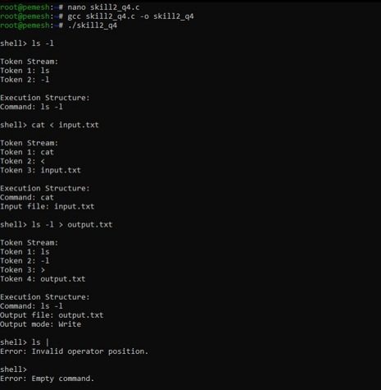
Observation:
The program successfully separates command input into tokens, identifies whitespace and operators, validates the token stream, detects empty or invalid commands, and generates an execution structure containing command and redirection information.
Result:
Command tokenization and parser logic were successfully implemented with delimiter identification, whitespace handling, token validation, syntax-error detection, empty-command handling, and execution-structure generation.

