SKILL-03
Name: B. Pemesh
Rollno: 2520030388
Section: 8

Experiment No. 05 (Q5)
Title: Implementation of Single and Double Quote Handling in a Command Parser
Aim:
To implement single and double quote handling in a command parser, where single quotes preserve literal content without variable expansion and double quotes preserve spaces while allowing variable expansion.
Objective:
- Apply single quotes.
- Preserve literal content.
- Ignore variable expansion inside single quotes.
- Store quoted strings.
- Validate parsing results.
- Test edge cases.
- Apply double quotes.
- Preserve spaces inside double quotes.
- Allow variable expansion inside double quotes.
- Parse multiple and nested tokens.
- Validate outputs.
Theory:
Single quotes are used to preserve the exact content written inside them. Characters such as $ are treated literally and variable expansion is not performed.
Double quotes preserve spaces within the quoted text while allowing environment variables to be expanded. For example, if NAME=Pemesh, then "Hello $NAME" becomes Hello Pemesh.
A command parser must identify quoted sections correctly and combine them with normal tokens to produce the required arguments.
Algorithm:
- Start the program.
- Read a command line from the user.
- Initialize an empty token.
- Read the input character by character.
- If a single quote is encountered, enter single-quote mode.
- Preserve all characters inside single quotes without variable expansion.
- If a double quote is encountered, enter double-quote mode.
- Preserve spaces inside double quotes.
- When $ is encountered inside double quotes, identify the variable name.
- Retrieve its value using the environment.
- Add the expanded value to the current token.
- Continue parsing until the complete input is processed.
- Store each completed token.
- Display the parsed tokens.
- End the program.
C Program:
#include <stdio.h>
#include <stdlib.h>
#include <string.h>
#include <ctype.h>

#define MAX_INPUT 1024
#define MAX_TOKENS 50
#define MAX_TOKEN 1024

void expand_variable(const char *input, int *i, char *token, int *pos)
{
char variable[100];
int j = 0;

(*i)++;

while (input[*i] != '\0' &&
(isalnum((unsigned char)input[*i]) || input[*i] == '_'))
{
if (j < 99)
{
variable[j++] = input[*i];
}

(*i)++;
}

variable[j] = '\0';

const char *value = getenv(variable);

if (value != NULL)
{
int k = 0;

while (value[k] != '\0' && *pos < MAX_TOKEN - 1)
{
token[(*pos)++] = value[k++];
}
}

(*i)--;
}

int parse_command(char *input, char tokens[MAX_TOKENS][MAX_TOKEN])
{
int i = 0;
int token_count = 0;

while (input[i] != '\0')
{
while (isspace((unsigned char)input[i]))
{
i++;
}

if (input[i] == '\0')
{
break;
}

if (token_count >= MAX_TOKENS)
{
break;
}

int pos = 0;
int single_quote = 0;
int double_quote = 0;

while (input[i] != '\0')
{
char c = input[i];

if (single_quote)
{
if (c == '\'')
{
single_quote = 0;
}
else if (pos < MAX_TOKEN - 1)
{
tokens[token_count][pos++] = c;
}

i++;
}
else if (double_quote)
{
if (c == '"')
{
double_quote = 0;
i++;
}
else if (c == '$')
{
expand_variable(input, &i,
tokens[token_count], &pos);
i++;
}
else
{
if (pos < MAX_TOKEN - 1)
{
tokens[token_count][pos++] = c;
}

i++;
}
}
else
{
if (c == '\'')
{
single_quote = 1;
i++;
}
else if (c == '"')
{
double_quote = 1;
i++;
}
else if (isspace((unsigned char)c))
{
break;
}
else
{
if (pos < MAX_TOKEN - 1)
{
tokens[token_count][pos++] = c;
}

i++;
}
}
}

tokens[token_count][pos] = '\0';
token_count++;

while (isspace((unsigned char)input[i]))
{
i++;
}
}

return token_count;
}

int main()
{
char input[MAX_INPUT];
char tokens[MAX_TOKENS][MAX_TOKEN];

printf("Enter a command: ");
fgets(input, sizeof(input), stdin);

input[strcspn(input, "\n")] = '\0';

int count = parse_command(input, tokens);

printf("\nParsed Tokens:\n");

for (int i = 0; i < count; i++)
{
printf("Token %d: %s\n", i + 1, tokens[i]);
}

return 0;
}
Output:
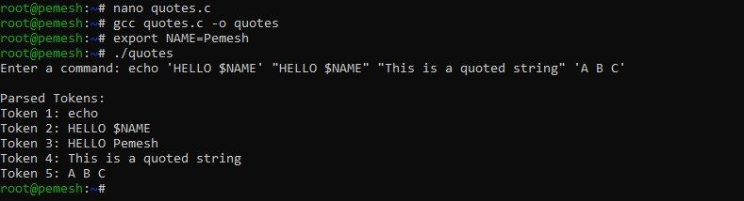
Observation:
Single quotes preserve the literal content and prevent variable expansion. Double quotes preserve spaces and allow environment variable expansion. The parser correctly stores the resulting quoted strings as individual tokens.
Result:
The command parser successfully implemented single-quote and double-quote handling, including literal preservation, space preservation, variable expansion, and token validation.

Experiment No. 06(Q6)
Title: Implementation of Escape Sequence Handling and Process Execution Using fork() and exec()
Aim:
To implement escape sequence handling for spaces and special characters and execute parsed commands using child processes created with fork() and exec().
Objective:
- Handle escaped spaces.
- Handle escaped special symbols.
- Preserve escaped characters.
- Validate parser output.
- Test complex inputs.
- Create child processes.
- Execute programs.
- Handle execution errors.
- Pass arguments to programs.
- Manage the parent process.
- Test command launching.
Theory:
An escape character \ is used to preserve the special meaning of the character that follows it.
For example:
Hello\ World
is interpreted as:
Hello World
Similarly:
\$HOME
is treated as the literal string:
$HOME
After parsing the command, fork() creates a child process. The child process uses execvp() to execute the requested program with its arguments. The parent process uses waitpid() to wait for the child to finish.
Algorithm:
- Start the program.
- Display the command prompt.
- Read a command from the user.
- Scan the command character by character.
- Detect the escape character \.
- Preserve the character following \ as a literal character.
- Separate the input into command and arguments.
- Check for the exit command.
- Create a child process using fork().
- In the child process, execute the command using execvp().
- If execution fails, display an error message.
- In the parent process, wait for the child using waitpid().
- Display the child completion message.
- Repeat until exit is entered.
- End the program.
C Program:
#include <stdio.h>
#include <stdlib.h>
#include <string.h>
#include <unistd.h>
#include <sys/types.h>
#include <sys/wait.h>

#define MAX_INPUT 1024
#define MAX_ARGS 50
#define MAX_ARG_LEN 256

int parse_command(char *input, char *args[])
{
int argc = 0;
int i = 0;

while (input[i] != '\0')
{
while (input[i] == ' ' || input[i] == '\t')
{
i++;
}

if (input[i] == '\0')
{
break;
}

if (argc >= MAX_ARGS - 1)
{
break;
}

args[argc] = malloc(MAX_ARG_LEN);

if (args[argc] == NULL)
{
perror("malloc");
exit(EXIT_FAILURE);
}

int pos = 0;

while (input[i] != '\0' &&
input[i] != ' ' &&
input[i] != '\t')
{
if (input[i] == '\\')
{
i++;

if (input[i] != '\0' &&
pos < MAX_ARG_LEN - 1)
{
args[argc][pos++] = input[i];
i++;
}
}
else
{
if (pos < MAX_ARG_LEN - 1)
{
args[argc][pos++] = input[i];
}

i++;
}
}

args[argc][pos] = '\0';
argc++;
}

args[argc] = NULL;

return argc;
}

void free_arguments(char *args[], int argc)
{
for (int i = 0; i < argc; i++)
{
free(args[i]);
}
}

int main()
{
char input[MAX_INPUT];
char *args[MAX_ARGS];

while (1)
{
printf("escape-shell> ");
fflush(stdout);

if (fgets(input, sizeof(input), stdin) == NULL)
{
break;
}

input[strcspn(input, "\n")] = '\0';

if (strcmp(input, "exit") == 0)
{
printf("Exiting shell.\n");
break;
}

if (strlen(input) == 0)
{
continue;
}

int argc = parse_command(input, args);

if (argc == 0)
{
continue;
}

printf("Parsed command: ");

for (int i = 0; i < argc; i++)
{
printf("[%s] ", args[i]);
}

printf("\n");

pid_t pid = fork();

if (pid < 0)
{
perror("fork");
free_arguments(args, argc);
continue;
}

if (pid == 0)
{
execvp(args[0], args);

perror("execvp");
exit(EXIT_FAILURE);
}
else
{
int status;

waitpid(pid, &status, 0);

printf("Parent: Child process %d completed.\n", pid);
}

free_arguments(args, argc);
}

return 0;
}
Output:
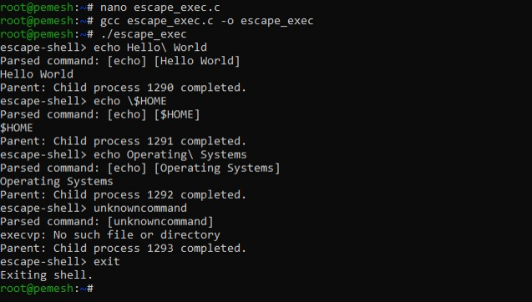
Observation:
The parser recognizes the escape character and preserves the character following it as part of the argument. The parsed command is then executed in a child process using fork() and execvp(). The parent process waits for the child using waitpid().
Result:
The program successfully handled escaped spaces and special characters, created child processes, passed arguments, executed commands, handled execution errors, and maintained the parent process.

