SKILL-04
Name: B. Pemesh
Rollno: 2520030388
Section: 8

Experiment No. 07(Q7)
Title: Process Synchronization, Child Process Monitoring and PATH-Based Command Resolution
Aim:
To implement process synchronization and child process monitoring using waitpid() and to retrieve the PATH environment variable, search for executable commands, verify permissions, and handle missing commands.
Objective:
- Create and monitor child processes.
- Use waitpid() for process synchronization.
- Retrieve the PATH environment variable.
- Parse PATH directories.
- Locate executable programs.
- Verify file permissions.
- Handle missing commands.
- Test command resolution.
Theory:
waitpid() is a system call used by a parent process to wait for a specific child process to change its state. It allows the parent to synchronize its execution with the child.
The PATH environment variable contains a list of directories where executable programs are normally located. The directories are separated by :.
For example:
/usr/local/sbin:/usr/local/bin:/usr/sbin:/usr/bin:/sbin:/bin
When a command such as ls is entered without its complete path, the shell searches the directories listed in PATH until it finds an executable file.
The program can use access() with X_OK to check whether the current user has permission to execute the file.
Algorithm:
- Start the program.
- Display the current PATH.
- Read a command name from the user.
- Check whether the command contains /.
- If it contains /, check that path directly.
- Otherwise, split the PATH variable using :.
- Search each PATH directory.
- Construct the complete path of the command.
- Check whether the file exists and is executable.
- Display the resolved executable path.
- Create a child process using fork().
- Execute the command in the child process.
- Use waitpid() in the parent process.
- Display the child's completion status.
- If the command is not found, display an appropriate error.
- Repeat until exit is entered.
- End the program.
C Program:
#include <stdio.h>
#include <stdlib.h>
#include <string.h>
#include <unistd.h>
#include <sys/types.h>
#include <sys/wait.h>
#include <limits.h>
#include <errno.h>

#define MAX_INPUT 1024
#define MAX_ARGS 50

int find_executable(const char *command, char *result)
{
if (strchr(command, '/') != NULL)
{
if (access(command, X_OK) == 0)
{
realpath(command, result);
return 1;
}

return 0;
}

char *path = getenv("PATH");

if (path == NULL)
{
return 0;
}

char *path_copy = strdup(path);

if (path_copy == NULL)
{
return 0;
}

char *directory = strtok(path_copy, ":");

while (directory != NULL)
{
char full_path[PATH_MAX];

snprintf(full_path,
sizeof(full_path),
"%s/%s",
directory,
command);

if (access(full_path, X_OK) == 0)
{
strncpy(result, full_path, PATH_MAX - 1);
result[PATH_MAX - 1] = '\0';

free(path_copy);
return 1;
}

directory = strtok(NULL, ":");
}

free(path_copy);
return 0;
}

int parse_command(char *input, char *args[])
{
int argc = 0;

char *token = strtok(input, " \t");

while (token != NULL && argc < MAX_ARGS - 1)
{
args[argc++] = token;
token = strtok(NULL, " \t");
}

args[argc] = NULL;

return argc;
}

int main()
{
char input[MAX_INPUT];
char *args[MAX_ARGS];
char executable[PATH_MAX];

while (1)
{
printf("path-shell> ");
fflush(stdout);

if (fgets(input, sizeof(input), stdin) == NULL)
{
break;
}

input[strcspn(input, "\n")] = '\0';

if (strcmp(input, "exit") == 0)
{
printf("Exiting shell.\n");
break;
}

if (strlen(input) == 0)
{
continue;
}

int argc = parse_command(input, args);

if (argc == 0)
{
continue;
}

printf("PATH: %s\n", getenv("PATH"));

if (!find_executable(args[0], executable))
{
printf("Command not found or not executable: %s\n",
args[0]);
continue;
}

printf("Executable found: %s\n", executable);

pid_t pid = fork();

if (pid < 0)
{
perror("fork");
continue;
}

if (pid == 0)
{
execv(executable, args);

perror("execv");
exit(EXIT_FAILURE);
}
else
{
int status;

if (waitpid(pid, &status, 0) == -1)
{
perror("waitpid");
continue;
}

if (WIFEXITED(status))
{
printf("Child process %d exited with status %d.\n",
pid,
WEXITSTATUS(status));
}
else if (WIFSIGNALED(status))
{
printf("Child process %d terminated by signal %d.\n",
pid,
WTERMSIG(status));
}
}
}

return 0;
}
Output:
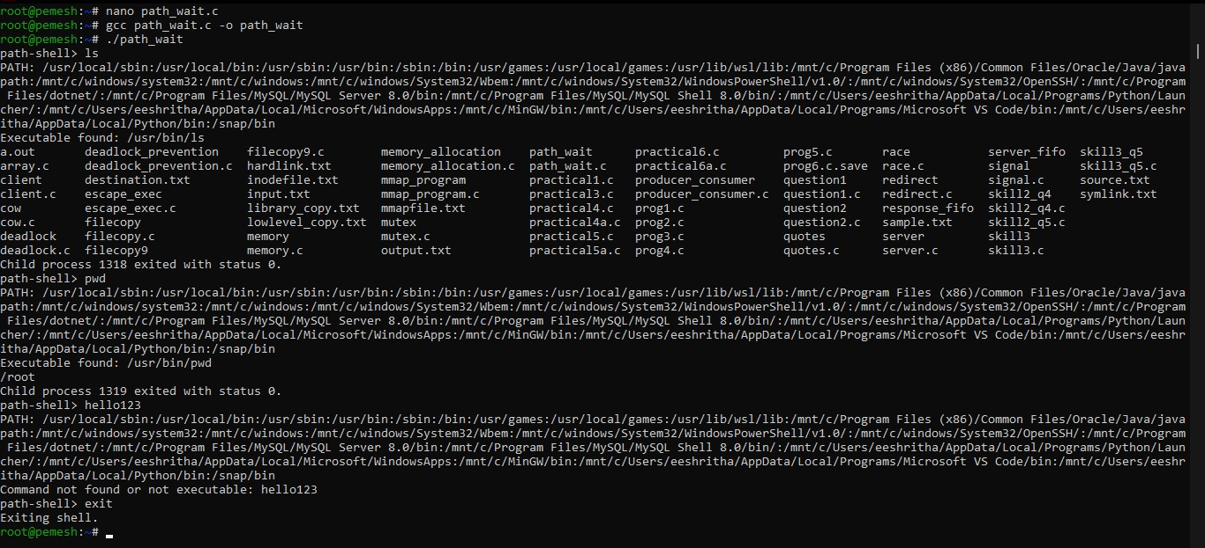
Observation:
The program retrieves the PATH environment variable and searches its directories for the requested executable. access() verifies executable permission. After locating the command, fork() creates a child process and execv() executes it. The parent process uses waitpid() to wait for the child to finish.
Result:
The program successfully implemented PATH-based command resolution, executable permission checking, child process creation, command execution, and process synchronization using waitpid().

Experiment No. 08(Q8)
Title: Environment Variable Expansion and Built-in Command Dispatch
Aim:
To implement environment variable expansion and a built-in command dispatch mechanism for executing commands within the shell.
Objective:
- Detect variable references.
- Expand environment variable values.
- Handle undefined variables.
- Update command tokens.
- Support variable expansion.
- Identify built-in commands.
- Create a dispatch table.
- Execute built-in commands without creating a new process.
- Handle invalid commands.
- Maintain shell state.
- Test command dispatch.
Theory:
Environment variables store information used by processes and shells. They can be accessed using the getenv() function.
A variable reference such as:
$HOME
can be replaced with the value stored in the HOME environment variable.
For example:
echo $HOME
may produce:
/root
A built-in command is handled directly by the shell instead of being executed as an external program. Examples include:
cd
pwd
export
exit
A dispatch table can associate each built-in command with the operation that should be performed.
Algorithm:
- Start the program.
- Display the shell prompt.
- Read a command from the user.
- Split the command into tokens.
- Check each token for $.
- Identify the environment variable name.
- Retrieve its value using getenv().
- Replace the variable reference with its value.
- Check whether the first token is a built-in command.
- Search the built-in command dispatch table.
- Execute the corresponding built-in operation.
- Handle invalid commands.
- Maintain the current shell state.
- Repeat until exit is entered.
- End the program.
C Program:
#include <stdio.h>
#include <stdlib.h>
#include <string.h>
#include <unistd.h>
#include <limits.h>
#include <ctype.h>

#define MAX_INPUT 1024
#define MAX_ARGS 50
#define MAX_TOKEN 1024

int expand_variables(char *input, char *output)
{
int i = 0;
int j = 0;

while (input[i] != '\0' && j < MAX_INPUT - 1)
{
if (input[i] == '$')
{
i++;

char variable[100];
int k = 0;

while (input[i] != '\0' &&
(isalnum((unsigned char)input[i]) ||
input[i] == '_'))
{
if (k < 99)
{
variable[k++] = input[i];
}

i++;
}

variable[k] = '\0';

const char *value = getenv(variable);

if (value != NULL)
{
int v = 0;

while (value[v] != '\0' &&
j < MAX_INPUT - 1)
{
output[j++] = value[v++];
}
}
}
else
{
output[j++] = input[i++];
}
}

output[j] = '\0';

return 0;
}

int parse_command(char *input, char *args[])
{
int argc = 0;

char *token = strtok(input, " \t");

while (token != NULL && argc < MAX_ARGS - 1)
{
args[argc++] = token;
token = strtok(NULL, " \t");
}

args[argc] = NULL;

return argc;
}

void builtin_pwd()
{
char directory[PATH_MAX];

if (getcwd(directory, sizeof(directory)) != NULL)
{
printf("%s\n", directory);
}
else
{
perror("pwd");
}
}

void builtin_cd(char *path)
{
if (path == NULL)
{
path = getenv("HOME");
}

if (path == NULL)
{
printf("cd: HOME is not set\n");
return;
}

if (chdir(path) != 0)
{
perror("cd");
}
}

void builtin_export(char *assignment)
{
if (assignment == NULL)
{
printf("export: variable assignment required\n");
return;
}

char *equals = strchr(assignment, '=');

if (equals == NULL)
{
printf("export: invalid format\n");
return;
}

*equals = '\0';

char *name = assignment;
char *value = equals + 1;

if (name[0] == '\0')
{
printf("export: invalid variable name\n");
return;
}

if (setenv(name, value, 1) != 0)
{
perror("export");
}
}

int main()
{
char input[MAX_INPUT];
char expanded[MAX_INPUT];
char *args[MAX_ARGS];

while (1)
{
printf("builtin-shell> ");
fflush(stdout);

if (fgets(input, sizeof(input), stdin) == NULL)
{
break;
}

input[strcspn(input, "\n")] = '\0';

if (strlen(input) == 0)
{
continue;
}

expand_variables(input, expanded);

int argc = parse_command(expanded, args);

if (argc == 0)
{
continue;
}

if (strcmp(args[0], "exit") == 0)
{
printf("Exiting shell.\n");
break;
}
else if (strcmp(args[0], "pwd") == 0)
{
builtin_pwd();
}
else if (strcmp(args[0], "cd") == 0)
{
builtin_cd(args[1]);
}
else if (strcmp(args[0], "export") == 0)
{
builtin_export(args[1]);
}
else if (strcmp(args[0], "echo") == 0)
{
for (int i = 1; i < argc; i++)
{
printf("%s", args[i]);

if (i < argc - 1)
{
printf(" ");
}
}

printf("\n");
}
else
{
printf("Command not found or not a built-in command: %s\n",
args[0]);
}
}

return 0;
}
Output:
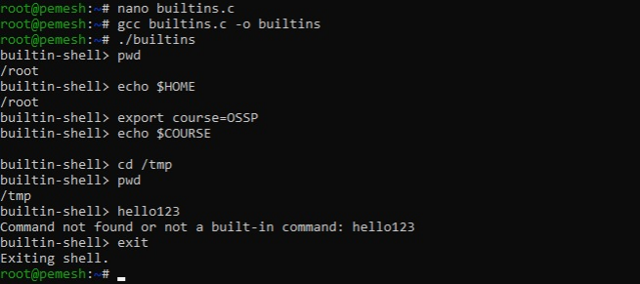
Observation:
The program identifies environment variable references beginning with $ and replaces them with their corresponding values. Built-in commands are recognized and handled directly inside the shell. The cd command changes the shell's current working directory, while export modifies the shell environment.
Result:
The program successfully implemented environment variable expansion, built-in command identification, command dispatch, directory management, environment updates, and handling of invalid commands.

