SKILL-05
Name: B. Pemesh
Rollno: 2520030388
Section: 8

Experiment No. 09(Q9)
Title: Implementation of Directory Navigation and Built-in Command Handling
Aim:
To implement directory navigation using cd, validate paths, update the working directory, handle errors, maintain the previous directory, and execute built-in commands using a dispatch mechanism.
Objective:
- Change directories.
- Validate directory paths.
- Update the working directory.
- Handle invalid directory errors.
- Maintain the previous directory.
- Support directory navigation.
- Identify built-in commands.
- Execute built-in commands within the shell.
- Handle invalid commands.
- Maintain shell state.
Theory:
The cd command is a built-in shell command used to change the current working directory.
The chdir() system call changes the working directory of the calling process. Since built-in commands are executed inside the shell process, the directory change remains effective for subsequent commands.
The getcwd() function retrieves the current working directory.
A previous directory can be maintained using the OLDPWD environment variable. When changing directories, the current directory can be saved before performing the change.
The program also uses a built-in command dispatch mechanism to identify commands such as cd, pwd, and exit.
Algorithm:
- Start the program.
- Display the shell prompt.
- Read the command from the user.
- Parse the command into tokens.
- Identify whether the command is a built-in command.
- If the command is cd, save the current directory.
- Validate the requested directory.
- Change the directory using chdir().
- Update OLDPWD.
- If the path is invalid, display an error.
- If the command is pwd, display the current directory.
- If the command is exit, terminate the shell.
- Handle invalid commands.
- Repeat until exit is entered.
- End the program.
C Program:
#include <stdio.h>
#include <stdlib.h>
#include <string.h>
#include <unistd.h>
#include <limits.h>

#define INPUT_SIZE 1024
#define MAX_ARGS 50

int parse_command(char *input, char *args[])
{
int argc = 0;

char *token = strtok(input, " \t");

while (token != NULL && argc < MAX_ARGS - 1)
{
args[argc++] = token;
token = strtok(NULL, " \t");
}

args[argc] = NULL;

return argc;
}

void builtin_pwd()
{
char current_dir[PATH_MAX];

if (getcwd(current_dir, sizeof(current_dir)) != NULL)
{
printf("%s\n", current_dir);
}
else
{
perror("pwd");
}
}

void builtin_cd(char *path)
{
char current_dir[PATH_MAX];
char new_dir[PATH_MAX];

if (getcwd(current_dir, sizeof(current_dir)) == NULL)
{
perror("getcwd");
return;
}

if (path == NULL)
{
path = getenv("HOME");
}

if (path == NULL)
{
printf("cd: HOME is not set\n");
return;
}

if (strcmp(path, "-") == 0)
{
path = getenv("OLDPWD");

if (path == NULL)
{
printf("cd: OLDPWD not set\n");
return;
}
}

if (chdir(path) != 0)
{
perror("cd");
return;
}

if (getcwd(new_dir, sizeof(new_dir)) == NULL)
{
perror("getcwd");
return;
}

setenv("OLDPWD", current_dir, 1);

printf("%s\n", new_dir);
}

int main()
{
char input[INPUT_SIZE];
char *args[MAX_ARGS];

while (1)
{
printf("directory-shell> ");
fflush(stdout);

if (fgets(input, sizeof(input), stdin) == NULL)
{
break;
}

input[strcspn(input, "\n")] = '\0';

if (strlen(input) == 0)
{
continue;
}

int argc = parse_command(input, args);

if (argc == 0)
{
continue;
}

if (strcmp(args[0], "cd") == 0)
{
builtin_cd(args[1]);
}
else if (strcmp(args[0], "pwd") == 0)
{
builtin_pwd();
}
else if (strcmp(args[0], "exit") == 0)
{
printf("Exiting shell.\n");
break;
}
else
{
printf("Command not found or not a built-in command: %s\n",
args[0]);
}
}

return 0;
}
Output:
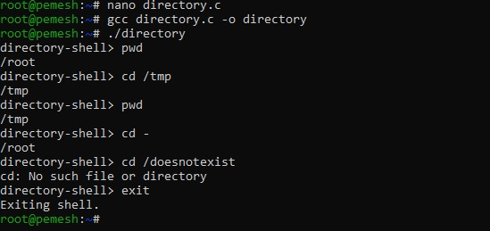
Observation:
The program successfully changes the current working directory using chdir(). The current directory is obtained using getcwd(). The previous directory is stored in OLDPWD, allowing cd - to return to the previous location. Invalid paths are detected and reported.
Result:
The program successfully implemented directory navigation, path validation, previous-directory handling, built-in command identification, and shell state maintenance.

Experiment No. 10(Q10)
Title: Implementation of Current Directory, Exit Handling and Environment Variable Export
Aim:
To retrieve and display the current working directory, process exit requests, clean up resources, maintain shell state, and implement the export command for environment variables.
Objective:
- Retrieve the current directory.
- Display the current path.
- Process exit requests.
- Perform cleanup before termination.
- Maintain shell state.
- Verify correct behaviour.
- Parse export syntax.
- Update environment variables.
- Validate variable names.
- Handle existing variables.
- Make variables available to child processes.
Theory:
The current working directory of a process can be obtained using getcwd().
The exit command terminates the shell. Before termination, allocated resources and other required cleanup operations should be performed.
Environment variables store configuration and information used by processes. The export command can be used to create or modify an environment variable.
The setenv() function creates or updates an environment variable. The getenv() function retrieves its value.
For example:
export COURSE=OSSP
creates an environment variable named COURSE with the value OSSP.
- Start the program.
- Display the shell prompt.
- Read user input.
- Parse the input into tokens.
- If the command is pwd, retrieve the current directory using getcwd().
- Display the current directory.
- If the command is export, validate the variable assignment.
- Separate the variable name and value.
- Validate the variable name.
- Create or update the environment variable using setenv().
- If the command is exit, perform required cleanup.
- Terminate the shell.
- Handle invalid commands.
- Repeat until exit is entered.
C Program:
#include <stdio.h>
#include <stdlib.h>
#include <string.h>
#include <unistd.h>
#include <limits.h>
#include <ctype.h>

#define INPUT_SIZE 1024
#define MAX_ARGS 50

int parse_command(char *input, char *args[])
{
int argc = 0;

char *token = strtok(input, " \t");

while (token != NULL && argc < MAX_ARGS - 1)
{
args[argc++] = token;
token = strtok(NULL, " \t");
}

args[argc] = NULL;

return argc;
}

int valid_variable_name(const char *name)
{
if (name == NULL || name[0] == '\0')
{
return 0;
}

if (!(isalpha((unsigned char)name[0]) ||
name[0] == '_'))
{
return 0;
}

for (int i = 1; name[i] != '\0'; i++)
{
if (!(isalnum((unsigned char)name[i]) ||
name[i] == '_'))
{
return 0;
}
}

return 1;
}

void builtin_pwd()
{
char current_dir[PATH_MAX];

if (getcwd(current_dir, sizeof(current_dir)) != NULL)
{
printf("%s\n", current_dir);
}
else
{
perror("pwd");
}
}

void builtin_export(char *assignment)
{
if (assignment == NULL)
{
printf("export: variable assignment required\n");
return;
}

char *equals = strchr(assignment, '=');

if (equals == NULL)
{
printf("export: invalid format\n");
return;
}

*equals = '\0';

char *name = assignment;
char *value = equals + 1;

if (!valid_variable_name(name))
{
printf("export: invalid variable name\n");
return;
}

if (setenv(name, value, 1) != 0)
{
perror("export");
return;
}

printf("Exported %s=%s\n", name, value);
}

int main()
{
char input[INPUT_SIZE];
char *args[MAX_ARGS];

while (1)
{
printf("environment-shell> ");
fflush(stdout);

if (fgets(input, sizeof(input), stdin) == NULL)
{
break;
}

input[strcspn(input, "\n")] = '\0';

if (strlen(input) == 0)
{
continue;
}

int argc = parse_command(input, args);

if (argc == 0)
{
continue;
}

if (strcmp(args[0], "pwd") == 0)
{
builtin_pwd();
}
else if (strcmp(args[0], "export") == 0)
{
builtin_export(args[1]);
}
else if (strcmp(args[0], "echo") == 0)
{
if (argc == 2 && args[1][0] == '$')
{
const char *value = getenv(args[1] + 1);

if (value != NULL)
{
printf("%s\n", value);
}
else
{
printf("\n");
}
}
else
{
for (int i = 1; i < argc; i++)
{
printf("%s", args[i]);

if (i < argc - 1)
{
printf(" ");
}
}

printf("\n");
}
}
else if (strcmp(args[0], "exit") == 0)
{
printf("Cleaning up resources...\n");
printf("Exiting shell.\n");
break;
}
else
{
printf("Command not found: %s\n", args[0]);
}
}

return 0;
}
Output:
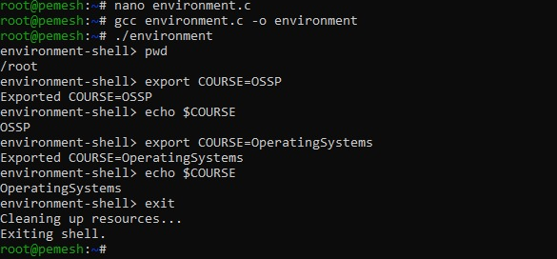
Observation:
The program retrieves the current working directory using getcwd(). The export command parses the variable assignment, validates the variable name, and uses setenv() to create or update the environment variable. The value can then be retrieved using getenv().

Result:
The program successfully implemented current-directory retrieval, exit handling, environment-variable creation and modification, variable-name validation, and shell-state maintenance.

