SKILL-06
Name: B. Pemesh
Rollno: 2520030388
Section: 8

Experiment No. 11(Q11)
Title: Implementation of Command History and Pipeline Structure
Aim:
To implement a command history buffer that stores and retrieves commands and to create pipeline structures that maintain command order and represent connections between processes.
Objective:
- Store commands in a history buffer.
- Maintain history capacity.
- Retrieve stored commands.
- Display command history.
- Validate history consistency.
- Create pipeline structures.
- Store pipeline commands.
- Maintain execution order.
- Connect processes logically.
- Validate pipeline layout.
Theory:
A command history stores previously entered commands so that they can be retrieved and displayed later. A history buffer has a fixed capacity and maintains the most recent commands when the capacity is exceeded.
A pipeline allows the output of one command to become the input of another command. For example:
ls | wc -l
The commands must be maintained in their execution order:
Command 1 → Command 2
The program below demonstrates both command history management and pipeline structure representation.
Algorithm:
- Start the program.
- Create a history buffer with a fixed capacity.
- Read commands from the user.
- Store each command in the history buffer.
- If the buffer becomes full, remove the oldest command.
- Display the stored history when history is entered.
- Parse a pipeline command using |.
- Store each command separately.
- Maintain the order of pipeline commands.
- Display the pipeline structure.
- Validate that the pipeline contains valid commands.
- Repeat until exit is entered.
- Free allocated memory.
- End the program.
C Program:
#include <stdio.h>
#include <stdlib.h>
#include <string.h>

#define INPUT_SIZE 1024
#define HISTORY_SIZE 10
#define MAX_COMMANDS 20

char *history[HISTORY_SIZE];
int history_count = 0;

void add_history(const char *command)
{
if (history_count < HISTORY_SIZE)
{
history[history_count] = strdup(command);
history_count++;
}
else
{
free(history[0]);

for (int i = 1; i < HISTORY_SIZE; i++)
{
history[i - 1] = history[i];
}

history[HISTORY_SIZE - 1] = strdup(command);
}
}

void display_history()
{
if (history_count == 0)
{
printf("History is empty.\n");
return;
}

printf("\nCommand History:\n");

for (int i = 0; i < history_count; i++)
{
printf("%d %s\n", i + 1, history[i]);
}
}

void display_pipeline(char *input)
{
char *commands[MAX_COMMANDS];
int count = 0;

char *token = strtok(input, "|");

while (token != NULL && count < MAX_COMMANDS)
{
while (*token == ' ')
{
token++;
}

commands[count++] = token;
token = strtok(NULL, "|");
}

if (count == 0)
{
printf("Invalid pipeline.\n");
return;
}

printf("\nPipeline Structure:\n");

for (int i = 0; i < count; i++)
{
printf("Command %d: %s", i + 1, commands[i]);

if (i < count - 1)
{
printf(" -> ");
}
}

printf("\n");
}

int main()
{
char input[INPUT_SIZE];

while (1)
{
printf("\nhistory-shell> ");
fflush(stdout);

if (fgets(input, sizeof(input), stdin) == NULL)
{
break;
}

input[strcspn(input, "\n")] = '\0';

if (strlen(input) == 0)
{
continue;
}

if (strcmp(input, "exit") == 0)
{
break;
}

if (strcmp(input, "history") == 0)
{
display_history();
continue;
}

add_history(input);

if (strchr(input, '|') != NULL)
{
char pipeline_input[INPUT_SIZE];

strcpy(pipeline_input, input);

display_pipeline(pipeline_input);
}
else
{
printf("Command stored in history.\n");
}
}

for (int i = 0; i < history_count; i++)
{
free(history[i]);
}

printf("History memory released.\n");

return 0;
}
Output:
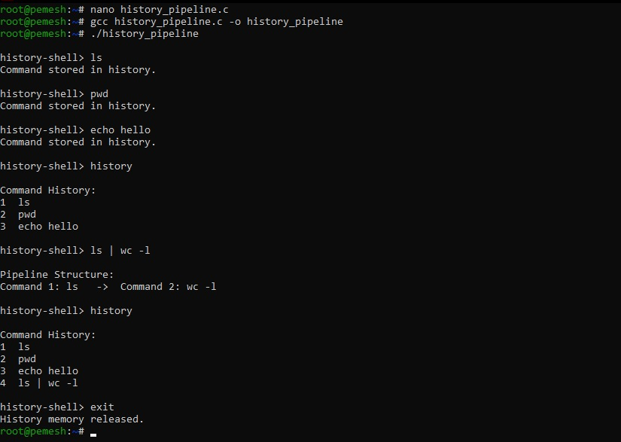
Observation:
The program stores commands in a history buffer and displays them when requested. When the history capacity is reached, the oldest command is removed. Pipeline commands separated by | are identified and displayed in their execution order.
Result:
The program successfully implemented command history storage, retrieval, capacity handling, and pipeline structure representation.

Experiment No. 12(Q12)
Title: Implementation of Pipes, Stream Redirection and Multiple Command Pipelines
Aim:
To create pipes for inter-process communication, redirect input and output streams, execute connected commands, close file descriptors correctly, synchronize processes, and support multiple pipes.
Objective:
- Create pipes.
- Redirect input and output streams.
- Execute connected commands.
- Close file descriptors.
- Synchronize processes.
- Test data flow.
- Support multiple pipes.
- Manage descriptor arrays.
- Launch multiple processes.
- Coordinate execution.
- Clean up resources.
- Test long pipelines.
Theory:
A pipe provides a communication channel between processes. Data written to the write end of a pipe can be read from the read end.
The pipe() system call creates two file descriptors:
pipefd[0] → Read end
pipefd[1] → Write end
dup2() can be used to redirect standard input or standard output to a pipe.
For example:
ls | wc -l
The output of ls becomes the input of wc.
For a longer pipeline:
ls | grep .c | wc -l
multiple pipes are required to connect the three processes.

Algorithm:
- Start the program.
- Read a pipeline command.
- Split the command using |.
- Count the number of commands.
- Create the required number of pipes.
- Create a child process for each command.
- Redirect the output of each command to the next pipe.
- Redirect the input of each command from the previous pipe.
- Close unused pipe descriptors.
- Execute each command using execvp().
- The parent waits for all child processes.
- Display completion information.
- Clean up all resources.
- Repeat until exit is entered.
- End the program.
C Program:
#include <stdio.h>
#include <stdlib.h>
#include <string.h>
#include <unistd.h>
#include <sys/wait.h>

#define INPUT_SIZE 1024
#define MAX_COMMANDS 10
#define MAX_ARGS 50

int parse_arguments(char *command, char *args[])
{
int argc = 0;

char *token = strtok(command, " \t");

while (token != NULL && argc < MAX_ARGS - 1)
{
args[argc++] = token;
token = strtok(NULL, " \t");
}

args[argc] = NULL;

return argc;
}

int main()
{
char input[INPUT_SIZE];

while (1)
{
printf("pipe-shell> ");
fflush(stdout);

if (fgets(input, sizeof(input), stdin) == NULL)
{
break;
}

input[strcspn(input, "\n")] = '\0';

if (strcmp(input, "exit") == 0)
{
break;
}

if (strlen(input) == 0)
{
continue;
}

char *commands[MAX_COMMANDS];
int command_count = 0;

char *token = strtok(input, "|");

while (token != NULL && command_count < MAX_COMMANDS)
{
commands[command_count++] = token;
token = strtok(NULL, "|");
}

if (command_count == 0)
{
continue;
}

int pipes[MAX_COMMANDS - 1][2];
pid_t pids[MAX_COMMANDS];

for (int i = 0; i < command_count - 1; i++)
{
if (pipe(pipes[i]) == -1)
{
perror("pipe");
return 1;
}
}

for (int i = 0; i < command_count; i++)
{
pids[i] = fork();

if (pids[i] < 0)
{
perror("fork");
return 1;
}

if (pids[i] == 0)
{
char *args[MAX_ARGS];

if (i > 0)
{
dup2(pipes[i - 1][0], STDIN_FILENO);
}

if (i < command_count - 1)
{
dup2(pipes[i][1], STDOUT_FILENO);
}

for (int j = 0; j < command_count - 1; j++)
{
close(pipes[j][0]);
close(pipes[j][1]);
}

parse_arguments(commands[i], args);

if (args[0] == NULL)
{
exit(EXIT_FAILURE);
}

execvp(args[0], args);

perror("execvp");
exit(EXIT_FAILURE);
}
}

for (int i = 0; i < command_count - 1; i++)
{
close(pipes[i][0]);
close(pipes[i][1]);
}

for (int i = 0; i < command_count; i++)
{
waitpid(pids[i], NULL, 0);
}

printf("Pipeline execution completed.\n");
}

return 0;
}
Output:
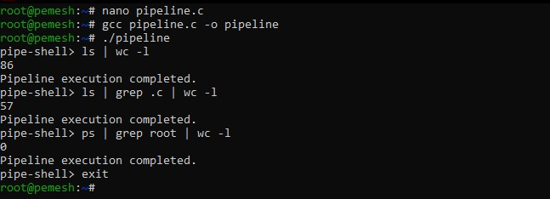
Observation:
The program creates pipes to establish communication between processes. dup2() redirects standard input and output to the appropriate pipe ends. Each command executes in a separate child process using execvp(). The parent closes unused descriptors and waits for all child processes using waitpid().
Result:
The program successfully implemented inter-process communication using pipes, input/output stream redirection, connected command execution, multiple pipelines, process synchronization, and file-descriptor cleanup.

