SKILL-07
Name: B. Pemesh
Rollno: 2520030388
Section: 8

Experiment No. 13(Q13)
Title: Implementation of Input and Output Redirection
Aim:
To implement input and output redirection by parsing redirection operators, opening files, redirecting standard input and output, handling errors, and verifying redirected data.
Objective:
- Parse input redirection.
- Open input files.
- Redirect stdin.
- Handle missing input files.
- Restore input streams.
- Test input redirection.
- Parse output redirection.
- Create output files.
- Redirect stdout.
- Handle file errors.
- Verify output data.
- Test output redirection.
Theory:
Input redirection allows a command to receive its input from a file instead of the keyboard. The < operator is used for input redirection.
Example:
wc -l < input.txt
Output redirection sends the output of a command to a file instead of the terminal. The > operator is used for output redirection.
Example:
echo Hello > output.txt
The open() system call is used to open or create files. dup2() is used to connect the file descriptor with standard input or output.
Algorithm:

Input Redirection
- Read the command from the user.
- Search for <.
- Extract the input filename.
- Open the file in read-only mode.
- Handle an error if the file cannot be opened.
- Save the original standard input.
- Redirect the file to stdin using dup2().
- Execute the command.
- Restore the original standard input.
- Close the file descriptors.

Output Redirection
- Read the command from the user.
- Search for >.
- Extract the output filename.
- Create or open the output file.
- Handle file-opening errors.
- Save the original standard output.
- Redirect stdout to the file using dup2().
- Execute the command.
- Restore the original standard output.
- Close the file descriptors.
C Program:
#include <stdio.h>
#include <stdlib.h>
#include <string.h>
#include <unistd.h>
#include <fcntl.h>
#include <sys/types.h>
#include <sys/wait.h>

#define INPUT_SIZE 1024
#define MAX_ARGS 50

int parse_arguments(char *input, char *args[])
{
int argc = 0;

char *token = strtok(input, " \t");

while (token != NULL && argc < MAX_ARGS - 1)
{
args[argc++] = token;
token = strtok(NULL, " \t");
}

args[argc] = NULL;

return argc;
}

int main()
{
char input[INPUT_SIZE];

while (1)
{
printf("redirect-shell> ");
fflush(stdout);

if (fgets(input, sizeof(input), stdin) == NULL)
{
break;
}

input[strcspn(input, "\n")] = '\0';

if (strcmp(input, "exit") == 0)
{
printf("Exiting shell.\n");
break;
}

if (strlen(input) == 0)
{
continue;
}

/* Input Redirection */
char *input_redirect = strchr(input, '<');

if (input_redirect != NULL)
{
*input_redirect = '\0';

char command[INPUT_SIZE];
char filename[INPUT_SIZE];

strcpy(command, input);

char *file = input_redirect + 1;

while (*file == ' ' || *file == '\t')
{
file++;
}

strncpy(filename, file, INPUT_SIZE - 1);
filename[INPUT_SIZE - 1] = '\0';

int fd = open(filename, O_RDONLY);

if (fd < 0)
{
perror("Error opening input file");
continue;
}

char *args[MAX_ARGS];
int argc = parse_arguments(command, args);

if (argc == 0)
{
printf("No command specified.\n");
close(fd);
continue;
}

int saved_stdin = dup(STDIN_FILENO);

if (dup2(fd, STDIN_FILENO) < 0)
{
perror("dup2");
close(fd);
close(saved_stdin);
continue;
}

close(fd);

pid_t pid = fork();

if (pid == 0)
{
execvp(args[0], args);
perror("execvp");
exit(EXIT_FAILURE);
}
else if (pid > 0)
{
waitpid(pid, NULL, 0);
}
else
{
perror("fork");
}

dup2(saved_stdin, STDIN_FILENO);
close(saved_stdin);

continue;
}

/* Output Redirection */
char *output_redirect = strchr(input, '>');

if (output_redirect != NULL)
{
*output_redirect = '\0';

char command[INPUT_SIZE];
char filename[INPUT_SIZE];

strcpy(command, input);

char *file = output_redirect + 1;

while (*file == ' ' || *file == '\t')
{
file++;
}

strncpy(filename, file, INPUT_SIZE - 1);
filename[INPUT_SIZE - 1] = '\0';

int fd = open(filename,
O_WRONLY | O_CREAT | O_TRUNC,
0644);

if (fd < 0)
{
perror("Error opening output file");
continue;
}

char *args[MAX_ARGS];
int argc = parse_arguments(command, args);

if (argc == 0)
{
printf("No command specified.\n");
close(fd);
continue;
}

int saved_stdout = dup(STDOUT_FILENO);

if (dup2(fd, STDOUT_FILENO) < 0)
{
perror("dup2");
close(fd);
close(saved_stdout);
continue;
}

close(fd);

pid_t pid = fork();

if (pid == 0)
{
execvp(args[0], args);
perror("execvp");
exit(EXIT_FAILURE);
}
else if (pid > 0)
{
waitpid(pid, NULL, 0);
}
else
{
perror("fork");
}

dup2(saved_stdout, STDOUT_FILENO);
close(saved_stdout);

printf("Output redirected to %s\n", filename);

continue;
}

printf("Use '<' for input or '>' for output redirection.\n");
}

return 0;
}
Output:
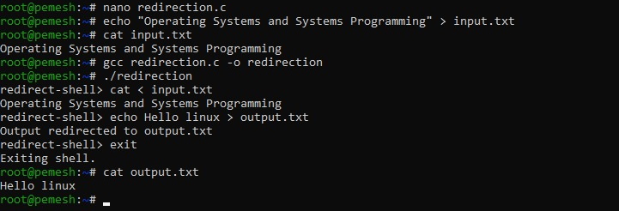
Observation:
The < operator successfully redirects standard input from a file, while the > operator redirects standard output to a file. The original standard streams are restored after command execution.
Result:
Input and output redirection were successfully implemented using file descriptors and dup2().

Experiment No. 14(Q14)
Title: Implementation of Append and Standard Error Redirection
Aim:
To implement append redirection using >> and standard error redirection using 2>, while preserving existing file contents, capturing error output, and verifying redirected files.
Objective:
  - Parse the append operator.
  - Open files in append mode.
  - Redirect output streams.
  - Preserve existing file data.
  - Validate append operations.
  - Test append scenarios.
  - Parse stderr redirection.
  - Redirect standard error.
  - Capture error output.
  - Verify error-file contents.
  - Handle command failures.
Theory:
The append operator >> redirects command output to a file without deleting its existing contents.
Example:
echo Second >> output.txt
The new output is added at the end of the file.
The 2> operator redirects standard error (stderr) to a file.
Example:
ls wrongfile 2> error.txt
Instead of displaying the error message on the terminal, the error is stored in error.txt.
The standard file descriptors are:
0 → stdin
1 → stdout
2 → stderr
dup2() can redirect these descriptors to files.

Algorithm:

Append Redirection
- Read the command.
- Search for >>.
- Extract the output filename.
- Open the file using append mode.
- Preserve existing file contents.
- Redirect stdout to the file.
- Execute the command.
- Restore stdout.
- Close the file descriptor.

Error Redirection
- Read the command.
- Search for 2>.
- Extract the error filename.
- Open or create the error file.
- Redirect stderr using dup2().
- Execute the command.
- Capture error output in the file.
- Restore stderr.
- Close the file descriptor.
- Verify the error file.
C Program:
#include <stdio.h>
#include <stdlib.h>
#include <string.h>
#include <unistd.h>
#include <fcntl.h>
#include <sys/types.h>
#include <sys/wait.h>

#define INPUT_SIZE 1024
#define MAX_ARGS 50

int parse_arguments(char *input, char *args[])
{
int argc = 0;

char *token = strtok(input, " \t");

while (token != NULL && argc < MAX_ARGS - 1)
{
args[argc++] = token;
token = strtok(NULL, " \t");
}

args[argc] = NULL;

return argc;
}

int main()
{
char input[INPUT_SIZE];

while (1)
{
printf("redirect-shell> ");
fflush(stdout);

if (fgets(input, sizeof(input), stdin) == NULL)
{
break;
}

input[strcspn(input, "\n")] = '\0';

if (strcmp(input, "exit") == 0)
{
printf("Exiting shell.\n");
break;
}

if (strlen(input) == 0)
{
continue;
}

/* Append Redirection */
char *append_redirect = strstr(input, ">>");

if (append_redirect != NULL)
{
*append_redirect = '\0';

char command[INPUT_SIZE];
char filename[INPUT_SIZE];

strcpy(command, input);

char *file = append_redirect + 2;

while (*file == ' ' || *file == '\t')
{
file++;
}

strncpy(filename, file, INPUT_SIZE - 1);
filename[INPUT_SIZE - 1] = '\0';

int fd = open(filename,
O_WRONLY | O_CREAT | O_APPEND,
0644);

if (fd < 0)
{
perror("Error opening append file");
continue;
}

char *args[MAX_ARGS];
int argc = parse_arguments(command, args);

if (argc == 0)
{
printf("No command specified.\n");
close(fd);
continue;
}

int saved_stdout = dup(STDOUT_FILENO);

if (dup2(fd, STDOUT_FILENO) < 0)
{
perror("dup2");
close(fd);
close(saved_stdout);
continue;
}

close(fd);

pid_t pid = fork();

if (pid == 0)
{
execvp(args[0], args);
perror("execvp");
exit(EXIT_FAILURE);
}
else if (pid > 0)
{
waitpid(pid, NULL, 0);
}
else
{
perror("fork");
}

dup2(saved_stdout, STDOUT_FILENO);
close(saved_stdout);

printf("Output appended to %s\n", filename);

continue;
}

/* Standard Error Redirection */
char *error_redirect = strstr(input, "2>");

if (error_redirect != NULL)
{
*error_redirect = '\0';

char command[INPUT_SIZE];
char filename[INPUT_SIZE];

strcpy(command, input);

char *file = error_redirect + 2;

while (*file == ' ' || *file == '\t')
{
file++;
}

strncpy(filename, file, INPUT_SIZE - 1);
filename[INPUT_SIZE - 1] = '\0';

int fd = open(filename,
O_WRONLY | O_CREAT | O_TRUNC,
0644);

if (fd < 0)
{
perror("Error opening error file");
continue;
}

char *args[MAX_ARGS];
int argc = parse_arguments(command, args);

if (argc == 0)
{
printf("No command specified.\n");
close(fd);
continue;
}

int saved_stderr = dup(STDERR_FILENO);

if (dup2(fd, STDERR_FILENO) < 0)
{
perror("dup2");
close(fd);
close(saved_stderr);
continue;
}

close(fd);

pid_t pid = fork();

if (pid == 0)
{
execvp(args[0], args);
perror("execvp");
exit(EXIT_FAILURE);
}
else if (pid > 0)
{
waitpid(pid, NULL, 0);
}
else
{
perror("fork");
}

dup2(saved_stderr, STDERR_FILENO);
close(saved_stderr);

printf("Error output redirected to %s\n", filename);

continue;
}

printf("Use '>>' for append or '2>' for error redirection.\n");
}

return 0;
}
Output:
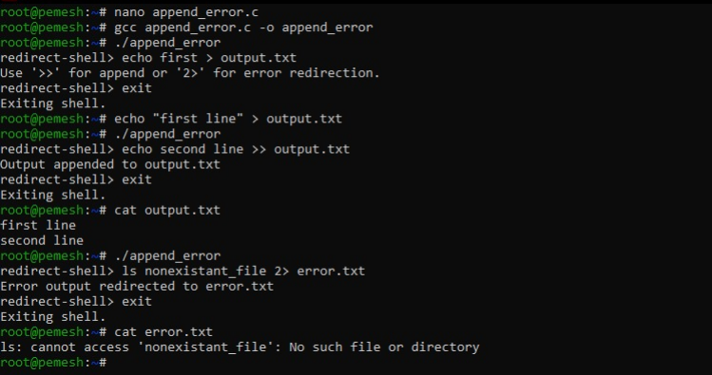
Observation:
The >> operator opens the file using append mode, so existing contents are preserved and new data is added at the end. The 2> operator redirects standard error to a separate file, preventing error messages from being displayed directly on the terminal.
Result:
The program successfully implemented append redirection and standard-error redirection, preserved existing file data, captured error messages, and verified the redirected contents.

