SKILL-08
Name: B. Pemesh
Rollno: 2520030388
Section: 8

Experiment No. 15(Q15)
Title: Implementation of Combined Redirection and Complex Commands Using Pipes
Aim:
To implement combined input/output redirection, duplicate file descriptors, merge streams, verify output ordering, and execute complex commands containing pipes and redirections.
Objective:
- Parse combined redirection.
- Duplicate file descriptors.
- Merge input and output streams.
- Verify output ordering.
- Handle edge cases.
- Parse complex commands.
- Combine pipes and redirections.
- Resolve execution order.
- Validate command syntax.
- Generate execution structures.
- Test complex command scenarios.
Theory:
Combined redirection allows more than one type of redirection to be used in the same command.
For example:
cat < input.txt > output.txt
takes input from input.txt and sends output to output.txt.
Pipes can also be combined with redirection:
cat < input.txt | grep Linux > output.txt
The execution flow is:
input.txt → cat → grep → output.txt
File descriptors can be duplicated using dup2(). Standard input, standard output and standard error are represented by file descriptors 0, 1, and 2.
Algorithm:
- Start the program.
- Read the command line.
- Identify input redirection <.
- Identify output redirection >.
- Identify pipe operators |.
- Parse the command into separate pipeline stages.
- Open input and output files when required.
- Create pipes between commands.
- Create child processes.
- Redirect each child's input and output using dup2().
- Close unused file descriptors.
- Execute each command using execvp().
- Wait for all child processes.
- Verify the resulting output.
- Handle invalid commands and files.
- Repeat until exit is entered.
C Program:
#include <stdio.h>
#include <stdlib.h>
#include <string.h>
#include <unistd.h>
#include <fcntl.h>
#include <sys/wait.h>

#define MAX_INPUT 1024
#define MAX_ARGS 100
#define MAX_PIPES 20

typedef struct {
char *input_file;
char *output_file;
char *append_file;
char *error_file;
int merge_error;
} Redirection;

/* Parse one command and remove redirection parts */
void parse_command(char *command, char **args, Redirection *redirection) {
int argc = 0;
char *token;
char *saveptr;

redirection->input_file = NULL;
redirection->output_file = NULL;
redirection->append_file = NULL;
redirection->error_file = NULL;
redirection->merge_error = 0;

token = strtok_r(command, " \t\n", &saveptr);

while (token != NULL && argc < MAX_ARGS - 1) {

if (strcmp(token, "<") == 0) {
token = strtok_r(NULL, " \t\n", &saveptr);

if (token != NULL)
redirection->input_file = token;
}

else if (strcmp(token, ">") == 0) {
token = strtok_r(NULL, " \t\n", &saveptr);

if (token != NULL)
redirection->output_file = token;
}

else if (strcmp(token, ">>") == 0) {
token = strtok_r(NULL, " \t\n", &saveptr);

if (token != NULL)
redirection->append_file = token;
}

else if (strcmp(token, "2>") == 0) {
token = strtok_r(NULL, " \t\n", &saveptr);

if (token != NULL)
redirection->error_file = token;
}

else if (strcmp(token, "2>&1") == 0) {
redirection->merge_error = 1;
}

else {
args[argc++] = token;
}

token = strtok_r(NULL, " \t\n", &saveptr);
}

args[argc] = NULL;
}

/* Apply redirections */
void apply_redirections(Redirection *r) {

int fd;

/* Input redirection */
if (r->input_file != NULL) {
fd = open(r->input_file, O_RDONLY);

if (fd < 0) {
perror("Input file");
exit(EXIT_FAILURE);
}

dup2(fd, STDIN_FILENO);
close(fd);
}

/* Output redirection */
if (r->output_file != NULL) {
fd = open(r->output_file,
O_WRONLY | O_CREAT | O_TRUNC,
0644);

if (fd < 0) {
perror("Output file");
exit(EXIT_FAILURE);
}

dup2(fd, STDOUT_FILENO);
close(fd);
}

/* Append redirection */
if (r->append_file != NULL) {
fd = open(r->append_file,
O_WRONLY | O_CREAT | O_APPEND,
0644);

if (fd < 0) {
perror("Append file");
exit(EXIT_FAILURE);
}

dup2(fd, STDOUT_FILENO);
close(fd);
}

/* Error redirection */
if (r->error_file != NULL) {
fd = open(r->error_file,
O_WRONLY | O_CREAT | O_TRUNC,
0644);

if (fd < 0) {
perror("Error file");
exit(EXIT_FAILURE);
}

dup2(fd, STDERR_FILENO);
close(fd);
}

/* Merge stderr into stdout */
if (r->merge_error) {
dup2(STDOUT_FILENO, STDERR_FILENO);
}
}

/* Execute a complete command with pipelines */
void execute_command(char *input) {

char *commands[MAX_PIPES];
int command_count = 0;

char *saveptr;
char *token;

/* Split command using | */
token = strtok_r(input, "|", &saveptr);

while (token != NULL && command_count < MAX_PIPES) {
commands[command_count++] = token;
token = strtok_r(NULL, "|", &saveptr);
}

if (command_count == 0)
return;

int pipes[MAX_PIPES - 1][2];
pid_t pids[MAX_PIPES];

/* Create required pipes */
for (int i = 0; i < command_count - 1; i++) {
if (pipe(pipes[i]) < 0) {
perror("pipe");
return;
}
}

/* Create processes */
for (int i = 0; i < command_count; i++) {

char *args[MAX_ARGS];
Redirection redirection;

parse_command(commands[i], args, &redirection);

if (args[0] == NULL)
continue;

/* Built-in exit */
if (command_count == 1 &&
strcmp(args[0], "exit") == 0) {

for (int j = 0; j < command_count - 1; j++) {
close(pipes[j][0]);
close(pipes[j][1]);
}

printf("Exiting shell.\n");
exit(0);
}

pids[i] = fork();

if (pids[i] < 0) {
perror("fork");
return;
}

if (pids[i] == 0) {

/* Connect input from previous pipe */
if (i > 0) {
dup2(pipes[i - 1][0], STDIN_FILENO);
}

/* Connect output to next pipe */
if (i < command_count - 1) {
dup2(pipes[i][1], STDOUT_FILENO);
}

/* Close all pipe descriptors */
for (int j = 0; j < command_count - 1; j++) {
close(pipes[j][0]);
close(pipes[j][1]);
}

/* Apply <, >, >>, 2>, 2>&1 */
apply_redirections(&redirection);

/* Execute command */
execvp(args[0], args);

perror("Command execution failed");
exit(EXIT_FAILURE);
}
}

/* Parent closes all pipes */
for (int i = 0; i < command_count - 1; i++) {
close(pipes[i][0]);
close(pipes[i][1]);
}

/* Wait for all child processes */
for (int i = 0; i < command_count; i++) {
waitpid(pids[i], NULL, 0);
}
}

int main() {

char input[MAX_INPUT];

printf("Combined-redirection-shell started.\n");
printf("Supports pipes and redirection.\n");
printf("Examples:\n");
printf(" cat < input.txt > output.txt\n");
printf(" cat < input.txt | grep Linux > linux.txt\n");
printf(" ls nonexistent 2> error.txt\n");
printf(" command > output.txt 2>&1\n\n");

while (1) {

printf("combined-shell> ");
fflush(stdout);

if (fgets(input, sizeof(input), stdin) == NULL)
break;

input[strcspn(input, "\n")] = '\0';

if (strlen(input) == 0)
continue;

execute_command(input);
}

return 0;
}
Output:
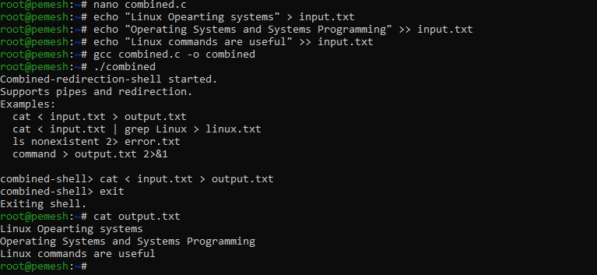
Observation:
The program combines file redirection with pipelines. Input is obtained from a file, passed through one or more processes, and the final output can be redirected to another file. dup2() connects the required file descriptors while unused pipe descriptors are closed.
Result:
Combined redirection and complex commands involving pipes were successfully implemented and tested.

Experiment No. 16(Q16)
Title Implementation of Background Jobs and Job Table Management
Aim:
To implement background job execution, return the shell prompt immediately, maintain a job table, track process states, monitor jobs, and remove completed jobs.
Objective:
- Detect background jobs using &.
- Launch non-blocking processes.
- Return the prompt immediately.
- Store job information.
- Monitor background processes.
- Track process states.
- Maintain a job table.
- Update job status.
- Remove completed jobs.
- Validate background-job execution.
Theory:
A background process runs without blocking the shell. The & operator is commonly used to indicate that a command should execute in the background.
For example:
sleep 10 &
allows the shell to immediately return to the prompt while sleep continues executing.
A job table stores information about active jobs, such as:
- Job ID
- Process ID
- Command
- Process state
waitpid() with WNOHANG can check whether a child process has completed without blocking the shell.
Algorithm:
- Start the shell.
- Display the prompt.
- Read a command.
- Check whether the command ends with &.
- If & is present, mark the command as a background job.
- Remove & from the command.
- Create a child process using fork().
- Execute the command in the child process.
- Store the process ID and job ID in the job table.
- Immediately return the prompt for background jobs.
- Periodically check background processes using waitpid() with WNOHANG.
- Update the status of completed jobs.
- Remove completed jobs from the job table.
- Display active jobs when jobs is entered.
- Repeat until exit is entered.
- Clean up remaining jobs and terminate.
C Program:
#include <stdio.h>
#include <stdlib.h>
#include <string.h>
#include <unistd.h>
#include <sys/types.h>
#include <sys/wait.h>

#define INPUT_SIZE 1024
#define MAX_ARGS 50
#define MAX_JOBS 20

typedef struct
{
int job_id;
pid_t pid;
char command[INPUT_SIZE];
int active;
} Job;

Job jobs[MAX_JOBS];
int job_count = 0;
int next_job_id = 1;

int parse_arguments(char *input, char *args[])
{
int argc = 0;

char *token = strtok(input, " \t");

while (token != NULL && argc < MAX_ARGS - 1)
{
args[argc++] = token;
token = strtok(NULL, " \t");
}

args[argc] = NULL;

return argc;
}

void check_jobs()
{
for (int i = 0; i < job_count; i++)
{
if (!jobs[i].active)
{
continue;
}

int status;

pid_t result = waitpid(jobs[i].pid,
&status,
WNOHANG);

if (result == jobs[i].pid)
{
printf("\n[%d]+ Done %s\n",
jobs[i].job_id,
jobs[i].command);

jobs[i].active = 0;
}
}
}

void display_jobs()
{
check_jobs();

int found = 0;

for (int i = 0; i < job_count; i++)
{
if (jobs[i].active)
{
printf("[%d] Running %s\n",
jobs[i].job_id,
jobs[i].command);

found = 1;
}
}

if (!found)
{
printf("No active background jobs.\n");
}
}

void cleanup_jobs()
{
for (int i = 0; i < job_count; i++)
{
if (jobs[i].active)
{
waitpid(jobs[i].pid, NULL, 0);
jobs[i].active = 0;
}
}
}

int main()
{
char input[INPUT_SIZE];

while (1)
{
check_jobs();

printf("job-shell> ");
fflush(stdout);

if (fgets(input, sizeof(input), stdin) == NULL)
{
break;
}

input[strcspn(input, "\n")] = '\0';

if (strcmp(input, "exit") == 0)
{
cleanup_jobs();
printf("Exiting shell.\n");
break;
}

if (strcmp(input, "jobs") == 0)
{
display_jobs();
continue;
}

if (strlen(input) == 0)
{
continue;
}

int background = 0;
int length = strlen(input);

if (length > 0 && input[length - 1] == '&')
{
background = 1;
input[length - 1] = '\0';

while (length > 0 &&
(input[length - 1] == ' ' ||
input[length - 1] == '\t'))
{
input[length - 1] = '\0';
length--;
}
}

char original_command[INPUT_SIZE];
strcpy(original_command, input);

char *args[MAX_ARGS];
int argc = parse_arguments(input, args);

if (argc == 0)
{
continue;
}

pid_t pid = fork();

if (pid < 0)
{
perror("fork");
continue;
}

if (pid == 0)
{
execvp(args[0], args);

perror("execvp");
exit(EXIT_FAILURE);
}

if (background)
{
if (job_count < MAX_JOBS)
{
jobs[job_count].job_id = next_job_id++;
jobs[job_count].pid = pid;

strncpy(jobs[job_count].command,
original_command,
INPUT_SIZE - 1);

jobs[job_count].command[INPUT_SIZE - 1] = '\0';
jobs[job_count].active = 1;

printf("[%d] %d\n",
jobs[job_count].job_id,
pid);

job_count++;
}
else
{
printf("Job table is full.\n");
}
}
else
{
waitpid(pid, NULL, 0);
}
}

return 0;
}
Output:
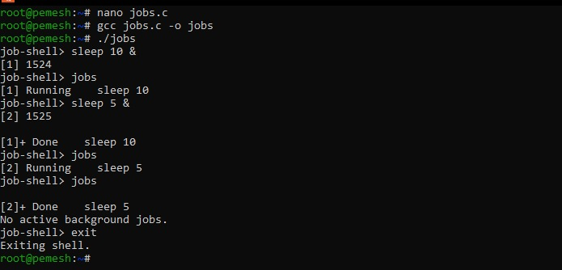
Observation:
The & operator identifies a background job. The shell does not wait for a background process and immediately displays the prompt. Job information is stored in a job table. waitpid() with WNOHANG checks whether a background process has completed without blocking the shell.
Result:
The program successfully implemented background-job detection, non-blocking execution, job-table management, process-state monitoring, completion handling, and cleanup.

