SKILL-09
Name: B. Pemesh
Rollno: 2520030388
Section: 8

Experiment No. 17(Q17)

Title: Job Listing and Foreground Switching
Aim:
To implement job listing and foreground job control in a shell by displaying active jobs, retrieving job IDs, updating job states, transferring terminal control, and resuming stopped processes.
Objective:
- List active background jobs.
- Display job IDs and process status.
- Update job state information.
- Identify a target job.
- Transfer terminal control to a foreground job.
- Resume a stopped process.
- Wait for the foreground process to complete.
Theory:
Job control allows a shell to manage processes running in the background and foreground.
A job ID identifies a job in the shell, while the process ID (PID) identifies the actual process.
The waitpid() system call is used to wait for a process to complete or change state. Terminal control can be transferred using tcsetpgrp() so that a selected process can run in the foreground.
Algorithm:
- Start the shell.
- Create a job table to store job information.
- Accept a command from the user.
- If the command ends with &, create a background process.
- Store the job ID, PID, command, and state.
- Use jobs to display active jobs.
- Use fg <job_id> to identify the required job.
- Transfer terminal control to the selected process.
- Resume the process using SIGCONT.
- Wait for the process to finish.
- Update the job state.
- Return terminal control to the shell.
- Repeat until exit is entered.
C Program:
#include <stdio.h>
#include <stdlib.h>
#include <string.h>
#include <unistd.h>
#include <signal.h>
#include <sys/wait.h>
#include <termios.h>

#define MAX_JOBS 20
#define MAX_CMD 256

typedef struct {
int job_id;
pid_t pid;
char command[MAX_CMD];
int active;
int stopped;
} Job;

Job jobs[MAX_JOBS];
int job_count = 0;

void add_job(pid_t pid, char *command) {
if (job_count >= MAX_JOBS) {
printf("Job table is full.\n");
return;
}

jobs[job_count].job_id = job_count + 1;
jobs[job_count].pid = pid;
strcpy(jobs[job_count].command, command);
jobs[job_count].active = 1;
jobs[job_count].stopped = 0;

job_count++;
}

void update_jobs() {
int status;

for (int i = 0; i < job_count; i++) {

if (!jobs[i].active)
continue;

pid_t result = waitpid(
jobs[i].pid,
&status,
WNOHANG | WUNTRACED | WCONTINUED
);

if (result == jobs[i].pid) {

if (WIFEXITED(status) || WIFSIGNALED(status)) {
jobs[i].active = 0;
}

else if (WIFSTOPPED(status)) {
jobs[i].stopped = 1;
}

else if (WIFCONTINUED(status)) {
jobs[i].stopped = 0;
}
}
}
}

void list_jobs() {

update_jobs();

int found = 0;

printf("\nActive Jobs:\n");

for (int i = 0; i < job_count; i++) {

if (jobs[i].active) {

found = 1;

if (jobs[i].stopped) {
printf("[%d] PID: %d Stopped %s\n",
jobs[i].job_id,
jobs[i].pid,
jobs[i].command);
}
else {
printf("[%d] PID: %d Running %s\n",
jobs[i].job_id,
jobs[i].pid,
jobs[i].command);
}
}
}

if (!found)
printf("No active jobs.\n");
}

int find_job(int job_id) {

for (int i = 0; i < job_count; i++) {

if (jobs[i].job_id == job_id &&
jobs[i].active) {

return i;
}
}

return -1;
}

void foreground_job(int job_id) {

int index = find_job(job_id);

if (index == -1) {
printf("Job %d not found.\n", job_id);
return;
}

pid_t pid = jobs[index].pid;

printf("Bringing job [%d] to foreground...\n", job_id);

/* Resume stopped process */
if (jobs[index].stopped) {
kill(pid, SIGCONT);
jobs[index].stopped = 0;
}

/* Transfer terminal control */
tcsetpgrp(STDIN_FILENO, pid);

/* Wait for the foreground process */
int status;

waitpid(pid, &status, WUNTRACED);

/* Return terminal control to shell */
tcsetpgrp(STDIN_FILENO, getpgrp());

if (WIFEXITED(status) || WIFSIGNALED(status)) {
jobs[index].active = 0;
printf("Job [%d] completed.\n", job_id);
}

else if (WIFSTOPPED(status)) {
jobs[index].stopped = 1;
printf("Job [%d] stopped.\n", job_id);
}
}

int main() {

char input[MAX_CMD];

printf("Foreground Job Control Shell\n");
printf("Commands:\n");
printf(" command & - Run in background\n");
printf(" jobs - List active jobs\n");
printf(" fg <job_id> - Bring job to foreground\n");
printf(" exit - Exit shell\n\n");

while (1) {

printf("fg-shell> ");
fflush(stdout);

if (fgets(input, sizeof(input), stdin) == NULL)
break;

input[strcspn(input, "\n")] = '\0';

if (strlen(input) == 0)
continue;

/* Exit */
if (strcmp(input, "exit") == 0) {
break;
}

/* List jobs */
if (strcmp(input, "jobs") == 0) {
list_jobs();
continue;
}

/* Foreground command */
if (strncmp(input, "fg ", 3) == 0) {

int job_id = atoi(input + 3);

foreground_job(job_id);

continue;
}

/* Background command */
int background = 0;

if (input[strlen(input) - 1] == '&') {

background = 1;

input[strlen(input) - 1] = '\0';

while (strlen(input) > 0 &&
input[strlen(input) - 1] == ' ') {
input[strlen(input) - 1] = '\0';
}
}

pid_t pid = fork();

if (pid < 0) {
perror("fork");
continue;
}

if (pid == 0) {

char *args[50];
int argc = 0;

char *token = strtok(input, " ");

while (token != NULL && argc < 49) {
args[argc++] = token;
token = strtok(NULL, " ");
}

args[argc] = NULL;

execvp(args[0], args);

perror("Command execution failed");
exit(EXIT_FAILURE);
}

else {

if (background) {

add_job(pid, input);

printf("[%d] %d\n",
jobs[job_count - 1].job_id,
pid);
}

else {

tcsetpgrp(STDIN_FILENO, pid);

int status;

waitpid(pid, &status, WUNTRACED);

tcsetpgrp(STDIN_FILENO, getpgrp());

if (WIFSTOPPED(status)) {
add_job(pid, input);
jobs[job_count - 1].stopped = 1;

printf("\n[%d] Stopped %s\n",
jobs[job_count - 1].job_id,
input);
}
}
}
}

return 0;
}
Output:
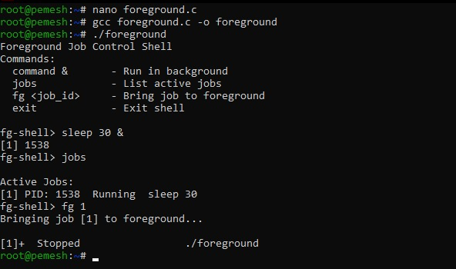
Observation:
- Background processes were successfully assigned job IDs.
- The jobs command displayed active jobs and their status.
- The selected job was identified using its job ID.
- Terminal control was transferred to the foreground process.
- The shell waited for the foreground process to complete.
- Job status was updated after completion.
Result:
Thus, active jobs were successfully listed and a selected job was switched from background execution to foreground execution.

Experiment No. 18(Q18)
Title: Implementation of Signal Handling and Background Job Recovery
Aim:
To implement signal handling and background job recovery by studying signal delivery, signal masks, process groups, terminal signals, and resuming stopped jobs using SIGCONT.
Objective:
- To understand signal delivery.
- To handle terminal-generated signals.
- To study process groups.
- To handle terminal signals.
- To resume stopped jobs.
- To send SIGCONT to stopped processes.
- To update job status.
- To maintain the job table.
Theory:
Signals are software notifications sent to processes to indicate that an event has occurred.
Important signals used in job control include:
- SIGINT — interrupts a process.
- SIGTSTP — stops a process.
- SIGCONT — continues a stopped process.
- SIGCHLD — indicates that a child process has changed state.
A process group allows related processes to be managed together. A stopped job can be resumed by sending SIGCONT to its process group.
Algorithm:
- Start the shell.
- Install signal handlers.
- Create a child process.
- Create a process group for the child.
- Execute the required command.
- Handle terminal signals.
- Store stopped jobs in the job table.
- Display job status.
- Identify the required job.
- Send SIGCONT to the stopped job.
- Update its status to running.
- Verify the process state.
- Update the job table.
- Repeat until exit is entered.
C Program:
#include <stdio.h>
#include <stdlib.h>
#include <string.h>
#include <unistd.h>
#include <signal.h>
#include <sys/wait.h>
#include <errno.h>
#include <termios.h>

#define MAX_JOBS 20
#define MAX_CMD 256

typedef struct {
int job_id;
pid_t pid;
pid_t pgid;
char command[MAX_CMD];
int active;
int stopped;
} Job;

Job jobs[MAX_JOBS];
int job_count = 0;

void add_job(pid_t pid, pid_t pgid, char *command, int stopped) {

if (job_count >= MAX_JOBS) {
printf("Job table is full.\n");
return;
}

jobs[job_count].job_id = job_count + 1;
jobs[job_count].pid = pid;
jobs[job_count].pgid = pgid;

strcpy(jobs[job_count].command, command);

jobs[job_count].active = 1;
jobs[job_count].stopped = stopped;

job_count++;
}

void check_jobs() {

int status;

for (int i = 0; i < job_count; i++) {

if (!jobs[i].active)
continue;

pid_t result = waitpid(
jobs[i].pid,
&status,
WNOHANG | WUNTRACED | WCONTINUED
);

if (result == jobs[i].pid) {

if (WIFEXITED(status) ||
WIFSIGNALED(status)) {

jobs[i].active = 0;
jobs[i].stopped = 0;
}

else if (WIFSTOPPED(status)) {
jobs[i].stopped = 1;
}

else if (WIFCONTINUED(status)) {
jobs[i].stopped = 0;
}
}
}
}

void list_jobs() {

check_jobs();

int found = 0;

printf("\nJob Table:\n");

for (int i = 0; i < job_count; i++) {

if (!jobs[i].active)
continue;

found = 1;

if (jobs[i].stopped) {

printf("[%d] PID: %d PGID: %d STOPPED %s\n",
jobs[i].job_id,
jobs[i].pid,
jobs[i].pgid,
jobs[i].command);
}
else {

printf("[%d] PID: %d PGID: %d RUNNING %s\n",
jobs[i].job_id,
jobs[i].pid,
jobs[i].pgid,
jobs[i].command);
}
}

if (!found)
printf("No active jobs.\n");
}

void resume_job(int job_id) {

if (job_id <= 0 || job_id > job_count) {
printf("Invalid job ID.\n");
return;
}

int index = job_id - 1;

if (!jobs[index].active) {
printf("Job is no longer active.\n");
return;
}

printf("Sending SIGCONT to job [%d]...\n", job_id);

kill(-jobs[index].pgid, SIGCONT);

jobs[index].stopped = 0;

printf("Job [%d] resumed.\n", job_id);
}

int main() {

char input[MAX_CMD];

/*
* Shell ignores terminal stop/interrupt signals.
* Child processes use the default actions.
*/
signal(SIGINT, SIG_IGN);
signal(SIGTSTP, SIG_IGN);
signal(SIGTTIN, SIG_IGN);
signal(SIGTTOU, SIG_IGN);

printf("Signal and Background Recovery Shell\n");
printf("Commands:\n");
printf(" command & - Start background job\n");
printf(" jobs - Display job table\n");
printf(" resume <id> - Send SIGCONT\n");
printf(" exit - Exit shell\n\n");

while (1) {

printf("signal-shell> ");
fflush(stdout);

if (fgets(input, sizeof(input), stdin) == NULL)
break;

input[strcspn(input, "\n")] = '\0';

if (strlen(input) == 0)
continue;

if (strcmp(input, "exit") == 0)
break;

if (strcmp(input, "jobs") == 0) {
list_jobs();
continue;
}

if (strncmp(input, "resume ", 7) == 0) {

int job_id = atoi(input + 7);

resume_job(job_id);

continue;
}

int background = 0;

if (input[strlen(input) - 1] == '&') {

background = 1;

input[strlen(input) - 1] = '\0';

while (strlen(input) > 0 &&
input[strlen(input) - 1] == ' ') {

input[strlen(input) - 1] = '\0';
}
}

pid_t pid = fork();

if (pid < 0) {
perror("fork");
continue;
}

if (pid == 0) {

/* Create new process group */
setpgid(0, 0);

/* Restore default signal behavior */
signal(SIGINT, SIG_DFL);
signal(SIGTSTP, SIG_DFL);
signal(SIGTTIN, SIG_DFL);
signal(SIGTTOU, SIG_DFL);

char *args[50];
int argc = 0;

char *token = strtok(input, " ");

while (token != NULL && argc < 49) {

args[argc++] = token;

token = strtok(NULL, " ");
}

args[argc] = NULL;

execvp(args[0], args);

perror("Command execution failed");
exit(EXIT_FAILURE);
}

else {

/* Put child in its own process group */
setpgid(pid, pid);

if (background) {

add_job(pid, pid, input, 0);

printf("[%d] PID: %d PGID: %d\n",
jobs[job_count - 1].job_id,
pid,
pid);
}

else {

int status;

/* Give terminal control to foreground process */
tcsetpgrp(STDIN_FILENO, pid);

/*
* Keep waiting if waitpid is interrupted
* by another signal.
*/
while (1) {

pid_t result = waitpid(
pid,
&status,
WUNTRACED
);

if (result == -1) {

if (errno == EINTR)
continue;

perror("waitpid");
break;
}

break;
}

/* Return terminal control to shell */
tcsetpgrp(STDIN_FILENO, getpgrp());

if (WIFSTOPPED(status)) {

add_job(pid, pid, input, 1);

printf("\n[%d] STOPPED %s\n",
jobs[job_count - 1].job_id,
input);
}

else if (WIFEXITED(status) ||
WIFSIGNALED(status)) {

printf("Foreground process completed.\n");
}
}
}
}

return 0;
}
Output:
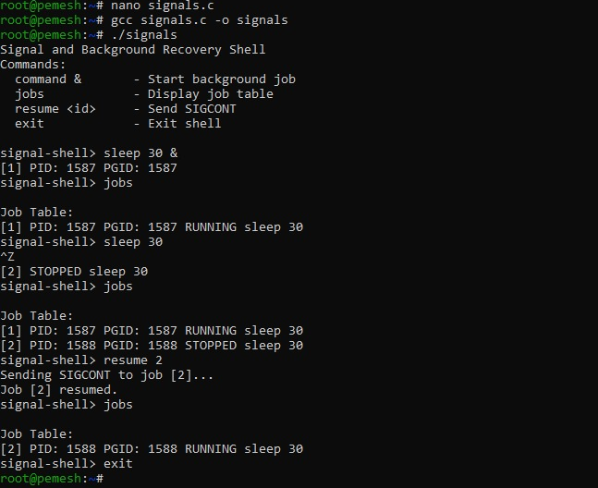
Observation:
- Signals were handled by the shell.
- Background jobs were stored in the job table.
- Process IDs and process group IDs were maintained.
- A stopped process was identified from the job table.
- SIGCONT was sent to resume the stopped process.
- The job status was updated after resuming.
- The job could be monitored using the jobs command.
Result:
Thus, signal handling and background job recovery were successfully implemented using process groups, terminal signals, SIGCONT, and job status management.

