SKILL-11

Name: P. Anuradha Nandini
Rollno: 2520030171
Section: 8

Experiment No. 11 (Q11)
Title: Command History Management and Pipeline Structures in a Custom Shell
Aim:
To implement a command-history mechanism that stores commands, maintains a history buffer, handles capacity limits, retrieves entries, displays history, and validates consistency. To implement pipeline structures that create a pipeline, store commands, maintain execution order, connect processes, validate pipeline layout, and test different configurations.
Objective:
Part 1 – Command History
- To store commands entered by the user.
- To maintain a fixed-size history buffer.
- To handle capacity limits once the buffer is full.
- To retrieve individual entries from the history.
- To display the stored command history.
- To validate the consistency of the history buffer.
Part 2 – Pipeline Structures
- To create a data structure representing a command pipeline.
- To store each command that makes up a stage of the pipeline.
- To maintain the execution order of the pipeline stages.
- To connect processes so one stage's output feeds the next stage's input.
- To validate the pipeline layout before execution.
- To test different pipeline configurations, including invalid ones.
Theory:
1. Command History
A shell typically keeps a record of previously entered commands so the user can review or re-run them. This record is stored in a history buffer, usually with a fixed maximum capacity to bound memory usage.
2. Circular Buffer for History Storage
Because the number of commands a user enters is unbounded, the history buffer is implemented as a circular buffer of fixed size. Once the buffer is full, the oldest entry is overwritten by the newest command, so the buffer always holds the most recent N commands.
3. Handling Capacity Limits
When the buffer reaches its maximum capacity, new commands overwrite the oldest stored command instead of being rejected or causing an overflow. An index tracks the position of the oldest entry so the buffer wraps around correctly.
4. Retrieving Entries and Displaying History
Individual entries can be retrieved by their position in the buffer. The full history is displayed in order from oldest to most recent, numbered using the total count of commands entered so far.
5. Validating Consistency
Consistency validation checks that the number of entries actually stored matches what is expected given the total number of commands added and the buffer's capacity — this confirms the wrap-around logic has not corrupted the buffer state.
6. Pipelines
A pipeline connects the output of one command to the input of the next, allowing several commands to be chained together, e.g. cmd1 | cmd2 | cmd3. Each command in the chain is a stage of the pipeline.
7. Pipeline Data Structure
A pipeline is represented as an ordered array of Command structures, where each Command holds its own argument vector. The order of the array defines the execution order of the stages.
typedef struct {
char *args[MAX_ARGS];
int argCount;
} Command;

typedef struct {
Command stages[MAX_STAGES];
int stageCount;
} Pipeline;

8. Connecting Processes with pipe() and fork()
The pipe() system call creates a unidirectional data channel with a read end and a write end. For each pair of consecutive stages, a pipe connects the write end of one process to the read end of the next, using dup2() to redirect standard input and standard output before calling execvp().
pipe(pipefds);
dup2(pipefds[1], STDOUT_FILENO); /* redirect this stage's output */
dup2(pipefds[0], STDIN_FILENO); /* redirect the next stage's input */

9. Validating Pipeline Layout
Before execution, the pipeline is checked to ensure it has at least one stage and that no stage is empty (for example, caused by malformed input such as two consecutive pipe symbols with nothing meaningful between them). An invalid layout is rejected before any process is created.
Algorithm:
Part 1 – Command History
- Start the program.
- Read a command entered by the user.
- If the history buffer is not full, append the command and increase the size.
- If the buffer is full, overwrite the oldest entry and advance the start index.
- Increase the total command counter.
- Display the history buffer in order.
- Retrieve a specific entry by its position when requested.
- Validate that the stored size matches the expected occupancy.
- Stop the program.
Part 2 – Pipeline Structures
- Start the program.
- Read the pipeline input string.
- Split the input on the pipe symbol to obtain each stage.
- Tokenize each stage into a command name and its arguments.
- Store each stage's Command structure in order inside the Pipeline structure.
- Validate that the pipeline has at least one stage and no empty stage.
- If invalid, report the error and skip execution.
- If valid, create the required pipes and fork a process per stage.
- Connect each stage's input/output to the adjacent pipes using dup2().
- Execute each stage using execvp() and wait for all stages to finish.
- Test the pipeline with single-command, multi-command and invalid configurations.
- Stop the program.
Functions Used:
Function | Purpose
main() | Starting point of the program
addHistory() | Stores a command into the circular history buffer
displayHistory() | Prints the stored command history in order
getHistoryEntry() | Retrieves a specific entry from the history buffer
validateHistoryConsistency() | Checks that the buffer state is internally consistent
tokenizeCommand() | Splits one pipeline stage into a command and its arguments
createPipeline() | Splits input on '|' and builds the Pipeline structure
validatePipeline() | Checks the pipeline has valid, non-empty stages
printPipelineLayout() | Displays the parsed stages of a pipeline
executePipeline() | Creates pipes, forks stages, and connects them with dup2()
pipe() | Creates a read/write file-descriptor pair for inter-process communication
fork() | Creates a child process for each pipeline stage
dup2() | Redirects standard input/output to a pipe end
execvp() | Replaces a child process image with the stage's command
waitpid() | Waits for each pipeline stage to complete

Hardware and Operating System Relationship
Hardware consists of physical components such as the CPU, RAM, storage devices, keyboard, mouse and display. The Operating System acts as an interface between application software and hardware. It manages processes, memory, files, devices and system resources.
Relationship
USER
|
v
SHELL (this program)
|
v
SYSTEM CALLS (pipe, fork, dup2, execvp, waitpid)
|
v
OPERATING SYSTEM
|
+----------+-----------+--------------+
v v v
CPU RAM I/O DEVICES
|
v
STORAGE DEVICES

How OS Interacts with Hardware
- Process Management – The OS creates and schedules one process per pipeline stage.
- Memory Management – The OS manages memory for the history buffer and process images.
- File Management – The OS manages the file descriptors created by pipe().
- Device Management – The OS controls the terminal used for command input and output.
- Security – The OS enforces permissions when executing pipeline commands.
Observation
The program successfully stores each entered command into a fixed-size circular history buffer, overwrites the oldest entry once capacity is reached, displays the history in order, retrieves individual entries by position, and confirms that the buffer's occupancy stays consistent with the total number of commands entered.
The pipeline module successfully parses multi-stage pipeline input into an ordered Pipeline structure, validates that every stage is non-empty before execution, connects consecutive stages using pipe() and dup2(), and correctly rejects a malformed pipeline containing an empty stage without attempting to execute it.
Result
Command-history management was successfully implemented, including storage, capacity handling through a circular buffer, entry retrieval, history display, and consistency validation. Pipeline structures were also successfully implemented, including pipeline creation, command storage in execution order, process connection using pipe() and fork(), layout validation, and testing across single-command, multi-command and invalid configurations.
Design / Flow
Command History Flow
Read command
|
v
Buffer full? --No--> Append entry, historySize++
| Yes
v
Overwrite oldest entry
Advance historyStart
|
v
historyTotal++
|
v
Display / Retrieve / Validate

Pipeline Execution Flow
Input: "cmd1 | cmd2 | cmd3"
|
v
Split on '|' -> stages[0..n-1]
|
v
Tokenize each stage into args[]
|
v
Validate: stageCount > 0, no empty stage
|
+----+----+
Valid Invalid
| |
v v
Create (n-1) pipes Report error,
| skip execution
v
fork() each stage
|
v
dup2() stdin/stdout to pipe ends
|
v
execvp(stage command)
|
v
Parent closes pipes, waitpid() all stages

CODE-
#include <stdio.h>
#include <stdlib.h>
#include <string.h>
#include <unistd.h>
#include <sys/types.h>
#include <sys/wait.h>

#define MAX_HISTORY 5
#define MAX_CMD_LEN 200
#define MAX_STAGES 10
#define MAX_ARGS 20

char history[MAX_HISTORY][MAX_CMD_LEN];
int historySize = 0;
int historyStart = 0;
int historyTotal = 0;

void addHistory(const char *cmd)
{
if (cmd == NULL || strlen(cmd) == 0)
return;

if (historySize < MAX_HISTORY)
{
strncpy(history[(historyStart + historySize) % MAX_HISTORY], cmd, MAX_CMD_LEN - 1);
historySize++;
}
else
{
strncpy(history[historyStart], cmd, MAX_CMD_LEN - 1);
historyStart = (historyStart + 1) % MAX_HISTORY;
}

historyTotal++;
}

void displayHistory(void)
{
printf("\n--- Command History ---\n");

if (historySize == 0)
{
printf("History is empty\n");
return;
}

for (int i = 0; i < historySize; i++)
{
int idx = (historyStart + i) % MAX_HISTORY;
printf("%2d: %s\n", historyTotal - historySize + i + 1, history[idx]);
}
}

const char *getHistoryEntry(int n)
{
if (n < 1 || n > historySize)
return NULL;

int idx = (historyStart + n - 1) % MAX_HISTORY;
return history[idx];
}

void validateHistoryConsistency(void)
{
printf("\n--- Validating History ---\n");

int expected = (historyTotal < MAX_HISTORY) ? historyTotal : MAX_HISTORY;

if (expected == historySize)
printf("OK: historySize = %d\n", historySize);
else
printf("ERROR: historySize = %d, expected = %d\n",
historySize, expected);

printf("Total commands: %d | Retained: %d | Capacity: %d\n",
historyTotal, historySize, MAX_HISTORY);
}

void testHistory(void)
{
printf("\n=== Part 1: Command History ===\n");

const char *cmds[] = {
"pwd",
"ls -l",
"cd /tmp",
"echo hello",
"whoami",
"date",
"uname -a"
};

int n = sizeof(cmds) / sizeof(cmds[0]);

for (int i = 0; i < n; i++)
{
printf("Adding command: %s\n", cmds[i]);
addHistory(cmds[i]);
}

displayHistory();
validateHistoryConsistency();

printf("\nEntry #2: %s\n", getHistoryEntry(2));

printf("Entry #99: %s\n",
getHistoryEntry(99) ? getHistoryEntry(99) : "(not found)");
}

typedef struct
{
char *args[MAX_ARGS];
int argCount;
} Command;

typedef struct
{
Command stages[MAX_STAGES];
int stageCount;
} Pipeline;

void tokenizeCommand(char *segment, Command *cmd)
{
cmd->argCount = 0;

char *token = strtok(segment, " \t");

while (token != NULL && cmd->argCount < MAX_ARGS - 1)
{
cmd->args[cmd->argCount++] = token;
token = strtok(NULL, " \t");
}

cmd->args[cmd->argCount] = NULL;
}

int createPipeline(char *input, Pipeline *p)
{
p->stageCount = 0;

char *saveptr;
char *segment = strtok_r(input, "|", &saveptr);

while (segment != NULL && p->stageCount < MAX_STAGES)
{
tokenizeCommand(segment, &p->stages[p->stageCount]);
p->stageCount++;

segment = strtok_r(NULL, "|", &saveptr);
}

return p->stageCount;
}

int validatePipeline(const Pipeline *p)
{
if (p->stageCount == 0)
{
printf("Pipeline invalid: no stages found.\n");
return 0;
}

for (int i = 0; i < p->stageCount; i++)
{
if (p->stages[i].argCount == 0)
{
printf("Pipeline invalid: stage %d is empty.\n", i + 1);
return 0;
}
}

printf("Pipeline valid: %d stage(s), %d pipe(s) needed.\n",
p->stageCount, p->stageCount - 1);

return 1;
}

void printPipelineLayout(const Pipeline *p)
{
for (int i = 0; i < p->stageCount; i++)
{
printf("Stage %d:", i + 1);

for (int j = 0; j < p->stages[i].argCount; j++)
printf(" %s", p->stages[i].args[j]);

printf("\n");
}
}

void executePipeline(Pipeline *p)
{
int numPipes = p->stageCount - 1;
int pipefds[2 * MAX_STAGES];

for (int i = 0; i < numPipes; i++)
{
if (pipe(pipefds + i * 2) < 0)
{
perror("pipe");
return;
}
}

pid_t pids[MAX_STAGES];

for (int i = 0; i < p->stageCount; i++)
{
pids[i] = fork();

if (pids[i] < 0)
{
perror("fork");
return;
}

if (pids[i] == 0)
{
if (i != 0)
dup2(pipefds[(i - 1) * 2], STDIN_FILENO);

if (i != p->stageCount - 1)
dup2(pipefds[i * 2 + 1], STDOUT_FILENO);

for (int j = 0; j < 2 * numPipes; j++)
close(pipefds[j]);

execvp(p->stages[i].args[0], p->stages[i].args);

fprintf(stderr, "%s: command not found\n",
p->stages[i].args[0]);

_exit(127);
}
}

for (int j = 0; j < 2 * numPipes; j++)
close(pipefds[j]);

for (int i = 0; i < p->stageCount; i++)
waitpid(pids[i], NULL, 0);
}

void testPipelineConfigurations(void)
{
printf("\n=== Part 2: Pipeline Testing ===\n");

char *tests[] = {
"ls",
"ls | wc -l",
"ls | grep c | wc -l",
"ls | | wc"
};

int n = sizeof(tests) / sizeof(tests[0]);

for (int i = 0; i < n; i++)
{
char buffer[MAX_CMD_LEN];

strncpy(buffer, tests[i], MAX_CMD_LEN - 1);
buffer[MAX_CMD_LEN - 1] = '\0';

printf("\nInput: \"%s\"\n", tests[i]);

Pipeline pipeline;

createPipeline(buffer, &pipeline);
printPipelineLayout(&pipeline);

if (validatePipeline(&pipeline))
{
printf("Output:\n");
executePipeline(&pipeline);
}
else
{
printf("Skipping execution due to invalid pipeline.\n");
}
}
}

int main(void)
{
setvbuf(stdout, NULL, _IONBF, 0);

testHistory();
testPipelineConfigurations();

return 0;
}
Compilation and Execution
1. Compile
gcc question11.c -o question11

2. Execute
./question11

Sample Output
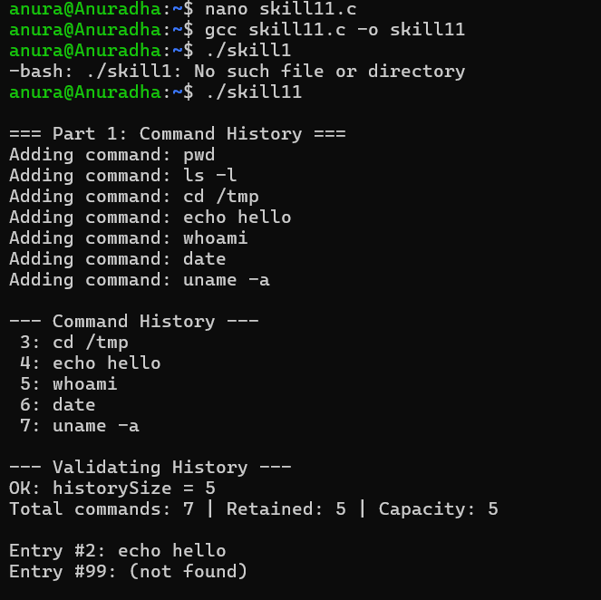
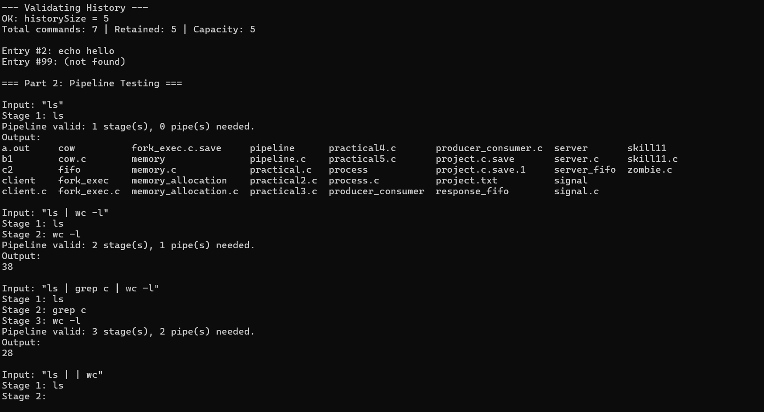
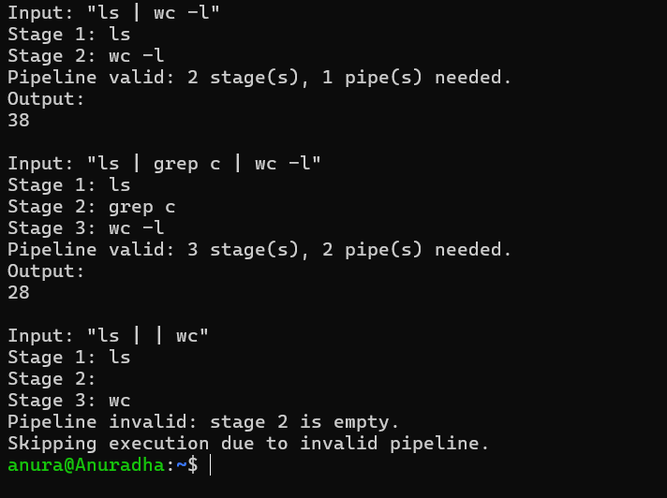
Conclusion
This experiment demonstrates command-history management using a circular buffer, including storage, capacity handling, entry retrieval, display and consistency validation. It also demonstrates pipeline structures that store commands in execution order and connect them into a working pipeline using pipe(), fork(), dup2() and execvp(), together with validation that rejects malformed pipeline layouts before execution. Together, these illustrate important Operating System concepts such as bounded-buffer data structures, inter-process communication, and multi-process pipeline execution.

