PRACTICAL-12

Name: B.PEMESH
Roll Number: 2520030388
Section: 08
EXPERIMENT – PRODUCER-CONSUMER USING SEMAPHORES AND DEADLOCK PREVENTION
Aim:
To implement the Producer-Consumer problem using counting semaphores and POSIX threads, evaluate synchronization and system throughput for different buffer sizes, and demonstrate deadlock and its prevention using resource ordering.
Objective:
- To implement the Producer-Consumer problem using POSIX threads.
- To use counting semaphores for synchronization.
- To evaluate system throughput for different buffer sizes.
- To demonstrate a deadlock scenario involving multiple threads.
- To identify the four necessary conditions for deadlock.
- To prevent deadlock using resource ordering.
Problem statement:
Implement the Producer-Consumer problem using counting semaphores and POSIX threads. Evaluate synchronization correctness and system throughput under different buffer sizes.
Design a deadlock scenario involving multiple threads competing for shared resources. Demonstrate deadlock occurrence, identify the four necessary conditions for deadlock, and implement a deadlock prevention strategy using resource ordering.
Theory:
The Producer-Consumer problem, also known as the bounded-buffer problem, is a synchronization problem involving a producer and a consumer sharing a fixed-size buffer. The producer adds items to the buffer, while the consumer removes items from it.
Counting semaphores are used to keep track of the available and occupied positions in the buffer. The empty semaphore represents the number of empty slots, while the full semaphore represents the number of occupied slots. A mutex is used to ensure that only one thread accesses the shared buffer at a time.
A deadlock occurs when multiple threads are permanently waiting for resources held by one another. Four conditions are necessary for deadlock:
- Mutual Exclusion – only one thread can use a resource at a time.
- Hold and Wait – a thread holds one resource while waiting for another.
- No Preemption – a resource cannot be forcibly taken from a thread.
- Circular Wait – threads form a circular chain where each thread waits for a resource held by another thread.
Deadlock can be prevented using resource ordering, where all threads acquire resources in the same predefined order.
Algorithm:
Part A – Producer-Consumer Problem
- Start the program.
- Read the buffer size from the command line.
- Allocate memory for the buffer.
- Initialize the empty semaphore with the buffer size.
- Initialize the full semaphore with 0.
- Initialize the mutex.
- Create producer and consumer threads.
- The producer waits for an empty buffer slot and inserts an item.
- The consumer waits for a filled buffer slot and removes an item.
- Use the mutex to protect access to the shared buffer.
- Continue until all items are produced and consumed.
- Calculate execution time and throughput.
- Display the results.
- Repeat the experiment with different buffer sizes.
- Terminate the program.

Part B – Deadlock Demonstration
- Start the program.
- Initialize two shared resources.
- Create two threads.
- Thread 1 acquires Resource 1 and waits for Resource 2.
- Thread 2 acquires Resource 2 and waits for Resource 1.
- Both threads remain waiting for each other.
- Observe the occurrence of deadlock.
- Terminate the program using a timeout.
Part C - Deadlock Prevention Using Resource Ordering
- Start the program.
- Initialize two shared resources.
- Create two threads.
- Make both threads acquire Resource 1 first.
- Make both threads acquire Resource 2 next.
- Perform the required operations.
- Release Resource 2.
- Release Resource 1.
- Join both threads.
- Display that deadlock was prevented.
- Terminate the program.
System Calls/functions used:
- pthread_create() – Creates a new thread and starts its execution.
- pthread_join() – Waits for a thread to finish its execution.
- pthread_mutex_lock() – Locks a mutex so that only one thread can access the protected resource.
- pthread_mutex_unlock() – Unlocks the mutex and allows another thread to access the resource.
- pthread_mutex_init() – Initializes a mutex before it is used.
- pthread_mutex_destroy() – Destroys a mutex after it is no longer needed.
- sem_init() – Initializes a semaphore with a specified starting value.
- sem_wait() – Decreases the semaphore value and waits if the resource is unavailable.
- sem_post() – Increases the semaphore value and signals that a resource is available.
- sem_destroy() – Destroys a semaphore after its use.
- clock_gettime() – Obtains the current time for measuring execution time.
- malloc() – Dynamically allocates memory for the buffer.
- free() – Releases dynamically allocated memory.
PROGRAM 1 – Producer-Consumer
C Program:
#include <stdio.h>
#include <stdlib.h>
#include <pthread.h>
#include <semaphore.h>
#include <time.h>

#define TOTAL_ITEMS 1000000

int *buffer;
int buffer_size;

int in = 0;
int out = 0;

sem_t empty;
sem_t full;

pthread_mutex_t mutex;

void *producer(void *arg)
{
for (int i = 0; i < TOTAL_ITEMS; i++)
{
sem_wait(&empty);

pthread_mutex_lock(&mutex);

buffer[in] = i;
in = (in + 1) % buffer_size;

pthread_mutex_unlock(&mutex);

sem_post(&full);
}

return NULL;
}

void *consumer(void *arg)
{
for (int i = 0; i < TOTAL_ITEMS; i++)
{
sem_wait(&full);

pthread_mutex_lock(&mutex);

int item = buffer[out];
out = (out + 1) % buffer_size;

pthread_mutex_unlock(&mutex);

sem_post(&empty);
}

return NULL;
}

int main(int argc, char *argv[])
{
pthread_t producer_thread;
pthread_t consumer_thread;

struct timespec start, end;

if (argc != 2)
{
printf("Usage: %s <buffer_size>\n", argv[0]);
return 1;
}

buffer_size = atoi(argv[1]);

if (buffer_size <= 0)
{
printf("Buffer size must be greater than 0.\n");
return 1;
}

buffer = malloc(buffer_size * sizeof(int));

if (buffer == NULL)
{
printf("Memory allocation failed.\n");
return 1;
}

sem_init(&empty, 0, buffer_size);
sem_init(&full, 0, 0);

pthread_mutex_init(&mutex, NULL);

clock_gettime(CLOCK_MONOTONIC, &start);

pthread_create(&producer_thread, NULL, producer, NULL);
pthread_create(&consumer_thread, NULL, consumer, NULL);

pthread_join(producer_thread, NULL);
pthread_join(consumer_thread, NULL);

clock_gettime(CLOCK_MONOTONIC, &end);

double time_taken =
(end.tv_sec - start.tv_sec) +
(end.tv_nsec - start.tv_nsec) / 1000000000.0;

double throughput = TOTAL_ITEMS / time_taken;

printf("\nProducer-Consumer completed successfully.\n");
printf("Buffer size: %d\n", buffer_size);
printf("Total items: %d\n", TOTAL_ITEMS);
printf("Execution time: %.6f seconds\n", time_taken);
printf("Throughput: %.2f items/second\n", throughput);

sem_destroy(&empty);
sem_destroy(&full);

pthread_mutex_destroy(&mutex);

free(buffer);

return 0;
}
Output:
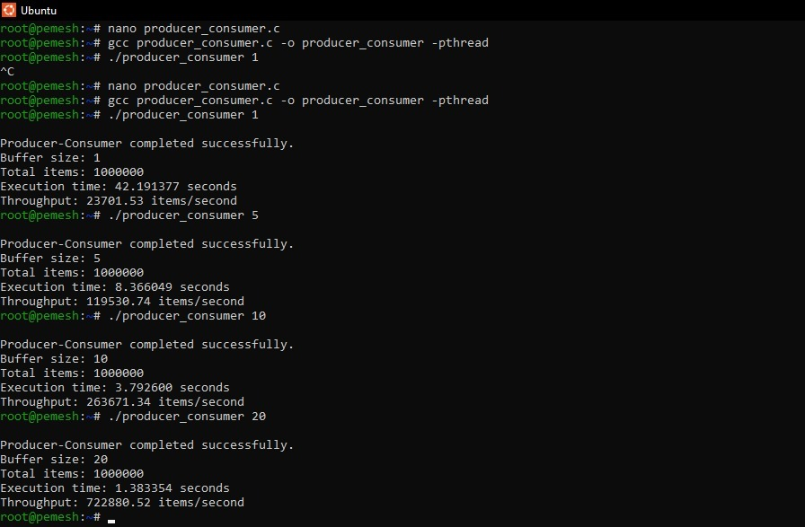
Program Explanation:
The program implements the Producer-Consumer problem using POSIX threads, counting semaphores, and a mutex. A shared buffer is used to store the produced items. The empty semaphore keeps track of available buffer slots, while the full semaphore keeps track of occupied slots. The producer waits for an empty slot before inserting an item, and the consumer waits for a filled slot before removing an item. The mutex ensures that only one thread accesses the shared buffer at a time. The program also calculates the execution time and throughput for different buffer sizes.
PROGRAM 2 – Deadlock Demonstration
C Program:
#include <stdio.h>
#include <pthread.h>
#include <unistd.h>

pthread_mutex_t resource1;
pthread_mutex_t resource2;

void *thread1(void *arg)
{
pthread_mutex_lock(&resource1);

printf("Thread 1 acquired Resource 1\n");

sleep(1);

printf("Thread 1 waiting for Resource 2\n");

pthread_mutex_lock(&resource2);

printf("Thread 1 acquired Resource 2\n");

pthread_mutex_unlock(&resource2);
pthread_mutex_unlock(&resource1);

return NULL;
}

void *thread2(void *arg)
{
pthread_mutex_lock(&resource2);

printf("Thread 2 acquired Resource 2\n");

sleep(1);

printf("Thread 2 waiting for Resource 1\n");

pthread_mutex_lock(&resource1);

printf("Thread 2 acquired Resource 1\n");

pthread_mutex_unlock(&resource1);
pthread_mutex_unlock(&resource2);

return NULL;
}

int main()
{
pthread_t t1, t2;

pthread_mutex_init(&resource1, NULL);
pthread_mutex_init(&resource2, NULL);

pthread_create(&t1, NULL, thread1, NULL);
pthread_create(&t2, NULL, thread2, NULL);

pthread_join(t1, NULL);
pthread_join(t2, NULL);

pthread_mutex_destroy(&resource1);
pthread_mutex_destroy(&resource2);

return 0;
}
Output:
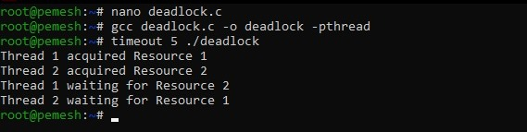
Program Explanation:
The program demonstrates a deadlock situation using two threads and two shared resources. Thread 1 acquires Resource 1 and then waits for Resource 2, while Thread 2 acquires Resource 2 and then waits for Resource 1. Since each thread is waiting for a resource held by the other thread, both threads remain blocked. This demonstrates the circular-wait condition and the occurrence of deadlock.
PROGRAM 3 - Deadlock Prevention Using Resource Ordering
C Program:
#include <stdio.h>
#include <pthread.h>

pthread_mutex_t resource1;
pthread_mutex_t resource2;

void *thread1(void *arg)
{
pthread_mutex_lock(&resource1);
printf("Thread 1 acquired Resource 1\n");

pthread_mutex_lock(&resource2);
printf("Thread 1 acquired Resource 2\n");

printf("Thread 1 completed successfully\n");

pthread_mutex_unlock(&resource2);
pthread_mutex_unlock(&resource1);

return NULL;
}

void *thread2(void *arg)
{
pthread_mutex_lock(&resource1);
printf("Thread 2 acquired Resource 1\n");

pthread_mutex_lock(&resource2);
printf("Thread 2 acquired Resource 2\n");

printf("Thread 2 completed successfully\n");

pthread_mutex_unlock(&resource2);
pthread_mutex_unlock(&resource1);

return NULL;
}

int main()
{
pthread_t t1, t2;

pthread_mutex_init(&resource1, NULL);
pthread_mutex_init(&resource2, NULL);

pthread_create(&t1, NULL, thread1, NULL);
pthread_create(&t2, NULL, thread2, NULL);

pthread_join(t1, NULL);
pthread_join(t2, NULL);

pthread_mutex_destroy(&resource1);
pthread_mutex_destroy(&resource2);

printf("Deadlock prevented using resource ordering.\n");

return 0;
}
Output:
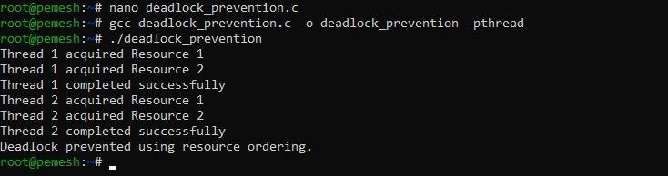

Program explanation:
The program demonstrates deadlock prevention using resource ordering. Both threads acquire Resource 1 before acquiring Resource 2. Since the resources are always acquired in the same predefined order, circular waiting cannot occur. After completing their operations, the threads release the resources and terminate successfully. Thus, the program demonstrates how resource ordering can prevent deadlock.

Analysis:
The Producer-Consumer experiment demonstrated synchronization between producer and consumer threads using counting semaphores. The empty and full semaphores controlled the available and occupied buffer positions, while the mutex protected access to the shared buffer. Different buffer sizes were tested to observe their effect on execution time and throughput. The semaphore-based approach follows the bounded-buffer synchronization method described in the course material.
The deadlock experiment demonstrated how two threads can become permanently blocked when each thread holds one resource and waits for another resource held by the other thread. The four necessary conditions for deadlock were identified. Resource ordering was then applied so that both threads acquired the resources in the same order, preventing circular wait.

Test Cases:
Test Case | Input / Action | Expected Result
1 | Run Producer-Consumer with buffer size 1 | Program completes successfully
2 | Run Producer-Consumer with buffer size 5 | Synchronization is maintained
3 | Run Producer-Consumer with buffer size 10 | Throughput is displayed
4 | Run Producer-Consumer with buffer size 20 | Program completes successfully
5 | Run the deadlock program | Threads become blocked due to circular waiting
6 | Run the deadlock prevention program | Threads complete successfully without deadlock

Observation:
The Producer-Consumer program successfully synchronized the producer and consumer threads using counting semaphores. The producer inserted items only when empty buffer space was available, while the consumer removed items only when items were available. The program completed successfully for different buffer sizes and displayed the corresponding execution time and throughput.
The deadlock program demonstrated that threads can become permanently blocked when each thread holds one resource and waits for another resource held by the other thread. This demonstrated the circular-wait condition of deadlock.
In the prevention program, both threads acquired the resources in the same predefined order. The threads completed successfully without becoming permanently blocked, showing that resource ordering can prevent deadlock.
Result:
The Producer-Consumer problem was successfully implemented using POSIX threads and counting semaphores. Synchronization was achieved and system throughput was evaluated using different buffer sizes.
A deadlock scenario was successfully demonstrated using multiple threads and shared resources. The four necessary conditions for deadlock were identified, and deadlock was successfully prevented using resource ordering.
Conclusion:
The experiment successfully demonstrated synchronization using counting semaphores and POSIX threads. The Producer-Consumer problem showed how semaphores coordinate access to a shared bounded buffer and maintain synchronization between producer and consumer threads.
The deadlock experiment demonstrated how multiple threads can become permanently blocked when the necessary deadlock conditions are present. By enforcing a fixed order for acquiring resources, circular wait was prevented and deadlock was successfully avoided.

