A CASE-STUDY BASED REPORT
ON
Heart Disease Prediction Using Ridge and Lasso Regularized Logistic Regression
submitted in partial fulfilment of the requirements for the Course
MACHINE LEARNING
BACHELOR OF TECHNOLOGY
in
A.Y.: 2026-27
by
Fathima Qhibtiya Khader 2520030155
Pakalapati Harini 2520030177
Under the Esteemed guidance of
Mr. Shaik Asif
Asst.Professor, Dept. of CSE




INDEX
Abstract 3
Introduction 3
Background 3
Motivation for the Project 3
Overview of the Work Carried Out 3
Scope and Responsible-Use Statement 4
Problem Statement 4
Case-Study Scenario 4
Central Case-Study Question 4
Formal Problem Definition 4
Objectives that Guide the Study 4
Assumptions and Limitations 4
Dataset and Exploratory Data Analysis 5
About the Dataset 5
Purpose of EDA 6
Preparation Steps Actually Performed 6
EDA Exploration - Implementation 6
Summary of EDA Findings 7
Algorithm Selection and Implementation 7

Conclusion 9

Signature of the Team members

1. Abstract
Cardiovascular disease remains one of the leading causes of death worldwide, and early, accurate identification of at-risk patients is essential for timely clinical intervention. This project presents a heart disease prediction system built on regularized logistic regression. Ridge (L2), LASSO (L1) and Elastic Net (L1 + L2) classifiers are used to control overfitting and the effect of correlated clinical features. The models are trained on a noisy heart disease dataset of 1,030 patient records with 13 clinical attributes, including age, sex, chest pain type, resting blood pressure, cholesterol, fasting blood sugar, resting ECG, maximum heart rate, exercise-induced angina, oldpeak, slope, number of major vessels and thalassemia.
Exploratory data analysis revealed 133 missing cells and 5 duplicate rows, which were handled through duplicate removal, median imputation and standard scaling inside a leakage-safe pipeline. The data were split 80:20 with stratification, and all models were evaluated on the same 205 unseen records using accuracy, precision, recall, F1-score, specificity and ROC-AUC. LASSO and Elastic Net reached 82.93% accuracy and a ROC-AUC of 0.935, slightly ahead of Ridge at 81.95% and 0.932. All three models detected about 92% of disease cases. The work shows that simple, interpretable regularized models give reliable screening support on noisy clinical data.

2. Introduction

Background
Heart disease continues to be a major global health concern, contributing to a significant proportion of deaths every year. Its progression is often silent, with symptoms appearing only after considerable damage has occurred, which makes early risk assessment critical. Hospitals and clinics generate large volumes of patient data, including vital signs, lab results and diagnostic test outcomes, but manually analysing this data to identify at-risk individuals is time-consuming and prone to human error.

Motivation for the Project
Machine Learning offers a data-driven alternative to traditional rule-based diagnostic approaches. By learning patterns from historical patient records, models can flag individuals at higher risk of heart disease and help doctors prioritise further testing. Logistic regression is widely used in medical prediction because it is simple, interpretable and gives probabilistic outputs that suit clinical decision-making. However, it can overfit when many features are correlated or uninformative, which is common in clinical datasets. Real clinical data is also noisy, with missing values, duplicates and outliers, so a method that stays stable under such conditions is needed.

Overview of the Work Carried Out
This project develops a Heart Disease Prediction System using Ridge-, LASSO- and Elastic Net-regularized models. Ridge (L2) penalises the sum of squared coefficients, shrinking them to reduce variance without removing any feature, which helps when predictors are correlated. LASSO (L1) penalises the sum of absolute coefficients and can shrink some of them to exactly zero, which supports feature selection. Elastic Net combines both penalties.
The work covers a full pipeline: exploratory data analysis, removal of duplicates, median imputation of missing values, feature scaling, an 80:20 stratified train-test split, model training and evaluation. A web interface was also built so that patient values can be entered and the three models return a prediction.

Scope and Responsible-Use Statement
The models are implemented in Python with scikit-learn and evaluated using accuracy, precision, recall, F1-score, specificity and ROC-AUC on a held-out test set. The system is intended as a learning project and as screening support. It is not a diagnostic tool, and its output must not replace the judgement of a qualified doctor.

3. Problem Statement

Case-Study Scenario
A 55-year-old patient visits a hospital with chest discomfort and shortness of breath. The doctor records age, sex, chest pain type, resting blood pressure, cholesterol, maximum heart rate, exercise-induced angina and other measurements. Some values are missing, and the scales differ widely, with cholesterol in the hundreds and oldpeak below 7. The record has to be cleaned, scaled and passed to a model that estimates whether heart disease is likely.

Central Case-Study Question
Can regularized linear classifiers (Ridge, LASSO and Elastic Net) give reliable heart disease predictions on real, noisy clinical data that contains missing values, duplicates and outliers?

Formal Problem Definition
Given a dataset D = {(xᵢ, yᵢ)} of patient records, where xᵢ is a vector of 13 clinical features and yᵢ ∈ {0, 1} indicates absence or presence of heart disease, learn a function f(x) that predicts y for unseen patients. A regularization term (L2, L1 or a mix of both) is added to the loss function to control model complexity. The goal is to maximise predictive performance on a held-out test set, measured by accuracy, precision, recall, F1-score, specificity and ROC-AUC.

Objectives that Guide the Study
- Understand the dataset’s structure, quality, distributions and correlations through EDA.
- Prepare the data by removing duplicates, imputing missing values and scaling features.
- Build Ridge, LASSO and Elastic Net regularized classifiers.
- Evaluate all models fairly on the same unseen test set using standard metrics.

Assumptions and Limitations
- Records are assumed to be independent and the target labels are assumed to be correct.
- Missing values are assumed to be fillable with the column median without changing the overall pattern.
- A single stratified 80:20 split was used, so results can vary with a different split.
- Regularization strengths were fixed (alpha = 1.0, C = 1.0, l1_ratio = 0.5) and not tuned by cross-validation.
- The dataset is small (1,030 records), so results may not carry over to other populations.
- The system is for learning and screening support only and is not a diagnostic tool.

4. Dataset and Exploratory Data Analysis

About the Dataset
The dataset contains 1,030 patient records and 14 columns (13 features and one target). The target indicates the presence (1) or absence (0) of heart disease. The features are:
Feature | Description
age | Age of the patient in years
sex | Sex (1 = male, 0 = female)
cp | Chest pain type
trestbps | Resting blood pressure
chol | Serum cholesterol
fbs | Fasting blood sugar above 120 mg/dl
restecg | Resting ECG result
thalach | Maximum heart rate achieved
exang | Exercise-induced angina
oldpeak | ST depression induced by exercise
slope | Slope of the peak exercise ST segment
ca | Number of major vessels
thal | Thalassemia result

Table 1: Features in the dataset
The data contains 133 missing cells and 5 duplicate rows. The target is nearly balanced, with 529 patients with disease and 501 without, so no resampling was needed.
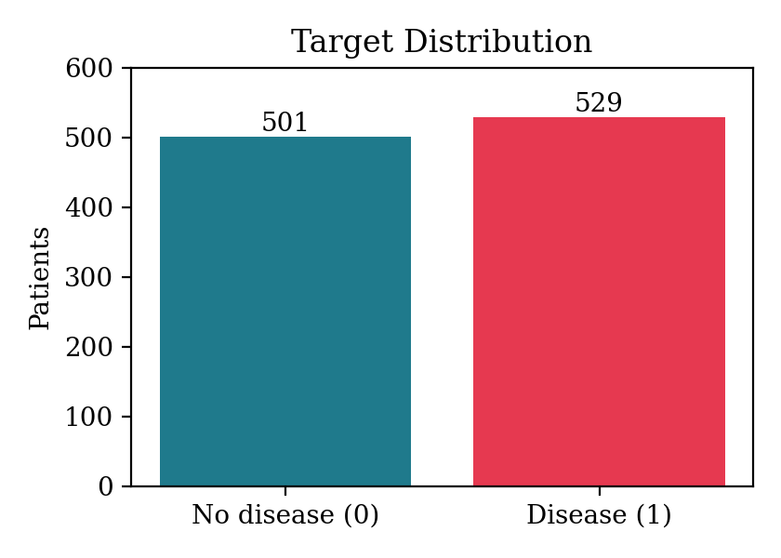
Figure 1: Distribution of the target variable

Purpose of EDA
EDA was carried out to check the structure and quality of the data before modelling. It reveals missing values, duplicates and outliers, shows how each feature relates to the target, and guides the preprocessing decisions so that the regularized models are trained on clean, comparable inputs.

Preparation Steps Actually Performed
- Remove duplicates: the 5 repeated rows were dropped, leaving 1,025 records.
- Median imputation: missing values were filled with each column’s median, which is robust to outliers.
- Standard scaling: features were scaled to zero mean and unit variance so the regularization penalty treats all features equally.
- Stratified 80:20 split: 820 training and 205 test records, with class proportions preserved.
Imputation and scaling were placed inside a scikit-learn pipeline and fitted on the training data only, which prevents data leakage into the test set.

EDA Exploration - Implementation
The EDA was implemented in Python using pandas, NumPy, Matplotlib and seaborn. It covered the following:
- Structure: first, last and random rows, shape, column names, data types and dataset information.
- Quality: statistical summary, missing values and their percentages, duplicate rows and unique values.
- Target: class counts, percentages and a count plot.
- Distributions: histograms of all numeric features, and separate plots for age, resting blood pressure, cholesterol, maximum heart rate, sex and chest pain type.
- Relationships: heart disease by sex, chest pain type and exercise-induced angina, and box plots of age, cholesterol, blood pressure, maximum heart rate and oldpeak against the target.
- Statistics: correlation matrix and heatmap, correlation with the target, IQR outlier counts, skewness, kurtosis, and group means and medians by target.

Summary of EDA Findings
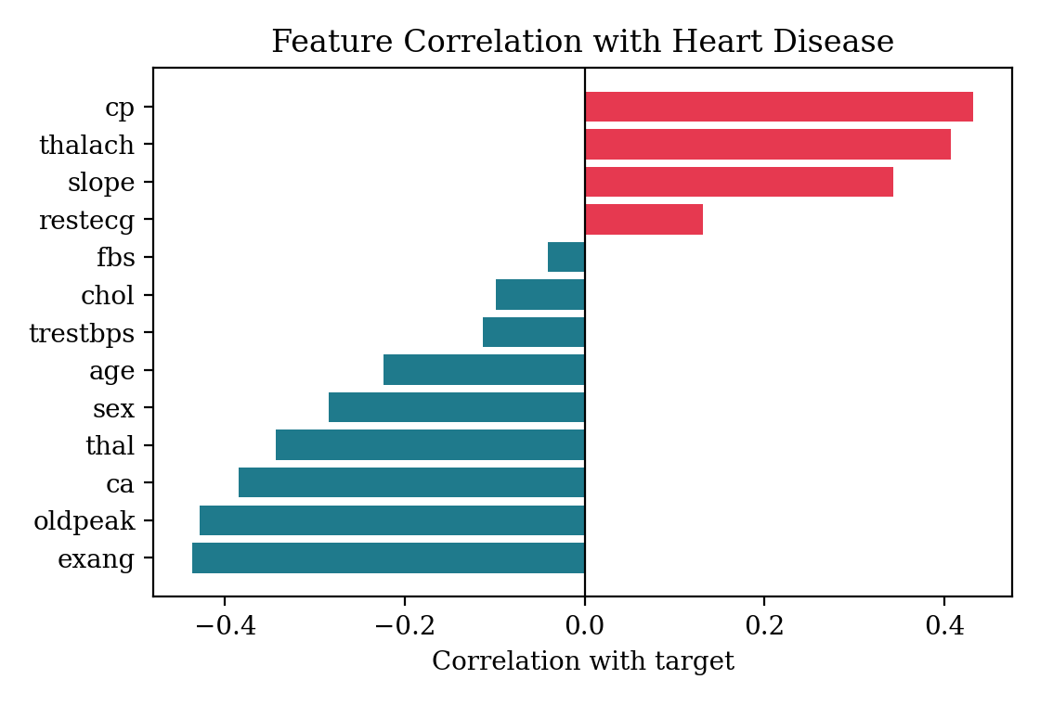
Figure 2: Correlation of each feature with the target
- Data quality: missing values in several attributes and a few duplicate rows needed handling.
- Positively related to disease: chest pain type (cp, +0.432), maximum heart rate (thalach, +0.407) and slope (+0.343).
- Negatively related to disease: exercise-induced angina (exang, −0.436), oldpeak (−0.428), number of major vessels (ca, −0.385) and thal (−0.344).
- Weak signals: fasting blood sugar (−0.041) and cholesterol (−0.099) show little linear relation with the target.
- Balanced target: 529 positive and 501 negative records.

5. Algorithm Selection and Implementation
Three regularized models were chosen. Each one runs inside the same pipeline of median imputer, StandardScaler and classifier, so differences in results come from the penalty and not from preprocessing.
Model | Implementation | Key settings
Ridge (L2) | RidgeClassifier | alpha = 1.0
LASSO (L1) | LogisticRegression, penalty l1 | C = 1.0, solver = liblinear
Elastic Net | LogisticRegression, penalty elasticnet | C = 1.0, l1_ratio = 0.5, solver = saga

Table 2: Models and settings
- Ridge shrinks large coefficients and copes well with correlated features.
- LASSO can drive coefficients to zero, which supports feature selection.
- Elastic Net combines the L1 and L2 penalties and balances both behaviours.

Results
All models were trained on the 820 training records and evaluated on the same 205 unseen test records.
Model | Accuracy | Precision | Recall | F1 | Specificity | ROC-AUC
Ridge | 0.8195 | 0.7698 | 0.9238 | 0.8398 | 0.7100 | 0.9317
LASSO | 0.8293 | 0.7823 | 0.9238 | 0.8472 | 0.7300 | 0.9346
Elastic Net | 0.8293 | 0.7823 | 0.9238 | 0.8472 | 0.7300 | 0.9346

Table 3: Test-set performance
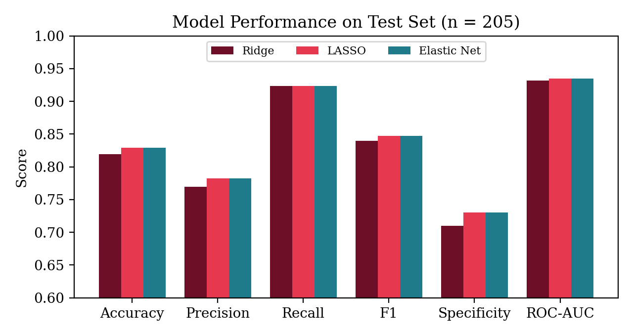
Figure 3: Comparison of the three models
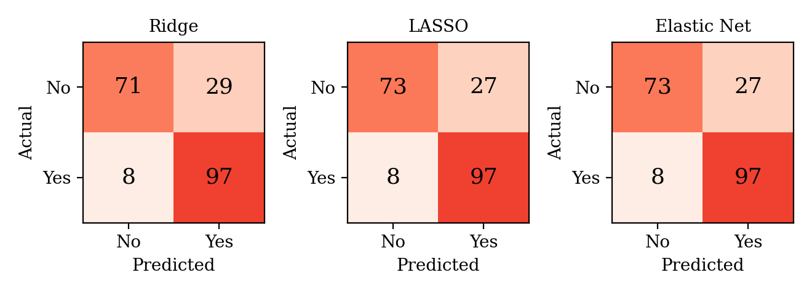
Figure 4: Confusion matrices (actual vs predicted)
Ridge produced 71 true negatives, 29 false positives, 8 false negatives and 97 true positives. LASSO and Elastic Net produced 73, 27, 8 and 97. All three models identified 97 of the 105 disease cases (recall 0.9238), so the main weakness is false positives, with 27 to 29 healthy patients flagged. LASSO and Elastic Net gave identical results and were slightly better than Ridge. At C = 1.0, LASSO kept all 13 features, so stronger regularization would be needed to obtain real feature selection.

6. Conclusion
This project built a complete heart disease prediction workflow covering EDA, preprocessing, three regularized models and evaluation on unseen data. EDA exposed the missing values and duplicates and identified the strongest predictors: chest pain type, maximum heart rate, slope, exercise-induced angina, oldpeak, major vessels and thal. All three models reached about 82–83% accuracy with a ROC-AUC near 0.93 and detected about 92% of disease cases. LASSO and Elastic Net performed identically and slightly better than Ridge. Regularized logistic regression is therefore a lightweight, interpretable option for early screening on noisy clinical data.
Future work: stratified cross-validation and a systematic search over C and l1_ratio, comparison with tree-based models, SHAP-based explanations, and validation on larger and more varied clinical datasets.

