1 INTRODUCTION 1.1

Overview

Business estimation involves the process of predicting or calculating various aspects of a business, such as sales, expenses, profits, and future growth. It helps in making informed decisions, setting realistic goals, and assessing the financial health of a business. Estimations can be done using historical data, market research, industry trends, and other relevant factors. It's an important tool for planning and strategizing in business.

Purpose

The purpose of estimating business expenses is to have a clear understanding of the projected costs involved in running a business. It helps in budgeting, financial planning, and decision-making. By estimating expenses, businesses can allocate resources effectively, identify areas for cost reduction, and ensure that they have sufficient funds to cover their operating costs. It's an essential part of managing the financial health of a business.

2 Problem Definition & Design Thinking

Empathy Map

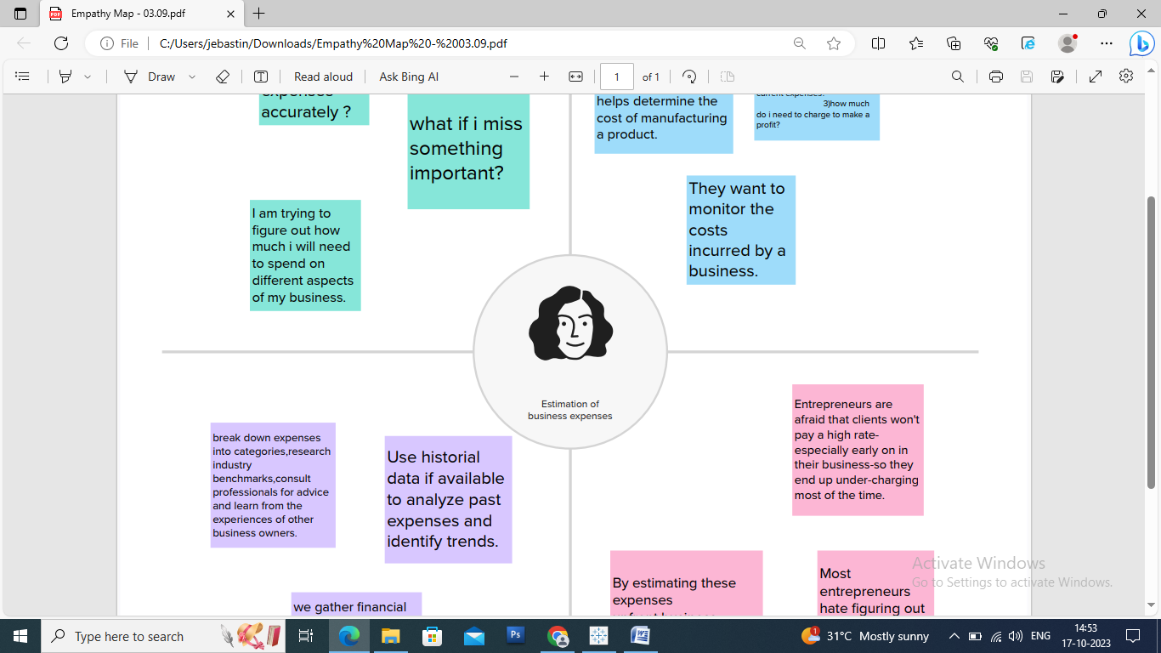

Ideation & Brainstorming Map

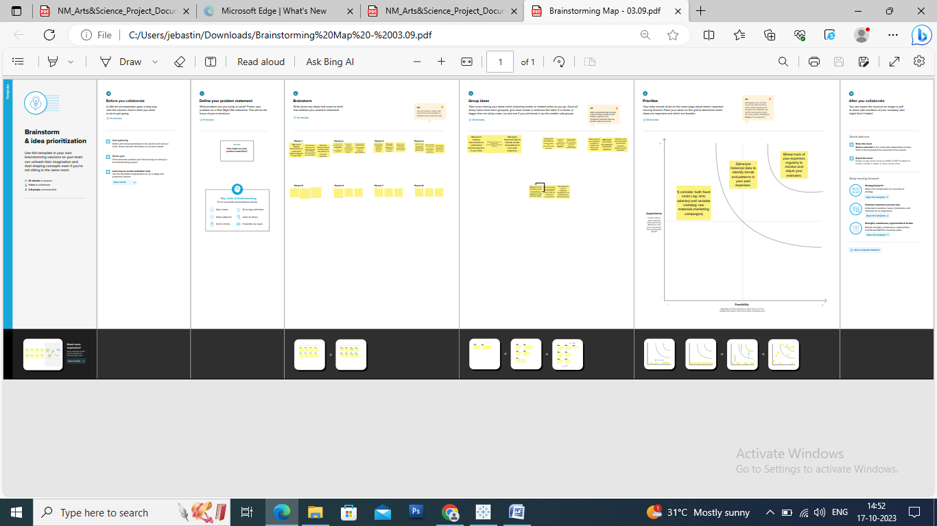

RESULT

The result of estimating business expenses is a projection or forecast of the expected costs that a business will incur. This can help businesses plan their budgets, make informed financial decisions, and evaluate the feasibility of their operations. By having a clear estimate of expenses, businesses can better manage their finances and work towards achieving their financial goals.

4 ADVANTAGES & DISADVANTAGES

ADVANTAGES

Estimating business expenses helps in budgeting, financial planning, and decision-making. It allows businesses to allocate resources effectively and identify areas for cost reduction. This helps in ensuring that there are sufficient funds to cover operating costs and achieve financial goals.

DISADVANTAGES

Estimations may not always be accurate, as they rely on various assumptions and projections. Unexpected changes in market conditions, inflation, or unforeseen expenses can impact the accuracy of the estimates. It's important for businesses to regularly review and update their estimations to account for any changes or uncertainties.

5 APPLICATIONS

The application of estimating business expenses is widespread. It is used in various areas such as financial planning, budgeting, forecasting, pricing strategies, investment decisions, and cost control. By accurately estimating expenses, businesses can make informed decisions, set realistic financial goals, allocate resources effectively, and ensure the financial health and sustainability of their operations. It is an essential tool for managing finances and making strategic business decisions.

6 CONCLUSION

In conclusion, estimating business expenses is crucial for effective financial management and decision-making. It helps businesses plan their budgets, allocate resources, and make informed financial decisions. By accurately estimating expenses, businesses can ensure they have sufficient funds, identify areas for cost reduction, and work towards achieving their financial goals. It's an essential practice for maintaining the financial health and sustainability of a business.

7 FUTURE SCOPE

Estimating future business expenses allows for proactive financial planning and helps businesses anticipate potential costs. By considering factors such as inflation, market trends, and business growth, businesses can make more accurate estimations and better prepare for the future. It enables businesses to adjust their budgets, optimize resource allocation, and make informed decisions to ensure long-term financial stability and success.

8 APPENDIX

1. Source Code

github.com/fathimarifaya/Estimation- Of-Business-Expenses_-NM2023TMID12826